Week 4 Homework Submission File: Linux Systems Administration

Step 1: Ensure/Double Check Permissions on Sensitive Files

1. Permissions on /etc/shadow should allow only root read and write access.

Command to inspect permissions: **ls -la | grep shadow**

Command to set permissions (if needed): **sudo chmod 600 ./shadow**

2. Permissions on /etc/gshadow should allow only root read and write access.

Command to inspect permissions: **ls -la | grep gshadow**

Command to set permissions (if needed): **sudo chmod 600 ./shadow**

3. Permissions on /etc/group should allow root read and write access, and allow everyone else read access only. Command to inspect permissions: **ls -la | grep group**

Command to set permissions (if needed): **sudo chmod 644 ./group**

4. Permissions on /etc/passwd should allow root read and write access, and allow everyone else read access only. Command to inspect permissions: **ls -la | grep passwd**

Command to set permissions (if needed): **sudo chmod 644 ./passwd**

Step 2: Create User Accounts

1. Add user accounts for sam , joe , amy , sara , and admin .

Command to add each user account (include all five users):

**sudo useradd sam**

**sudo useradd joe**

**sudo useradd amy**

**sudo useradd sara**

**sudo useradd admin**

2. Ensure that only the admin has general sudo access.

Command to add admin to the sudo group: **sudo usermod -G sudo admin**

Step 3: Create User Group and Collaborative Folder

1. Add an engineers group to the system.

Command to add group: **sudo groupadd engineers**

2. Add users sam , joe , amy , and sara to the managed group.

Command to add users to engineers group (include all four users):

**sudo usermod -G engineers sam**

**sudo usermod -G engineers joe**

**sudo usermod -G engineers amy**

**sudo usermod -G engineers sara**

3. Create a shared folder for this group at /home/engineers .

Command to create the shared folder: **sudo mkdir /home/engineers**

4. Change ownership on the new engineers' shared folder to the engineers group.

Command to change ownership of engineer's shared folder to engineer group:

**sudo chown :engineers /home/engineers**

Step 4: Lynis Auditing

1. Command to install Lynis: **sudo apt install lynis**

2. Command to see documentation and instructions: **man lynis**

3. Command to run an audit: **sudo lynis audit system**

4. Provide a report from the Lynis output on what can be done to harden the system.

Screenshot of report output:

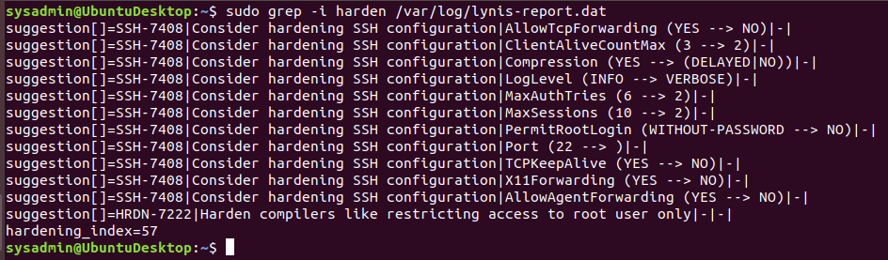

Bonus

1. Command to install chkrootkit: **sudo apt install chkrootkit**

2. Command to see documentation and instructions: **man chkrootkit**

3. Command to run expert mode: **sudo chkrootkit -x**

4. Provide a report from the chrootkit output on what can be done to harden the system.

Screenshot of end of sample output: 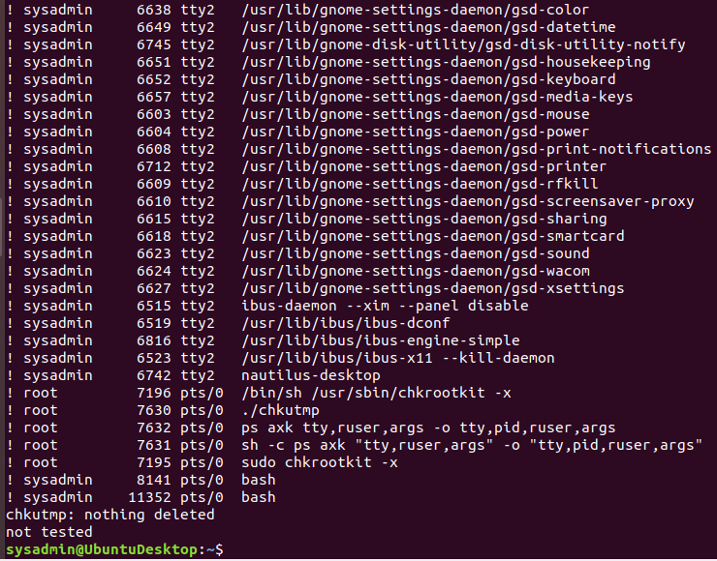

© 2020 Trilogy Education Services, a 2U, Inc. brand. All Rights Reserved.