### Mission 1

* nslookup asltx.2.google.com gives the following information:
* Server: 8.8.8.8  
  Address: 8.8.8.8#53  
    
  Non-authoritative answer:  
  starwars.com mail exchanger = 5 alt2.aspmx.l.google.com.  
  starwars.com mail exchanger = 5 alt1.aspx.l.google.com.  
  starwars.com mail exchanger = 1 aspmx.l.google.com.  
  starwars.com mail exchanger = 10 aspmx2.googlemail.com.  
  starwars.com mail exchanger = 10 aspmx3.googlemail.com.
* This shows that MX record is not set correctly, to be specific they are missing some information using only asltx.l.google.com and asltx.2.google.com as their MX record
* Starwars.com MX records should be configured as follows:
* starwars.com mail exchanger = 1 asltx.1.google.com  
    
  starwars.com mail exchanger = 2 asltx.2.google.com

### Mission 2

* nslookup -type=TXT theforce.net gives the following information for thforce.net mail server:
* theforce.net text = "v=spf1 a mx mx:smtp.secureserver.net include:aspmx.googlemail.com ip4:104.156.250.80 ip4:45.63.15.159 ip4:45.63.4.215"
* This shows the current SPF reccord does not include theforce.net’s new mail server **45.23.176.21**. it is still set to include:aspmx.googlemail.com
* Because **theforce.net** updated their mail server to **45.23.176.21** the current DNS records are not correct. this means that mail from their new server is considered untrustworthy and is blocked or sent to spam
* In order to resolve this issue the TXT record needs to be updated as follows:
* theforce.net text = "v=spf1 a mx mx:smtp.secureserver.net include:45-23-176-21 ip4:104.156.250.80 ip4:45.63.15.159 ip4:45.63.4.215"

### Mission 3

* nslookup -type=CNAME www.theforce.net shows the following:
* www.theforce.net canonical name = theforce.net
* This shows that the DNS CNAME record does not include any refrences of “resistance.theforce.net” and is therefore not being redirected to “www.theforce.net”
* to resolve this issue the a redirect should be added to the DNS record as follows:
* www.theforce.net canonical name = theforce.net  
    
  resistance.theforce.net conocial name = www.theforce.net

### Mission 4

* nslookup -type=NS princessleia.site shows the current DNS servers as:
* princessleia.site nameserver = ns25.domaincontrol.com.  
  princessleia.site nameserver = ns26.domaincontrol.com.
* Adding the backup DNS server is as easy as updating the DNS server to include:
* princessleia.site nameserver = ns25.domaincontrol.com  
    
  princessleia.site nameserver = ns2.galaxybackup.com

### Mission 5

* The shortest OSPF path from Battu to Jedha is a s follows:
* Batuu D C E F J I L Q T V Jedha  
  hops 1 2 1 1 1 1 6 4 2 2 = 21 hops
* This OSPF path does not include the dreaded “Planet N” and can be used as a static route from Batuu to Jedha

### Mission 6

* Opening Darkside.pcap in wireshark shows that all of their wirless traffic is encripted and a key needs to be optained
* Before attempting to find a key I would like to find the network SSID. I found this through the broadcast in packet 9. Looking in IEEE 802.11 Wireless Management > Tagged Parameters the SSID can be seen as linksys
* Next I ran aircrack-ng -w /usr/share/wordlist/rockyou.txt ~/Homework09/Darkside.pcap to find the decription key dictionary
* In wireshard I enabled deciption with the following: Preferences > Protocols > IEEE 802.11 > Enable Decryption > Decryption Keys > Edit > wpa-pwd key=dictionary:linksys
* Packets 312-315 a two MAC and IP addresses of note:
* 00:0f:66:e3:e4:01 is at 172.16.0.1  
    
  00:13:ce:55:98:ef is at 172.16.0.101
* looking through IP 172.16.0.101’s traffic packets 62-65 also show a TCP traffic at:
* 00:14:bf:0f:03:30 at 172.16.0.9

### Mission 7

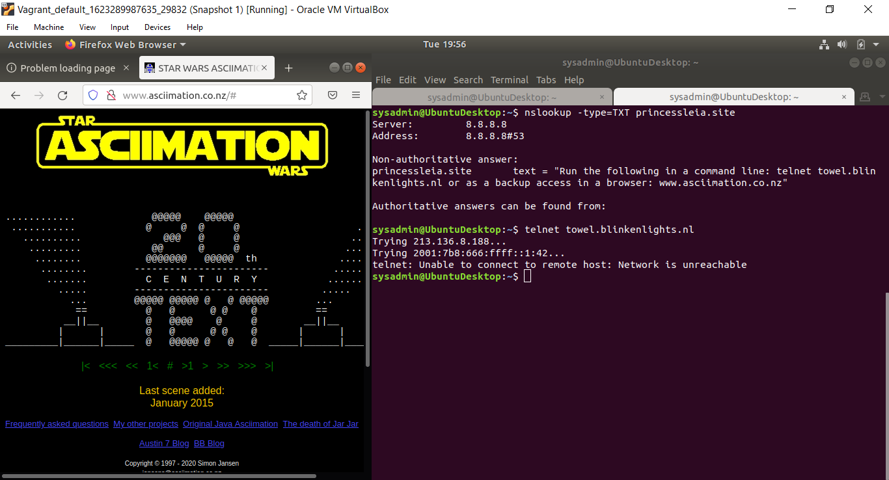

screenshot