# Week 18 - SEIMS 01

## Step 1: The Need for Speed

* Use the following search to create a new eval field of “ratio” and build a table:
* source="server_speedtest.csv" host="23395582292c" sourcetype="csv"  
  | eval ratio = DOWNLOAD_MEGABITS / UPLOAD_MEGABITS  
  | table _time IP_ADDRESS DOWNLOAD_MEGABITS UPLOAD_MEGABITS ratio
* 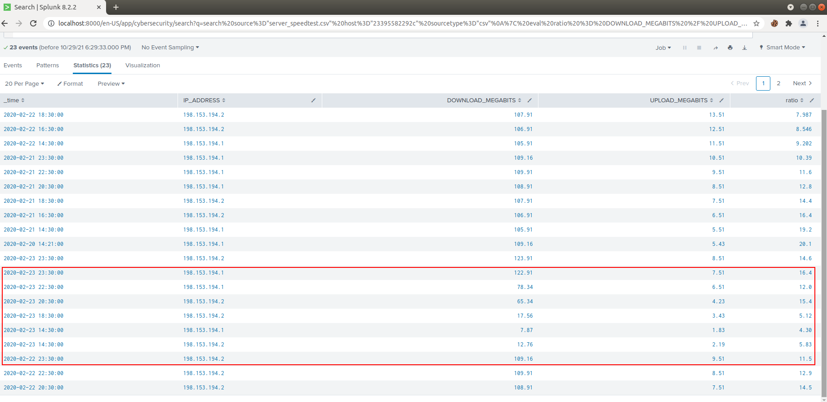
* Based on the report created, what is the approximate date and time of the attack? > We know that download and upload speeds suffer during and after DDOS attacks on Vandaly Industry’s servers. We can see a noticeable drop in speeds on **February 23, 2020 around 14:30.**
* How long did it take your systems to recover? > Speeds did not begin to return to normal until February 23, 2020 around 22:30 indicating it took the servers about **8 hours to recover.**

## Sep 2: Are We Vulnerable?

* The search used to find the count of vulnerabilities on server 10.11.36.23 is:
* source="nessus_logs.csv" host="23395582292c" sourcetype="csv" dest_ip="10.11.36.23" severity=critical  
  | stats count by severity
* 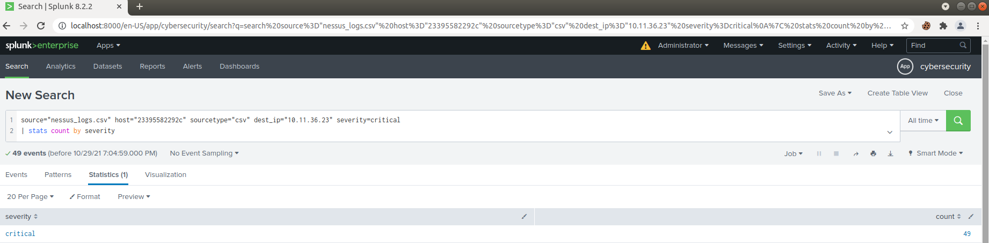
* 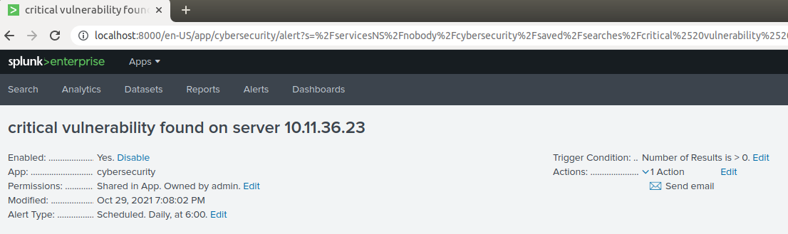

## Step 3: Drawing the (base)line

* To get a baseline of how many failed logins there are start with:
* source="Administrator_logs.csv" host="23395582292c" sourcetype="csv" EventCode=4625  
  | timechart count span=1h
* 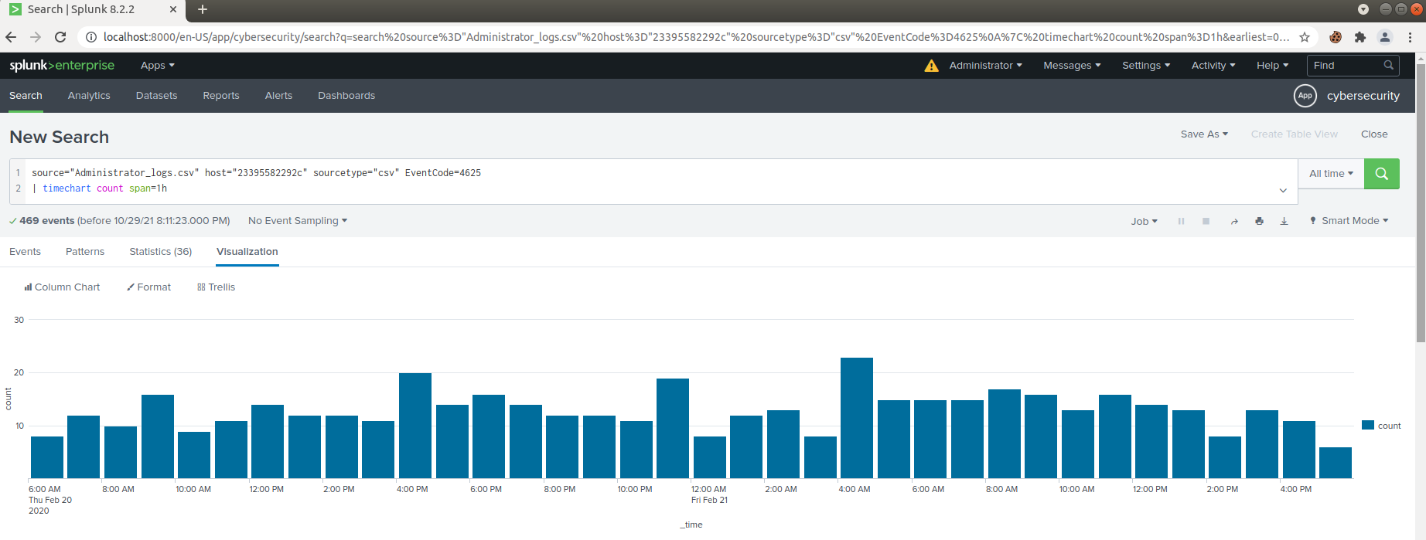
* This will give the number of failed logins every hour
* Using the search below we can see there are an average of **13** failed logins per hour
* source="Administrator_logs.csv" host="23395582292c" sourcetype="csv" EventCode=4625  
  | timechart count span=1h  
  | stats avg
* 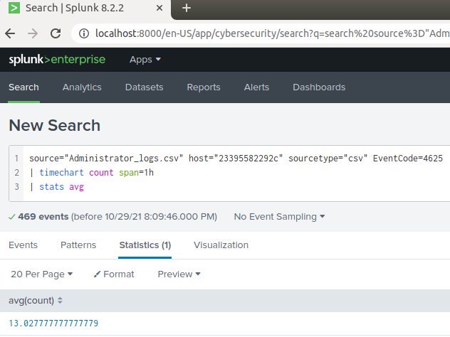
* We will set an alert to check every hour if there are more than 14 failed login attempts and alert the SOC via email.
* 