Too many requests, please try again later -- why this error ? not bale to login to any of three
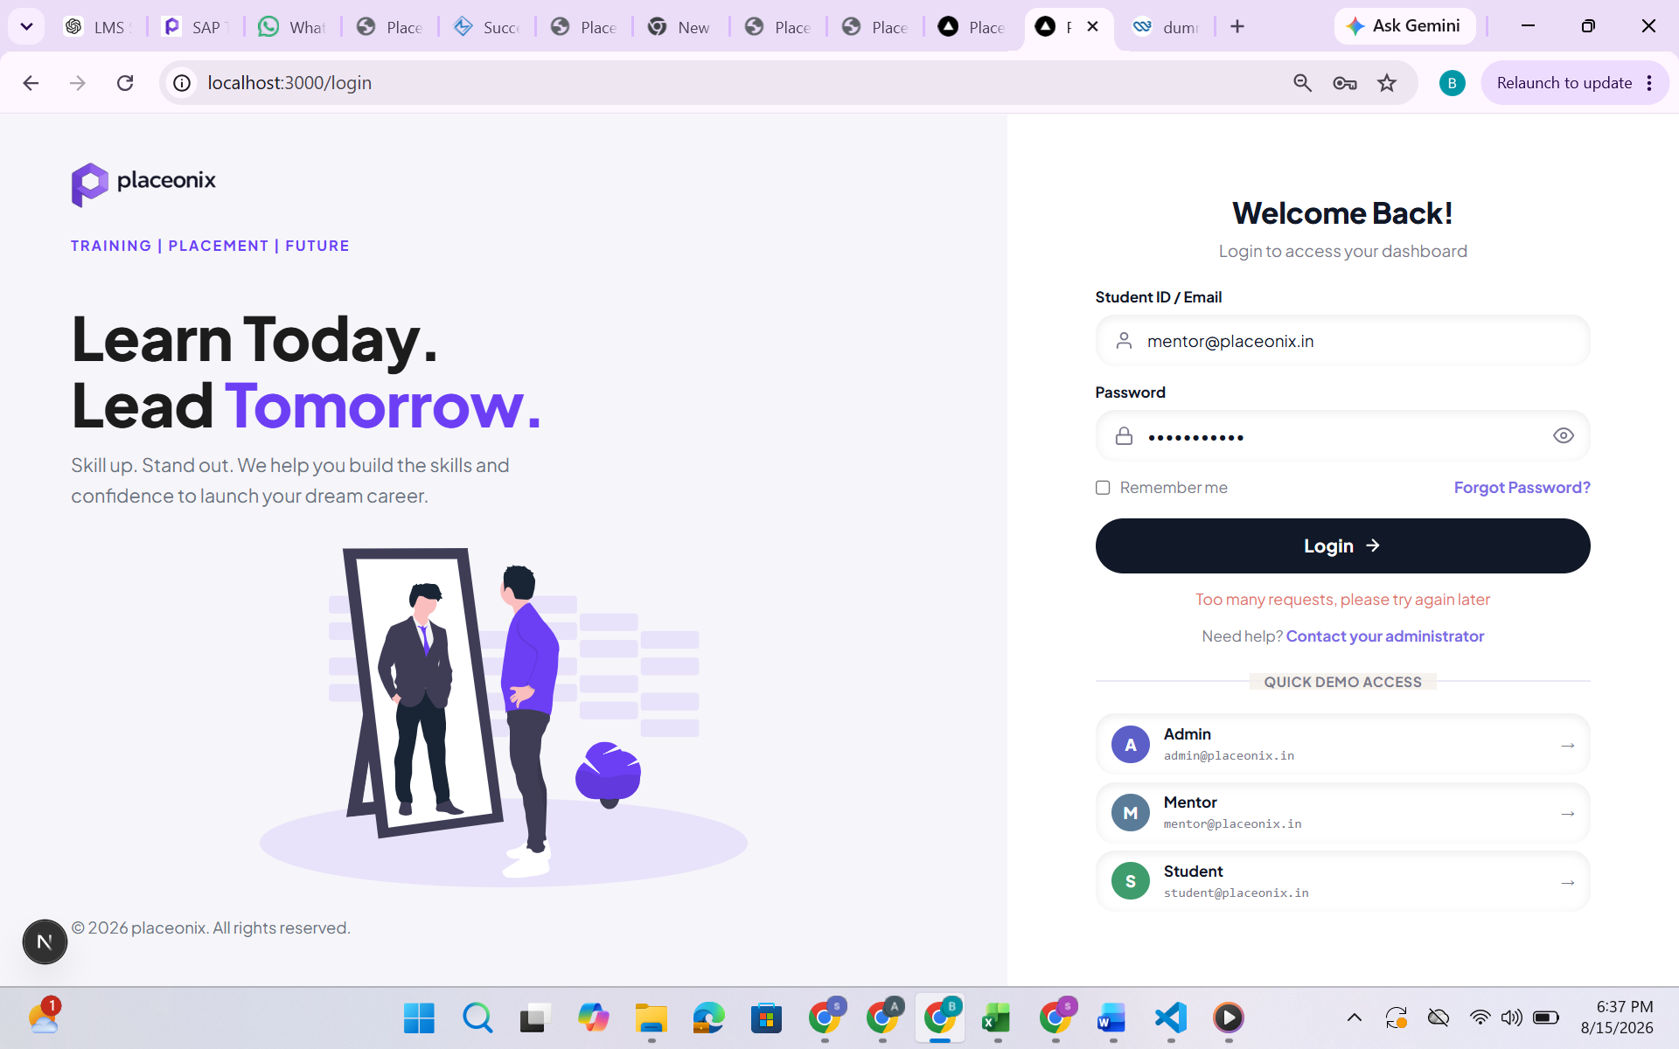

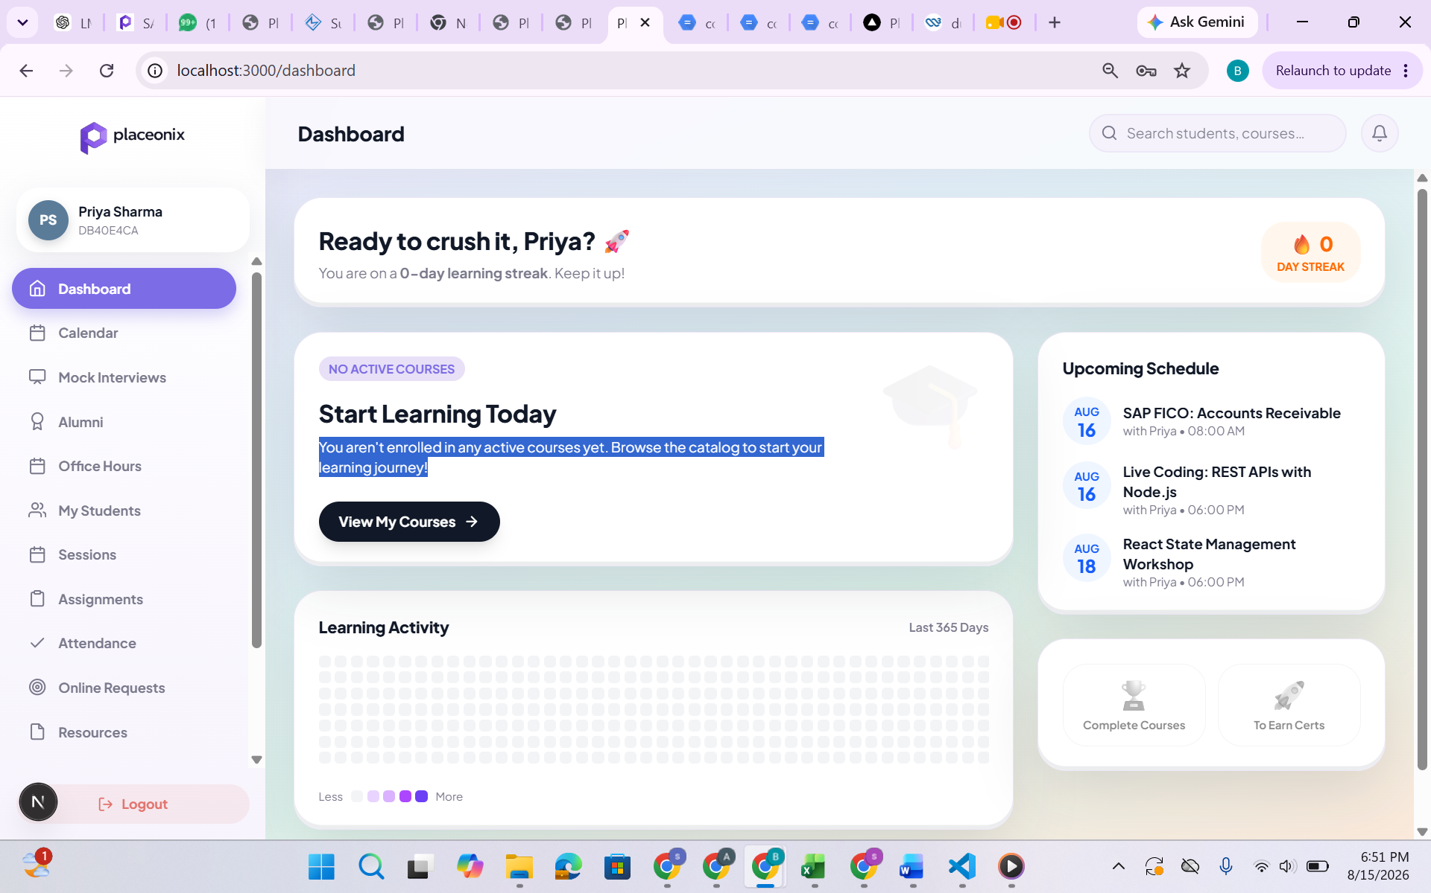

- You aren't enrolled in any active courses yet. Browse the catalog to start your learning journey!
- Learning Activity
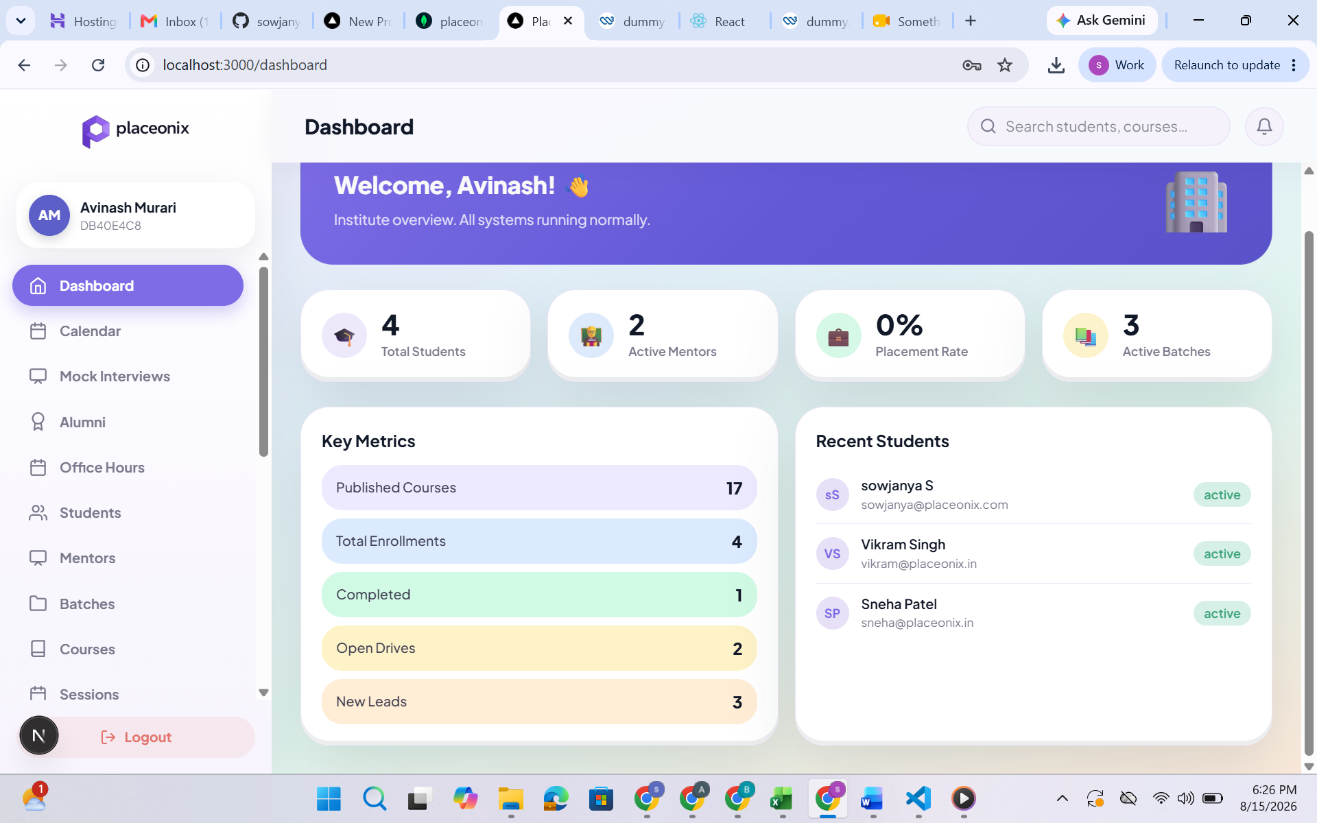
Active session also can add in key metrics

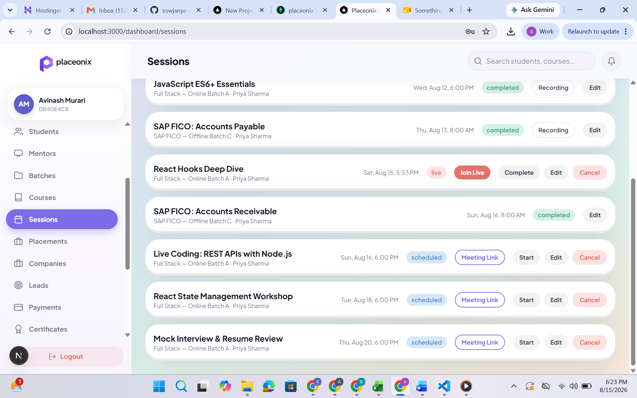

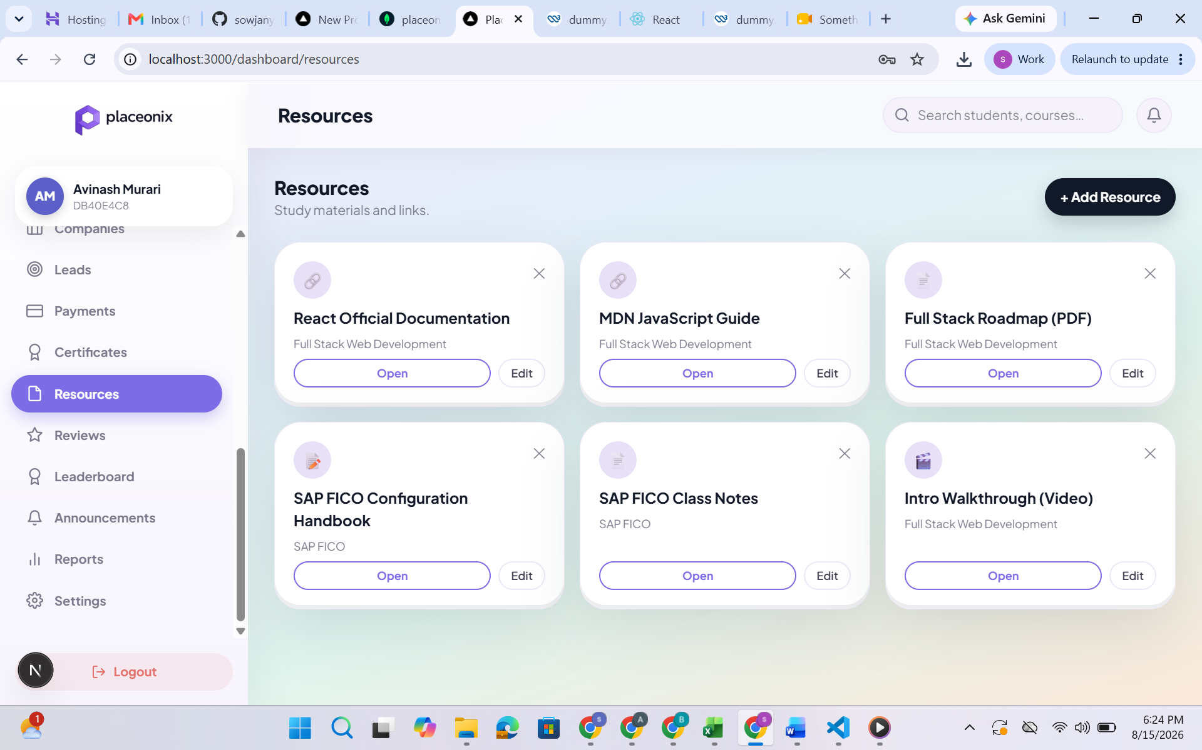
View access to students
These should not be downloadable (if pdf or words docs)

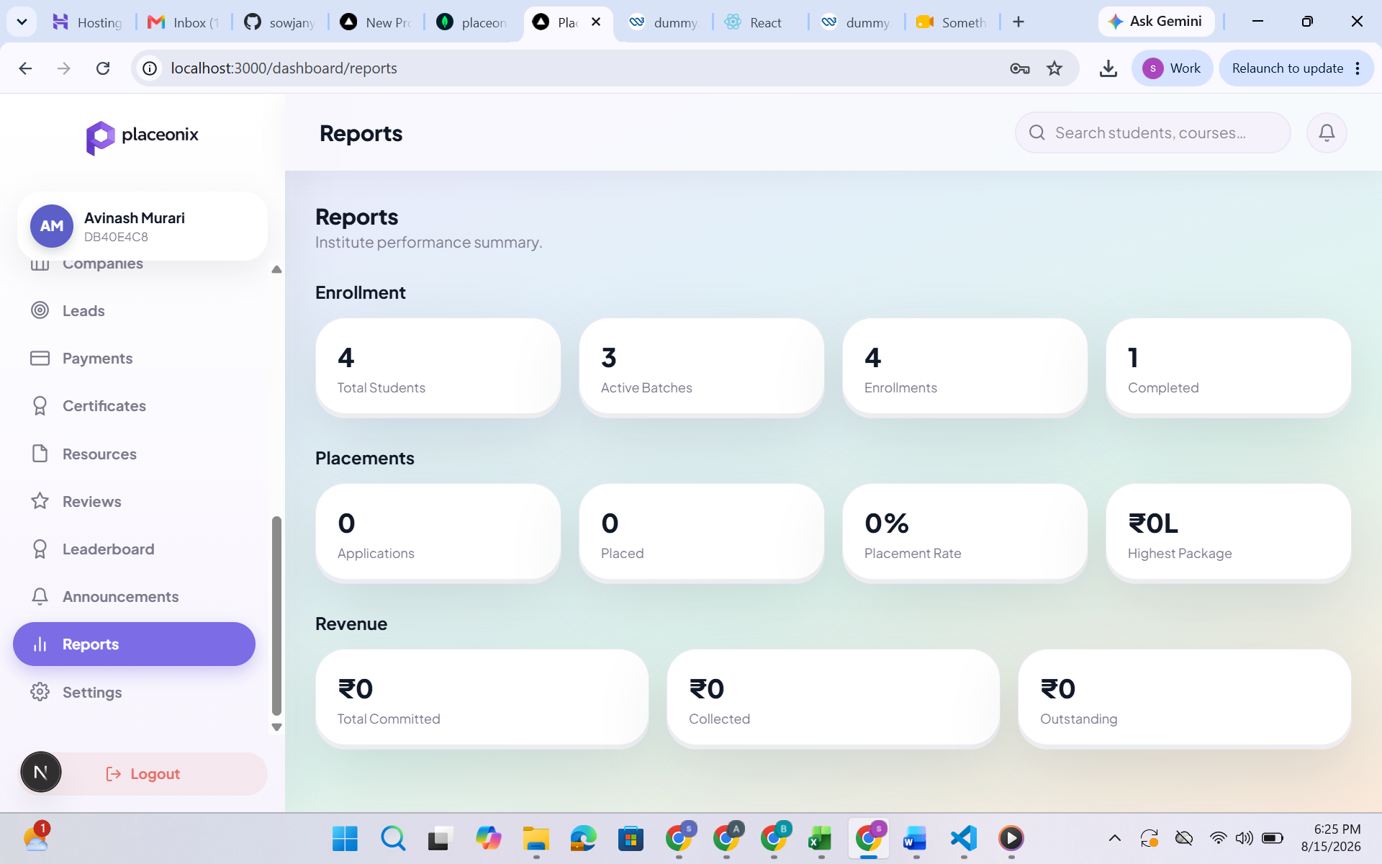

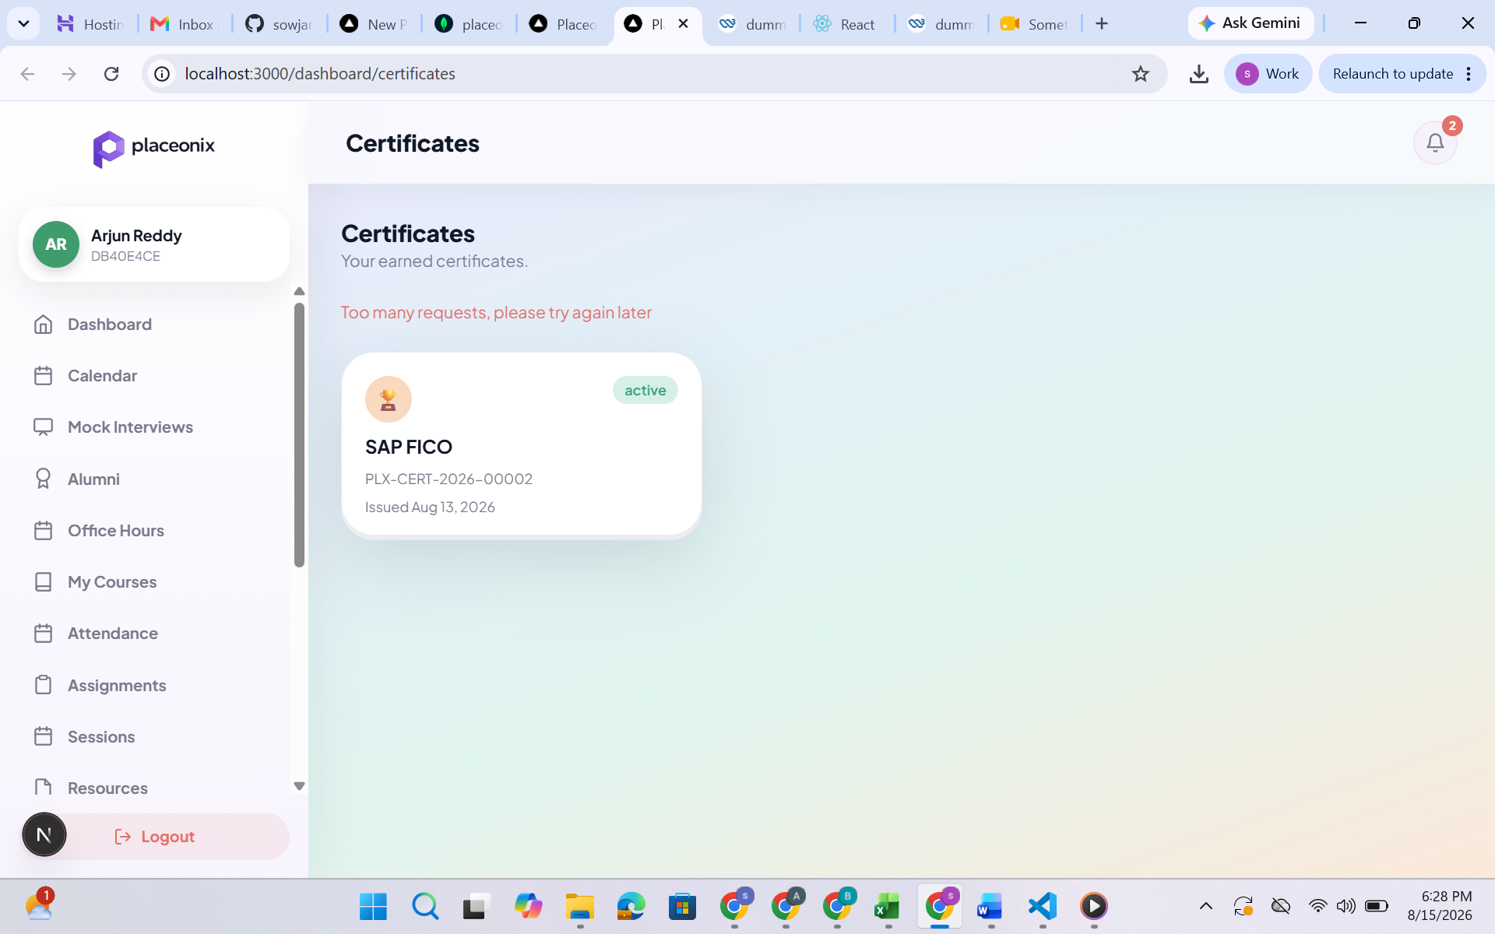

Too many requests ? also certificate is not opening

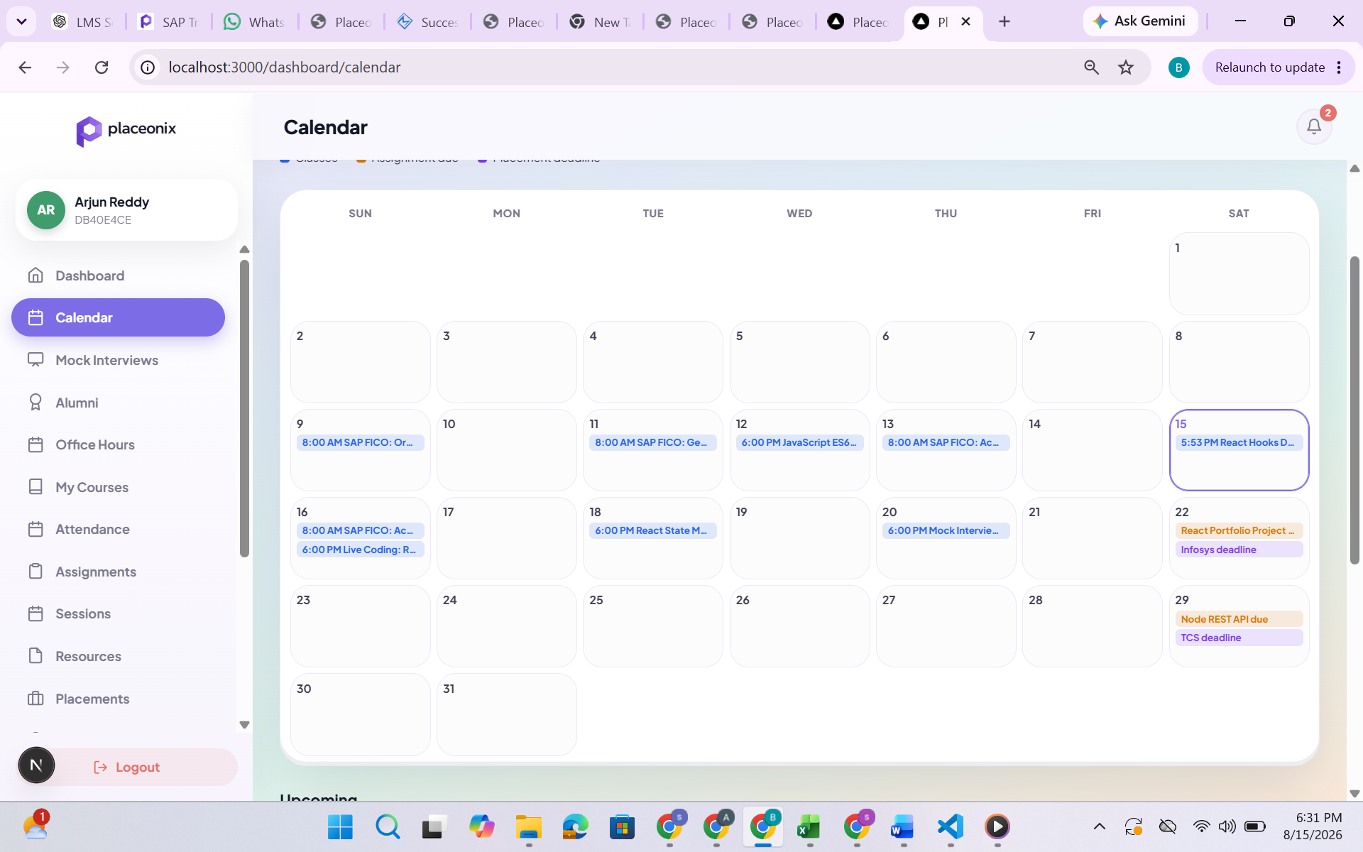

No need to show all classes to everyone.
Eg: I enrolled for fico I can only see fico classes scheduled and drives and general drives or announcements

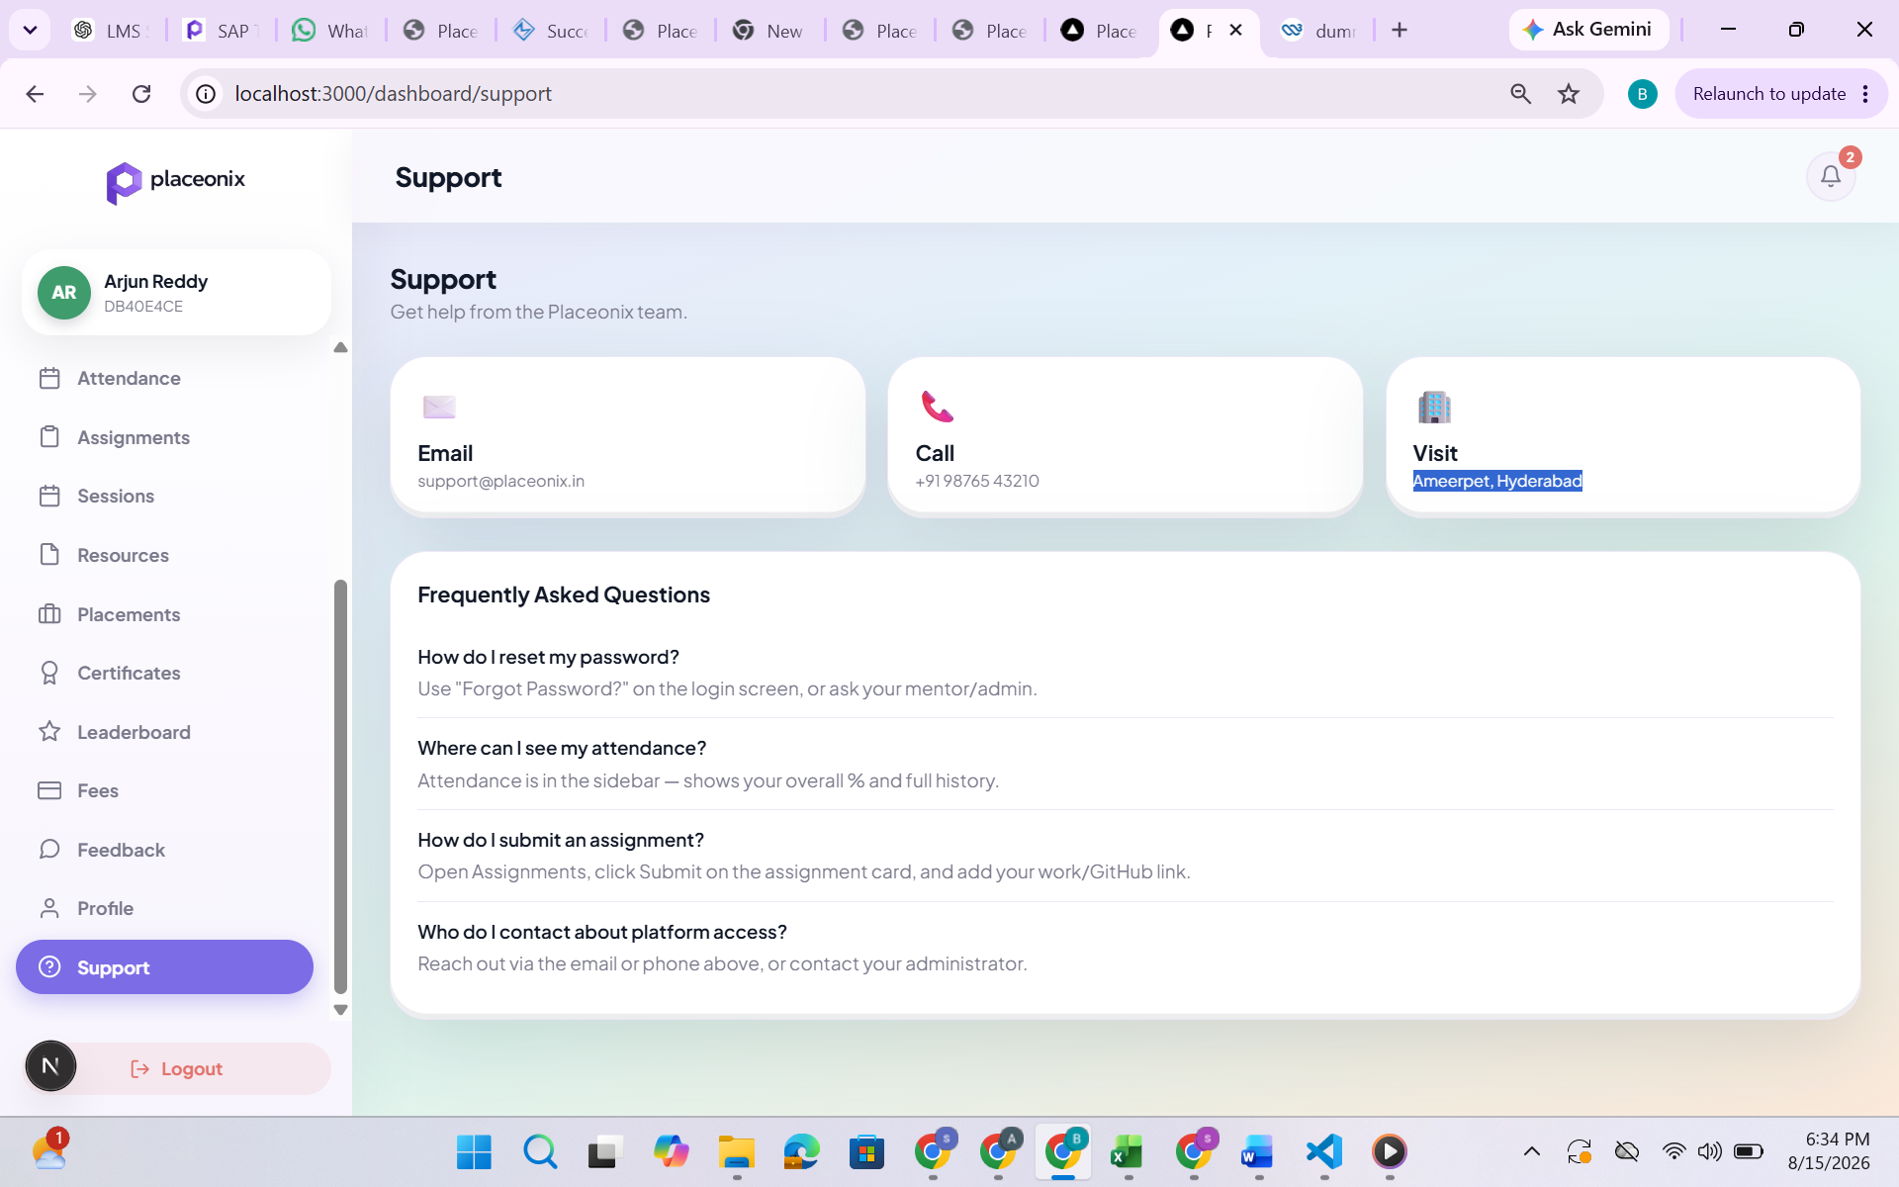

Ameerpet ?

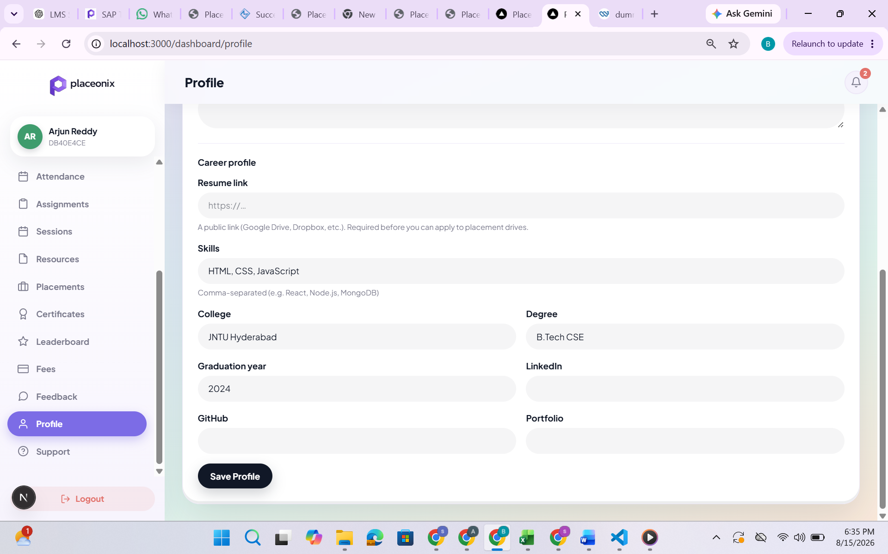

Can add few fields in career profile

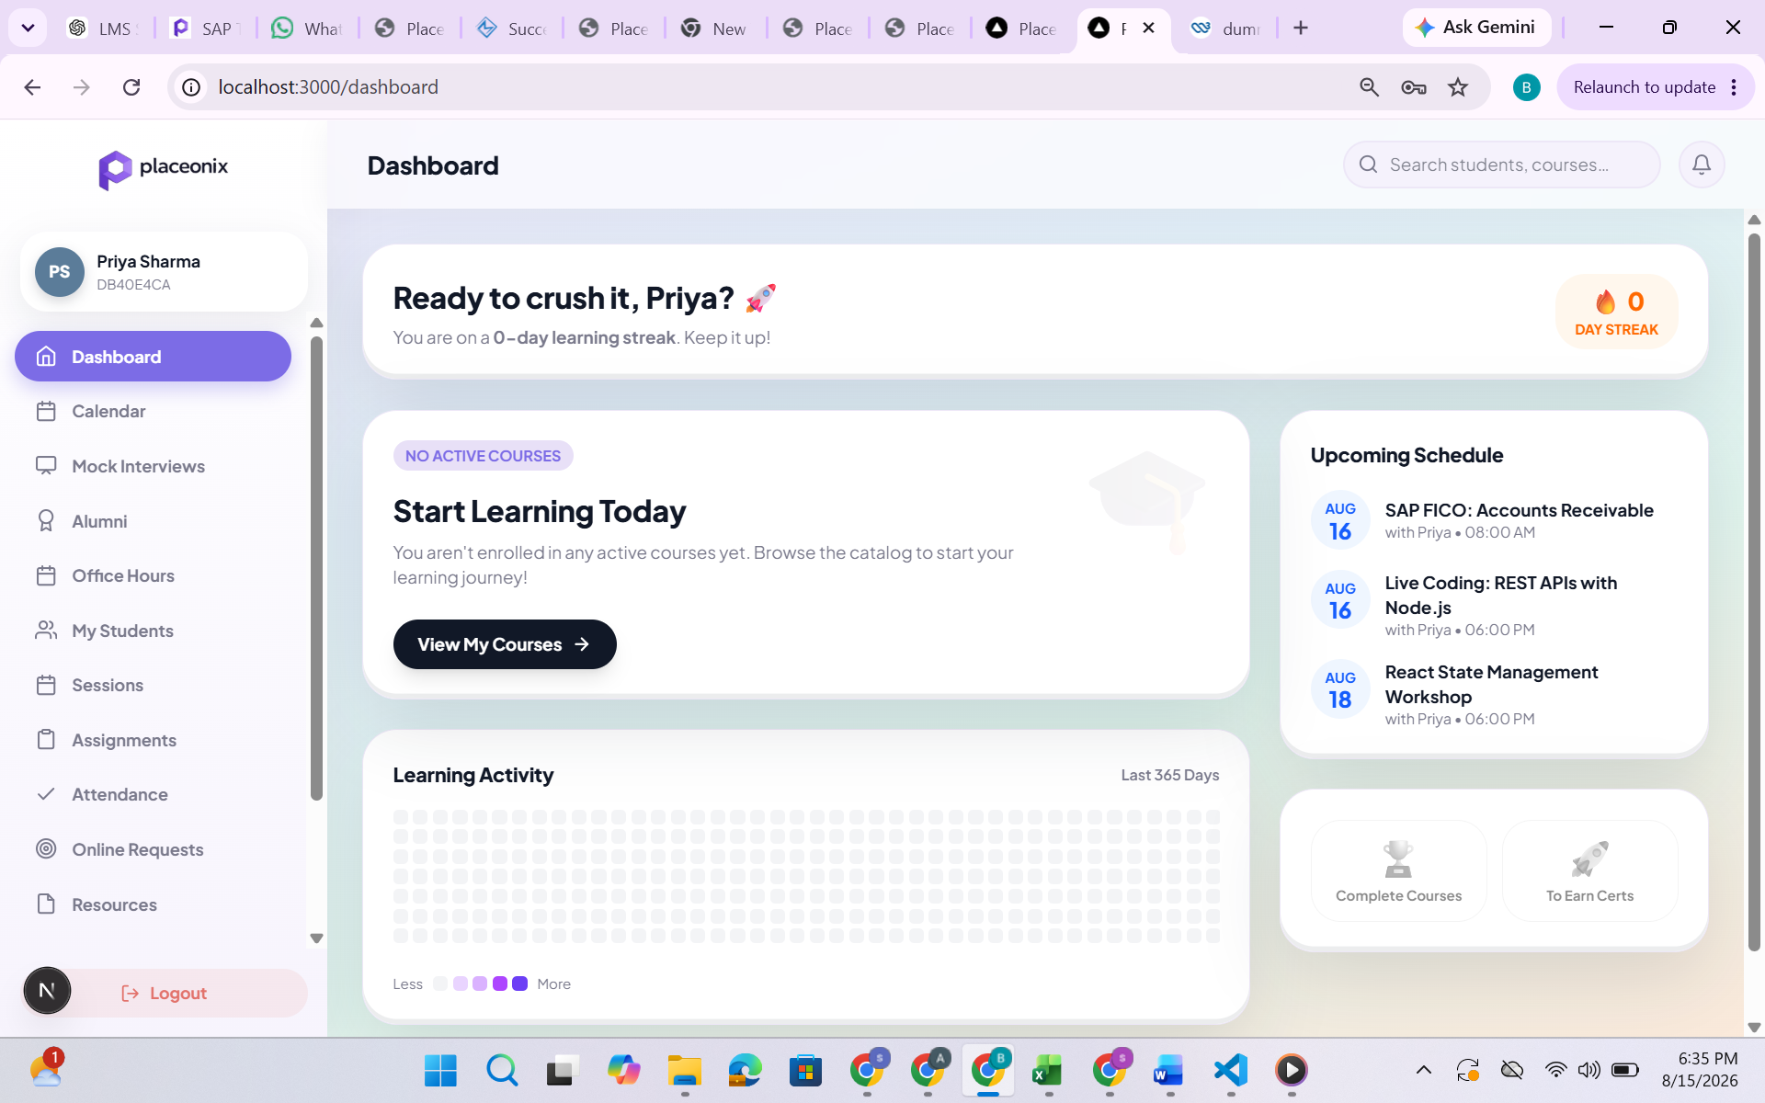

Priya she is mentor then why 0-day learning streak ? also ready to crush it ?

