SEO Audit Report
Website Performance Review — www.placeonix.com

Site Audited: https://www.placeonix.com/
Data Sources: Seobility SEO Checker (seobility.net) · SEO Site Checkup (seositecheckup.com)
Report Type: Consolidated summary of free/snapshot-tier SEO audit results

1. Executive Summary
This report consolidates results from two independent, publicly available SEO audit tools — Seobility SEO Checker and SEO Site Checkup — both run against the Placeonix homepage (www.placeonix.com). The site is performing at or above typical benchmarks on both platforms: Seobility awards an on-page score of 77/100, and SEO Site Checkup awards an SEO score of 80/100, ahead of the 75/100 average it reports for top-100 benchmark sites.
Both tools flag a similar, small set of technical issues holding the score back — most notably a missing www/non-www redirect, weak server response performance, render-blocking resources, and unoptimized images. None of these require a site rebuild; all are standard, fixable technical SEO items. Section 5 consolidates them into a ranked action plan.
77 / 100  Seobility — On-Page Score | 80 / 100  SEO Site Checkup — SEO Score | 66 / 100  AI Visibility Score (ChatGPT, Gemini, Perplexity)
Figure 1: Headline scores from the two audit tools.
Worth flagging separately: the AI Visibility Score is a newer metric that estimates how often AI answer engines mention the Placeonix brand when responding to relevant queries. At 66/100, the brand already has moderate presence — a category worth monitoring as AI search grows, alongside traditional Google rankings.

2. Website Snapshot
Basic crawl data for the homepage, as captured by Seobility SEO Checker:
Field | Value
URL | https://www.placeonix.com/
Meta Title | Placeonix: SAP & IT Training Courses with Placement
Meta Description | Placeonix offers top SAP, Cloud, and IT training courses in Hyderabad. Launch your IT career with real placement support.
HTTP Status Code | 200 (OK)
Indexing Status | Follow, Index
Language | English (EN)
Server Response Time | 0.58 sec
Page File Size | 108.70 KB
Word Count | 1,307 words

3. Seobility SEO Checker — Findings
Seobility awards the homepage an overall on-page score of 77% and flags 1 critical issue.

3.1 On-Page Score Breakdown
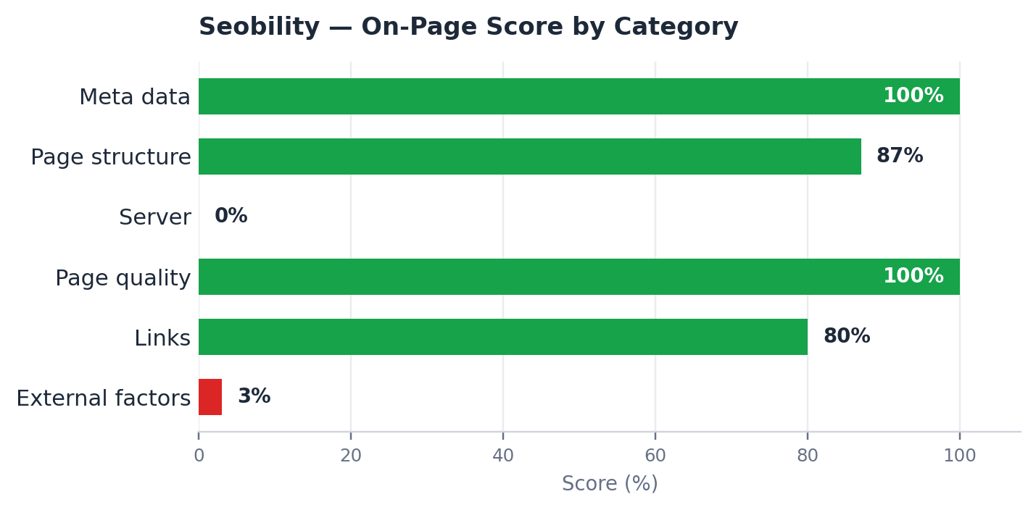
Category | Score | Status
Meta data | 100% | Good
Page structure | 87% | Good
Server | 0% | Needs Attention
Page quality | 100% | Good
Links | 80% | Good
External factors | 3% | Needs Attention

3.2 Priority To-Do List
Priority | Recommended Action
ERROR | Use 301 redirects so both the www and non-www versions of the domain resolve to a single canonical URL. Currently flagged as an error — search engines may be splitting authority across two versions of the same site.
TIP | Improve the page's server response time (currently 0.58 sec). This will likely also lift the 0% "Server" category score above.
TIP | Run a full website audit — this snapshot covers the homepage only. Other pages on the site may carry additional, unseen issues.

4. SEO Site Checkup — Findings
SEO Site Checkup awards the homepage an SEO score of 80/100 across 63 checks: 8 failed, 5 warnings, and 50 passed.

4.1 Category Breakdown
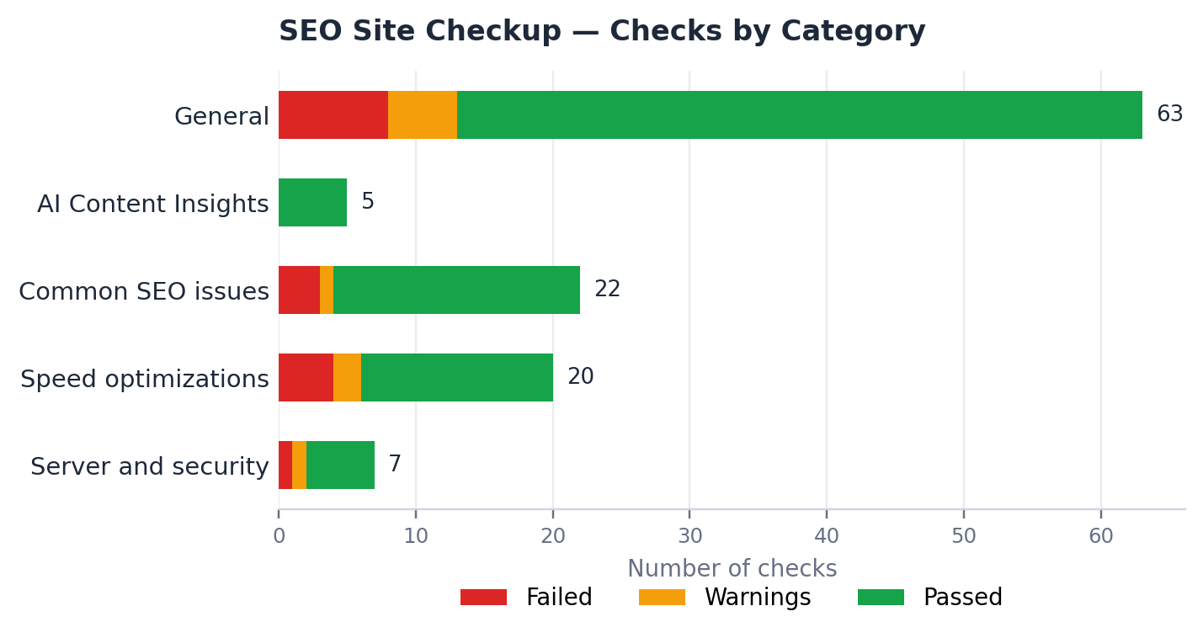
Category | Failed | Warnings | Passed | Total
General (overall total) | 8 | 5 | 50 | 63
AI Content Insights | 0 | 0 | 5 | 5
Common SEO issues | 3 | 1 | 18 | 22
Speed optimizations | 4 | 2 | 14 | 20
Server and security | 1 | 1 | 5 | 7
Note: "General" reflects the same overall total shown in the top-line SEO Score summary (8 failed / 5 warnings / 50 passed of 63 checks). The four rows below it break specific checks out into categories.

4.2 Issues to Fix
Priority | Issue
HIGH | Eliminate render-blocking resources on the webpage to improve load speed and overall user experience.
HIGH | Convert images to a modern format (e.g., WebP/AVIF) to significantly reduce file size and improve loading speed.
MEDIUM | Serve appropriately sized images, rather than scaling large images down in the browser, to reduce page load time.
MEDIUM | Avoid using distorted or stretched images, as they can negatively affect user experience.
The tool listed a fifth medium-priority item referencing Google's First Contentful Paint benchmark; its text was cut off in the source screenshot. Recommend pulling the full issue list directly from SEO Site Checkup for the complete wording.
Separately, the AI Content Insights panel passed all 5 of the checks it ran (0 failed, 0 warnings) but also displayed a "Score: 0" figure alongside that result — an apparent inconsistency that may reflect a partial data load in the free snapshot rather than an actual issue. Worth confirming directly in the tool.

5. Consolidated Priority Action Plan
Combining both tools' findings, ranked by likely impact and ease of fix:
- Fix the www / non-www redirect — Implement a 301 redirect so all traffic and search authority consolidate to one canonical version of the domain. Flagged as an outright error by Seobility.
- Improve server response time — Seobility scores the "Server" category at 0%, and SEO Site Checkup separately logs a failed and a warning check under "Server and security." Investigate hosting/server configuration.
- Eliminate render-blocking resources — Flagged as a high-priority item by SEO Site Checkup. Deferring or inlining blocking CSS/JS will speed up initial page rendering.
- Optimize images — The single most-cited issue across the two reports: convert images to modern formats, serve properly sized versions, and fix any distorted images. Likely the highest-impact, most straightforward fix available.
- Run a full-site audit — Both free snapshots audited the homepage only. A full crawl (paid tier, or an alternate full-site tool) is recommended to surface issues on other pages.
- Track the AI Visibility Score going forward — At 66/100, the brand already has moderate presence in AI answer engines. Worth a recurring check as AI-driven search continues to grow.

6. Methodology & Notes
- Data was captured from two free/snapshot-tier third-party tools; neither reflects a full paid audit.
- Seobility's snapshot covers on-page factors for the homepage only — meta data, page structure, links, server, page quality, and external factors.
- SEO Site Checkup's snapshot evaluated 63 checks on the homepage (8 failed, 5 warnings, 50 passed) and separately reports an AI Visibility Score estimating how often AI answer engines mention the brand.
- Both platforms prompt for a paid upgrade to unlock full-site monitoring, complete issue lists, and weekly tracking — worth considering if ongoing SEO monitoring becomes a priority.
- This document compiles and organizes third-party tool output for internal review. It is not a substitute for a manual technical SEO audit.

