Minikube Setup
- Installed and started Minikube using Docker driver on WSL Ubuntu
- Deleted and recreated Minikube cluster to fix apiserver connectivity issue
- Switched terminal to Minikube's internal Docker environment using eval $(minikube docker-env)
- Built all 4 service images inside Minikube's Docker so Kubernetes can access them locally
- Verified cluster is running using kubectl get nodes — status: Ready

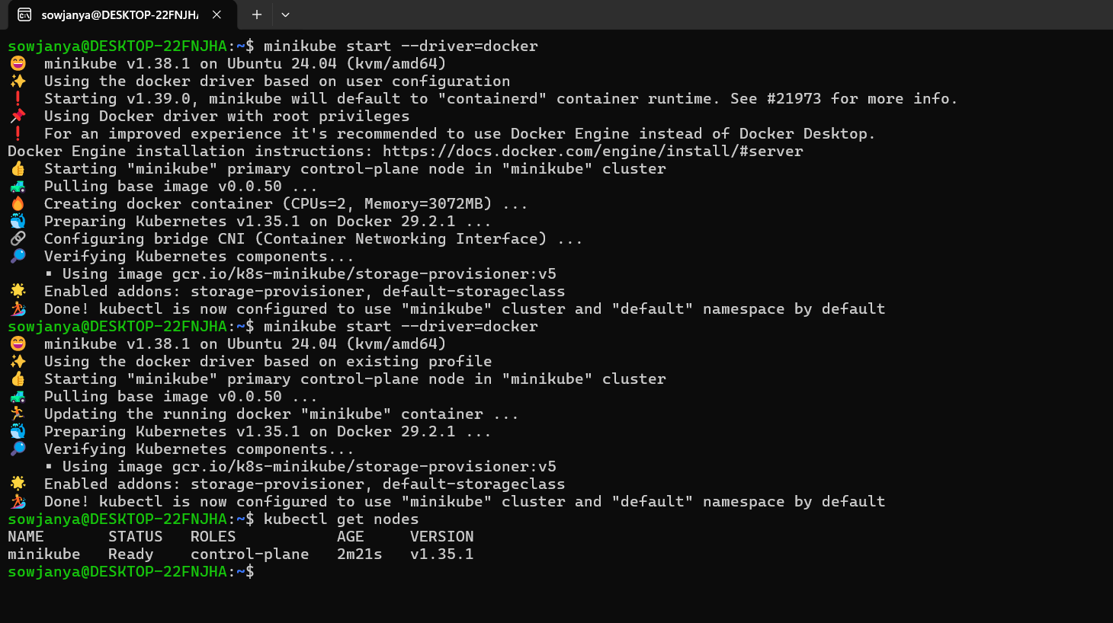

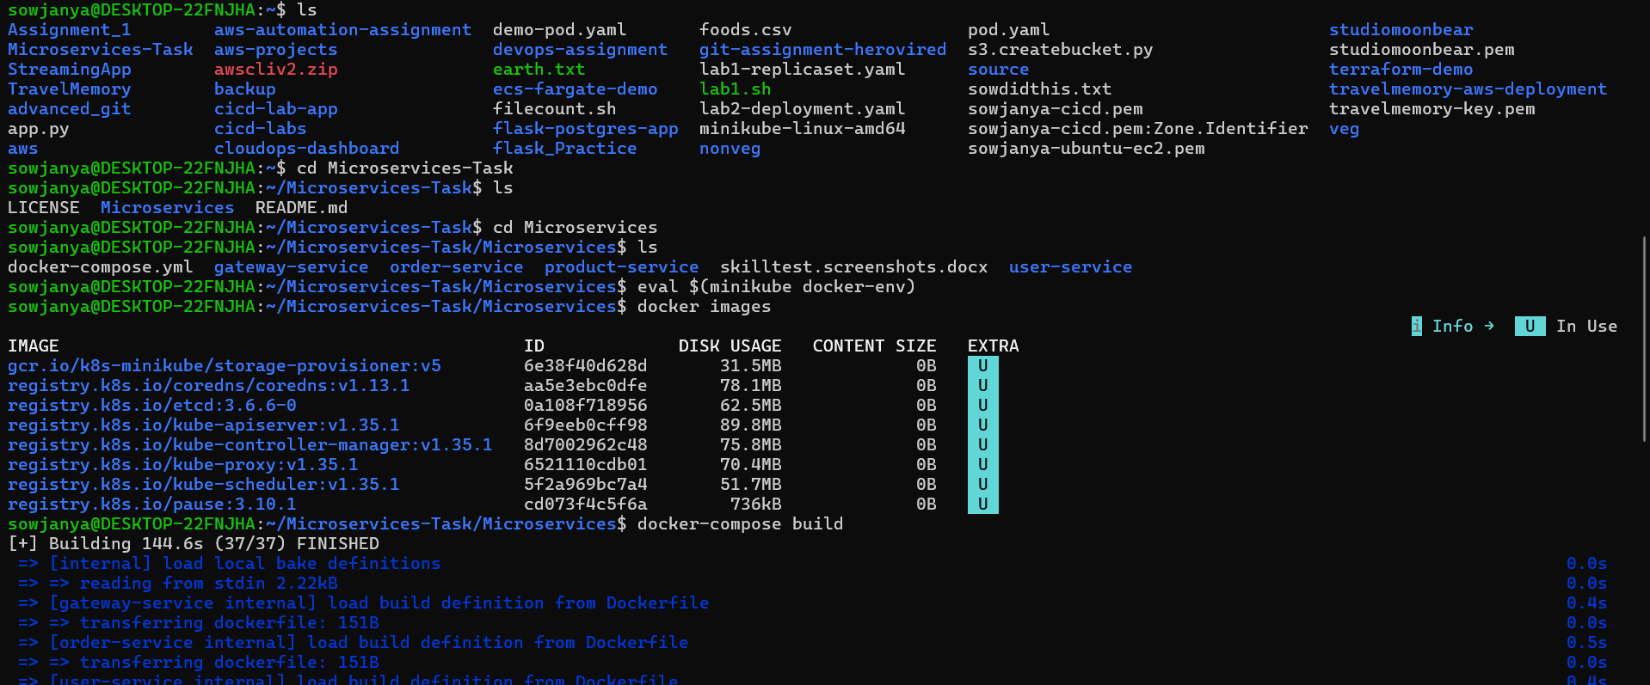

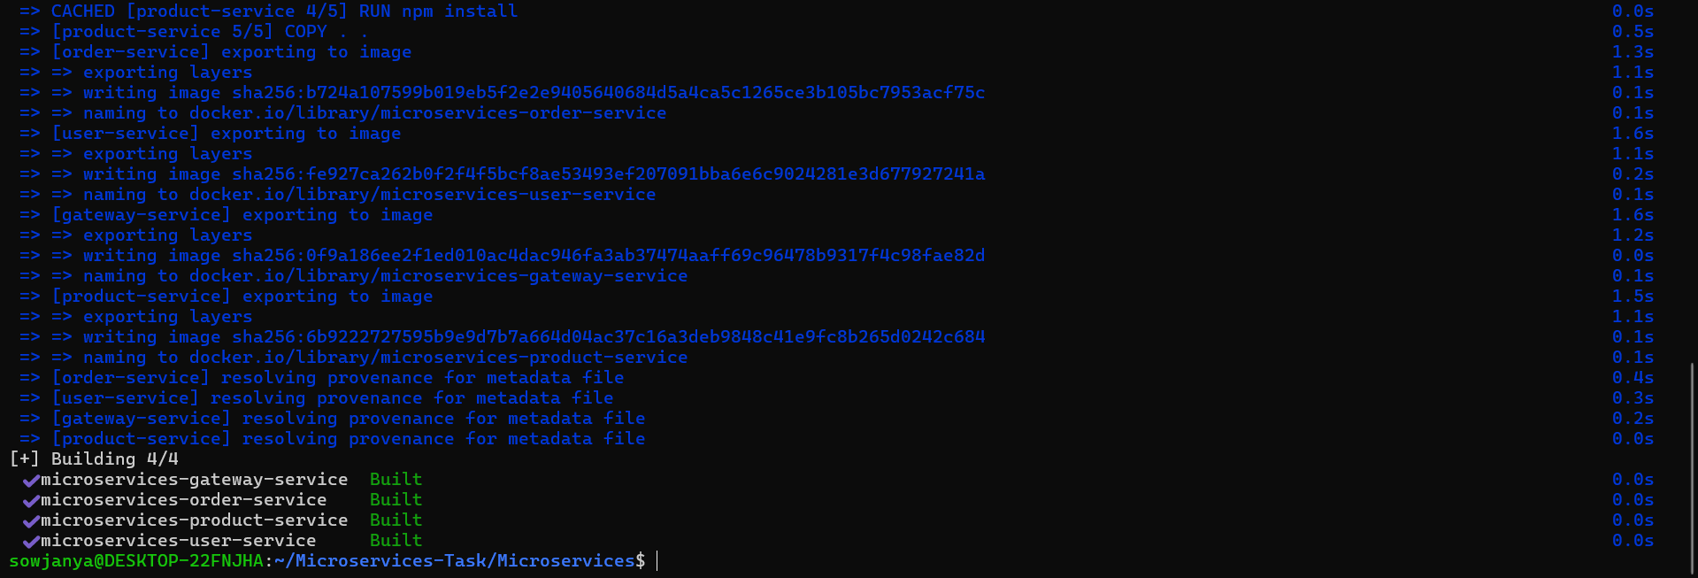

Kubernetes Deployments
- Created deployment YAML files for all 4 services: user, product, order and gateway
- Each deployment includes correct container image reference, resource limits and requests, environment variables, liveness and readiness probes, and proper labels and selectors
- Used imagePullPolicy: Never to use locally built images instead of pulling from internet
- Initial deployment failed because liveness and readiness probes were checking / which returns 404 — fixed by updating probe path to /health which returns 200
- Reapplied deployments using kubectl apply -f deployments/ — all 4 pods moved to 1/1 Running status

Kubernetes Services
- Created ClusterIP service for user, product and order services for internal cluster communication
- Created NodePort service for gateway service to allow external access
- All services discovered and accessible within the cluster using service names as hostnames

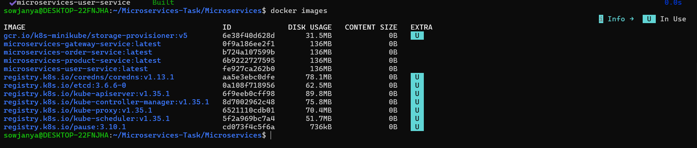

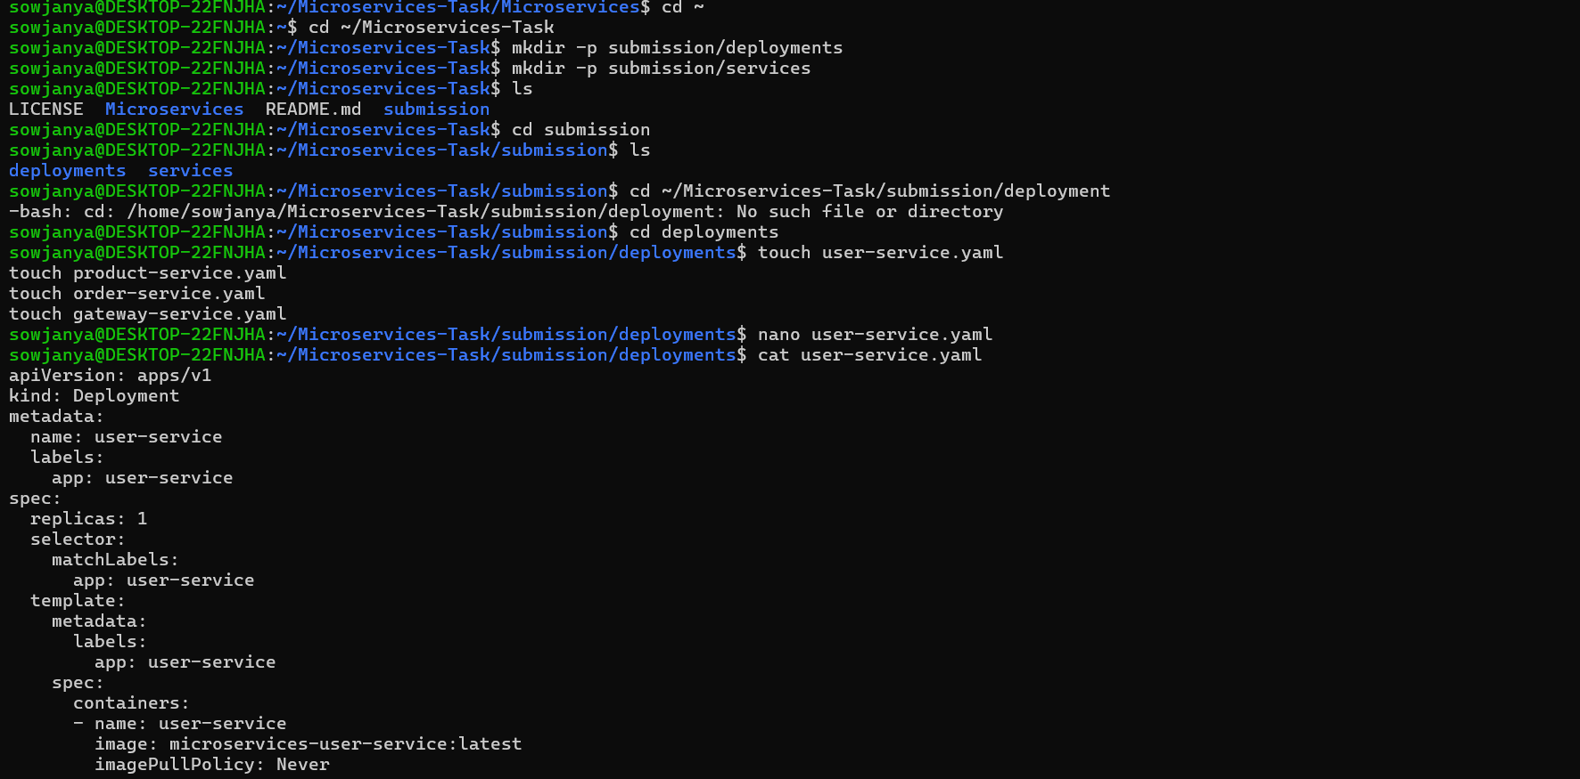

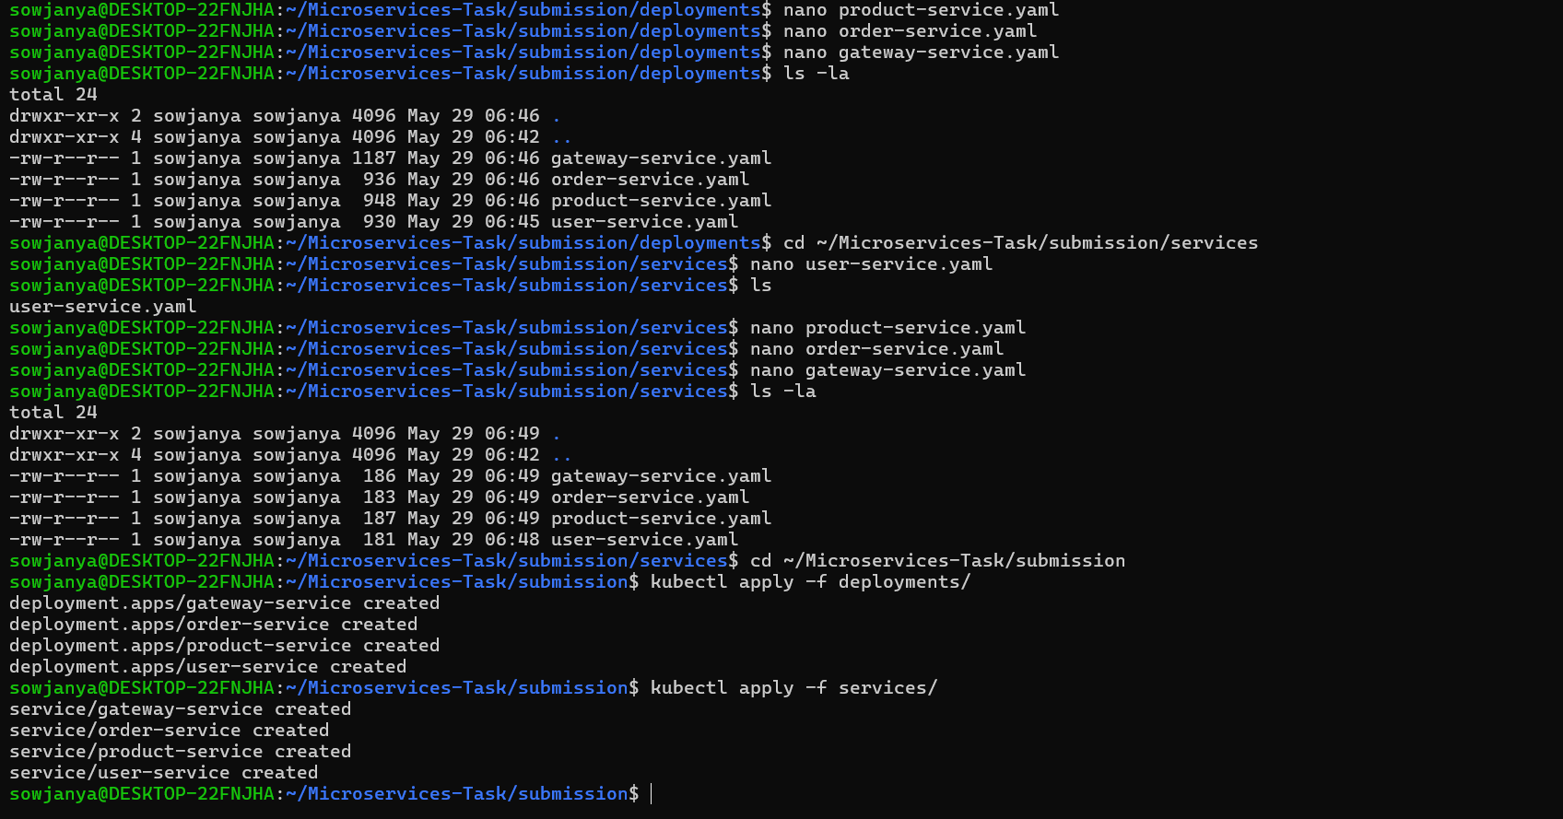
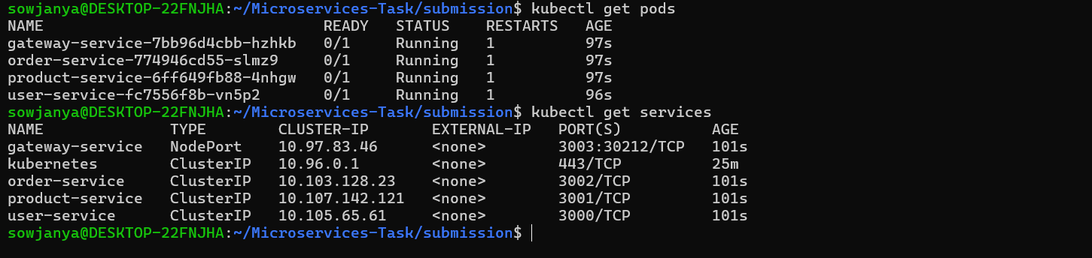

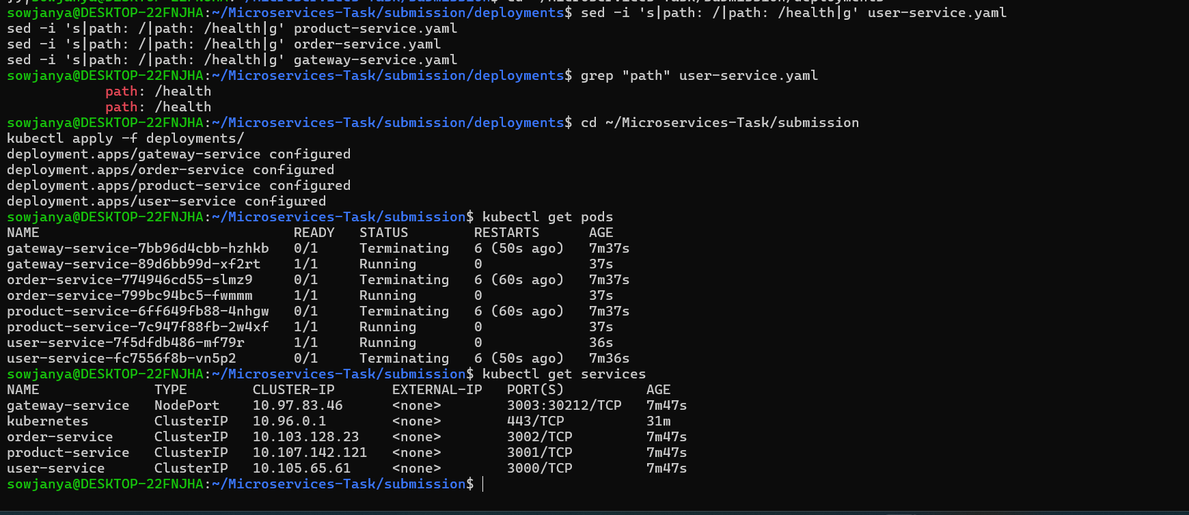

Testing and Validation
- Used kubectl port-forward to temporarily tunnel into each ClusterIP service for testing
- Used minikube service gateway-service --url to get external URL for gateway
- Verified all health endpoints returning 200 OK
- Verified data endpoints returning correct JSON responses:
  - /users → John Doe, Jane Smith
  - /products → Laptop, Phone with prices
  - /orders → empty array but service healthy
  - /health on all services → healthy status confirmed

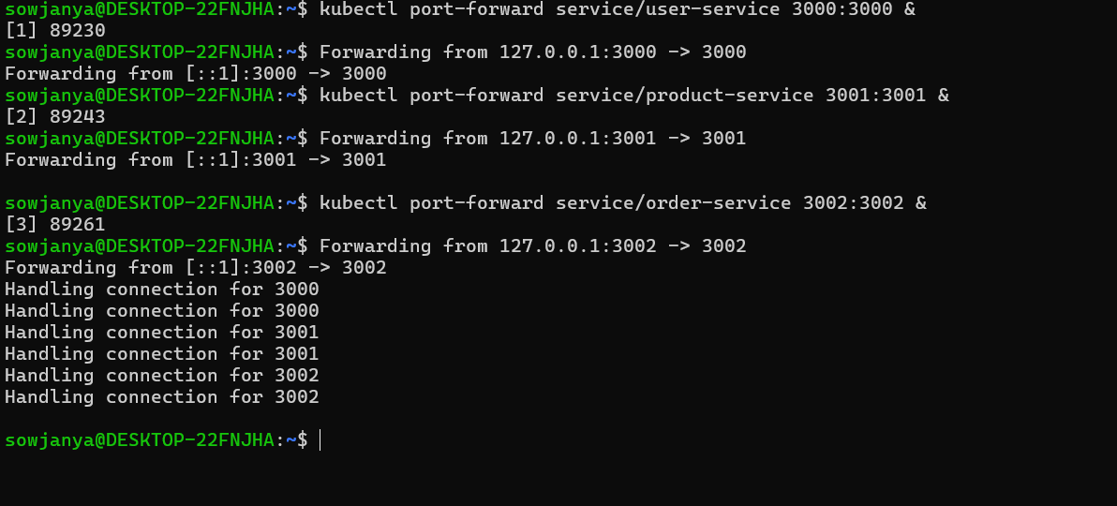

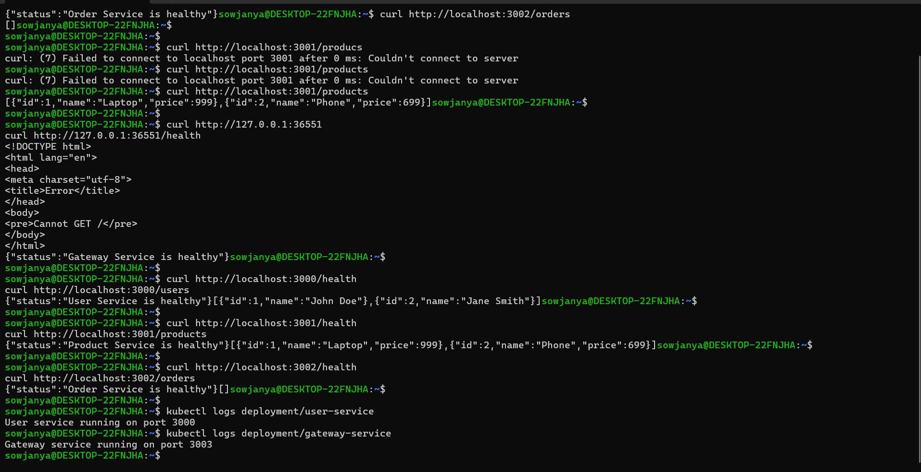

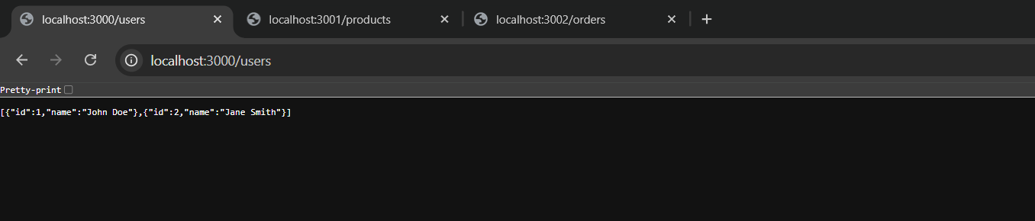
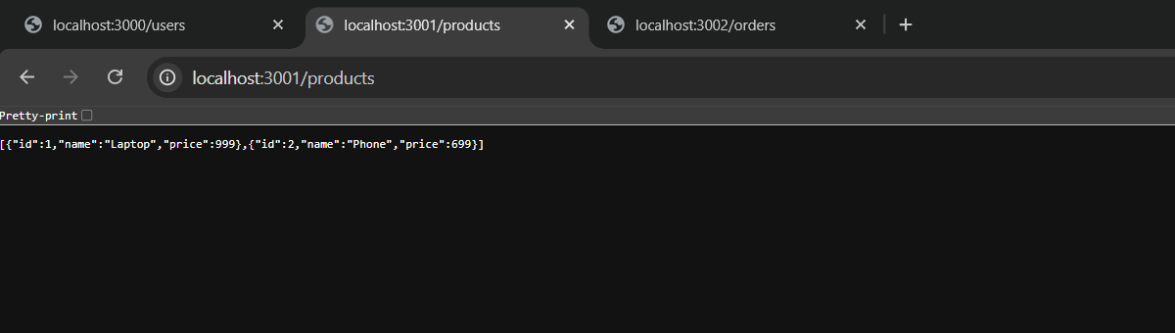
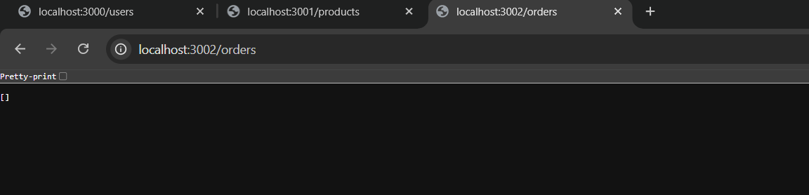

Errors Made and Fixed
- Minikube apiserver was stopped on first start — fixed by deleting and recreating the cluster
- Liveness and readiness probes were set to path / — app returns 404 there, causing pods to crash loop and restart repeatedly — fixed by changing probe path to /health
- Built images in local Docker initially — Kubernetes couldn't see them — fixed by switching to Minikube's Docker using eval $(minikube docker-env) before building

