Flow:
- Forked the repo and cloned it locally
- Navigated into Microservices-Task/Microservices folder
- Created a Dockerfile for each service manually using touch and nano
- All Dockerfiles follow the same structure, only the EXPOSE port changes per service
- Created docker-compose.yml with all 4 services, shared network and restart policy
- Ran docker-compose up --build to build images and start containers
- Verified all services running using docker ps and browser

I made few errors in the process, which lead to build failed multiple times and I fixed it:

- Typo in service name, typed prodcut-service instead of product-service in docker-compose.yml. Docker couldn't match it with depends_on and threw an error
- Wrong port mapping, typed 3002:3003 for order-service instead of 3002:3002. Left and right side should match
- Typo in Dockerfile, typed napm instead of npm in RUN npm install.
- version field, kept version: '3.8' initially in the docker-compose.yml but got a warning that it's obsolete and removed it

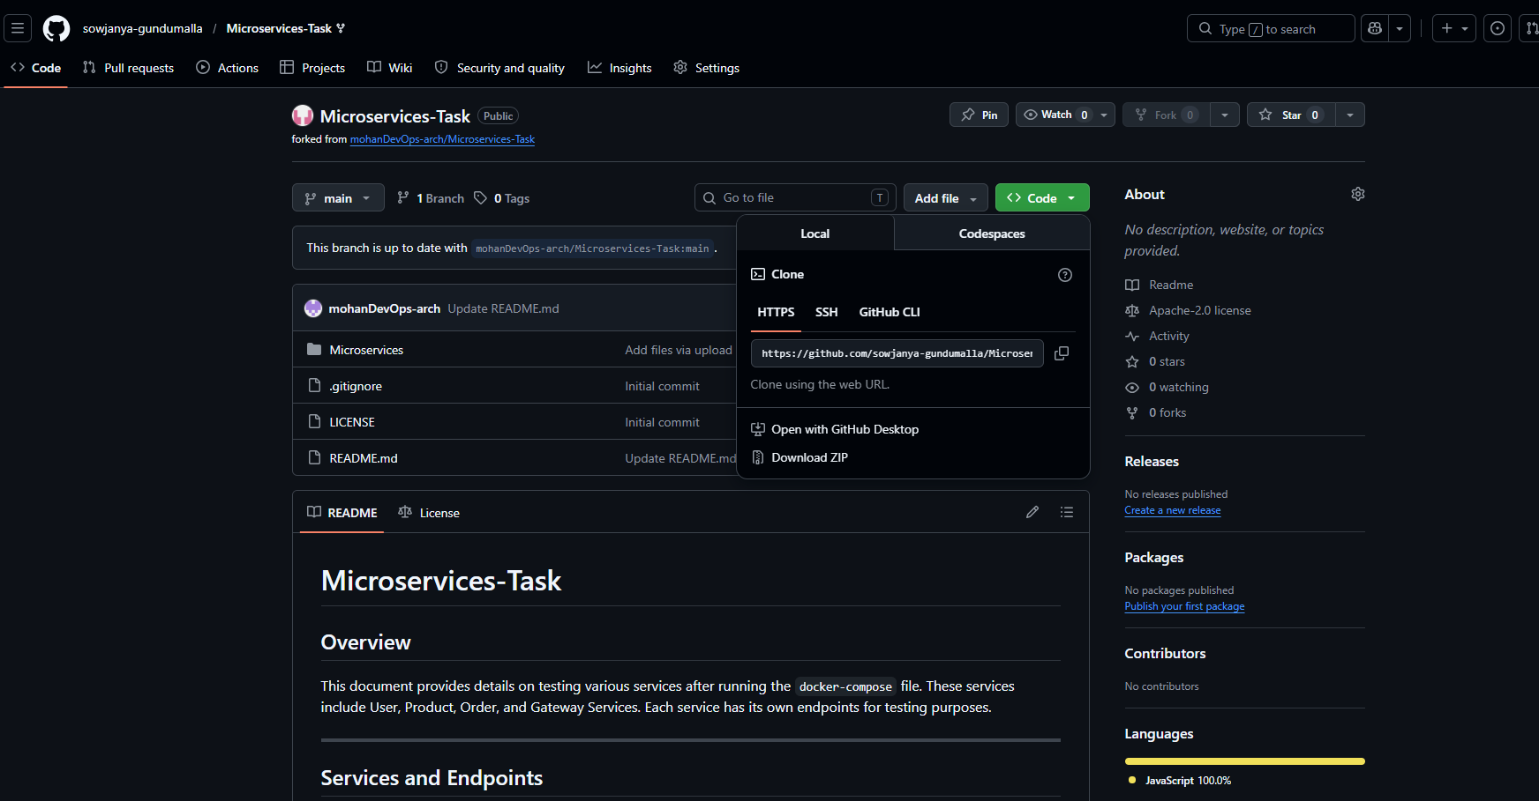

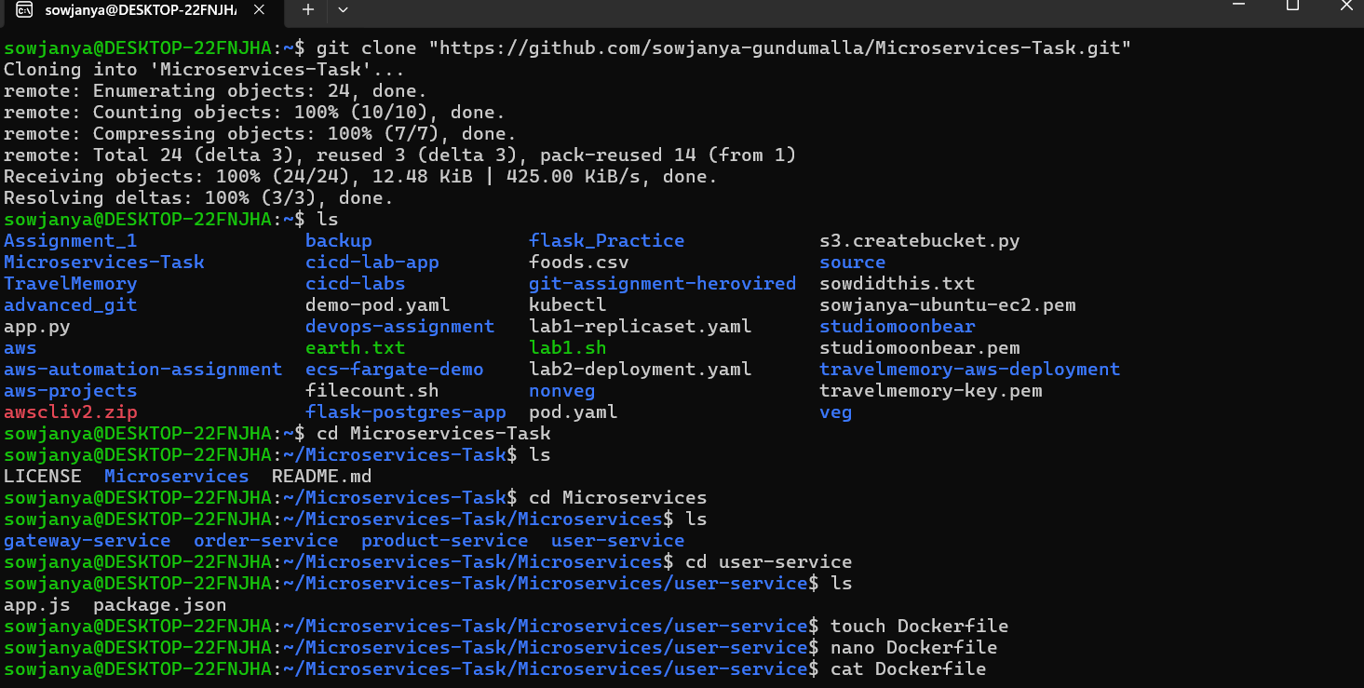

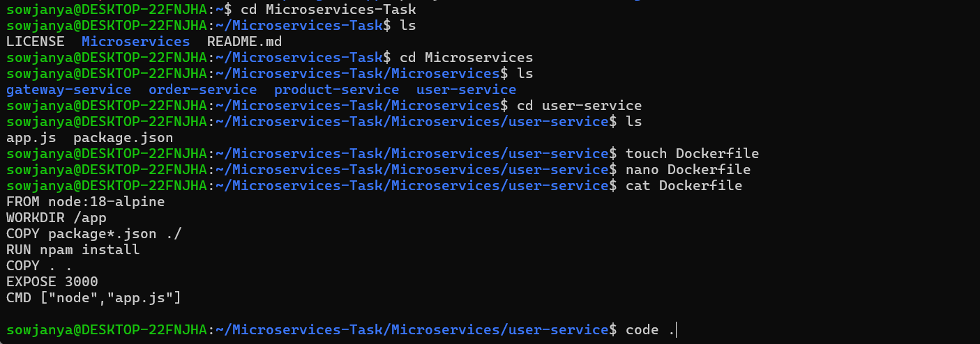
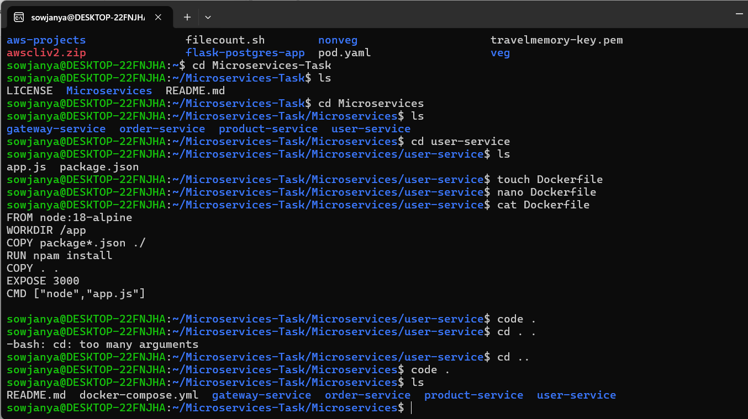
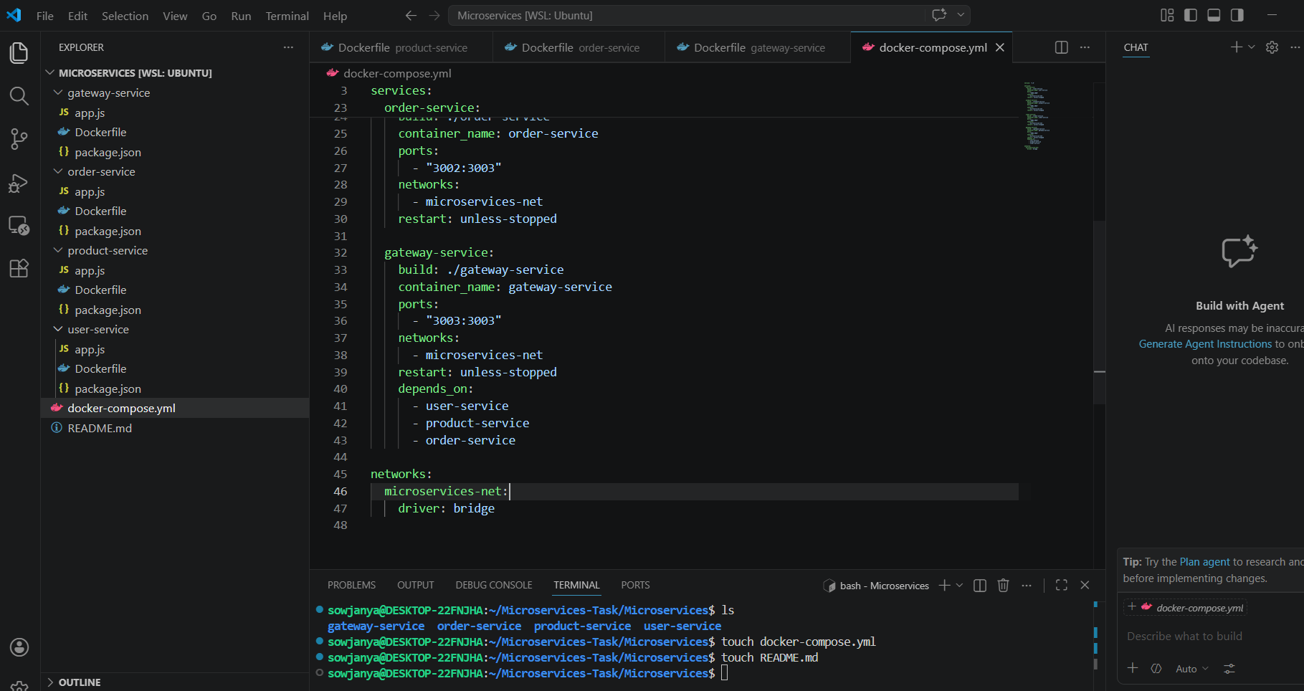
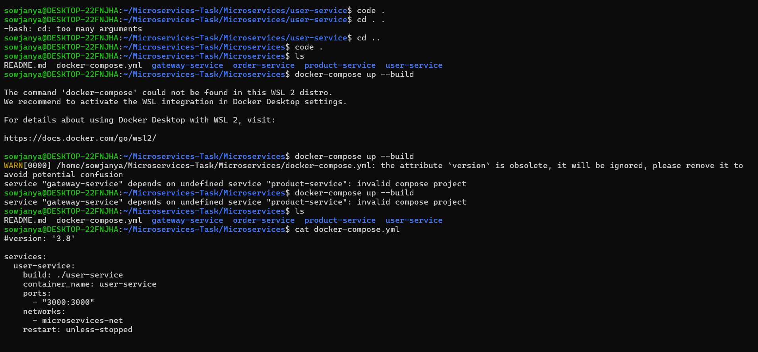
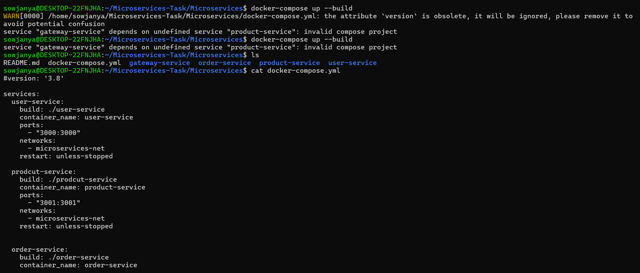
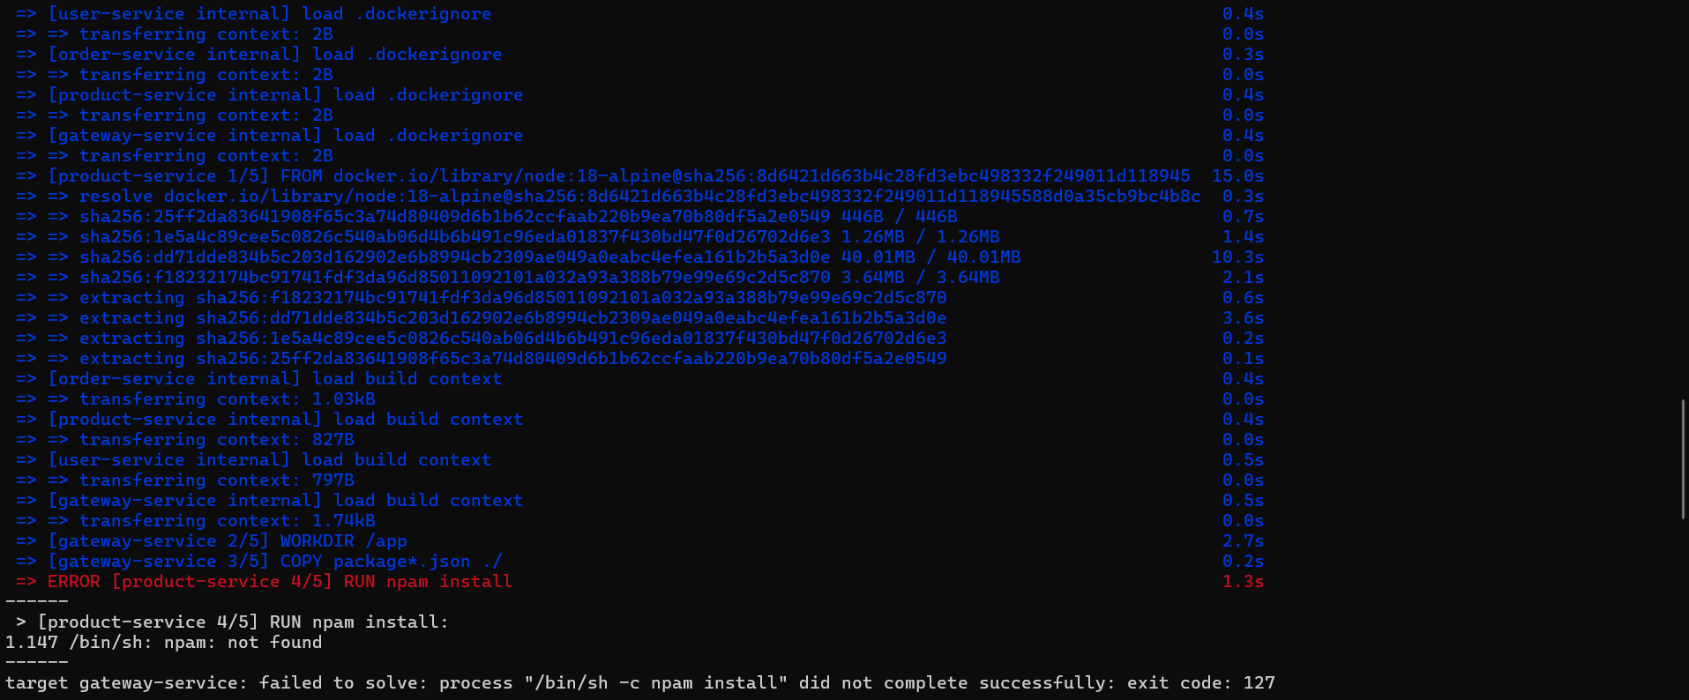

There were spelling mistakes in the Dockerfile. Fixed it.

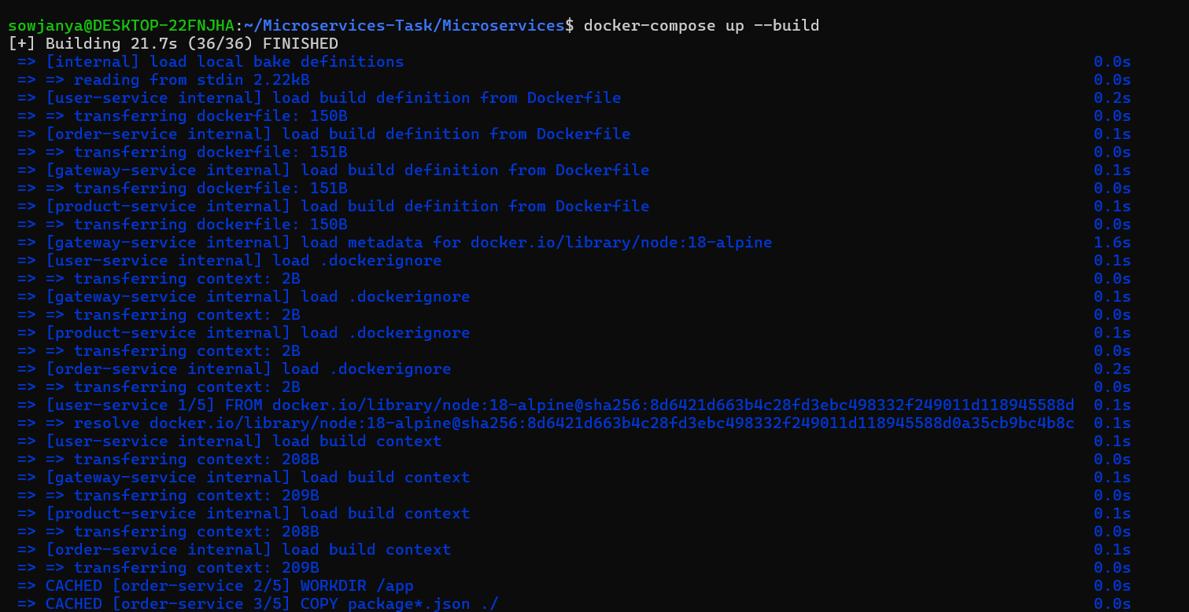

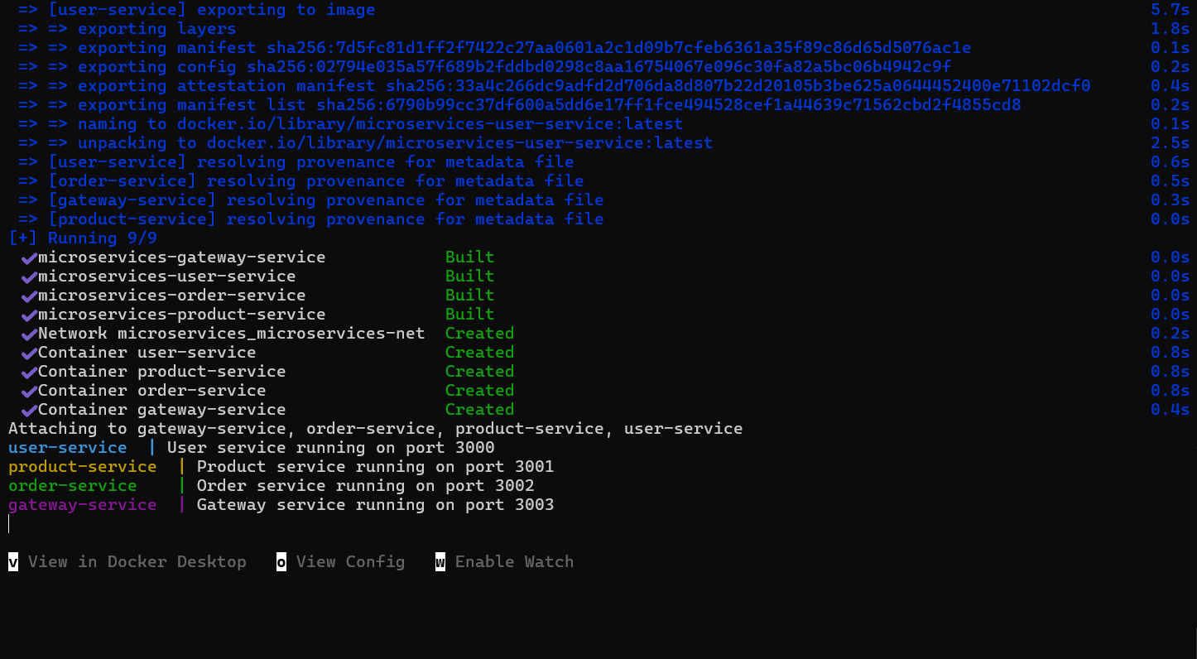

Testing the containers:

Tested all services and the screenshots pasted below.
