Part 1: Infrastructure Setup with Terraform

1. AWS Setup and Terraform Initialization
- Verified AWS CLI configuration using aws sts get-caller-identity
- Confirmed active AWS account in region ap-south-1
- Installed Terraform and initialized project using terraform init
- Hashicorp AWS provider v5.100.0 installed successfully
2. Terraform Files Created
- variables.tf — defined region, CIDR blocks, instance type (t3.small), AMI, key pair
- main.tf — configured AWS provider for ap-south-1
- vpc.tf — defined VPC, subnets, IGW, NAT Gateway, route tables
- security_groups.tf — defined web-sg and db-sg rules
- ec2.tf — defined two EC2 instances (web in public, db in private subnet)
- outputs.tf — outputs web server public IP, DNS, and DB private IP
3. VPC and Network Configuration
- Created VPC with CIDR 10.0.0.0/16
- Created public subnet 10.0.1.0/24 in ap-south-1a
- Created private subnet 10.0.2.0/24 in ap-south-1a
- Attached Internet Gateway for public subnet
- Created NAT Gateway with Elastic IP for private subnet outbound access
- Configured public route table → Internet Gateway
- Configured private route table → NAT Gateway
4. Security Groups
- Web server SG: inbound SSH (22), HTTP (80), Node.js (3000) from anywhere
- DB server SG: inbound MongoDB (27017) and SSH (22) from web server SG only
- Both SGs: outbound all traffic allowed
5. EC2 Instances Provisioned
- travelmemory-web-server — t3.small, public subnet, public IP 13.207.188.131
- travelmemory-db-server — t3.small, private subnet, private IP 10.0.2.221
- Both using Ubuntu 24.04 AMI, key pair sowjanya-cicd
6. Terraform Apply Output
- 14 resources created, 0 errors
- Web server public IP: 13.207.188.131
- Web server DNS: ec2-13-207-188-131.ap-south-1.compute.amazonaws.com
- DB server private IP: 10.0.2.221

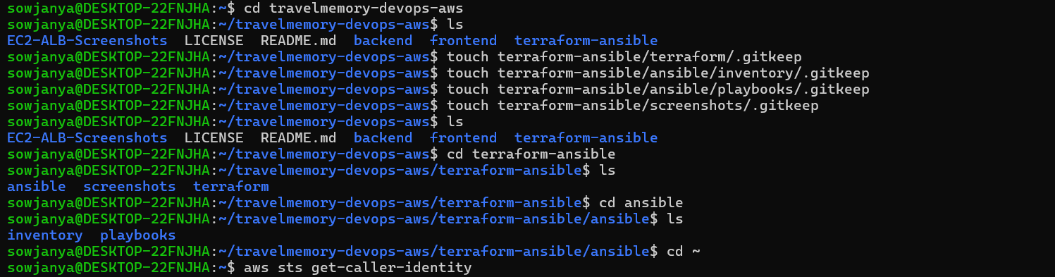

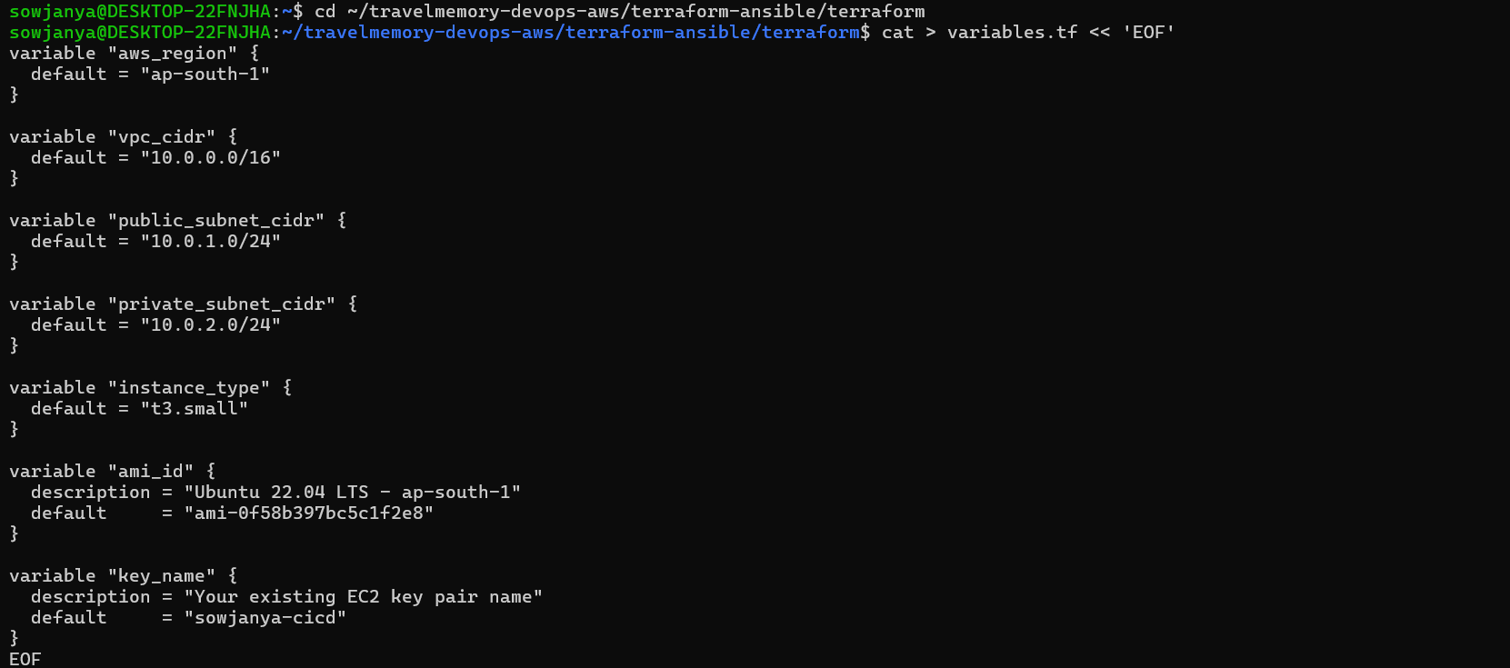
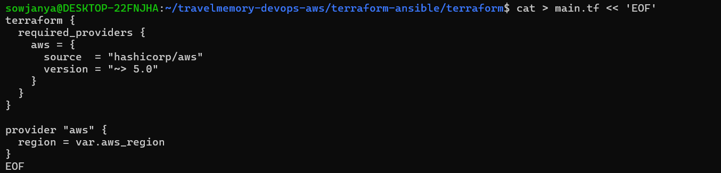
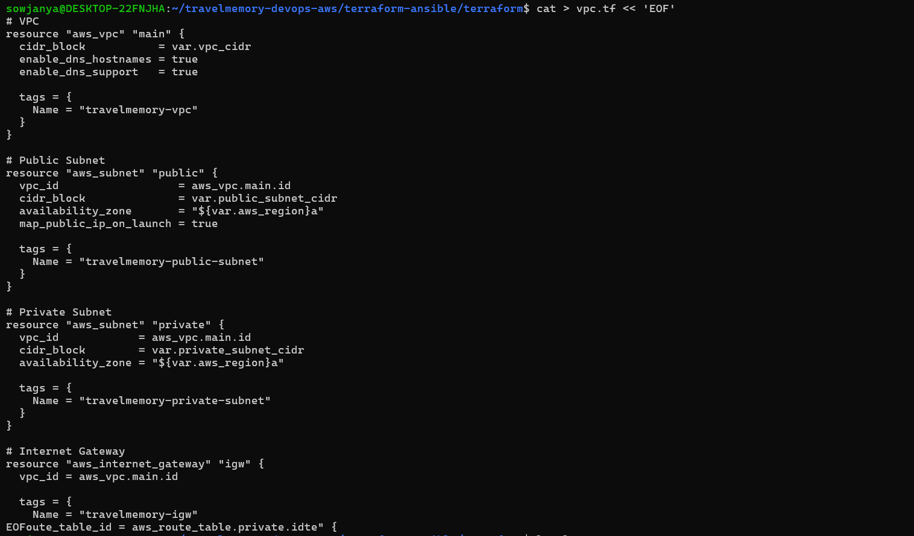
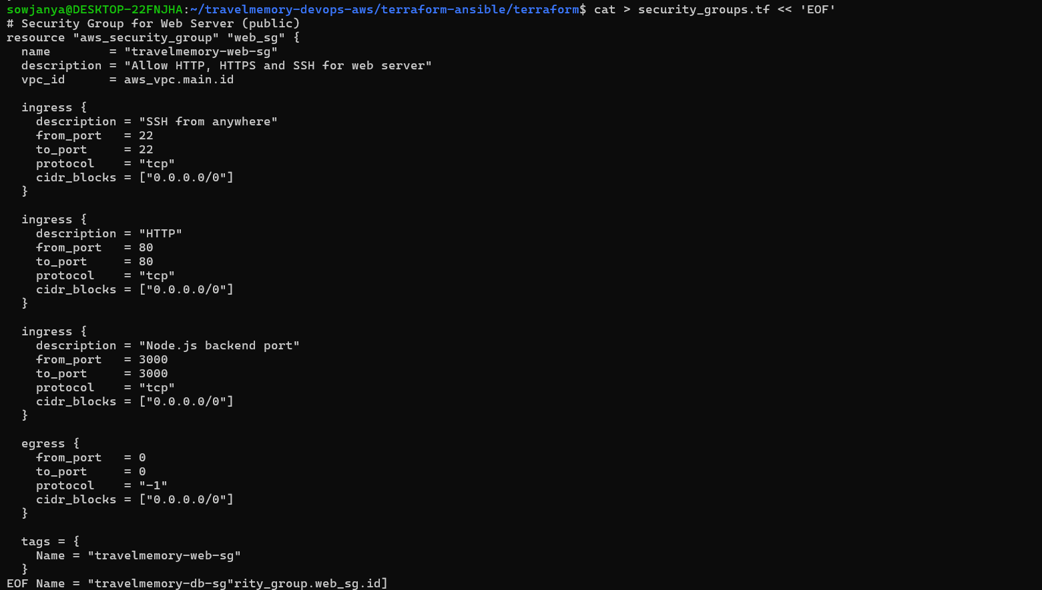
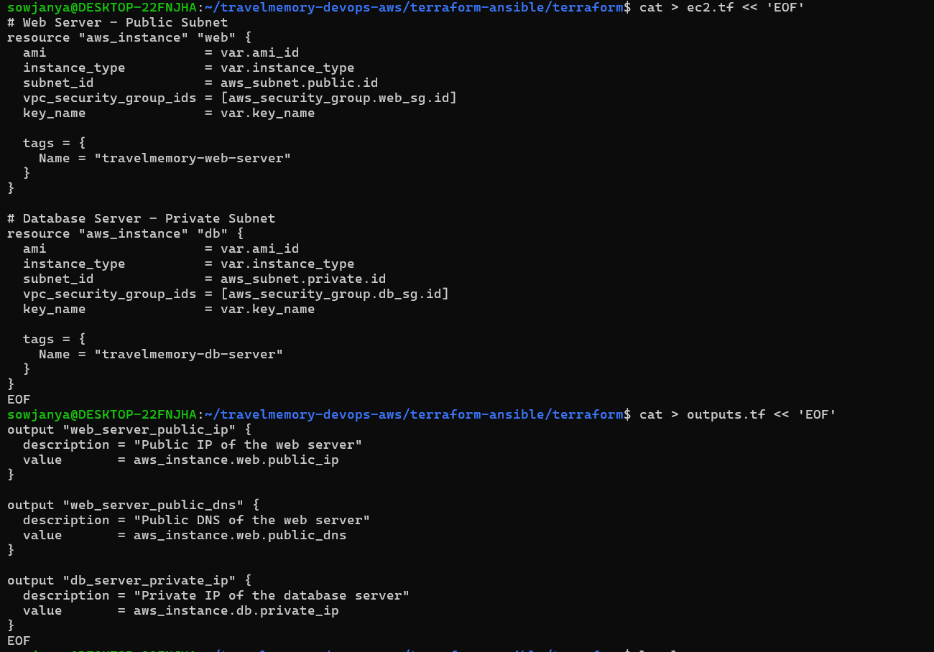
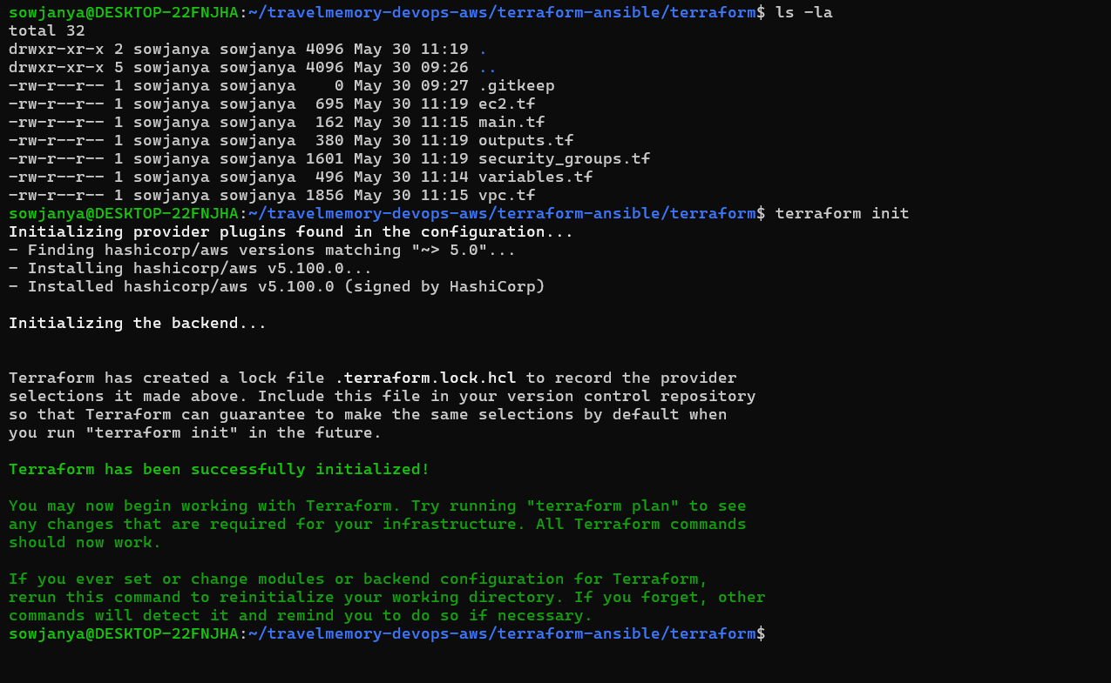

sowjanya@DESKTOP-22FNJHA:~/travelmemory-devops-aws/terraform-ansible/terraform$ terraform plan

Terraform used the selected providers to generate the following execution plan. Resource actions are indicated with the following symbols:
+ create

Terraform will perform the following actions:

# aws_eip.nat will be created
+ resource "aws_eip" "nat" {
+ allocation_id = (known after apply)
+ arn = (known after apply)
+ association_id = (known after apply)
+ carrier_ip = (known after apply)
+ customer_owned_ip = (known after apply)
+ domain = "vpc"
+ id = (known after apply)
+ instance = (known after apply)
+ ipam_pool_id = (known after apply)
+ network_border_group = (known after apply)
+ network_interface = (known after apply)
+ private_dns = (known after apply)
+ private_ip = (known after apply)
+ ptr_record = (known after apply)
+ public_dns = (known after apply)
+ public_ip = (known after apply)
+ public_ipv4_pool = (known after apply)
+ tags_all = (known after apply)
+ vpc = (known after apply)
}

# aws_instance.db will be created
+ resource "aws_instance" "db" {
+ ami = "ami-0f58b397bc5c1f2e8"
+ arn = (known after apply)
+ associate_public_ip_address = (known after apply)
+ availability_zone = (known after apply)
+ cpu_core_count = (known after apply)
+ cpu_threads_per_core = (known after apply)
+ disable_api_stop = (known after apply)
+ disable_api_termination = (known after apply)
+ ebs_optimized = (known after apply)
+ enable_primary_ipv6 = (known after apply)
+ get_password_data = false
+ host_id = (known after apply)
+ host_resource_group_arn = (known after apply)
+ iam_instance_profile = (known after apply)
+ id = (known after apply)
+ instance_initiated_shutdown_behavior = (known after apply)
+ instance_lifecycle = (known after apply)
+ instance_state = (known after apply)
+ instance_type = "t3.small"
+ ipv6_address_count = (known after apply)
+ ipv6_addresses = (known after apply)
+ key_name = "sowjanya-cicd"
+ monitoring = (known after apply)
+ outpost_arn = (known after apply)
+ password_data = (known after apply)
+ placement_group = (known after apply)
+ placement_partition_number = (known after apply)
+ primary_network_interface_id = (known after apply)
+ private_dns = (known after apply)
+ private_ip = (known after apply)
+ public_dns = (known after apply)
+ public_ip = (known after apply)
+ secondary_private_ips = (known after apply)
+ security_groups = (known after apply)
+ source_dest_check = true
+ spot_instance_request_id = (known after apply)
+ subnet_id = (known after apply)
+ tags = {
+ "Name" = "travelmemory-db-server"
}
+ tags_all = {
+ "Name" = "travelmemory-db-server"
}
+ tenancy = (known after apply)
+ user_data = (known after apply)
+ user_data_base64 = (known after apply)
+ user_data_replace_on_change = false
+ vpc_security_group_ids = (known after apply)

+ capacity_reservation_specification (known after apply)

+ cpu_options (known after apply)

+ ebs_block_device (known after apply)

+ enclave_options (known after apply)

+ ephemeral_block_device (known after apply)

+ instance_market_options (known after apply)

+ maintenance_options (known after apply)

+ metadata_options (known after apply)

+ network_interface (known after apply)

+ private_dns_name_options (known after apply)

+ root_block_device (known after apply)
}

# aws_instance.web will be created
+ resource "aws_instance" "web" {
+ ami = "ami-0f58b397bc5c1f2e8"
+ arn = (known after apply)
+ associate_public_ip_address = (known after apply)
+ availability_zone = (known after apply)
+ cpu_core_count = (known after apply)
+ cpu_threads_per_core = (known after apply)
+ disable_api_stop = (known after apply)
+ disable_api_termination = (known after apply)
+ ebs_optimized = (known after apply)
+ enable_primary_ipv6 = (known after apply)
+ get_password_data = false
+ host_id = (known after apply)
+ host_resource_group_arn = (known after apply)
+ iam_instance_profile = (known after apply)
+ id = (known after apply)
+ instance_initiated_shutdown_behavior = (known after apply)
+ instance_lifecycle = (known after apply)
+ instance_state = (known after apply)
+ instance_type = "t3.small"
+ ipv6_address_count = (known after apply)
+ ipv6_addresses = (known after apply)
+ key_name = "sowjanya-cicd"
+ monitoring = (known after apply)
+ outpost_arn = (known after apply)
+ password_data = (known after apply)
+ placement_group = (known after apply)
+ placement_partition_number = (known after apply)
+ primary_network_interface_id = (known after apply)
+ private_dns = (known after apply)
+ private_ip = (known after apply)
+ public_dns = (known after apply)
+ public_ip = (known after apply)
+ secondary_private_ips = (known after apply)
+ security_groups = (known after apply)
+ source_dest_check = true
+ spot_instance_request_id = (known after apply)
+ subnet_id = (known after apply)
+ tags = {
+ "Name" = "travelmemory-web-server"
}
+ tags_all = {
+ "Name" = "travelmemory-web-server"
}
+ tenancy = (known after apply)
+ user_data = (known after apply)
+ user_data_base64 = (known after apply)
+ user_data_replace_on_change = false
+ vpc_security_group_ids = (known after apply)

+ capacity_reservation_specification (known after apply)

+ cpu_options (known after apply)

+ ebs_block_device (known after apply)

+ enclave_options (known after apply)

+ ephemeral_block_device (known after apply)

+ instance_market_options (known after apply)

+ maintenance_options (known after apply)

+ metadata_options (known after apply)

+ network_interface (known after apply)

+ private_dns_name_options (known after apply)

+ root_block_device (known after apply)
}

# aws_internet_gateway.igw will be created
+ resource "aws_internet_gateway" "igw" {
+ arn = (known after apply)
+ id = (known after apply)
+ owner_id = (known after apply)
+ tags = {
+ "Name" = "travelmemory-igw"
}
+ tags_all = {
+ "Name" = "travelmemory-igw"
}
+ vpc_id = (known after apply)
}

# aws_nat_gateway.nat will be created
+ resource "aws_nat_gateway" "nat" {
+ allocation_id = (known after apply)
+ association_id = (known after apply)
+ connectivity_type = "public"
+ id = (known after apply)
+ network_interface_id = (known after apply)
+ private_ip = (known after apply)
+ public_ip = (known after apply)
+ secondary_private_ip_address_count = (known after apply)
+ secondary_private_ip_addresses = (known after apply)
+ subnet_id = (known after apply)
+ tags = {
+ "Name" = "travelmemory-nat"
}
+ tags_all = {
+ "Name" = "travelmemory-nat"
}
}

# aws_route_table.private will be created
+ resource "aws_route_table" "private" {
+ arn = (known after apply)
+ id = (known after apply)
+ owner_id = (known after apply)
+ propagating_vgws = (known after apply)
+ route = [
+ {
+ cidr_block = "0.0.0.0/0"
+ nat_gateway_id = (known after apply)
# (11 unchanged attributes hidden)
},
]
+ tags = {
+ "Name" = "travelmemory-private-rt"
}
+ tags_all = {
+ "Name" = "travelmemory-private-rt"
}
+ vpc_id = (known after apply)
}

# aws_route_table.public will be created
+ resource "aws_route_table" "public" {
+ arn = (known after apply)
+ id = (known after apply)
+ owner_id = (known after apply)
+ propagating_vgws = (known after apply)
+ route = [
+ {
+ cidr_block = "0.0.0.0/0"
+ gateway_id = (known after apply)
# (11 unchanged attributes hidden)
},
]
+ tags = {
+ "Name" = "travelmemory-public-rt"
}
+ tags_all = {
+ "Name" = "travelmemory-public-rt"
}
+ vpc_id = (known after apply)
}

# aws_route_table_association.private will be created
+ resource "aws_route_table_association" "private" {
+ id = (known after apply)
+ route_table_id = (known after apply)
+ subnet_id = (known after apply)
}

# aws_route_table_association.public will be created
+ resource "aws_route_table_association" "public" {
+ id = (known after apply)
+ route_table_id = (known after apply)
+ subnet_id = (known after apply)
}

# aws_security_group.db_sg will be created
+ resource "aws_security_group" "db_sg" {
+ arn = (known after apply)
+ description = "Allow MongoDB only from web server"
+ egress = [
+ {
+ cidr_blocks = [
+ "0.0.0.0/0",
]
+ from_port = 0
+ ipv6_cidr_blocks = []
+ prefix_list_ids = []
+ protocol = "-1"
+ security_groups = []
+ self = false
+ to_port = 0
# (1 unchanged attribute hidden)
},
]
+ id = (known after apply)
+ ingress = [
+ {
+ cidr_blocks = []
+ description = "MongoDB from web server only"
+ from_port = 27017
+ ipv6_cidr_blocks = []
+ prefix_list_ids = []
+ protocol = "tcp"
+ security_groups = (known after apply)
+ self = false
+ to_port = 27017
},
+ {
+ cidr_blocks = []
+ description = "SSH from web server only"
+ from_port = 22
+ ipv6_cidr_blocks = []
+ prefix_list_ids = []
+ protocol = "tcp"
+ security_groups = (known after apply)
+ self = false
+ to_port = 22
},
]
+ name = "travelmemory-db-sg"
+ name_prefix = (known after apply)
+ owner_id = (known after apply)
+ revoke_rules_on_delete = false
+ tags = {
+ "Name" = "travelmemory-db-sg"
}
+ tags_all = {
+ "Name" = "travelmemory-db-sg"
}
+ vpc_id = (known after apply)
}

# aws_security_group.web_sg will be created
+ resource "aws_security_group" "web_sg" {
+ arn = (known after apply)
+ description = "Allow HTTP, HTTPS and SSH for web server"
+ egress = [
+ {
+ cidr_blocks = [
+ "0.0.0.0/0",
]
+ from_port = 0
+ ipv6_cidr_blocks = []
+ prefix_list_ids = []
+ protocol = "-1"
+ security_groups = []
+ self = false
+ to_port = 0
# (1 unchanged attribute hidden)
},
]
+ id = (known after apply)
+ ingress = [
+ {
+ cidr_blocks = [
+ "0.0.0.0/0",
]
+ description = "HTTP"
+ from_port = 80
+ ipv6_cidr_blocks = []
+ prefix_list_ids = []
+ protocol = "tcp"
+ security_groups = []
+ self = false
+ to_port = 80
},
+ {
+ cidr_blocks = [
+ "0.0.0.0/0",
]
+ description = "Node.js backend port"
+ from_port = 3000
+ ipv6_cidr_blocks = []
+ prefix_list_ids = []
+ protocol = "tcp"
+ security_groups = []
+ self = false
+ to_port = 3000
},
+ {
+ cidr_blocks = [
+ "0.0.0.0/0",
]
+ description = "SSH from anywhere"
+ from_port = 22
+ ipv6_cidr_blocks = []
+ prefix_list_ids = []
+ protocol = "tcp"
+ security_groups = []
+ self = false
+ to_port = 22
},
]
+ name = "travelmemory-web-sg"
+ name_prefix = (known after apply)
+ owner_id = (known after apply)
+ revoke_rules_on_delete = false
+ tags = {
+ "Name" = "travelmemory-web-sg"
}
+ tags_all = {
+ "Name" = "travelmemory-web-sg"
}
+ vpc_id = (known after apply)
}

# aws_subnet.private will be created
+ resource "aws_subnet" "private" {
+ arn = (known after apply)
+ assign_ipv6_address_on_creation = false
+ availability_zone = "ap-south-1a"
+ availability_zone_id = (known after apply)
+ cidr_block = "10.0.2.0/24"
+ enable_dns64 = false
+ enable_resource_name_dns_a_record_on_launch = false
+ enable_resource_name_dns_aaaa_record_on_launch = false
+ id = (known after apply)
+ ipv6_cidr_block_association_id = (known after apply)
+ ipv6_native = false
+ map_public_ip_on_launch = false
+ owner_id = (known after apply)
+ private_dns_hostname_type_on_launch = (known after apply)
+ tags = {
+ "Name" = "travelmemory-private-subnet"
}
+ tags_all = {
+ "Name" = "travelmemory-private-subnet"
}
+ vpc_id = (known after apply)
}

# aws_subnet.public will be created
+ resource "aws_subnet" "public" {
+ arn = (known after apply)
+ assign_ipv6_address_on_creation = false
+ availability_zone = "ap-south-1a"
+ availability_zone_id = (known after apply)
+ cidr_block = "10.0.1.0/24"
+ enable_dns64 = false
+ enable_resource_name_dns_a_record_on_launch = false
+ enable_resource_name_dns_aaaa_record_on_launch = false
+ id = (known after apply)
+ ipv6_cidr_block_association_id = (known after apply)
+ ipv6_native = false
+ map_public_ip_on_launch = true
+ owner_id = (known after apply)
+ private_dns_hostname_type_on_launch = (known after apply)
+ tags = {
+ "Name" = "travelmemory-public-subnet"
}
+ tags_all = {
+ "Name" = "travelmemory-public-subnet"
}
+ vpc_id = (known after apply)
}

# aws_vpc.main will be created
+ resource "aws_vpc" "main" {
+ arn = (known after apply)
+ cidr_block = "10.0.0.0/16"
+ default_network_acl_id = (known after apply)
+ default_route_table_id = (known after apply)
+ default_security_group_id = (known after apply)
+ dhcp_options_id = (known after apply)
+ enable_dns_hostnames = true
+ enable_dns_support = true
+ enable_network_address_usage_metrics = (known after apply)
+ id = (known after apply)
+ instance_tenancy = "default"
+ ipv6_association_id = (known after apply)
+ ipv6_cidr_block = (known after apply)
+ ipv6_cidr_block_network_border_group = (known after apply)
+ main_route_table_id = (known after apply)
+ owner_id = (known after apply)
+ tags = {
+ "Name" = "travelmemory-vpc"
}
+ tags_all = {
+ "Name" = "travelmemory-vpc"
}
}

Plan: 14 to add, 0 to change, 0 to destroy.

Changes to Outputs:
+ db_server_private_ip = (known after apply)
+ web_server_public_dns = (known after apply)
+ web_server_public_ip = (known after apply)

─────────────────────────────────────────────────────────────────────────────────────────────────────────────────────────────────────────────────────────────────────────

Note: You didn't use the -out option to save this plan, so Terraform can't guarantee to take exactly these actions if you run "terraform apply" now.
sowjanya@DESKTOP-22FNJHA:~/travelmemory-devops-aws/terraform-ansible/terraform$ terraform apply

Terraform used the selected providers to generate the following execution plan. Resource actions are indicated with the following symbols:
+ create

Terraform will perform the following actions:

# aws_eip.nat will be created
+ resource "aws_eip" "nat" {
+ allocation_id = (known after apply)
+ arn = (known after apply)
+ association_id = (known after apply)
+ carrier_ip = (known after apply)
+ customer_owned_ip = (known after apply)
+ domain = "vpc"
+ id = (known after apply)
+ instance = (known after apply)
+ ipam_pool_id = (known after apply)
+ network_border_group = (known after apply)
+ network_interface = (known after apply)
+ private_dns = (known after apply)
+ private_ip = (known after apply)
+ ptr_record = (known after apply)
+ public_dns = (known after apply)
+ public_ip = (known after apply)
+ public_ipv4_pool = (known after apply)
+ tags_all = (known after apply)
+ vpc = (known after apply)
}

# aws_instance.db will be created
+ resource "aws_instance" "db" {
+ ami = "ami-0f58b397bc5c1f2e8"
+ arn = (known after apply)
+ associate_public_ip_address = (known after apply)
+ availability_zone = (known after apply)
+ cpu_core_count = (known after apply)
+ cpu_threads_per_core = (known after apply)
+ disable_api_stop = (known after apply)
+ disable_api_termination = (known after apply)
+ ebs_optimized = (known after apply)
+ enable_primary_ipv6 = (known after apply)
+ get_password_data = false
+ host_id = (known after apply)
+ host_resource_group_arn = (known after apply)
+ iam_instance_profile = (known after apply)
+ id = (known after apply)
+ instance_initiated_shutdown_behavior = (known after apply)
+ instance_lifecycle = (known after apply)
+ instance_state = (known after apply)
+ instance_type = "t3.small"
+ ipv6_address_count = (known after apply)
+ ipv6_addresses = (known after apply)
+ key_name = "sowjanya-cicd"
+ monitoring = (known after apply)
+ outpost_arn = (known after apply)
+ password_data = (known after apply)
+ placement_group = (known after apply)
+ placement_partition_number = (known after apply)
+ primary_network_interface_id = (known after apply)
+ private_dns = (known after apply)
+ private_ip = (known after apply)
+ public_dns = (known after apply)
+ public_ip = (known after apply)
+ secondary_private_ips = (known after apply)
+ security_groups = (known after apply)
+ source_dest_check = true
+ spot_instance_request_id = (known after apply)
+ subnet_id = (known after apply)
+ tags = {
+ "Name" = "travelmemory-db-server"
}
+ tags_all = {
+ "Name" = "travelmemory-db-server"
}
+ tenancy = (known after apply)
+ user_data = (known after apply)
+ user_data_base64 = (known after apply)
+ user_data_replace_on_change = false
+ vpc_security_group_ids = (known after apply)

+ capacity_reservation_specification (known after apply)

+ cpu_options (known after apply)

+ ebs_block_device (known after apply)

+ enclave_options (known after apply)

+ ephemeral_block_device (known after apply)

+ instance_market_options (known after apply)

+ maintenance_options (known after apply)

+ metadata_options (known after apply)

+ network_interface (known after apply)

+ private_dns_name_options (known after apply)

+ root_block_device (known after apply)
}

# aws_instance.web will be created
+ resource "aws_instance" "web" {
+ ami = "ami-0f58b397bc5c1f2e8"
+ arn = (known after apply)
+ associate_public_ip_address = (known after apply)
+ availability_zone = (known after apply)
+ cpu_core_count = (known after apply)
+ cpu_threads_per_core = (known after apply)
+ disable_api_stop = (known after apply)
+ disable_api_termination = (known after apply)
+ ebs_optimized = (known after apply)
+ enable_primary_ipv6 = (known after apply)
+ get_password_data = false
+ host_id = (known after apply)
+ host_resource_group_arn = (known after apply)
+ iam_instance_profile = (known after apply)
+ id = (known after apply)
+ instance_initiated_shutdown_behavior = (known after apply)
+ instance_lifecycle = (known after apply)
+ instance_state = (known after apply)
+ instance_type = "t3.small"
+ ipv6_address_count = (known after apply)
+ ipv6_addresses = (known after apply)
+ key_name = "sowjanya-cicd"
+ monitoring = (known after apply)
+ outpost_arn = (known after apply)
+ password_data = (known after apply)
+ placement_group = (known after apply)
+ placement_partition_number = (known after apply)
+ primary_network_interface_id = (known after apply)
+ private_dns = (known after apply)
+ private_ip = (known after apply)
+ public_dns = (known after apply)
+ public_ip = (known after apply)
+ secondary_private_ips = (known after apply)
+ security_groups = (known after apply)
+ source_dest_check = true
+ spot_instance_request_id = (known after apply)
+ subnet_id = (known after apply)
+ tags = {
+ "Name" = "travelmemory-web-server"
}
+ tags_all = {
+ "Name" = "travelmemory-web-server"
}
+ tenancy = (known after apply)
+ user_data = (known after apply)
+ user_data_base64 = (known after apply)
+ user_data_replace_on_change = false
+ vpc_security_group_ids = (known after apply)

+ capacity_reservation_specification (known after apply)

+ cpu_options (known after apply)

+ ebs_block_device (known after apply)

+ enclave_options (known after apply)

+ ephemeral_block_device (known after apply)

+ instance_market_options (known after apply)

+ maintenance_options (known after apply)

+ metadata_options (known after apply)

+ network_interface (known after apply)

+ private_dns_name_options (known after apply)

+ root_block_device (known after apply)
}

# aws_internet_gateway.igw will be created
+ resource "aws_internet_gateway" "igw" {
+ arn = (known after apply)
+ id = (known after apply)
+ owner_id = (known after apply)
+ tags = {
+ "Name" = "travelmemory-igw"
}
+ tags_all = {
+ "Name" = "travelmemory-igw"
}
+ vpc_id = (known after apply)
}

# aws_nat_gateway.nat will be created
+ resource "aws_nat_gateway" "nat" {
+ allocation_id = (known after apply)
+ association_id = (known after apply)
+ connectivity_type = "public"
+ id = (known after apply)
+ network_interface_id = (known after apply)
+ private_ip = (known after apply)
+ public_ip = (known after apply)
+ secondary_private_ip_address_count = (known after apply)
+ secondary_private_ip_addresses = (known after apply)
+ subnet_id = (known after apply)
+ tags = {
+ "Name" = "travelmemory-nat"
}
+ tags_all = {
+ "Name" = "travelmemory-nat"
}
}

# aws_route_table.private will be created
+ resource "aws_route_table" "private" {
+ arn = (known after apply)
+ id = (known after apply)
+ owner_id = (known after apply)
+ propagating_vgws = (known after apply)
+ route = [
+ {
+ cidr_block = "0.0.0.0/0"
+ nat_gateway_id = (known after apply)
# (11 unchanged attributes hidden)
},
]
+ tags = {
+ "Name" = "travelmemory-private-rt"
}
+ tags_all = {
+ "Name" = "travelmemory-private-rt"
}
+ vpc_id = (known after apply)
}

# aws_route_table.public will be created
+ resource "aws_route_table" "public" {
+ arn = (known after apply)
+ id = (known after apply)
+ owner_id = (known after apply)
+ propagating_vgws = (known after apply)
+ route = [
+ {
+ cidr_block = "0.0.0.0/0"
+ gateway_id = (known after apply)
# (11 unchanged attributes hidden)
},
]
+ tags = {
+ "Name" = "travelmemory-public-rt"
}
+ tags_all = {
+ "Name" = "travelmemory-public-rt"
}
+ vpc_id = (known after apply)
}

# aws_route_table_association.private will be created
+ resource "aws_route_table_association" "private" {
+ id = (known after apply)
+ route_table_id = (known after apply)
+ subnet_id = (known after apply)
}

# aws_route_table_association.public will be created
+ resource "aws_route_table_association" "public" {
+ id = (known after apply)
+ route_table_id = (known after apply)
+ subnet_id = (known after apply)
}

# aws_security_group.db_sg will be created
+ resource "aws_security_group" "db_sg" {
+ arn = (known after apply)
+ description = "Allow MongoDB only from web server"
+ egress = [
+ {
+ cidr_blocks = [
+ "0.0.0.0/0",
]
+ from_port = 0
+ ipv6_cidr_blocks = []
+ prefix_list_ids = []
+ protocol = "-1"
+ security_groups = []
+ self = false
+ to_port = 0
# (1 unchanged attribute hidden)
},
]
+ id = (known after apply)
+ ingress = [
+ {
+ cidr_blocks = []
+ description = "MongoDB from web server only"
+ from_port = 27017
+ ipv6_cidr_blocks = []
+ prefix_list_ids = []
+ protocol = "tcp"
+ security_groups = (known after apply)
+ self = false
+ to_port = 27017
},
+ {
+ cidr_blocks = []
+ description = "SSH from web server only"
+ from_port = 22
+ ipv6_cidr_blocks = []
+ prefix_list_ids = []
+ protocol = "tcp"
+ security_groups = (known after apply)
+ self = false
+ to_port = 22
},
]
+ name = "travelmemory-db-sg"
+ name_prefix = (known after apply)
+ owner_id = (known after apply)
+ revoke_rules_on_delete = false
+ tags = {
+ "Name" = "travelmemory-db-sg"
}
+ tags_all = {
+ "Name" = "travelmemory-db-sg"
}
+ vpc_id = (known after apply)
}

# aws_security_group.web_sg will be created
+ resource "aws_security_group" "web_sg" {
+ arn = (known after apply)
+ description = "Allow HTTP, HTTPS and SSH for web server"
+ egress = [
+ {
+ cidr_blocks = [
+ "0.0.0.0/0",
]
+ from_port = 0
+ ipv6_cidr_blocks = []
+ prefix_list_ids = []
+ protocol = "-1"
+ security_groups = []
+ self = false
+ to_port = 0
# (1 unchanged attribute hidden)
},
]
+ id = (known after apply)
+ ingress = [
+ {
+ cidr_blocks = [
+ "0.0.0.0/0",
]
+ description = "HTTP"
+ from_port = 80
+ ipv6_cidr_blocks = []
+ prefix_list_ids = []
+ protocol = "tcp"
+ security_groups = []
+ self = false
+ to_port = 80
},
+ {
+ cidr_blocks = [
+ "0.0.0.0/0",
]
+ description = "Node.js backend port"
+ from_port = 3000
+ ipv6_cidr_blocks = []
+ prefix_list_ids = []
+ protocol = "tcp"
+ security_groups = []
+ self = false
+ to_port = 3000
},
+ {
+ cidr_blocks = [
+ "0.0.0.0/0",
]
+ description = "SSH from anywhere"
+ from_port = 22
+ ipv6_cidr_blocks = []
+ prefix_list_ids = []
+ protocol = "tcp"
+ security_groups = []
+ self = false
+ to_port = 22
},
]
+ name = "travelmemory-web-sg"
+ name_prefix = (known after apply)
+ owner_id = (known after apply)
+ revoke_rules_on_delete = false
+ tags = {
+ "Name" = "travelmemory-web-sg"
}
+ tags_all = {
+ "Name" = "travelmemory-web-sg"
}
+ vpc_id = (known after apply)
}

# aws_subnet.private will be created
+ resource "aws_subnet" "private" {
+ arn = (known after apply)
+ assign_ipv6_address_on_creation = false
+ availability_zone = "ap-south-1a"
+ availability_zone_id = (known after apply)
+ cidr_block = "10.0.2.0/24"
+ enable_dns64 = false
+ enable_resource_name_dns_a_record_on_launch = false
+ enable_resource_name_dns_aaaa_record_on_launch = false
+ id = (known after apply)
+ ipv6_cidr_block_association_id = (known after apply)
+ ipv6_native = false
+ map_public_ip_on_launch = false
+ owner_id = (known after apply)
+ private_dns_hostname_type_on_launch = (known after apply)
+ tags = {
+ "Name" = "travelmemory-private-subnet"
}
+ tags_all = {
+ "Name" = "travelmemory-private-subnet"
}
+ vpc_id = (known after apply)
}

# aws_subnet.public will be created
+ resource "aws_subnet" "public" {
+ arn = (known after apply)
+ assign_ipv6_address_on_creation = false
+ availability_zone = "ap-south-1a"
+ availability_zone_id = (known after apply)
+ cidr_block = "10.0.1.0/24"
+ enable_dns64 = false
+ enable_resource_name_dns_a_record_on_launch = false
+ enable_resource_name_dns_aaaa_record_on_launch = false
+ id = (known after apply)
+ ipv6_cidr_block_association_id = (known after apply)
+ ipv6_native = false
+ map_public_ip_on_launch = true
+ owner_id = (known after apply)
+ private_dns_hostname_type_on_launch = (known after apply)
+ tags = {
+ "Name" = "travelmemory-public-subnet"
}
+ tags_all = {
+ "Name" = "travelmemory-public-subnet"
}
+ vpc_id = (known after apply)
}

# aws_vpc.main will be created
+ resource "aws_vpc" "main" {
+ arn = (known after apply)
+ cidr_block = "10.0.0.0/16"
+ default_network_acl_id = (known after apply)
+ default_route_table_id = (known after apply)
+ default_security_group_id = (known after apply)
+ dhcp_options_id = (known after apply)
+ enable_dns_hostnames = true
+ enable_dns_support = true
+ enable_network_address_usage_metrics = (known after apply)
+ id = (known after apply)
+ instance_tenancy = "default"
+ ipv6_association_id = (known after apply)
+ ipv6_cidr_block = (known after apply)
+ ipv6_cidr_block_network_border_group = (known after apply)
+ main_route_table_id = (known after apply)
+ owner_id = (known after apply)
+ tags = {
+ "Name" = "travelmemory-vpc"
}
+ tags_all = {
+ "Name" = "travelmemory-vpc"
}
}

Plan: 14 to add, 0 to change, 0 to destroy.

Changes to Outputs:
+ db_server_private_ip = (known after apply)
+ web_server_public_dns = (known after apply)
+ web_server_public_ip = (known after apply)

Do you want to perform these actions?
Terraform will perform the actions described above.
Only 'yes' will be accepted to approve.

Enter a value: yes

aws_eip.nat: Creating...
aws_vpc.main: Creating...
aws_eip.nat: Creation complete after 1s [id=eipalloc-0e5553d90b0fec848]
aws_vpc.main: Still creating... [00m10s elapsed]
aws_vpc.main: Creation complete after 13s [id=vpc-0968d8bc6d32b60fc]
aws_internet_gateway.igw: Creating...
aws_subnet.public: Creating...
aws_subnet.private: Creating...
aws_security_group.web_sg: Creating...
aws_internet_gateway.igw: Creation complete after 0s [id=igw-0cddca62a6bdfa7bd]
aws_route_table.public: Creating...
aws_subnet.private: Creation complete after 1s [id=subnet-0719d42d10ec957d2]
aws_route_table.public: Creation complete after 2s [id=rtb-0419445a79045c8b6]
aws_security_group.web_sg: Creation complete after 3s [id=sg-0ca13842c0bf5776c]
aws_security_group.db_sg: Creating...
aws_security_group.db_sg: Creation complete after 3s [id=sg-0332483ef55ca1692]
aws_instance.db: Creating...
aws_subnet.public: Still creating... [00m10s elapsed]
aws_subnet.public: Creation complete after 11s [id=subnet-06a52a6fedce6e010]
aws_route_table_association.public: Creating...
aws_nat_gateway.nat: Creating...
aws_instance.web: Creating...
aws_route_table_association.public: Creation complete after 0s [id=rtbassoc-0c9bc98e000aa012d]
aws_instance.db: Still creating... [00m11s elapsed]
aws_instance.db: Creation complete after 14s [id=i-0df7e04f7a4ba444c]
aws_nat_gateway.nat: Still creating... [00m09s elapsed]
aws_instance.web: Still creating... [00m09s elapsed]
aws_instance.web: Creation complete after 13s [id=i-033132a37b269a9a1]
aws_nat_gateway.nat: Still creating... [00m19s elapsed]
aws_nat_gateway.nat: Still creating... [00m29s elapsed]
aws_nat_gateway.nat: Still creating... [00m39s elapsed]
aws_nat_gateway.nat: Still creating... [00m49s elapsed]
aws_nat_gateway.nat: Still creating... [00m59s elapsed]
aws_nat_gateway.nat: Still creating... [01m09s elapsed]
aws_nat_gateway.nat: Still creating... [01m19s elapsed]
aws_nat_gateway.nat: Creation complete after 1m24s [id=nat-0af79379a93d64eaa]
aws_route_table.private: Creating...
aws_route_table.private: Creation complete after 2s [id=rtb-082dd5bbbf0173682]
aws_route_table_association.private: Creating...
aws_route_table_association.private: Creation complete after 0s [id=rtbassoc-0ee31f0070f874aaf]

Apply complete! Resources: 14 added, 0 changed, 0 destroyed.

Outputs:

db_server_private_ip = "10.0.2.221"
web_server_public_dns = "ec2-13-207-188-131.ap-south-1.compute.amazonaws.com"
web_server_public_ip = "13.207.188.131"
sowjanya@DESKTOP-22FNJHA:~/travelmemory-devops-aws/terraform-ansible/terraform$

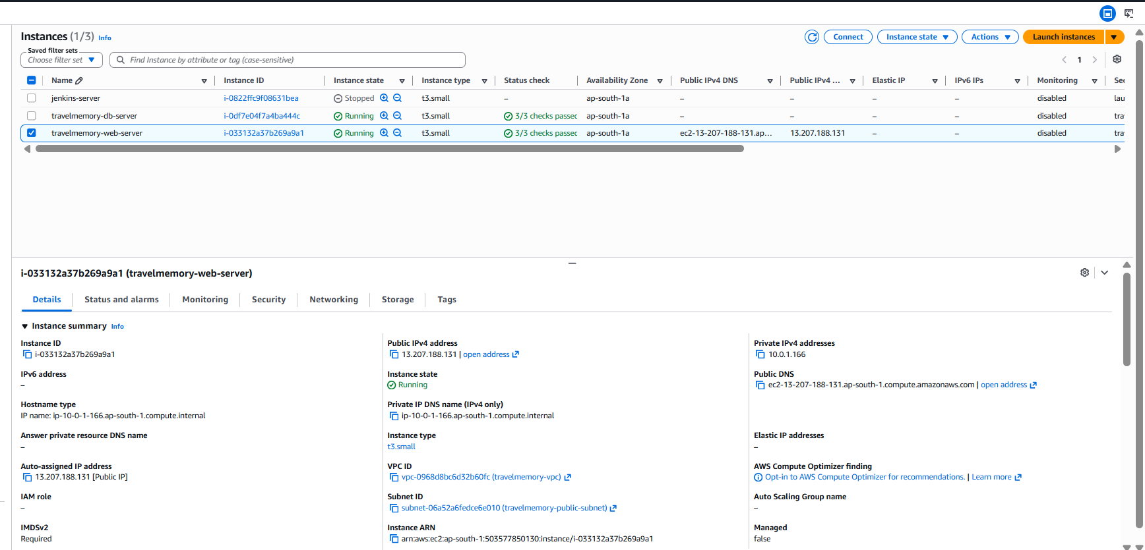

Part 2: Configuration and Deployment with Ansible

1. Ansible Installation and Verification
- Ansible was already installed on the local machine
- Verified version: Ansible core 2.19.3 with Python 3.12.3
2. Inventory Configuration
- Created ansible/inventory/hosts.ini with webserver and dbserver groups
- Initial inventory used basic SSH config for webserver
- DB server in private subnet required jump host configuration via web server
3. Connectivity Issue with DB Server — Error and Fix
- Error 1: Running ansible-playbook database.yml failed with Connection closed by UNKNOWN port 65535
  - Cause: DB server in private subnet not directly reachable from local machine
  - Fix: Added ProxyJump via web server in inventory for dbserver group
- Error 2: After adding ProxyJump, got no such identity: /home/sowjanya/.ssh/sowjanya-cicd.pem: No such file or directory
  - Cause: Inventory referenced ~/.ssh/sowjanya-cicd.pem but key was at ~/sowjanya-cicd.pem
  - Fix 1: Copied PEM key to web server using scp and set chmod 600
  - Fix 2: Updated inventory to use correct path ~/sowjanya-cicd.pem for both hosts
4. Database Server Setup — database.yml
- Ran ansible-playbook -i inventory/hosts.ini playbooks/database.yml
- Tasks completed (9 ok, 7 changed, 0 failed):
  - Updated apt cache
  - Installed gnupg and curl
  - Added MongoDB 7.0 GPG key
  - Added MongoDB 7.0 apt repository
  - Installed mongodb-org package
  - Configured MongoDB bindIp to 0.0.0.0 to accept connections from web server
  - Started and enabled mongod service
5. Web Server Setup — webserver.yml
- Ran ansible-playbook -i inventory/hosts.ini playbooks/webserver.yml
- Tasks completed (16 ok, 13 changed, 0 failed):
  - Updated apt cache
  - Installed curl and gnupg
  - Added NodeSource repository for Node.js 18
  - Installed Node.js 18
  - Installed PM2 globally
  - Installed git
  - Cloned TravelMemory repository to /home/ubuntu/TravelMemory
  - Installed backend npm dependencies
  - Created .env file with PORT, MONGO_URI pointing to 10.0.2.221:27017, JWT_SECRET
  - Started backend with PM2 and saved process list
  - Installed Nginx
  - Configured Nginx reverse proxy (port 80 → 3000)
  - Enabled site and removed default Nginx config
  - Restarted Nginx
6. PM2 Process Issue — Error and Fix
- Error: After playbook ran, pm2 list showed empty table when checked remotely
  - Cause: PM2 spawns a new daemon per SSH session context, remote check showed different daemon instance
  - Fix: SSH'd directly into web server and ran pm2 start index.js --name travelmemory-backend manually
  - Result: Process started successfully, status online, memory 61.6mb
7. Verification
- Ran curl http://localhost:3000/trip on web server — returned [] ✅
- Ran curl http://localhost/trip on web server — confirmed Nginx proxy working ✅
- Ran curl http://13.207.188.131/trip from local machine — returned [] ✅
- Confirmed full stack working: Local → Nginx (80) → Node.js (3000) → MongoDB (27017)

