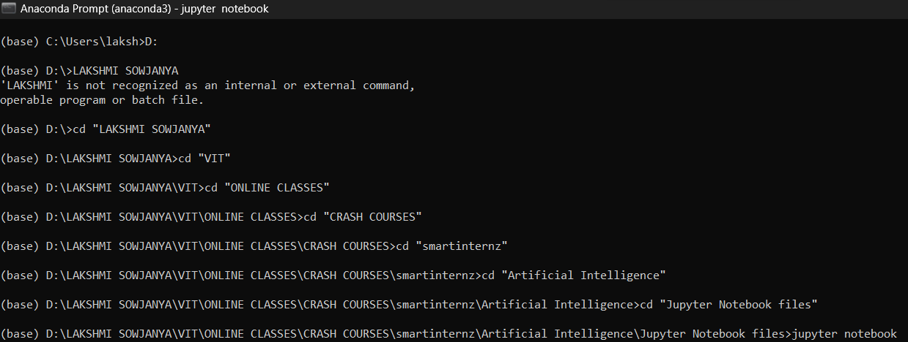
Introduction to Artificial Intelligence
This course is a high-level overview of artificial intelligence (AI) for people with little or no knowledge of computer science and statistics. In it we’ll cover the essential concepts of AI and show you how to apply custom
The course will show you some some simple but powerful ways that data scientists make predictions about objects, people, and the future. Later, we’ll cover exciting, complex topics you may have heard of, such as neural networks, computer vision, deep learning, and unsupervised learning.
In this lesson, we’ll introduce you to some key concepts and get you trying out some AI tools.
What is artificial intelligence?
AI is the study of how to make computers perform tasks that humans consider difficult through the creation of intelligent agents. The study of AI began in the 1950s, and it has improved dramatically over time with better statistical methods and greater computing power.
AI is now used for all sorts of things, such as intelligent opponents in video games, accurate medical diagnosis, speech commands on mobile phones, and keeping email inboxes clear of spam. People who use AI often want it to perform repetitive tasks that take a lot of time for a person to do, or to solve problems that seem almost impossible to solve with a calculator. For example, AI can be used to:
intelligently guess the products that someone may want to buy
- count cells in a microscope picture
- find the optimum number of taxis that a city needs
- read the license plates of cars in a video
- predict the number of ingredients a restaurant needs to order to minimize waste, but not run out of stock.
- Although this sounds very difficult, there are free tools available online which make it easy to get started.

Here is the history of AI during 20th century −
1950 - Alan Turing publishes “Computing Machinery and Intelligence” in which he proposes “the imitation game” which will later become known as the “Turing Test.”
1951 - Marvin Minsky and Dean Edmunds build SNARC (Stochastic Neural Analog Reinforcement Calculator), the first artificial neural network, using 3000 vacuum tubes to simulate a network of 40 neurons.
August 31, 1955 The term “artificial intelligence” is coined in a proposal for a “2 month, 10 man study of artificial intelligence” submitted by John McCarthy (Dartmouth College), Marvin Minsky (Harvard University), Nathaniel Rochester (IBM), and Claude Shannon (Bell Telephone Laboratories). The workshop, which took place a year later, in July and August 1956, is generally considered as the official birthdate of the new field.

1966 Shakey the robot is the first general-purpose mobile robot to be able to reason about its own actions. In a Life magazine 1970 article about this “first electronic person,” Marvin Minsky is quoted saying with “certitude”: “In from three to eight years we will have a machine with the general intelligence of an average human being.”
1972 The first anthropomorphic robot, the WABOT-1, is built at Waseda University in Japan. It consisted of a limb-control system, a vision system and a conversation system.
1997 Deep Blue becomes the first computer chess-playing program to beat a reigning world chess champion.
2011 Watson, a natural language question answering computer, competes on Jeopardy! and defeats two former champions.
June 2012 Jeff Dean and Andrew Ng report on an experiment in which they showed a very large neural network 10 million unlabeled images randomly taken from YouTube videos, and “to our amusement, one of our artificial neurons learned to respond strongly to pictures of... cats.”
October 2012 A convolutional neural network designed by researchers at the University of Toronto achieve an error rate of only 16% in the ImageNet Large Scale Visual Recognition Challenge, a significant improvement over the 25% error rate achieved by the best entry the year before.
March 2016 Google DeepMind's AlphaGo defeats Go champion Lee Sedol.

Applications of AI
Artificial Intelligence has various applications in today's society. It is becoming essential for today's time because it can solve complex problems with an efficient way in multiple industries, such as Healthcare, entertainment, finance, education, etc. AI is making our daily life more comfortable and fast.
Following are some sectors which have the application of Artificial Intelligence:
AI in Astronomy
Artificial Intelligence can be very useful to solve complex universe problems. AI technology can be helpful for understanding the universe such as how it works, origin, etc.
AI in Healthcare
In the last, five to ten years, AI becoming more advantageous for the healthcare industry and going to have a significant impact on this industry.
Healthcare Industries are applying AI to make a better and faster diagnosis than humans. AI can help doctors with diagnoses and can inform when patients are worsening so that medical help can reach to the patient before hospitalization.
AI in Finance
AI and finance industries are the best matches for each other. The finance industry is implementing automation, chatbot, adaptive intelligence, algorithm trading, and machine learning into financial processes.
AI in Data Security
The security of data is crucial for every company and cyber-attacks are growing very rapidly in the digital world. AI can be used to make your data more safe and secure. Some examples such as AEG bot, AI2 Platform,are used to determine software bug and cyber-attacks in a better way.
AI in Social Media
Social Media sites such as Facebook, Twitter, and Snapchat contain billions of user profiles, which need to be stored and managed in a very efficient way. AI can organize and manage massive amounts of data. AI can analyze lots of data to identify the latest trends, hashtag, and requirement of different users.
AI in Travel & Transport
AI is becoming highly demanding for travel industries. AI is capable of doing various travel related works such as from making travel arrangement to suggesting the hotels, flights, and best routes to the customers. Travel industries are using AI-powered chatbots which can make human-like interaction with customers for better and fast response.
AI in Agriculture
Agriculture is an area which requires various resources, labor, money, and time for best result. Now a day's agriculture is becoming digital, and AI is emerging in this field. Agriculture is applying AI as agriculture robotics, solid and crop monitoring, predictive analysis. AI in agriculture can be very helpful for farmers.
AI in E-commerce
AI is providing a competitive edge to the e-commerce industry, and it is becoming more demanding in the e-commerce business. AI is helping shoppers to discover associated products with recommended size, color, or even brand.
AI in education:
AI can automate grading so that the tutor can have more time to teach. AI chatbot can communicate with students as a teaching assistant.
AI in the future can be work as a personal virtual tutor for students, which will be accessible easily at any time and any place.

Artificial intelligence is a science like mathematics or biology. It studies ways to build intelligent programs and machines that can creatively solve problems, which has always been considered a human prerogative.
Machine learning is a subset of artificial intelligence (AI) that provides systems the ability to automatically learn and improve from experience without being explicitly programmed. In ML, there are different algorithms (e.g. neural networks) that help to solve problems.
Deep learning, or deep neural learning, is a subset of machine learning, which uses the neural networks to analyze different factors with a structure that is similar to the human neural system.

Machine Learning Concepts
Types of Learning
The Supervised Learning mainly divided into two parts which are as follows-
Types of Supervised Learning
Regression
Regression is the type of Supervised Learning in which labelled data used, and this data is used to make predictions in a continuous form. The output of the input is always ongoing, and the graph is linear. Regression is a form of predictive modelling technique which investigates the relationship between a dependent variable[Outputs] and independent variable[Inputs]. This technique used for forecasting the weather, time series modelling, process optimisation. Ex:- One of the examples of the regression technique is House Price Prediction, where the price of the house will predict from the inputs such as No of rooms, Locality, Ease of transport, Age of house, Area of a home.
Types of Regression Algorithms
There are many Regression algorithms are present in machine learning, which will use for different regression applications. Some of the main regression algorithms are as follows
- Simple Linear Regression
- Multiple Linear Regression
- Polynomial Regression
- Support Vector Regression
- Ridge Regression
- Lasso Regression
- Elastic Net Regression
- Bayesian Regression
- Decision Tree Regression
- Random Forest Regression
Classification
Classification is the type of Supervised Learning in which labelled data can use, and this data is used to make predictions in a non-continuous form. The output of the information is not always continuous, and the graph is non-linear. In the classification technique, the algorithm learns from the data input given to it and then uses this learning to classify new observation. This data set may merely be bi-class, or it may be multi-class too. Ex:- One of the examples of classification problems is to check whether the email is spam or not spam by train the algorithm for different spam words or emails.
Types of Classification Algorithms
There are many Classification algorithms are present in machine learning, which used for different classification applications. Some of the main classification algorithms are as follows-
- Logistic Regression/Classification
- Nearest Neighbour
- Support Vector Machines
- Kernel Support Vector Machines
- Naive Bayes
- Decision Tree Classification
- Random Forest Classification
Unsupervised Learning
Unsupervised Learning is the second type of machine learning, in which unlabeled data are used to train the algorithm, which means it used against data that has no historical labels. What is being showing must figure out by the algorithm. The purpose is to explore the data and find some structure within. In unsupervised learning the data is unlabeled, and the input of raw information directly to the algorithm without pre-processing of the data and without knowing the output of the data and the data can not divide into a train or test data. The algorithm figures out the data and according to the data segments, it makes clusters of data with new labels.
Types of Unsupervised Learning
The Unsupervised Learning mainly divided into two parts which are as follows-
Clustering
Clustering is the type of Unsupervised Learning in which unlabeled data used, and it is the process of grouping similar entities together, and then the grouped data is used to make clusters. The goal of this unsupervised machine learning technique is to find similarities in the data point and group similar data points together and to figures out that new data should belong to which cluster.
Types of Clustering Algorithms
There are many Clustering algorithms are present in machine learning, which is used for different clustering applications. Some of the main clustering algorithms are as follows-
- K-Means Clustering
- K-Means Clustering showing 3 clusters
- Hierarchical Clustering

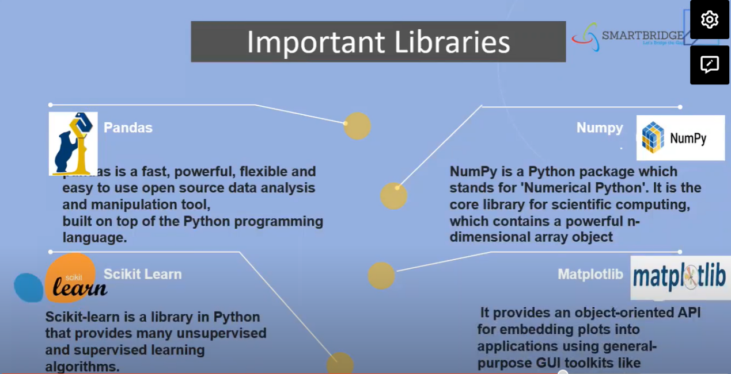
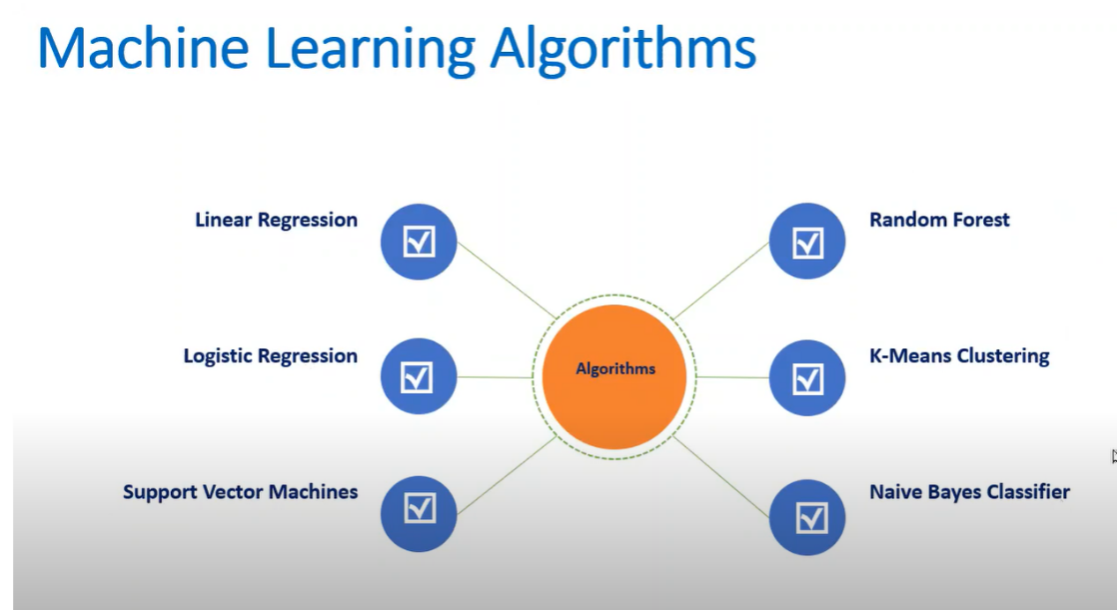

PYTHON PROGRAMMING
INTRODUCTION TO PYTHON

Python is developed by Guido van Rossum. Guido van Rossum started implementing Python in 1989. Python is a very simple programming language so even if you are new to programming, you can learn python without facing any issues.
Features of Python
Readable :Python is a very readable language.
Easy to Learn: Learning python is easy as this is a expressive and high level programming language, which means it is easy to understand the language and thus easy to learn.
Cross platform: Python is available and can run on various operating systems such as Mac, Windows, Linux, Unix etc. This makes it a cross platform and portable language.
Open Source: Python is a open source programming language.
Large standard library: Python comes with a large standard library that has some handy codes and functions which we can use while writing code in Python.
Free: Python is free to download and use. This means you can download it for free and use it in your application. See: Open Source Python License. Python is an example of a FLOSS (Free/Libre Open Source Software), which means you can freely distribute copies of this software, read its source code and modify it.

In this tutorial, you will learn about keywords (reserved words in Python) and identifiers (names given to variables, functions, etc.)

Python Keywords
Keywords are the reserved words in Python.
We cannot use a keyword as a variable name, function name or any other identifier. They are used to define the syntax and structure of the Python language.
In Python, keywords are case sensitive.
There are 33 keywords in Python 3.7. This number can vary slightly over the course of time.

You can always get the list of keywords in your current version by typing the following in the prompt.
import keyword
print(keyword.kwlist)
Python Identifiers
An identifier is a name given to entities like class, functions, variables, etc. It helps to differentiate one entity from another.

Rules for writing identifiers
- Identifiers can be a combination of letters in lowercase (a to z) or uppercase (A to Z) or digits (0 to 9) or an underscore _. Names like myClass, var_1 and print_this_to_screen, all are valid example.
- An identifier cannot start with a digit. 1variable is invalid, but variable1 is a valid name.
- An identifier can be of any length.

In this tutorial, you will learn about Python statements, why indentation is important and use of comments in programming.
Python Statement
Instructions that a Python interpreter can execute are called statements. For example, a = 1 is an assignment statement. if statement, for a statement, while statement, etc. are other kinds of statements which will be discussed later.

Python Indentation
Most of the programming languages like C, C++, and Java use braces { } to define a block of code. Python, however, uses indentation.
A code block (body of a function, loop, etc.) starts with indentation and ends with the first unindented line. The amount of indentation is up to you, but it must be consistent throughout that block.
Python Comments
Comments are very important while writing a program. They describe what is going on inside a program, so that a person looking at the source code does not have a hard time figuring it out.
You might forget the key details of the program you just wrote in a month's time. So taking the time to explain these concepts in the form of comments is always fruitful.
In Python, we use the hash (#) symbol to start writing a comment.
It extends up to the newline character. Comments are for programmers to better understand a program. Python Interpreter ignores comments.

What is Loop?
Loops can execute a block of the code a number of times until a certain condition is met. Their usage is fairly common in programming. Unlike other programming language that have For Loop, while loop, dowhile, etc.
What is For Loop?
For loop is used to iterate over elements of a sequence. It is often used when you have a piece of code which you want to repeat "n" number of time.
What is While Loop?
While Loop is used to repeat a block of code. Instead of running the code block once, It executes the code block multiple times until a certain condition is met.
In this tutorial, we will learn
- How to use "While Loop"
- How to use "For Loop"
- Break statements in For Loop
- Continue statement in For Loop
- Pass statement in For Loop

Loops:
Loops are a programming element that repeats a portion of code a set number of times until the desired process is complete. Repetitive tasks are common in programming, and loops are essential to save time and minimize errors.
While Loop :
In python, while loop is used to execute a block of statements repeatedly until a given condition is satisfied. And when the condition becomes false, the line immediately after the loop in the program is executed.
For Loop:
For loops are used for sequential traversal. For example: traversing a list or string or array etc. In Python, there is no C style for loop, i.e., for (i=0; i<n; i++). There is “for in” loop which is similar to for each loop in other languages. Let us learn how to use for in loop for sequential traversals.

What is an Exception in Python?
An exception is an error that happens at the time of execution of a program. However, while running a program, Python generates an exception that should be handled to avoid your program to crash. In Python language, exceptions trigger automatically on errors, or they can be triggered and intercepted by your code.
The exception indicates that, although the event can occur, this type of event happens infrequently. When the method is not able to handle the exception, it is thrown to its caller function. Eventually, when an exception is thrown out of the main function, the program is terminated abruptly.

In this Python exceptional handling tutorial, you will learn :
- What is an Exception in Python?
- Common Examples of Exception
- Why should you use Exceptions?
- The Try Statement
- The catch Statement
- The Raise Statement
Common Examples of Exception:
- Division by Zero
- Accessing a file which does not exist.
- Addition of two incompatible types
- Trying to access a nonexistent index of a sequence
- Removing the table from the disconnected database server.

ARTIFICIAL NEURAL NETWORKS

Artificial Neural Network (ANN)
Artificial Neural Network (ANN) is a deep learning algorithm that emerged and evolved from the idea of Biological Neural Networks of human brains. An attempt to simulate the workings of the human brain culminated in the emergence of ANN. ANN works very similar to the biological neural networks but doesn’t exactly resemble its workings.
ANN algorithm would accept only numeric and structured data as input. To accept unstructured and non-numeric data formats such as Image, Text, and Speech, Convolutional Neural Networks (CNN), and Recursive Neural Networks (RNN) are used respectively. In this post, we concentrate only on Artificial Neural Networks.
Biological neurons vs Artificial neurons
Structure of Biological neurons and their functions
- Dendrites receive incoming signals.
- Soma (cell body) is responsible for processing the input and carries biochemical information.
- Axon is tubular in structure responsible for the transmission of signals.
- Synapse is present at the end of the axon and is responsible for connecting other neurons.
Structure of Artificial neurons and their functions
A neural network with a single layer is called a perceptron. A multi-layer perceptron is called Artificial Neural Networks.
A Neural network can possess any number of layers. Each layer can have one or more neurons or units. Each of the neurons is interconnected with each and every other neuron. Each layer could have different activation functions as well.
ANN consists of two phases Forward propagation and Backpropagation. The forward propagation involves multiplying weights, adding bias, and applying activation function to the inputs and propagating it forward.
The backpropagation step is the most important step which usually involves finding optimal parameters for the model by propagating in the backward direction of the Neural network layers. The backpropagation requires optimization function to find the optimal weights for the model.
ANN can be applied to both Regression and Classification tasks by changing the activation functions of the output layers accordingly. (Sigmoid activation function for binary classification, Softmax activation function for multi-class classification and Linear activation function for Regression).
Why Neural Networks?
Traditional Machine Learning algorithms tend to perform at the same level when the data size increases but ANN outperforms traditional Machine Learning algorithms when the data size is huge as shown in the graph below.
Feature Learning. The ANN tries to learn hierarchically in an incremental manner layer by layer. Due to this reason, it is not necessary to perform feature engineering explicitly.
Neural Networks can handle unstructured data like images, text, and speech. When the data contains unstructured data the neural network algorithms such as CNN (Convolutional Neural Networks) and RNN (Recurrent Neural Networks) are used.

Activation functions
The purpose of an activation function is to introduce non-linearity to the data. Introducing non-linearity helps to identify the underlying patterns which are complex. It is also used to scale the value to a particular interval. For example, the sigmoid activation function scales the value between 0 and 1.
Logistic or Sigmoid function
Logistic/ Sigmoid function scales the values between 0 and 1.
It is used in the output layer for Binary classification.
It may cause a vanishing gradient problem during backpropagation and slows the training time.
Tanh function
Tanh is the short form for Hyperbolic Tangent. Tanh function scales the values between -1 and 1.
ReLU function
ReLU (Rectified Linear Unit) outputs the same number if x>0 and outputs 0 if x<0.
It prevents the vanishing gradient problem but introduces an exploding gradient problem during backpropagation. The exploding gradient problem can be prevented by capping gradients.
Leaky ReLU function
Leaky ReLU is very much similar to ReLU but when x<0 it returns (0.01 * x) instead of 0.
If the data is normalized using Z-Score it may contain negative values and ReLU would fail to consider it but leaky ReLU overcomes this problem.

How ANN works
The working of ANN can be broken down into two phases,
- Forward Propagation
- Back Propagation
Forward Propagation
Forward propagation involves multiplying feature values with weights, adding bias, and then applying an activation function to each neuron in the neural network.
Multiplying feature values with weights and adding bias to each neuron is basically applying Linear Regression. If we apply Sigmoid function to it then each neuron is basically performing a Logistic Regression.
Backpropagation
Backpropagation is done to find the optimal value for parameters for the model by iteratively updating parameters by partially differentiating gradients of the loss function with respect to the parameters.
An optimization function is applied to perform backpropagation. The objective of an optimization function is to find the optimal value for parameters.
The optimization functions available are,
Gradient Descent
Adam optimizer
Gradient Descent with momentum
RMS Prop (Root Mean Square Prop)
The Chain rule of Calculus plays an important role in backpropagation. The formula below denotes partial differentiation of Loss (L) with respect to Weights/ parameters (w).
A small change in weights ‘w’ influences the change in the value ‘z’ (∂

