1

© Capgemini 2017. All rights reserved

|

Presentation Title | Author | Date



**Strengths**

**Achievements**

**Education and certificates**

**Base Location:**

**Email ID:**

**Mobile No:**

**Grade:**



**Airline Reservation System**

Completed end to end case study Airline Reservation

System along with JWT authentication

Web API and MS SQL Server.

**Learned AZ – 900 Microsoft azure fundamentals in Degreed platform**

r

Leadership Qualities

Analyst/Software Engineer

Hyderabad

Sowjanya.gudise@capgemini.com

+91 9515392431

•

A self-driven learner with Front

-

End and Back

-

End

knowledge. Passionate about implementing and

launching new projects.

•

Ready to learn new technologies/Frameworks and

implement them to further improve my knowledge.

•

A team player with good communication skill always

ready to work for the enrichment of knowledge.

•

Have working knowledge on SQL Server and C#.

•

Also has basic knowledge on Azure.

Bachelor of Technology

ECE: 2016 -2020

**Skills**

C#

Dot Net Core

EF Core

ASP .Net Core MVC

**Database**

MS SQL Server 2019

**Web Technologies**

HTML5

CSS3

**AddOns**

GitHub

Swagger

Postman

**Additional Details**

Quick Learner

Team Player

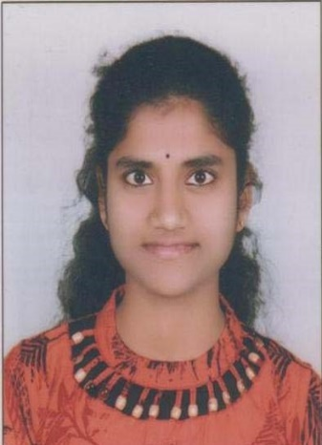

**Sowjanya Gudise**

A4

Swagger and Postman testing using ASP.NET Core