

clc; clear; close all;

% Parameters
dt = 0.05; % Time step
N = 100; % Number of iterations
L = 60; % Length of board
W = 30; % Width of board
mu = 0.5; % Friction coefficient
g = 9.81; % Acceleration due to gravity

% Board setup
figure('position',[500 150 700 500]);
rectangle('Position', [-L/2 -W/2 L W], 'EdgeColor', 'k', 'LineWidth', 2);
rectangle('Position', [-L/2 -W/2 L W], 'FaceColor', [0.2 0.7 0.2]);

% Coin setup
r = 1; % Coin radius
xc = [10 -10 0 0 0]; % x-coordinate of coins
yc = [0 0 10 -10 0]; % y-coordinate of coins
vc = zeros(2,5); % Velocity of coins
hc = zeros(1,5); % Handle for coins
color = ['w', 'w', 'w', 'w', 'k']; % Color of coins

% Add striker
rs = 1.5*r; % Striker radius
xs = 0; % x-coordinate of striker
ys = 0; % y-coordinate of striker
vs = zeros(2,1); % Velocity of striker
hs = rectangle('Position', [xs-rs, ys-rs, 2*rs, 2*rs], 'Curvature', [1 1], 'FaceColor', 'r'); % Handle for striker

% Create handles for coins
for i = 1:5
hc(i) = rectangle('Position', [xc(i)-r, yc(i)-r, 2*r, 2*r], 'Curvature', [1 1], 'FaceColor', color(i));
end

% Run simulation
for i = 1:N
% Update positions
xc = xc + vc(1,:)*dt;
yc = yc + vc(2,:)*dt;
xs = xs + vs(1)*dt;
ys = ys + vs(2)*dt;
% Handle collisions with board boundaries
out_of_bounds = xc > L/2-r | xc < -L/2+r | yc > W/2-r | yc < -W/2+r;
vc(:,out_of_bounds) = -mu*vc(:,out_of_bounds);
xc(out_of_bounds) = xc(out_of_bounds) - 2*dt*vc(1,out_of_bounds);
yc(out_of_bounds) = yc(out_of_bounds) - 2*dt*vc(2,out_of_bounds);
vs(:,xs > L/2-rs | xs < -L/2+rs | ys > W/2-rs | ys < -W/2+rs) = -mu*vs(:,xs > L/2-rs | xs < -L/2+rs | ys > W/2-rs | ys < -W/2+rs);
% Handle collisions with other coins and striker
for j = 1:5
for k = 1:5
if j ~= k
dist = norm([xc(j) yc(j)] - [xc(k) yc(k)]);

ID6108 - Process and Design for Additive Manufacturing

Assignment-6

1) DEM Simulation of Carrom Board :
Matlab code:

if dist < 2*r

n = ([xc(j) yc(j)] - [xc(k) yc(k)])/dist;
vt1 = dot(vc(:,j), n);
vt2 = dot(vc(:,k), n);
if vt1 > vt2
vc(:,j) = vc(:,j) - (1+mu)*(vt1-vt2)*n;
end
end
end
end
end
End

Result:

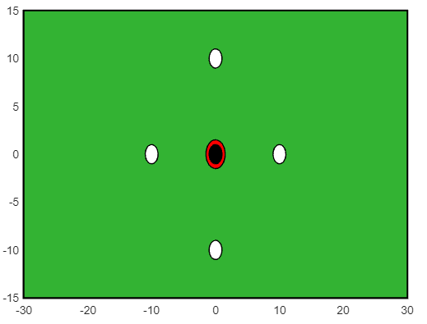

Name: K Sowjanya
Roll No: MM22M023

END

Dear Sir/Madam,

I am writing to request your assistance regarding my current situation. I am currently pursuing M.Tech at IIT Madras, and I have completed my first year of coursework. However, I have recently been selected for the contract-based job advertised under the BIS Notification Number: Advertisement No. 04 (YP)/ 2022/ HRD.

While I am excited about this opportunity, I am also committed to continuing my education and completing my M.Tech degree. Therefore, I would like to request an extension in my reporting date to the new location and a change in the job location to accommodate my studies.

Additionally, as the second year of my M.Tech program is entirely project-based, I plan to manage my academic commitments by requesting my current guide's support. I would like to request his guidance in pursuing the project remotely, and I am willing to coordinate with him/ to ensure that my project work meets the program's requirements.

I am aware that this request may require additional arrangements, and I am willing to comply with any conditions that may arise. Please let me know if it is possible to make these arrangements or if there are any other alternatives that may be more feasible.

I would be grateful for your consideration of my request and for any assistance you may provide in this matter.

Thank you for your attention to this matter.

Sincerely,

K.Sowjanya

