A MINI PROJECT
On
RGUKT HOSPITAL MANAGEMENt SYSTEM
Submitted in partial fulfillment of the Requirements for the award of the degree of
Bachelor Of Technology
In
Computer Science and Engineering
Submitted By
Tanneru Srikanth ( O180454)
Athmakuru Kavya ( O180491)
Pilla Sowjanya ( O180485)
Kalam Sirresha ( O180483)
Under the guidance of
Ms P.Archana(PhD)
Assistant Professor


DEPARTMENT OF COMPUTER SCIENCE AND ENGINEERING,
RGUKT ONGOLE CAMPUS,
ANDHRA PRADESH.
CERTIFICATE
This is to certify that the project entitled ”RGUKT HOSPITAL MANAGEMENT SYSTEM ” being submitted by T.srikanth (O180454), A.Kavya (O180491), K.Sireesha (O180483) and P.Sowjanya (O180485) in partial fulfillment of the requirements for the award of the degree of the Bachelor of Technology in Computer Science and Engineering in Rajiv Gandhi University of Knowledge Technologies is a record of bonafide work carried out by them under my guidance and supervision during the academic year 2022-2023. This project has fulfilled all the requirements as per the regulations of the institute and in my opinionreached for the standard for submission

Project Guide: External Signature:
Ms.P.Archana(PhD)
Assistant Professor,
RGUKT ONGOLE

Mr.B.Sampath Babu
Head of Department
Dept of CSE
RGUKT Ongole

APPROVAL SHEET

This project entitled “RGUKT Hospital Management System” submitted by T.Srikanth (O180454), A.Kavya (O180491), P.Sowjanya (O180485), and K.Sireesha (O180483) in partial fulfilment of the requirement for the award of Bachelor of Technology in Computer Science and Engineering is approved by Ms.P.Archana(PhD)

Internal Examiner :__________________________________

Supervisor :___________________________________

External Examiner :___________________________________

Head of the Department :___________________________________

Date:_____________
Place:____________

ACKNOWLEDGEMENT
We are highly indebted to Ms.P.Archana mam for their guidance and constant supervision as well as for providing necessary information regarding the project and also for their kind cooperation, encouragement and their support in completing the project. We would like to express our special gratitude and thanks to Head of the Department for giving us such attention and time. We have taken efforts in this project. However, it could not have been possible without the kind support and help of many individuals and RGUKT. We would like to extend our sincere thanks to all of them.

With sincere Regards,
T.Sriakanth(O180454)
A.Kavya(O180491)
P.Sowjanya(O180485)
K.Sireesha(O180483)

DECLARATION
We declare that this written submission represents our ideas in our own words and where others ideas or words have been included, we have adequately cited and referenced the original sources. We also declare that we have adhere to our principles of academic honesty and integrity and have not misrepresented or fabricated or falsified any idea/data/fact/source in our submission. I undestrand that any violation of the above will because for disciplinary action by the institute and can also evoke penal action from the sources which have thus not been properly cited or from whom proper permission has not been taken when needed.

Signature

___________________________

T Srikanth(O180454)
A Kavya(O180491)
P Sowjanya(O180485)
K Sireesha(O180483)

Date:_________________________
ABSTRACT
Medicines are one of the important factors that are necessary to cure a person’s diseases. Due to delay of the medicines, there are chances that the person might even loose his life. To solve these all problems hospital management system plays main role The project is designed for developing the medical store management system whose purpose is to reduce the complexities of record keeping and documentation in the inventory management , on the basis of database management system we can manage the bill, stock, staff details of the hospital very easily and also we can update the medical details time to time without overdue. The system provides information of all the medicines at a single portal which is accessed by all the student of ongole , the admin can manage the staff information and medicine information. To check the availability of staff and medicines.

CONTENTS
S.NO PAGE NO.
1. Introduction 1-2
1.1. Purpose 1
1.2. Objectives of the project 1
2. Literature Survey 3-4
3. Analysis 5-7
3.1. Existing System 5
3.2. Proposed System 5
3.3. Software Requirement Specification 5
3.3.1. Purpose 6
3.3.2. Scope 7
3.3.3. Overall Description 7
4. Design 8-20
4.1. UML Diagrams
5. Implementation 21-26
5.1. Modules 21
5.2. Module description 21
5.3. Introduction of technologies used 22
5.4. Sample code 22-26
6. Test cases 27-30
7. Screenshots 31-33
8. Conclusion 34
9. Future Enhancement 35
10. Bibliography 36

1. INTRODUCTION
“RGUKT HOSPITAL MANAGEMENT SYSTEM”
Our project is about maintaining the medical records of rgukt ongole hospital on the basis of database management system using sql and php .Here we can manage the stock, staff details, medicine details, student records of the hospital very easily. We can update the medical details time to time without overdue. The purpose of Hopsital Management System is to automate the existing manual system by the help of computerized equipment’s and full -fledged computer software, fulfilling their requirements ,so that their valuable data/information can be stored for a longer period with easy accessing and manipulation of the same. The required software and hardware are easily available and easy to work with. Hospital Management System, as described above, can lead to error free secure, reliable and fast management system. It can assist the user to concentrate on the record keeping, Thus it will help organization in better utilization of resources.
1.1 Purpose
The main purpose and the motivation for us to work upon this project is whenever we to go hospital the staff maintaining the records of medicines , student records, staff information in the of registers. It is difficult to get the information about a particular thing and it’s a time consuming process to refer about it in large registers;
There is no any computerized system to maintain these records in the hospital. So that we designed to develop a Hospital Management System on the basis of database management system in where we can efficiently store the medicine details, its stock, student records and w can easily update the details.
1.2 Objectives of the project
The objective of this project is to organize the hospital details like stocks, medicines, student records and others. This project is mainly developed at the administrative end and therefore it only provide access to the administrator of the hospital. The hospital management system is developed as application program for reducing manual work managing medical store, It also helps in keeping track of all the details regarding the medicines, stocks and student records.
In this project we are giving access to the students of RGUKT to view the medicines which are available in the hospital and doctors information who are available at that particular time. Students and view the medicine and its purpose. So that thay can ask for a Particular medicine when they go to hospital. Students are only allowed to view information on the website. They can’t make any changes in the information. Only admin and hospital staff has the access to make changes in the website. Whatever changes has done by the admin it will reflect on the users page.has the Daily transactions are computerized for easy of operations. To maintain accounts with precision. To access the entire stock at any time at a click of a button. By selecting one option you can access the details.

2. LITERATURE SURVEY
BACKGROUN : Medical stores management in hospitals is a tedious and time consuming chore with limited resources tasked for the purpose and poor penetration of information technology. The process of automation is slow paced due to various inherent factors and is being challenged by the increasing inventory loads and escalating budgets for procurement of drugs.
2006 The 4th Institution of Engineering and Technology Seminar on Appropriate Healthcare Technologies for Developing Countries
This paper describes an open-source software system developed to dispense antiretroviral (ARV) drugs to HIV+ patients in South Africa. There are numerous constraints to the scaling up of antiretroviral treatment (ART) in resource poor settings; one being the difficulty in monitoring and capturing of relevant patient data. South Africa has a severe lack of qualified medical staff, from doctors and pharmacists to nursing sisters, and it is imperative that the existing scarce resources are utilized effectively. Based on an assessment of the local context, the system is comprised of two applications which reside at geographically separate locations. The first is housed at a central supply pharmacy where ARV drugs are packaged by a pharmacist for individual patients. The second application is housed at a service point or ARV site, where patients collect their medication from a nurse. Using HCI theory, it is designed to be user friendly and easy to learn for the nurses working at this health care facility. Features such as stock control and patient history (of timeous medication collection) make it easy for the pharmacist to assess each site receiving drugs from the central store.
Lecturer, Computer Engineering, SVERI’s College of Engineering( Polytechnic), Pandharpur, India
The purpose of Hospital Management System is to automate the existing manual system by the help of computerized equipment’s and full-fledged computer software, fulfilling their requirements, so that their valuable data/information can be stored for a longer period with easy accessing and manipulation of the same. The required software and hardware are easily available and easy to work with. Medical Store Management System, as described above, can lead to error free, secure, reliable and fast management system. It can assist the user to concentrate on their other activities rather to concentrate on the record keeping. Thus it will help organization in better utilization of resources. The organization can maintain computerized records without redundant entries.
U Rivett
University of Cape Town, Rondebosch, Western Cape, ZA
The pharmacy management system kept paper and pen away mostly cause of the wait's Managing a very huge pharmacy with records stored online and on papers which surely seems difficult to keep track of inventories with dignity but this system makes it look easier. The drugs in the pharmacy store, expiry date, quantity of drugs available are fixed on the categories and their functions. A pharmacist has to order drugs to replenish the already diminishing stock. In addition, the ordering of drugs is being carried out manually. A major amount of time is taken for writing the order as the pharmacist needs to check through the stock balance and make an estimate of the amount to order based on Figures. As we know drugs are not suppose to be used after they have expired. This project work will notify the pharmacist about drugs that are near to expire, preventing those drugs from being sold and also providing a solution to the earliest problems.
OUR PROJECT:
Our RGUKT Hospital management system is a project which maintains the details of medical drugs and staff details which you can access it from anywhere with the login details. The reason for us to build this project as we don’t have a website regarding to access the details of medical info. Due to the problems of our fellow friends faced while visiting the hospital made us to do this project , situations like the stock of medicines getting over the absence of staff in hospital the incomplete information of which doctors present on which day.
THINGS WE CAN ADD TO THIS PROJECT:-
If any students willing to help as volunteers ,we can perform door delivery in future.

3. ANALYSIS
3.1. EXISTED SYSTEMS
Existed system related to our project are there are some of the apps or websites already existed. APOLLO 247 – this is best online doctor pharmacy app which brings you medicine delivery, doctor consultations and lab tests on single platform. Other websites are PHARMEASY,NETMEDS,FLIPCARD HEALTH,MED PLUS MART.

3.2. PROPOSED SYSTEM
Our RGUKT hospital management system is a project which maintains the details of medical drugs and staff details which you can access it from anywhere with the login details. The amount of data related to the patients staff medicines can be managed by the system securely. Data and information is stored in the database securely.
Daily transactions are computerized for easy of operations. By selecting one option you can access the details. It contains bill, staff and stock details.

3.3. SOFTWARE REQUIREMENT SPECIFICATION
Our website contains both Frontend and Backend. In the process of creation of websites we use different programming languages in frontend and backend.
Frontend Programming Languages:
- Html
- Css
- Javascript &Bootstrap
- JQuery
Backend Programming Languages:
- Php
- Mysql Server

By using the above mentioned Programming Languages we completed our project. In this project we use Software languages as well as some Hardware Materials also. They are:

Hardware Requirements:
- Processor
- Ethernet Connection
- Hard drive
- Hard drive
- Monitor
- Keyboard

By using the Above mentioned Software and Hardware requirements we completed our project successfully.

3.4 PURPOSE
The reason for us to build this project as we don’t have a website regarding to access the details of medical info.
Due to the problems of our fellow friends faced while visiting the hospital made us to do this, situations like
stock of medicines getting over
the absence of staff in hospital
The incomplete information of which doctors present on which day.
3.5 SCOPE
The software product to be produced is a Medical Store Management System which will automate the major medical store operations. The first subsystem is to keep record of the stock of the medicines available and expiry date of the medicines. The second subsystem is for billing and keep record of the customer. The third subsystem is keep record of the sale and supplier and keep record of the profits and losses. These three subsystems functionality will be described. It is designed as to ease the work load of medical shop professionals. The main feature includes invoicing, inventory and stock control, accounting ,client and vendor management.
3.6 OVERALL DESCRIPTION
Describes the general factors that affect the product and its requirements. This section does not state specific requirements. Instead it provides a background for those requirements, which are defined in section 3, and makes them easier to understand. The MSMS is an independent stand–alone system. It is totally self contained.The MSMS will be placed on PC’s throughout the medical store. All databases for the MSMS will be configured using MS Access. These databases include medicine stocks customers information and their billing. These can be modified by the end users. The medicine stock database will include the number of stock of medicines available and keep track of their expiry dates. The customers information database will contain all the information of the customer such as first name, last name, phone number, id, number of medicines purchased, details of medicine purchased, total amount, mode of payment(cash/debit or credit card) . Sale and Supplier Management System. Keep in record the details of their supplier such as supplier name, id, quantity of stock of medicines supplied, bill of the stock supplied etc. Keep track of the profit and losses of the shop. Keep record of the sales of shop. Complete record of all the purchases is maintained.

4. DESIGN

4.1 UML DIAGRAMS:
UML is the short form of Unified Modelling Language. UML is a standardized general-purpose modeling language in the field of object-oriented software engineering. The standard is managed, and was created by, the Object Management Group. The important goal for UML is to create a common modelling language for the sake of Object Oriented Software engineering. In its current form UML consists of two major components: a Meta-model and a notation. In the future, some form of method or process may also be added to; or associated with, UML. The Unified Modeling Language is a standard language for specifying, Visualization Constructing and documenting the artifacts of software systems, as well as for business modeling and other non-software systems. The UML represents a collection of best engineering practices that have proven successful in the modeling of large and complex systems. The UML is a very important part of developing object oriented software and the software development process.
GOALS
The Primary goals in the design of the UML are as follows:
1.Provide users a ready-to-use, expressive visual modeling Language so that they can develop and exchange meaningful models.
2.Provide extendibility and specialization mechanisms to extend the core concep3.ts. 3.Be independent of particular programming languages and development processes. 4.Provide a formal basis for understanding the modeling language.
5.Encourage the growth of the OO tools market.
6. Support higher level development concepts such as collaborations frameworks, patterns and components and Integrate best practices.

A UML Diagram is based on UML(Unified Modeling Language)with the purpose of visually representing a system along with its main actors, roles, actions,
artifacts or classes, in order to better understand, maintain, or document information about the system. The UML diagrams are divided into Structural and Behavioural UML diagrams.
Structural diagrams
Structural diagrams depict a static view of a structure of a system. It is widely used in the Documentation of software architecture. The Structural UML Diagrams involves 7 diagrams They are:
- Class Diagram
- Object Diagram
- Component Diagram
- Composite Structure Diagram
- Deployment Diagram
- Package Diagram
- Profile Diagram
BEHAVIOURAL UML DIAGRAM:
Behavioural diagrams portray a dynamic view of a system or the behaviour of a system, which describes the functioning the system. It involves 7 diagrams They are:
- Usecase Diagram
- Sequence Diagram
- Activity Diagram
- State Machine Diagram
- Interaction Overview Diagram
- Communication Diagram
- Timing Diagram

Class Diagram
Class diagrams are one of the most widely used diagrams. It is the backbone of all the object-oriented software systems. It depicts the static structure of the system. It displays the system's class, attributes, and methods. It is helpful in recognizing the relation between different objects as well as class
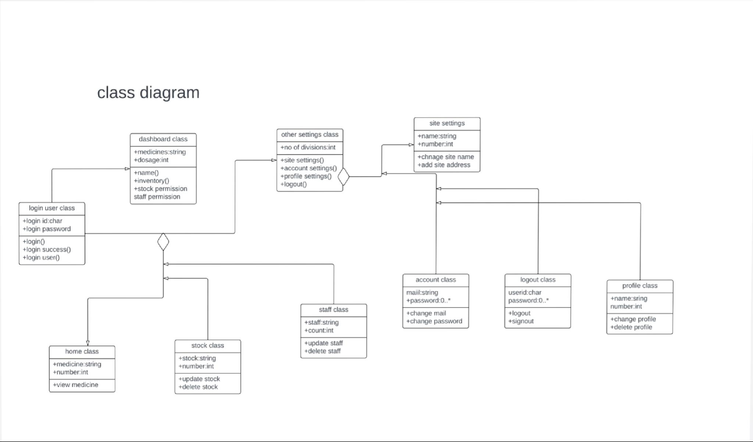

OBJECT DIAGRAM
Object Diagrams represents an instance of class diagrams. The basic concepts are similar for class diagram and Object diagram. It describes the static structure of a system at a particular point in time. It can be used to test the accuracy of class diagrams. It represents distinct instances of classes and the relationship between them at a time.

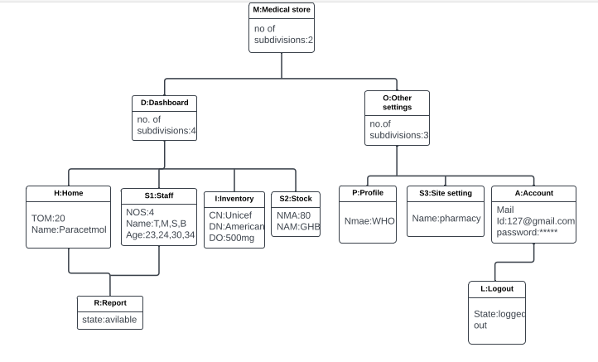

COMPONENT DIAGRAM
It portrays the organization of the physical components within the system. It is used for modeling execution details. It determines whether the desired functional requirements have been considered by the planned development or not, as it has structural relationships between the elements of a software system.
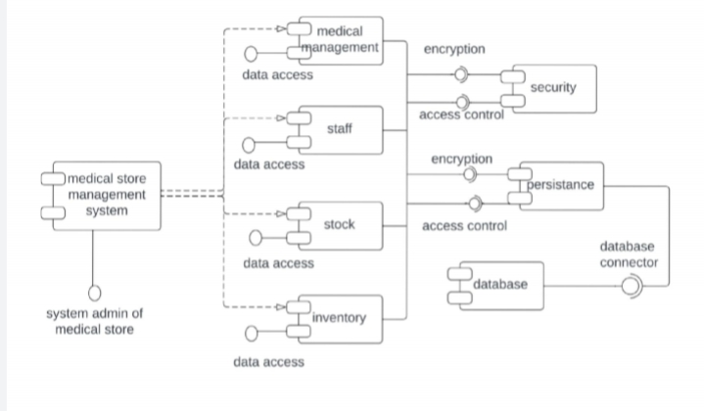

COMPOSITE STRUCTURE DIAGRAM
The composite structure diagrams show parts within the class. It displays the relationship between the parts and their configuration that ascertain the behavior of the class. It makes full use of ports, parts, and connectors to portray the internal structure of a structured classifier. It is similar to class diagrams, just the fact it represents individual parts in a detailed manner when compared with class diagrams.
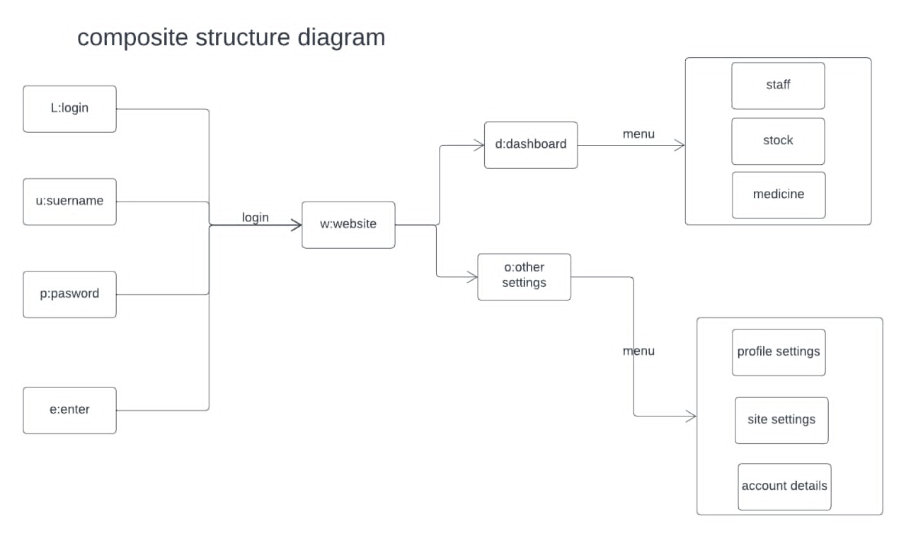

DEPLOYMENT DIAGRAM
It presents the system's software and its hardware by telling what the existing physical components are and what software components are running on them. It produces information about system software. It is incorporated whenever software is used, distributed, or deployed across multiple machines with dissimilar configurations.

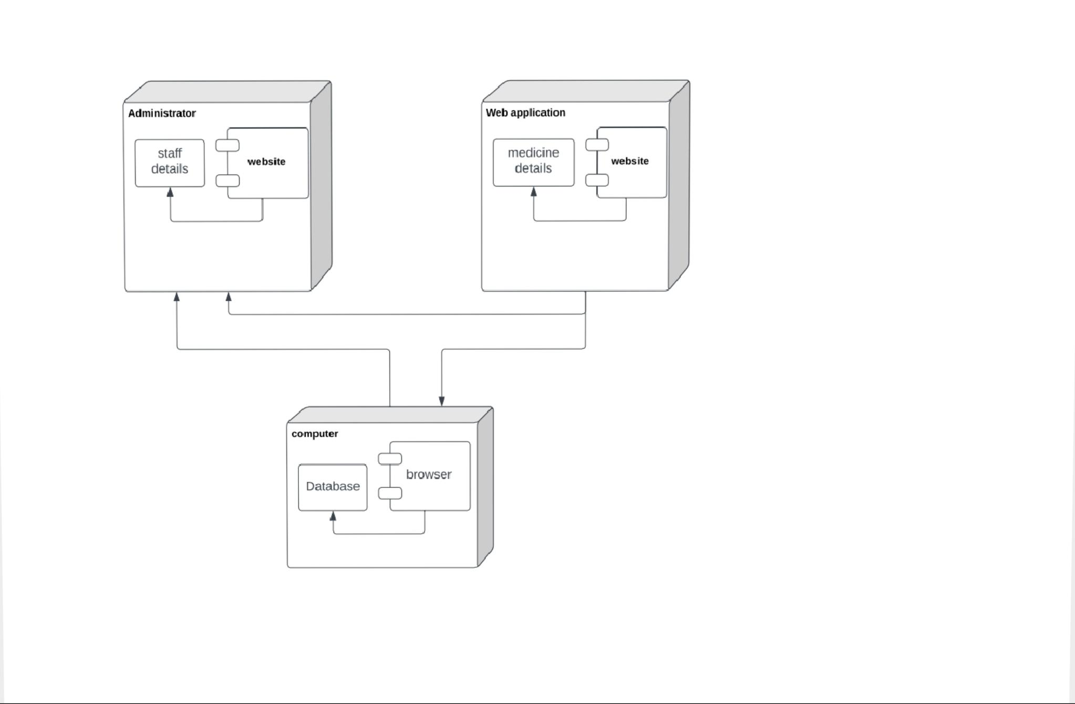

PACKAGE DIAGRAM
It is used to illustrate how the packages and their elements are organized. It shows the dependencies between distinct packages. It manages UML diagrams by making it easily understandable. It is used for organizing the class and use case diagrams.
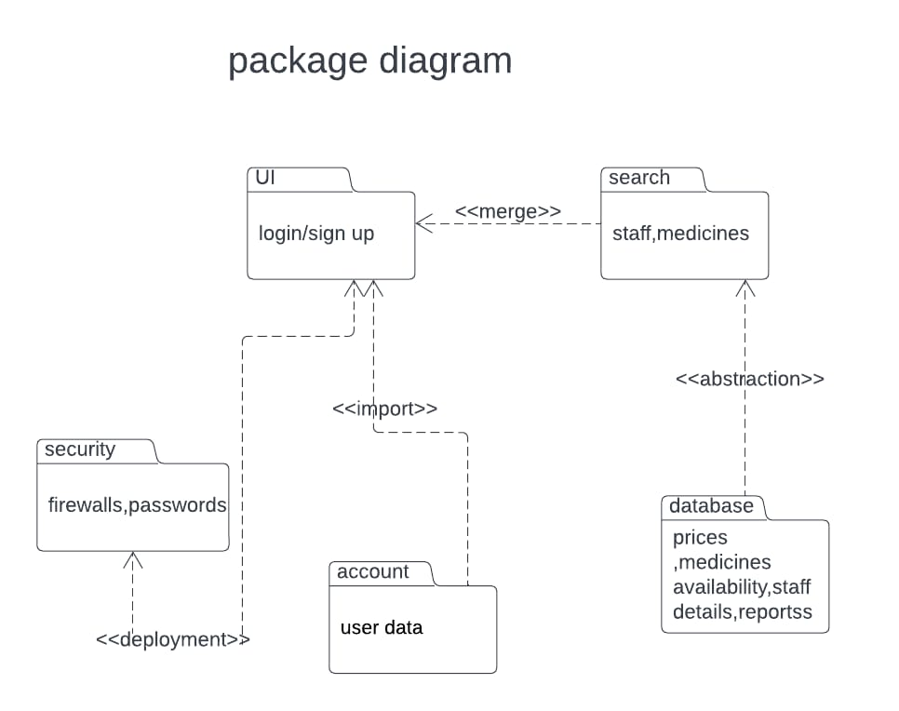

PROFILE DIAGRAM
Profile diagram, a kind of structural diagram in the Unified Modeling Language (UML), provides a generic extension mechanism for customizing UML models for particular domains and platforms. Extension mechanisms allow refining standard semantics in strictly additive manner, preventing them from contradicting standard semantics. Profiles are defined using stereotypes, tagged value definitions, and constraints which are applied to specific model elements, like Classes, Attributes, Operations, and Activities.

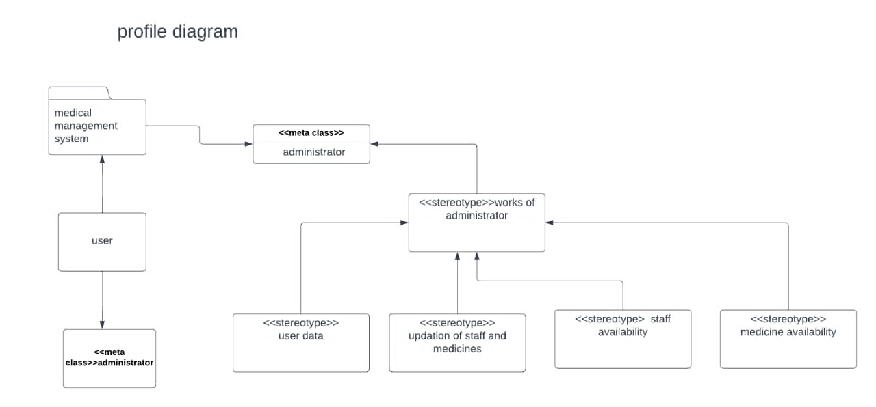

USECASE DIAGRAM
In UML, use-case diagrams model the behavior of a system and help to capture the requirements of the system. Use-case diagrams describe the high-level functions and scope of a system. These diagrams also identify the interactions between the system and its actors. The use cases and actors in use-case diagrams describe what the system does and how the actors use it, but not how the system operates internally.

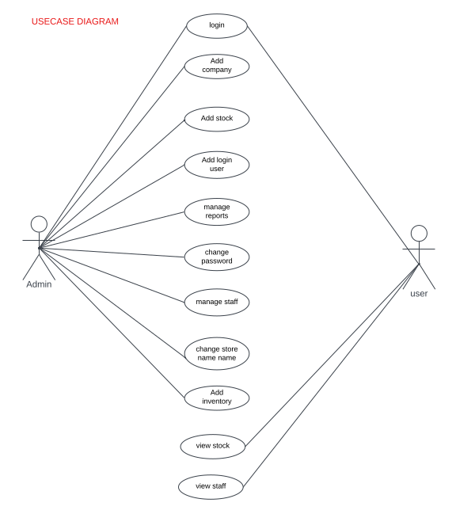

SEQUENCE DIAGRAM
The sequence diagram represents the flow of messages in the system and is also termed as an event diagram. It helps in envisioning several dynamic scenarios. It portrays the communication between any two lifelines as a time-ordered sequence of events, such that these lifelines took part at the run time.

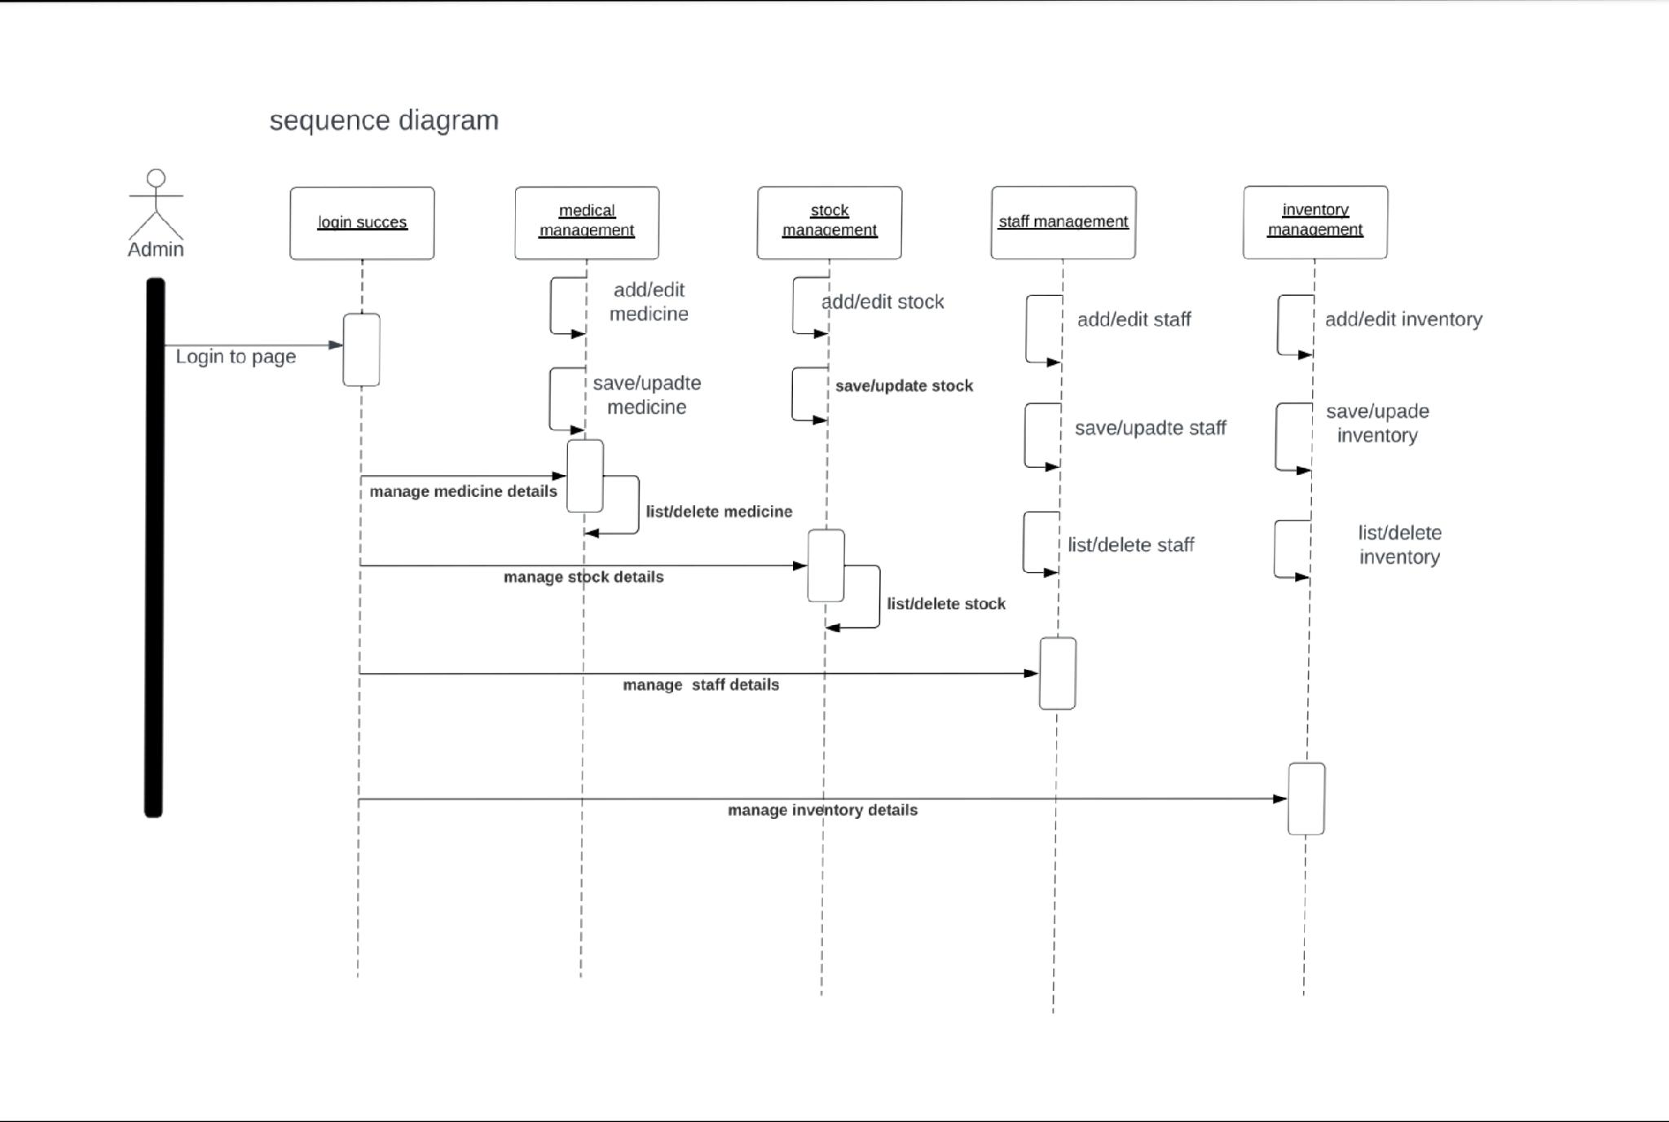

ACTIVITY DIAGRAM
In UML, the activity diagram is used to demonstrate the flow of control within the system rather than the implementation. It models the concurrent and sequential activities. The activity diagram helps in envisioning the workflow from one activity to another. It put emphasis on the condition of flow and the order in which it occurs.

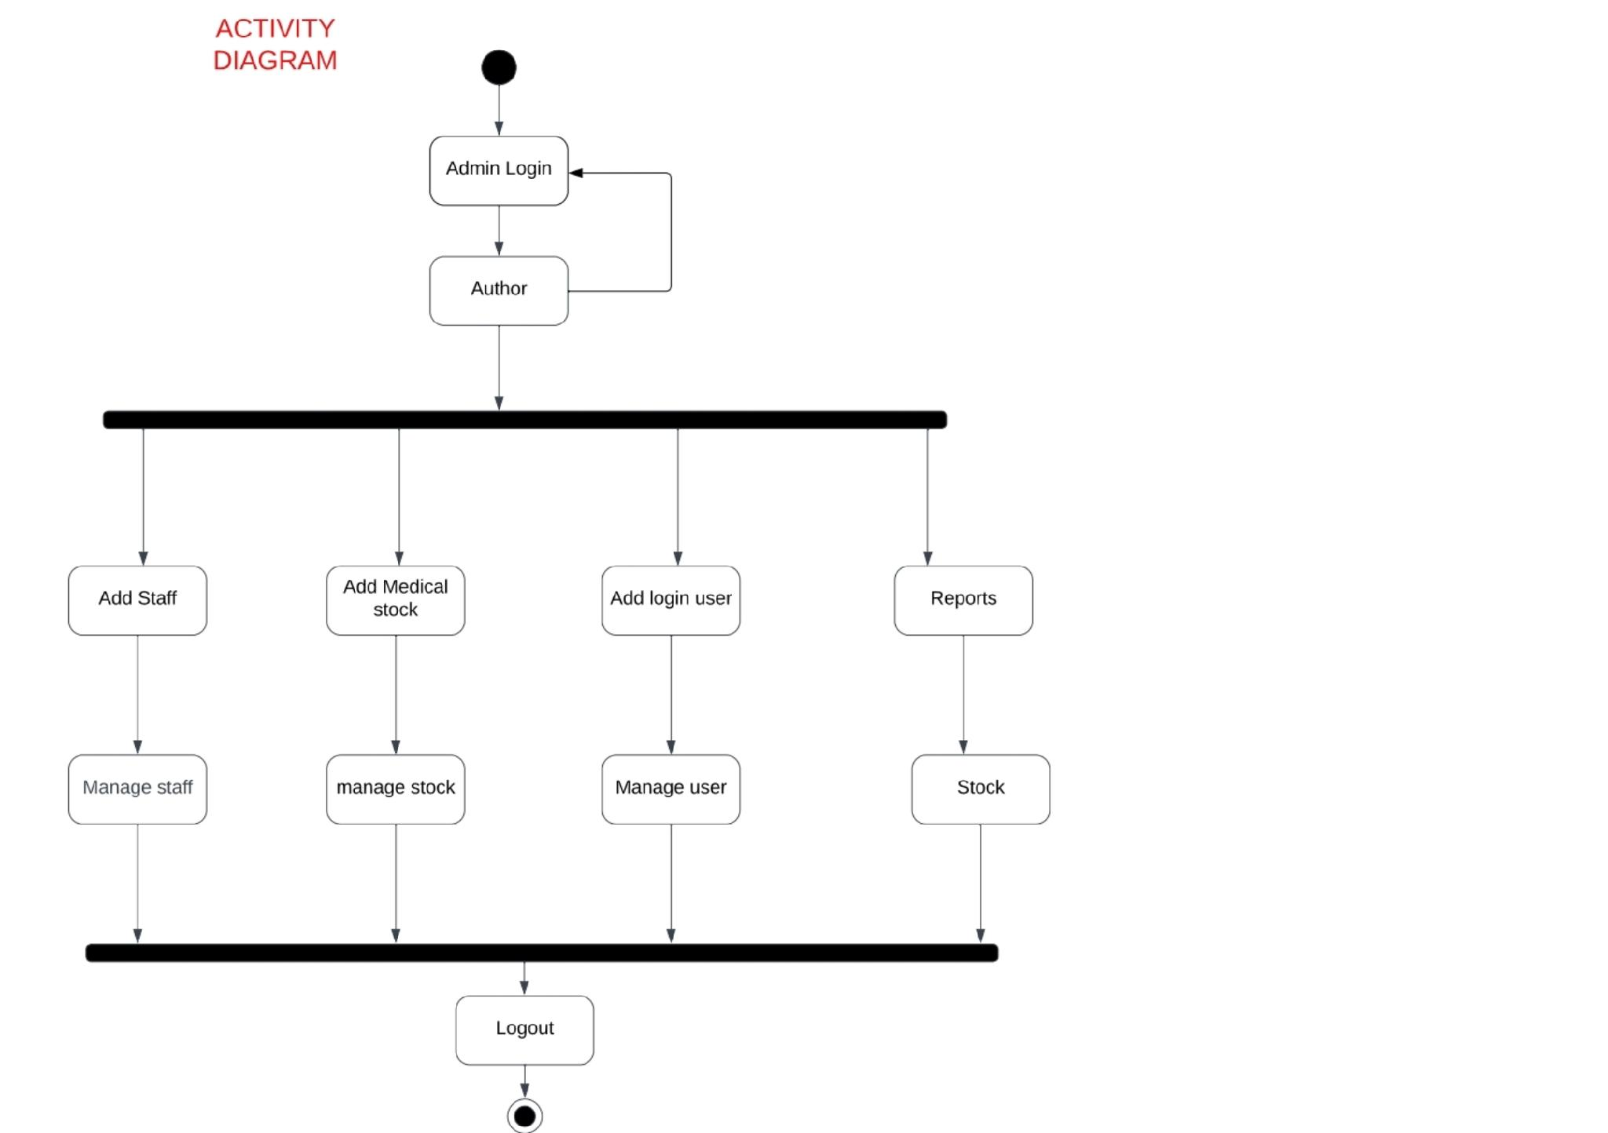

STATE MACHINE DIAGRAM
The state machine diagram is also called the State chart or State Transition diagram, which shows the order of states underwent by an object within the system. It captures the software system's behavior. It models the behavior of a class, a subsystem, a package, and a complete system. It tends out to be an efficient way of modeling the interactions and collaborations in the external entities and the system.

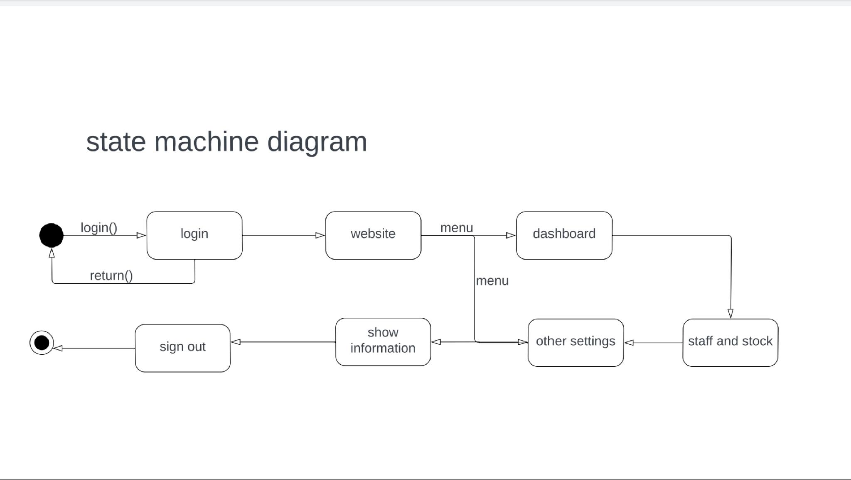

5. IMPLEMENTATION

  - MODULES
1. Admin login
2. Inventory
3. Add new items
4. Student records
5. Profile settings
5.2 Module Description
First we have admin login page in this login page we enter the details of the user email and password. If enter email and password are correct then we will enter into the website homepage, if it is incorrect it shows the user invalid email or password.

Inventory
In this Inventory we update the new items and new joined staff members to the database, and also update the if any stock is outdated then it shows the out of stock to the users.
Stock
In this stock, users can see the details of stock which medicine is available which is not available in the hospital. It is controlled by the admin the details also updated by the admin.
Staff
In this staff, users can see the details of staff which staff members are available which are not available and their timings in the hospital. It is also controlled by the admin the details also updated by the admin.
Profile settings
Here admin can change the settings related to the profile.
5.3 Introduction of technologies used
MySql:-We use the database for the sake of store the details medicine staff ,stock members and newly updated values. Mysql is a tool used to manage databases and servers.so while it’s not a database, it’s widely used in relation to managing and organizing data in database.
PHP:-PHP is an open-source-side scripting language that many days use for web development. It is also a general-purpose language that you can use to make lots of projects including Graphical User Interface.
Html:-Hypertext markup language is the code that is used to structure a web page and its content. For example, content could be structured within a set of paragraphs, a list of bulleted points, or using images and data tables.
CSS:-It is used to style and layout web pages-For example, to alter the font, color, size and spacing of your content, split it into multiple columns, or add animations and other decorative features.
JavaScript:-It is used by programmers across the world to create dynamic and interactive web content like applications and browsers. JavaScript is so popular that it’s the most used programming language in the world, used as a client-side programming language by 97.0% of all websites.
5.4 Sample code
Login page
<?php require "assets/function.php" ?>
<!DOCTYPE html>
<html>
<head>
<title>Login</title>
<?php require "assets/autoloader.php" ?>
<style type="text/css">
<?php include 'css/customStyle.css'; ?>

</style>
</head>
<body style="background: url('photo/start.jpg');background-size: 100%">
<div class="login-box">
<div class="well well-sm center" style="width: 25%;margin: auto;padding:4px 11px;margin-top: 111px;text-align: center;">
<h3 class="center">Login</h3>
</div>
<!-- /.login-logo -->
<div class="well well-sm" style="width: 25%;margin:auto;padding: 22px;margin-top: 22px;z-index: 6">
<p class="login-box-msg">Sign in to start your session</p>
<form action="" method="post">
<div class="form-group has-feedback">
<input type="email" name="email" class="form-control" placeholder="Email" required>
<span class="glyphicon glyphicon-envelope form-control-feedback"></span>
</div>
<div class="form-group has-feedback">
<input type="password" name="password" class="form-control" placeholder="Password" required>
<span class="glyphicon glyphicon-lock form-control-feedback"></span>
</div>

<button type="submit" name="login" class="btn btn-primary btn-block btn-flat">Sign In</button>
</form>
</div>
<br>
<div class="alert alert-danger" id="error" style="width: 25%;margin: auto;display: none;"></div>
<div style="position: fixed;;top:0;background: rgba(0,0,0,0.7); width: 100%;height: 100%;z-index: -1"></div>

<!-- /.login-box-body -->
</div>
</body>
</html>

<?php

if (isset($_POST['login']))
{
$user = $_POST['email'];
$pass = $_POST['password'];
$con = new mysqli('localhost','root','','store');

$result = $con->query("select * from users where email='$user' AND password='$pass'");
if($result->num_rows>0)
{
session_start();
$data = $result->fetch_assoc();
$_SESSION['userId']=$data['id'];
$_SESSION['bill'] = array();
header('location:index.php');
}
else
{
echo
"<script>
\$(document).ready(function(){\$('#error').slideDown().html('Login Error! Try again.').delay(3000).fadeOut();});
</script>
";
}
}

?>

Database Code:
<?php
$con = new mysqli('localhost','root','','store');
//for user informationa making available for all pages

$array = $con->query("select * from users where id ='$_SESSION[userId]'");
$user = $array->fetch_assoc();

$base_path = "http://localhost/dev.test/store";
?>

6. TEST CASES

1.Login
Test Engineer: | P.Sowjanya
Test Case ID: | 1
Related UC/FR/NFR | UC1
Date: | 13-12-2022
Purpose: | The purpose of this test insure that the user can log in with his id to use this app.
Pre-Req: | The user enters his correct name and password for a successful login page.
Test Data: | sname, sid, spassword
Steps: | The steps are below.  - visit Login Page  - enter UserId  - enter password  - click login  - recovery password  - change password  - keep login
Status: | Pass

Employ Records
Test Engineer: | Kavya
Test Case ID: | 2
Related UC/FR/NFR | UC2
Date: | 13-12-2022
Purpose: | The purpose of this test for registered employ by his name, password, email, and mobile number for use this app and work on the app.
Pre-Req: | Employ sure that login with his name and id to use this app.
Test Data: | none (test is just visual test)
Steps: | Step formatting rules below.  - enter employ name  - enter employ password  - enter employ email  - enter employ a mobile number
Status: | Pass

Main form
Test Engineer: | T.Srikanth
Test Case ID: | 3
Related UC/FR/NFR | UC3
Date: | 13-12-2022
Purpose: | The purpose of this test is to make sure that the design of the front page of the admin website is consistent and readable.
Pre-Req: | The main activity of the website should be up and running.
Test Data: | none (test is just visual test)
Steps: | Following steps will take place in the test  - Home  - Inventory  - Add new item  - Site settings  - Profile settings  - Login settings
Status: | Pass

Category Record
Test Engineer: | Sireesha
Test Case ID: | 4
Related UC/FR/NFR | UC4
Date: | 13-12-2022
Purpose: | The purpose of this testing to insert, update, delete and view category.
Pre-Req: | The user enter category by its correct name.
Test Data: | none(test is visual test)
Steps: | Step formatting rules below.  - open the category form  - insert the category name of items  - update the category name of items  - delete the category name of items  - insert the category name of items  - view the category names  - Export the category records to user page.
Pass

7. Screenshots

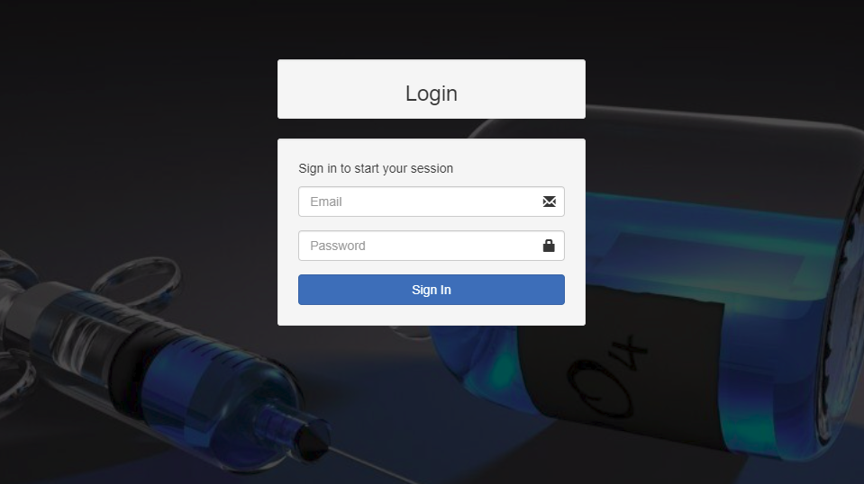
Admin login:
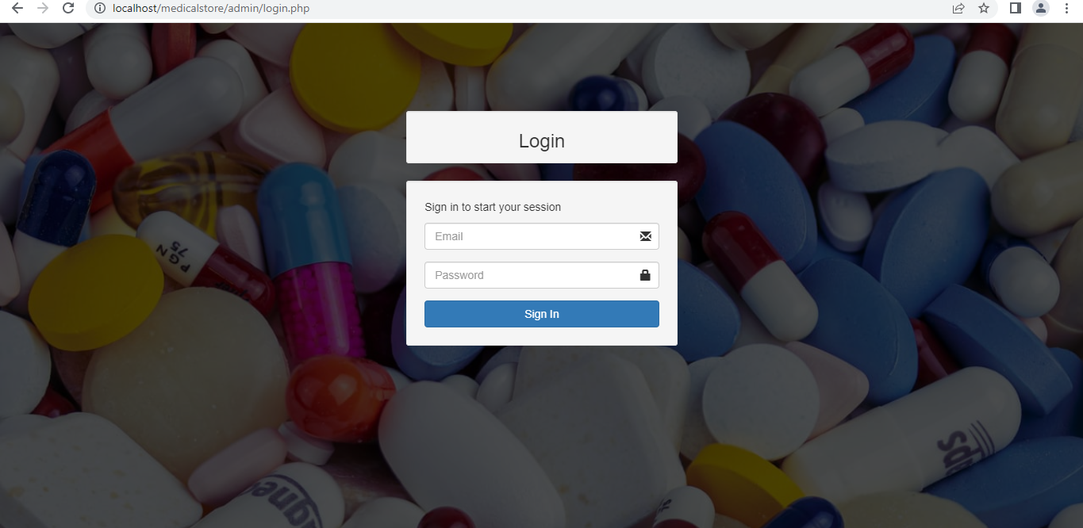

User Login Page

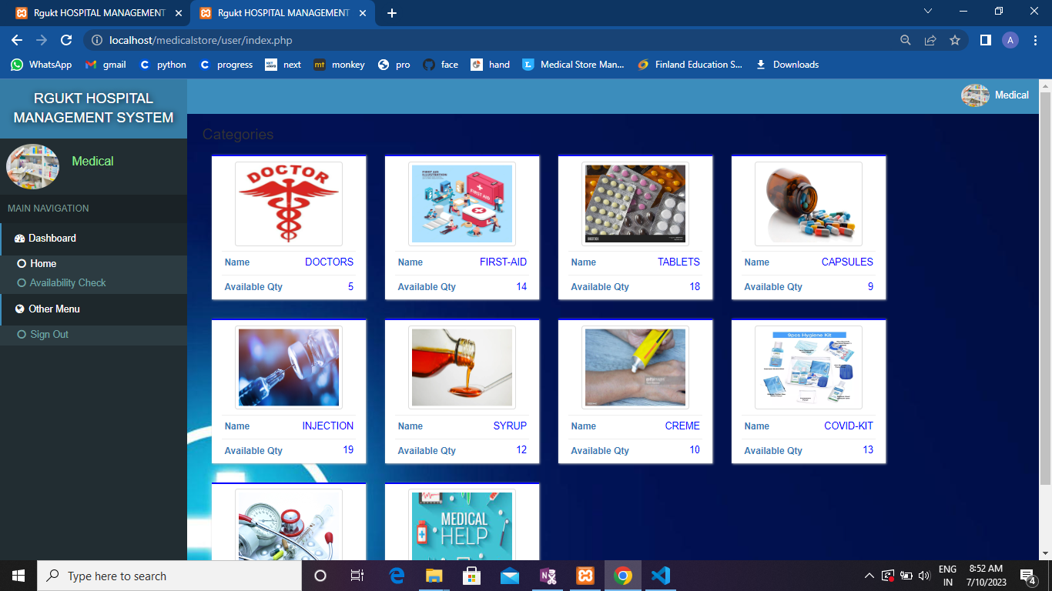

Add inventory page
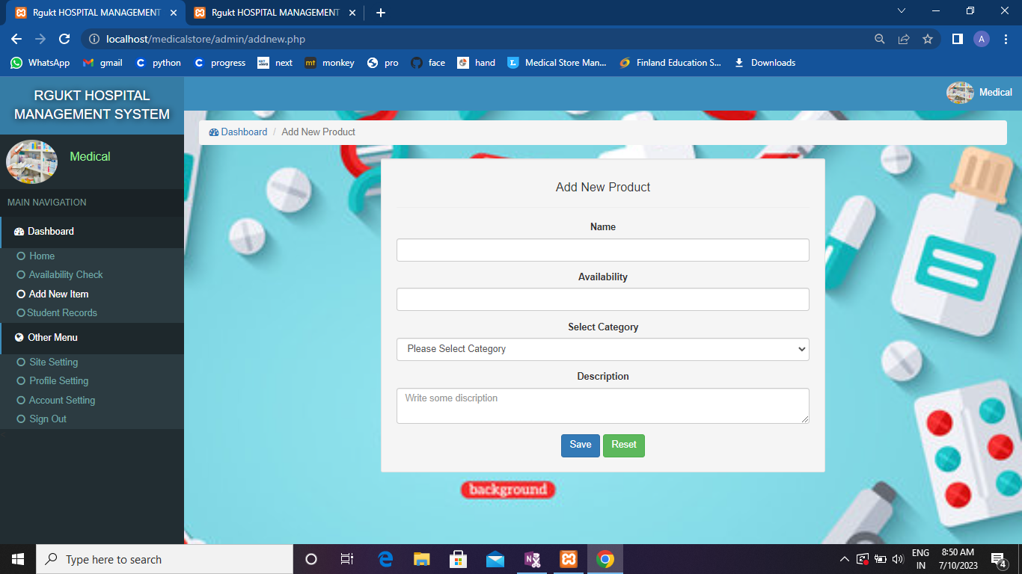

Account Settings
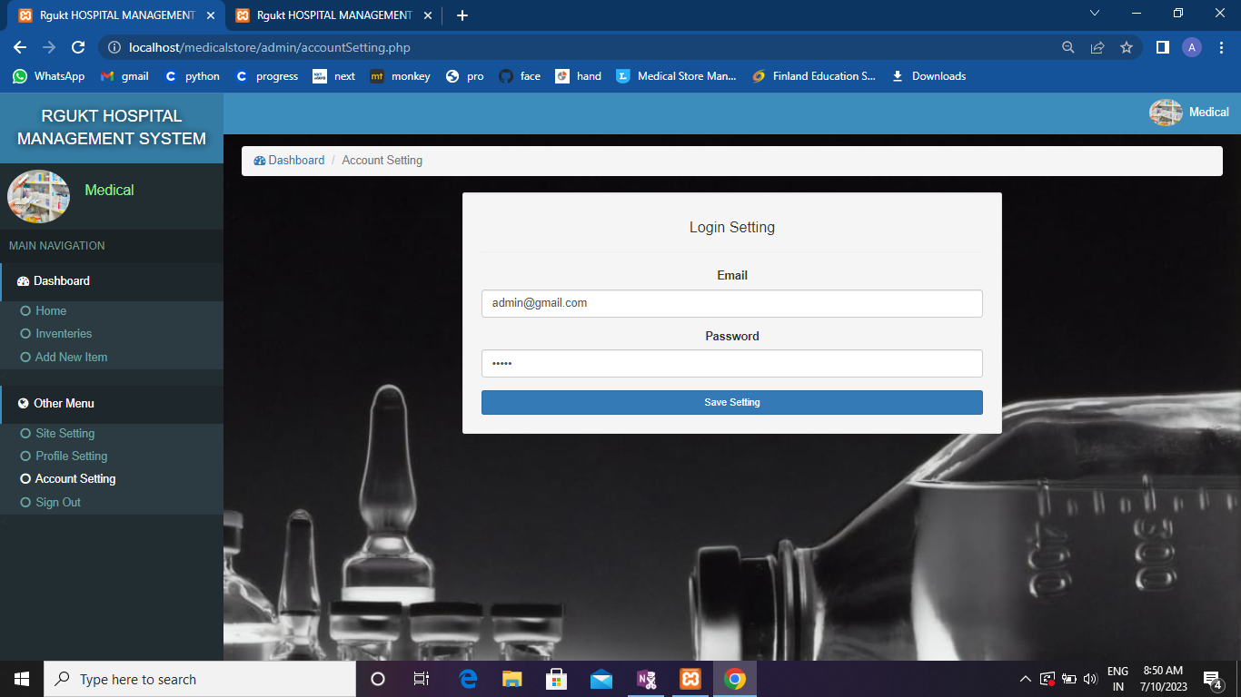
Admin Medicine Availability Check

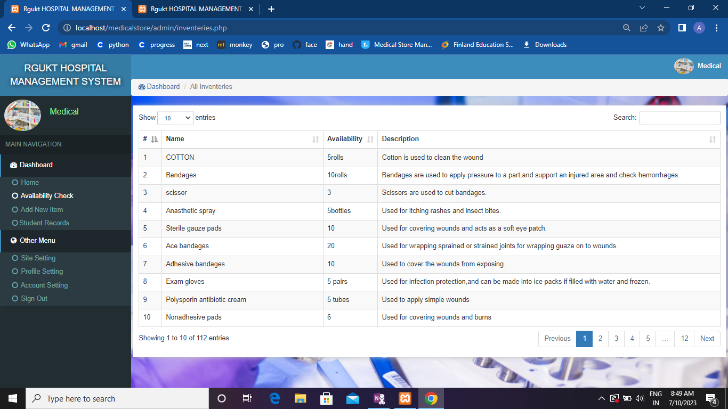

8. CONCLUSION
The purpose of “RGUKT HOSPITAL MANAGEMENT SYSTEM” is to automate the existing manual system by the help of computerized equipments and full-fledged computer software,fulfilling their requirements,so that their valuable data/information can be stored for a longer period with easy accessing and manupulation of the same.
This system provides an easy way for the operator to interact with the database and to manipulate the data in the database.
The operator can add,delete and update the records in the database with ease.In this the major components are inventory and warehouse management.It is also manage the details of stock,staff and company.

9. FUTURE ENHANCEMENT
This project has a very vast scope in future.The project can be implemented on intranet in future.Project can be updated in near future as and when requirement for the same arises,as it is very flexible in terms of expansion. With the proposed software of database space manager ready and fully functional the client is now able to manage and hence run the entire work in a much better,accurate and error free manner. Anybody may develop any app based on this project in future.

10. BIBLIOGRAPHY
1) MSH (Management Science for Health), Health System in Action An enhandbook for Leaders and Managers. 2010.
2) K. M. Cresswell, A. Worth,and A.Sheikh,” Integration of a nationally procured electronic health record system intouser work practices,”BMC Med. Inform. Decis. Mak.,2012.
3) P.W.Handayani, A.N.Hidayanto, A. A. Pinem, I.C.Hapsari, P.I. Sandhyaduhita, and I. Budi, “Acceptance model of a Hospital Information System,”Int. J.Med.Inform., 2017.
4) D.H. Gadhari, Y.P.Kadam, and P.P.Suman,”Hospital Management System,” Int. J.Res.Eng.Appl.Mnag.,2016.
5) E.D. Zepeda, G.N.Nyaga, and G.J.Young, “Supply chain risk management and hospital information system,”J,Bus. Res.,2019.
6) C. ULLrich, F. Van Utterbeeck, E. Dejardin , M. Debacker,and E.Dhondt, “Pre-hospital simulation model for medical disaster management,” in Proceedings of the 2013 Winter Simulation Conference – Simulation: Making Decisions in a Complex World, WSC 2013,2013,pp.2432-2443.
7) J. W. Nance, C. Meenam, and P.G.Nagy,”The Future of the radiology informationsystem,” American Journal of Roentgenology. 2013.

References
1. www.google.com
2. www.slideshare.com

