Create Database

1. Browse to the Select SQL Deployment option page. that is search for Azure sql

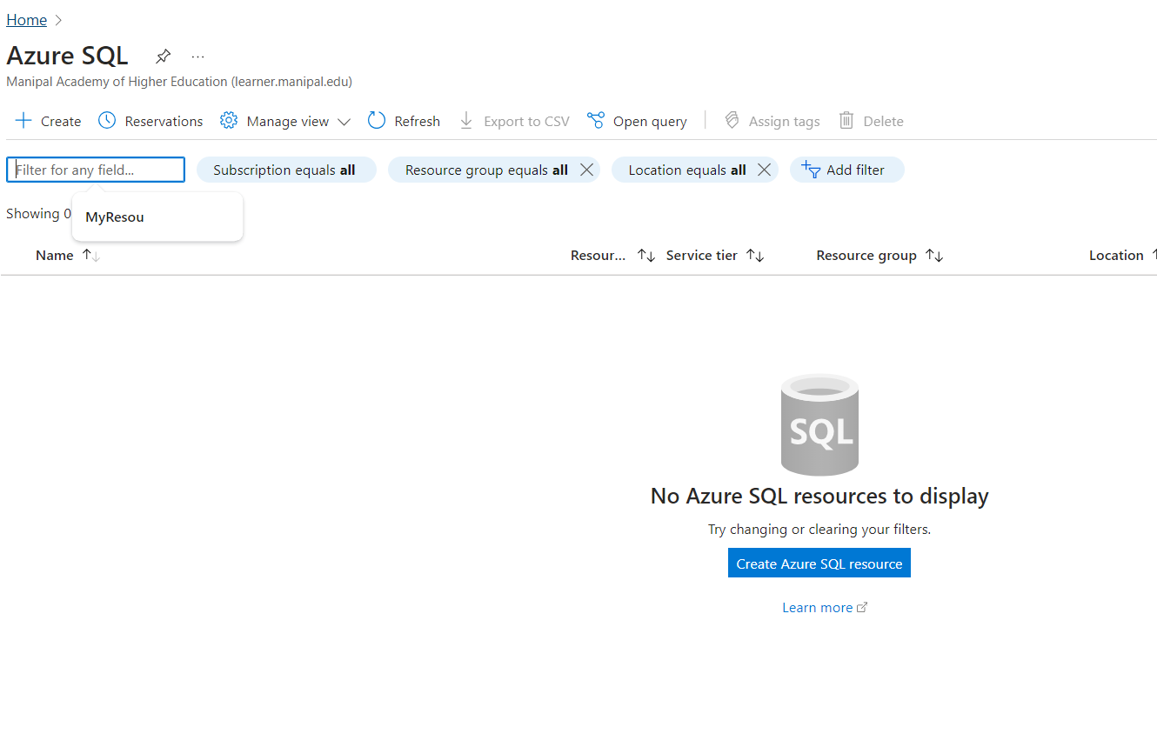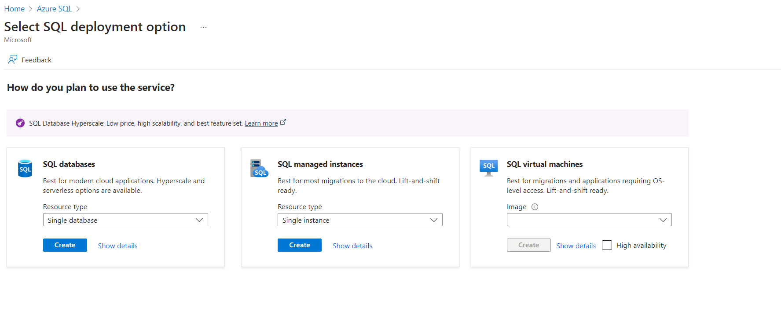

1. Under **SQL databases**, leave **Resource type** set to **Single database**, and select **Create**.
2. For **Resource group**, select **Create new**, enter myResourceGroup, and select **OK**.
3. For **Database name**, enter pharmacy-db.
4. For **Server**, select **Create new**, and fill out the **New server** form with the following values:
   * **Server name**: Enter mysqlserver, and add some characters for uniqueness. We can't provide an exact server name to use because server names must be globally unique for all servers in Azure, not just unique within a subscription. So enter something like mysqlserver12345, and the portal lets you know if it's available or not.
   * **Location**: Select a location from the dropdown list.
   * **Authentication method**: Select **Use SQL authentication**.
   * **Server admin login**: Enter azureuser.
   * **Password**: Enter a password that meets requirements, and enter it again in the **Confirm password** field.

Select **OK**.

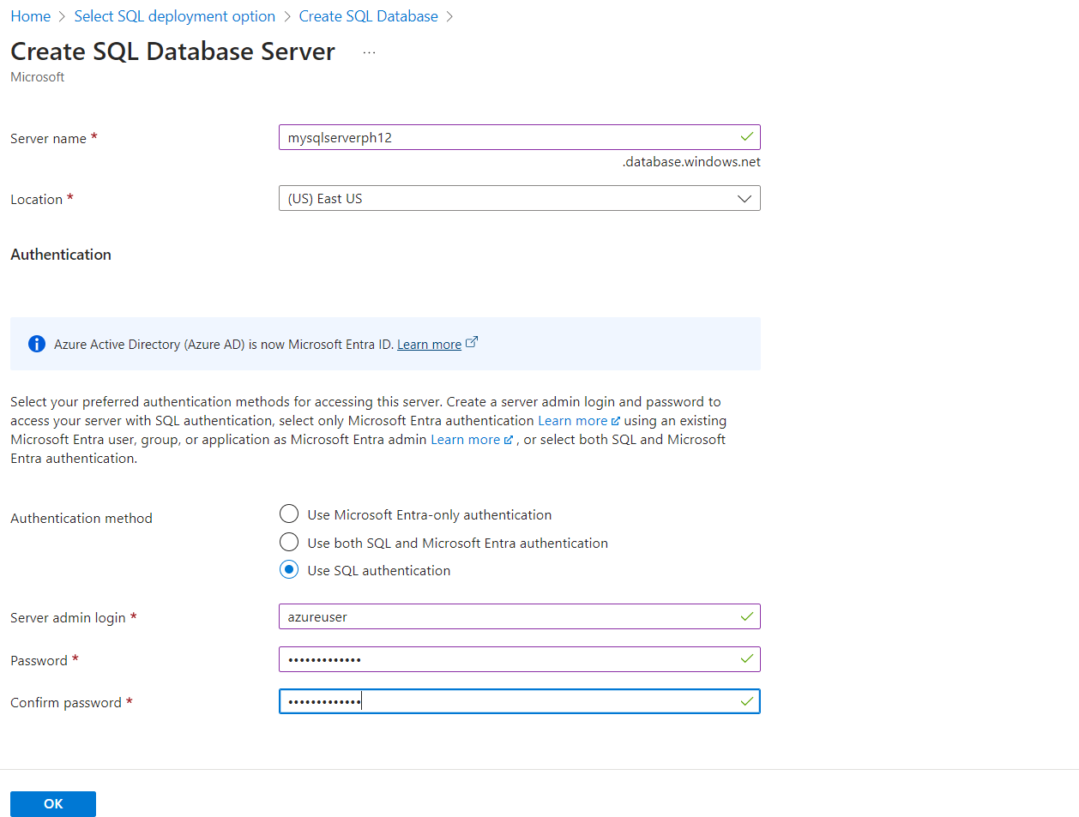

1. For **Workload environment**, specify **Development** for this exercise.

The Azure portal provides a **Workload environment** option that helps to preset some configuration settings. These settings can be overridden. This option applies to the **Create SQL Database** portal page only. Otherwise, the **Workload environment** option has no impact on licensing or other database configuration settings.

* + Choosing the **development** workload environment sets a few options, including:
    - **Backup storage redundancy** option is locally redundant storage. Locally redundant storage incurs less cost and is appropriate for pre-production environments that do not require the redundance of zone- or geo-replicated storage.
    - **Compute + storage** is General Purpose, Serverless with a single vCore. By default, there is a [one-hour auto-pause delay](https://learn.microsoft.com/en-us/azure/azure-sql/database/serverless-tier-overview?view=azuresql&preserve-view=true&tabs=general-purpose#performance-configuration).
  + Choosing the **Production** workload environment sets:
    - **Backup storage redundancy** is geo-redundant storage, the default.
    - **Compute + storage** is General Purpose, Provisioned with 2 vCores and 32 GB of storage. This can be further modified in the next step.

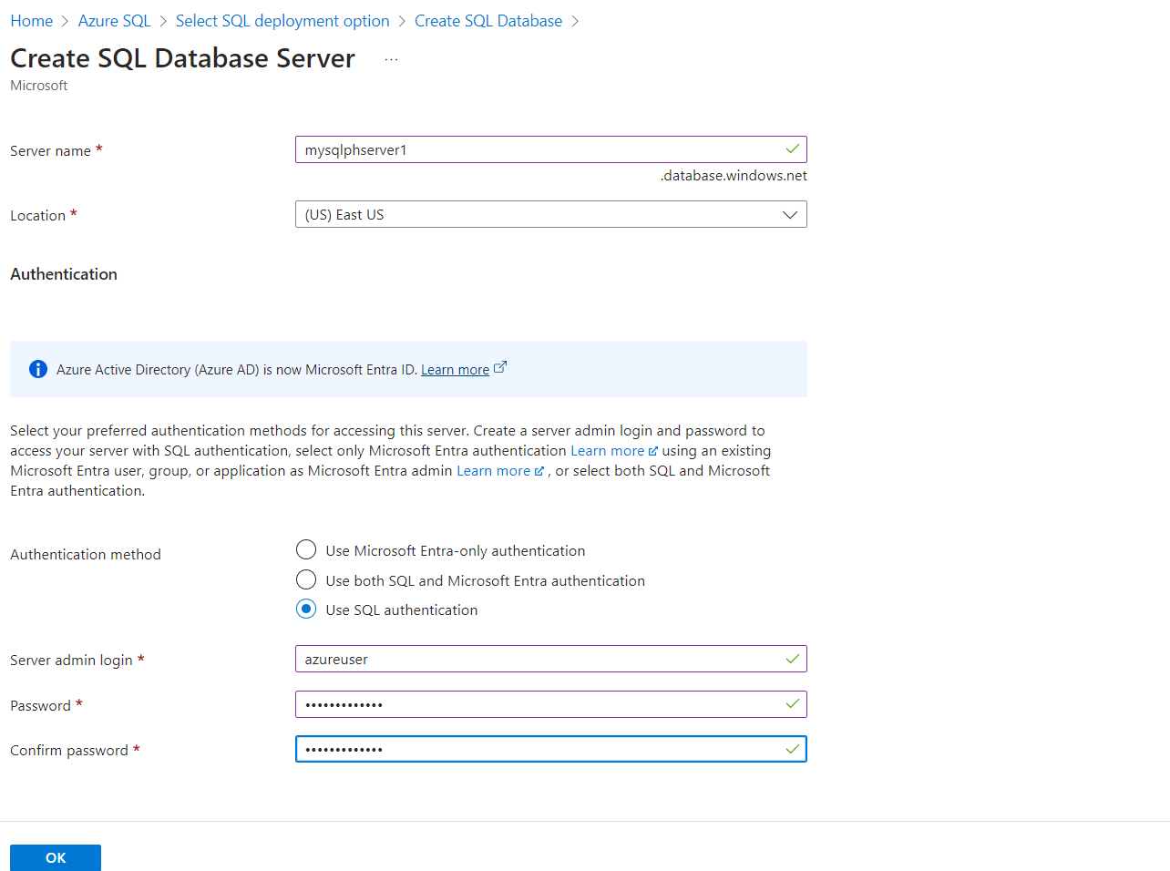

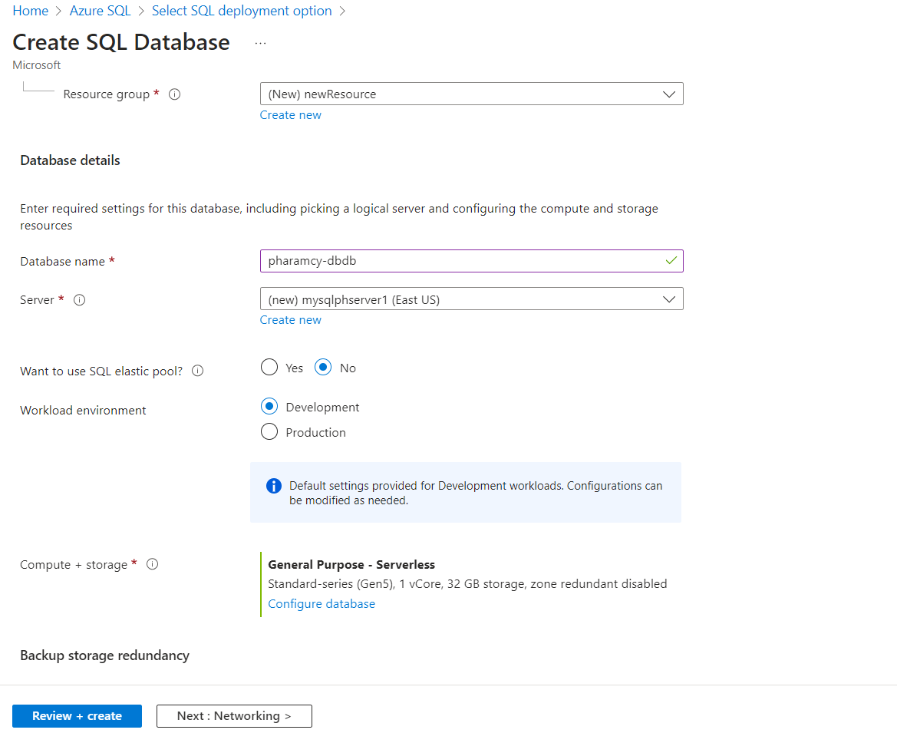

1. Under **Compute + storage**, select **Configure database**.
2. This quickstart uses a serverless database, so leave **Service tier** set to **General Purpose (Most budget-friendly, serverless compute)** and set **Compute tier** to **Serverless**. Select **Apply**.
3. Under **Backup storage redundancy**, choose a redundancy option for the storage account where your backups will be saved. To learn more, see [backup storage redundancy](https://learn.microsoft.com/en-us/azure/azure-sql/database/automated-backups-overview?view=azuresql#backup-storage-redundancy).
4. Select **Next: Networking** at the bottom of the page.
5. On the **Networking** tab, for **Connectivity method**, select **Public endpoint**.
6. For **Firewall rules**, set **Add current client IP address** to **Yes**. Leave **Allow Azure services and resources to access this server** set to **No**.

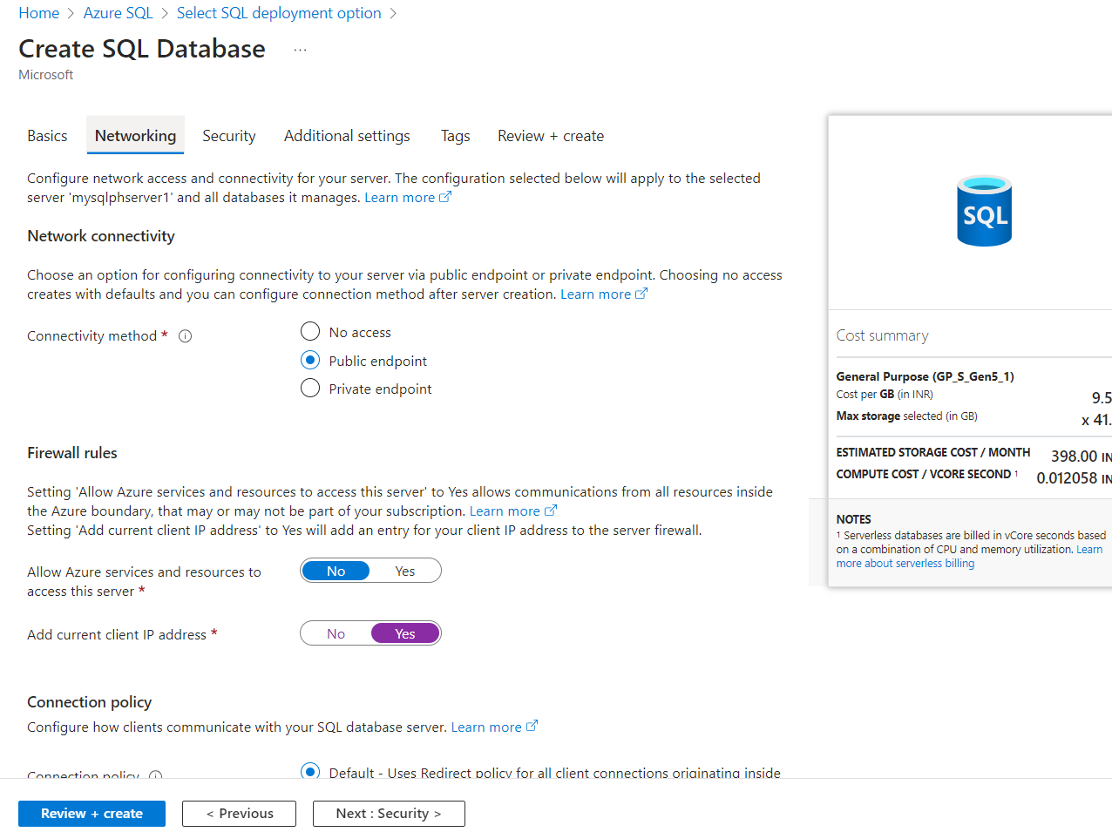

15. On the **Security** page, you can choose to start a free trial of [Microsoft Defender for SQL](https://learn.microsoft.com/en-us/azure/azure-sql/database/azure-defender-for-sql?view=azuresql), as well as configure [Ledger](https://learn.microsoft.com/en-us/sql/relational-databases/security/ledger/ledger-overview), [Managed identities](https://learn.microsoft.com/en-us/azure/active-directory/managed-identities-azure-resources/overview) and [Transparent data encryption (TDE)](https://learn.microsoft.com/en-us/azure/azure-sql/database/transparent-data-encryption-byok-overview?view=azuresql) if you desire. Select **Next: Additional settings** at the bottom of the page.

16.On the **Additional settings** tab, in the **Data source** section, for **Use existing data**, select **Sample**. This creates an AdventureWorksLT sample database so there's some tables and data to query and experiment with, as opposed to an empty blank database. You can also configure [database collation](https://learn.microsoft.com/en-us/sql/t-sql/statements/collations) and a [maintenance window](https://learn.microsoft.com/en-us/azure/azure-sql/database/maintenance-window?view=azuresql).

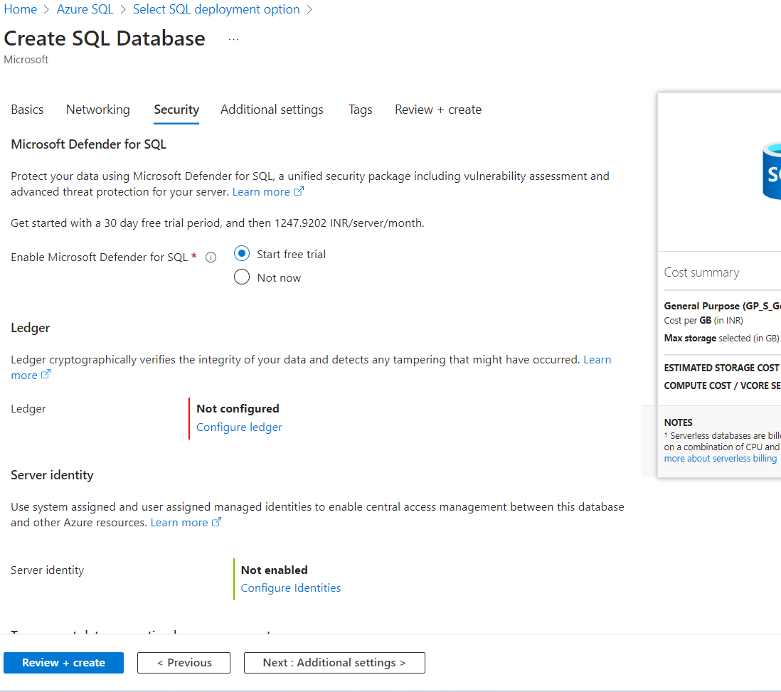

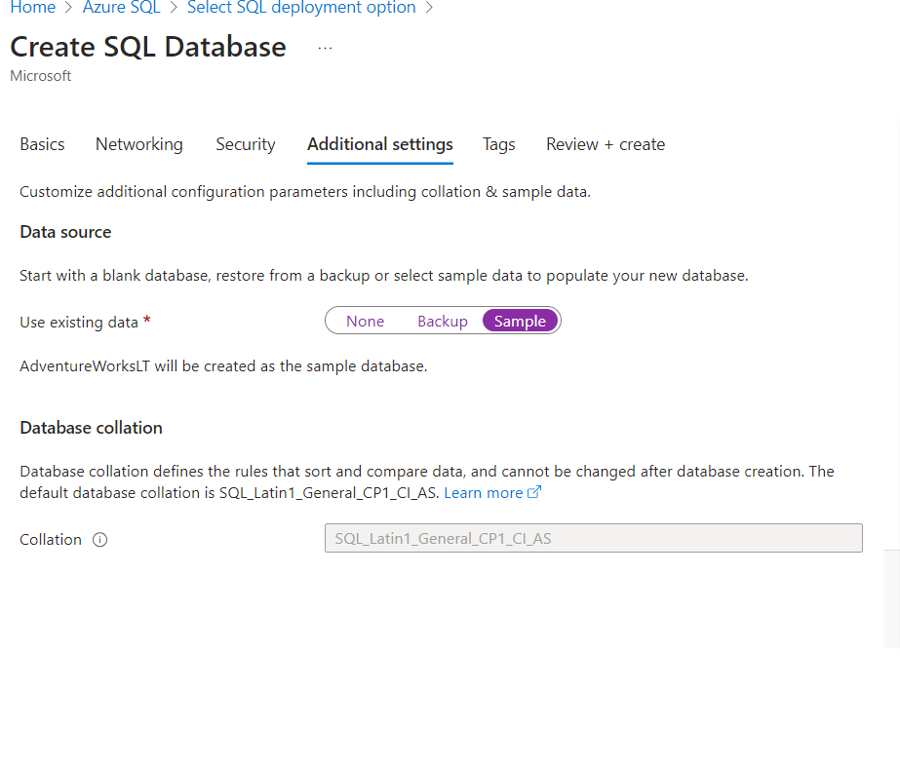**2.Create a static web page steps followed in lab exp**

**3.Databse Connectivity**

1. Go to your Azure SQL Server in the [Azure portal](https://portal.azure.com/).
2. Under the Security section, select **Networking**.
3. Under the Public access tab, next to Public network access, select **Selected networks**.
4. Under the Firewall rules section, select the **Add your client IPv4 address** button. This step ensures you can use this database for your local development.
5. Under the Exceptions section, select the **Allow Azure services and resources to access this server** checkbox. This step ensures that your deployed Static Web Apps resource can access your database.
6. Select **Save**.
7. 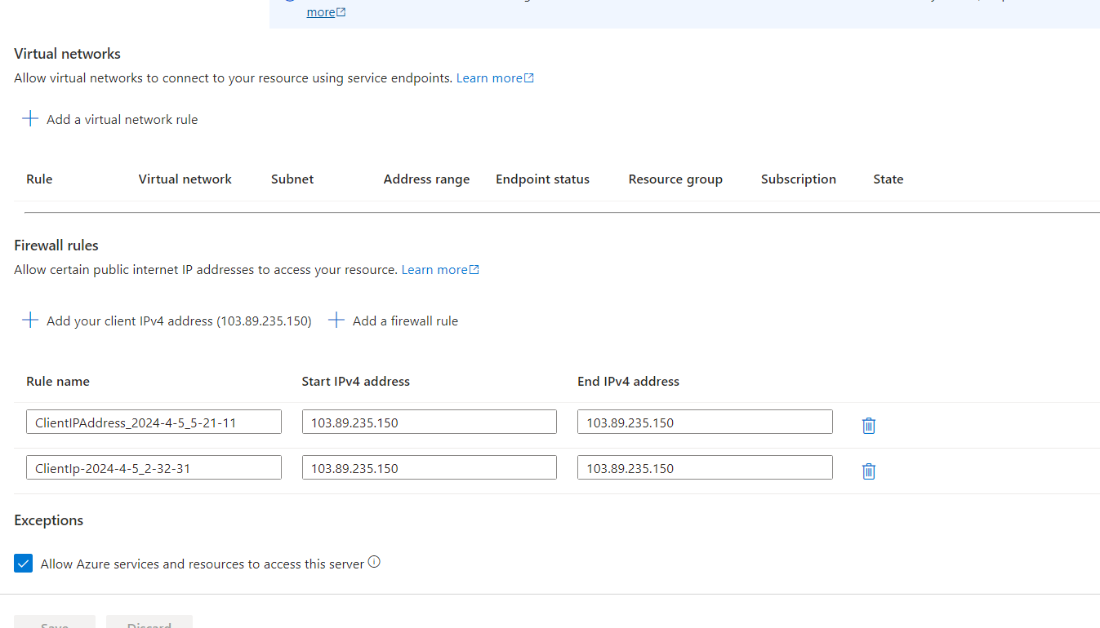

**Get database connection string for local development**

To use your Azure database for local development, you need to retrieve the connection string of your database. You may skip this step if you plan to use a local database for development purposes.

1. Go to your Azure SQL Server in the [Azure portal](https://portal.azure.com/).
2. Under the *Settings* section, select **SQL databases**.
3. Select the SQL database you created for this tutorial.
4. In the *Settings* section, select **Connection strings**
5. From the *ADO.NET (SQL authentication)* box, copy the connection string and set it aside in a text editor.

Make sure to replace the {your_password} placeholder in the connection string with your password.

## Connect the database to your static web app

Use the following steps to create a connection between the Static Web Apps instance of your site and your database.

1. Open your static web app in the Azure portal.
2. In the Settings section, select **Database connection**.
3. Under the Production section, select the **Link existing database** link.
4. In the Link existing database window, enter the following values:

And add environment variable

