https://www.youtube.com/watch?v=r_iMsRTit2k

//https://docs.aws.amazon.com/codecommit/latest/userguide/setting-up-ssh-windows.html?icmpid=docs_acc_console_connect#setting-up-ssh-windows-keys-windows <--- folow this

Prerequiste: gitbash,git account, notepad,amazone details

Step 1: Deployoing it through ssh.

we need to create ssh key details

for this, Login to amazon console, go to codeCommit, create new repository name and description.

(This repo is empty)

We can do it in 2ways .. I am following ssh

Step 2: open git bash

type:

ssh-keygen

(It will ask to give the place wer u wnt to store the key So for windows you have to give it like this) C:/Users/venum/.ssh/codecommit_rsa

(if it says the file exist then dont mention any place just press enter and it will ask to give password if u want gve it or else just press enter and it will be created)

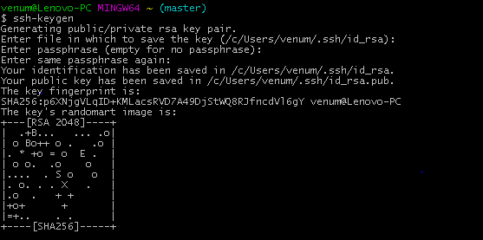

Step3:

Once this is done u will be having a key files in ur users/.ssh folder(for me : C:\Users\venum\.ssh)

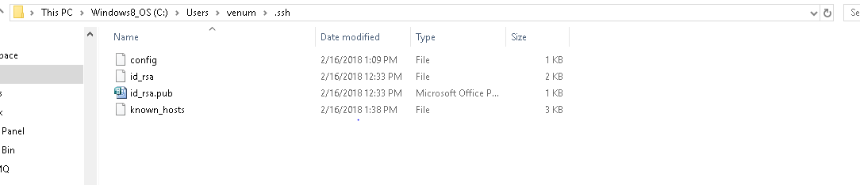

Copy the id_rsa.pub using notepad

Now we need to go our aws console

There we need to go to IAM 🡪 Users->Security Credentials->Upload SSh key(paste the copied id_rsa)

Copy the AccesskeyId just above the uploadSSHkey

Step4:

No go to .ssh folder and create a config file (**** remember not config.txt file just config file change its extensions once the modification is done)

In the config file –Type dis

Host git-codecommit.*.amazonaws.com

User APKAJG423E5RYGA7LLJA -🡪This is ur accesskeyid

IdentityFile ~/.ssh/id_rsa --->this is ur id_rsa name

Once it is done save it.

Step 5:

Type this in your previous git bash prompt

$ ssh git-codecommit.us-east-2.amazonaws.com



$ ssh -v git-codecommit.us-east-2.amazonaws.com

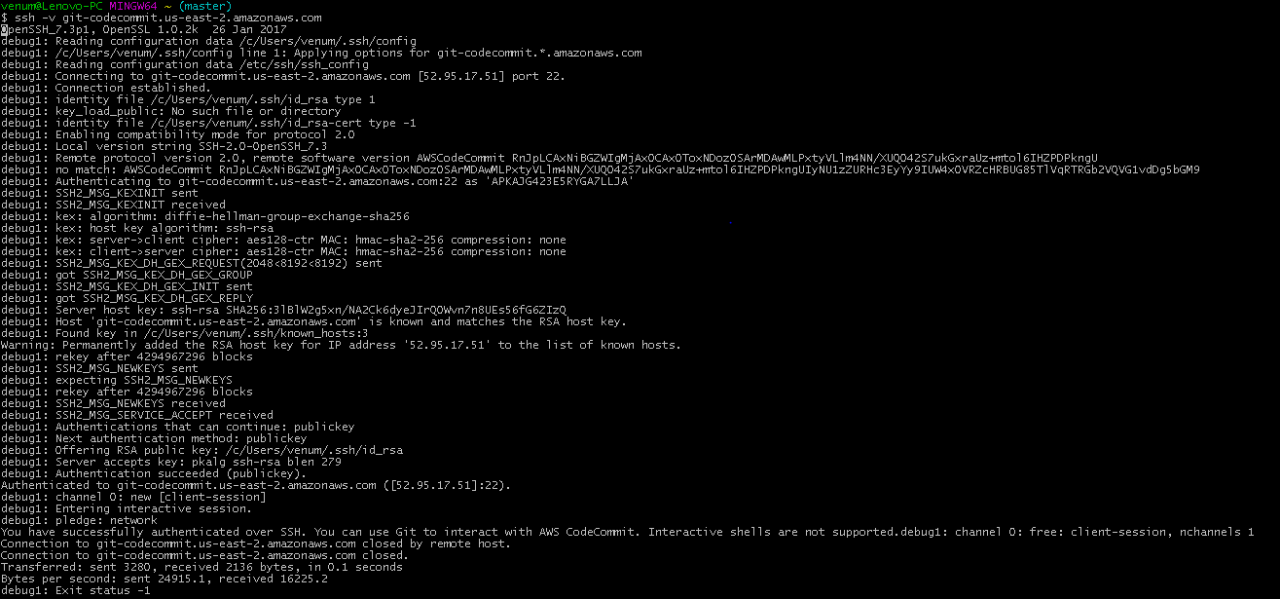

By this your are done with granting persionons to code commit …now you can do code commiting using ssh or https

I will follow ssh format:

Step6:

Open you console and copy the git clone url

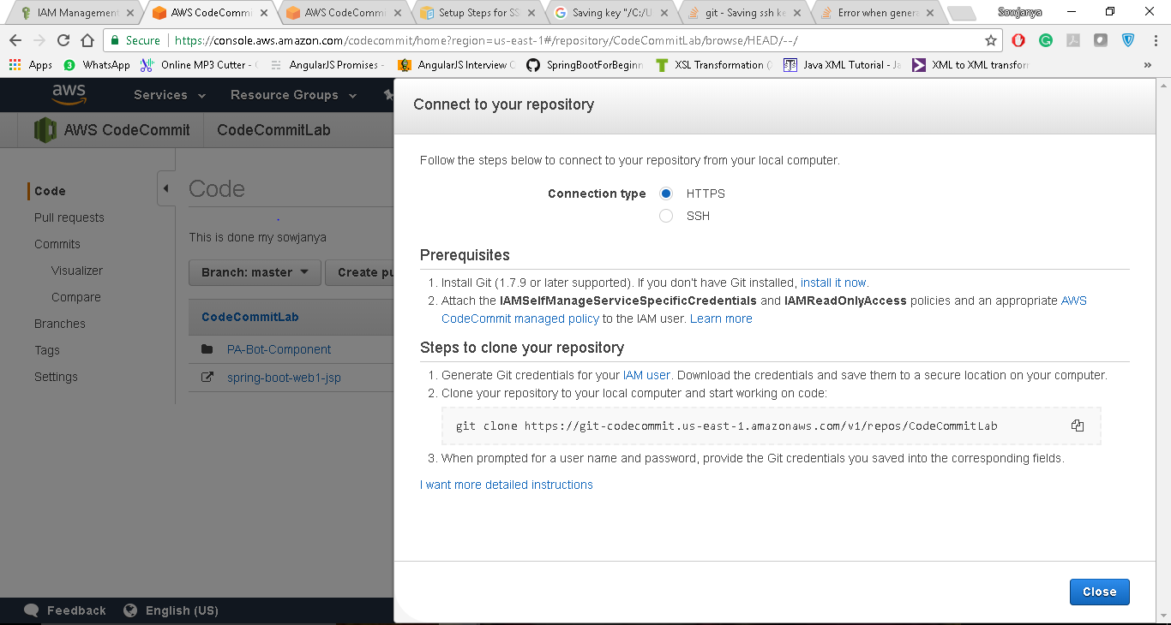

Step 7:

Create folder in ur desktop and open git bash in it and paste that url

Here I have created a folder name LAB1 in my deskptop and opened gitbash

git clone ssh://git-codecommit.us-east-1.amazonaws.com/v1/repos/CodeCommitLab

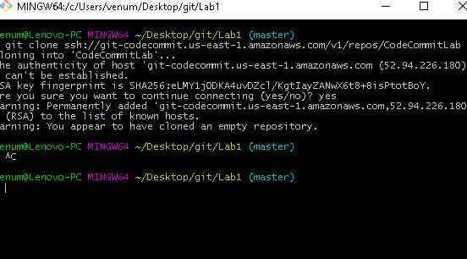

Now open the LAB1 folder and you can see the cloned repository

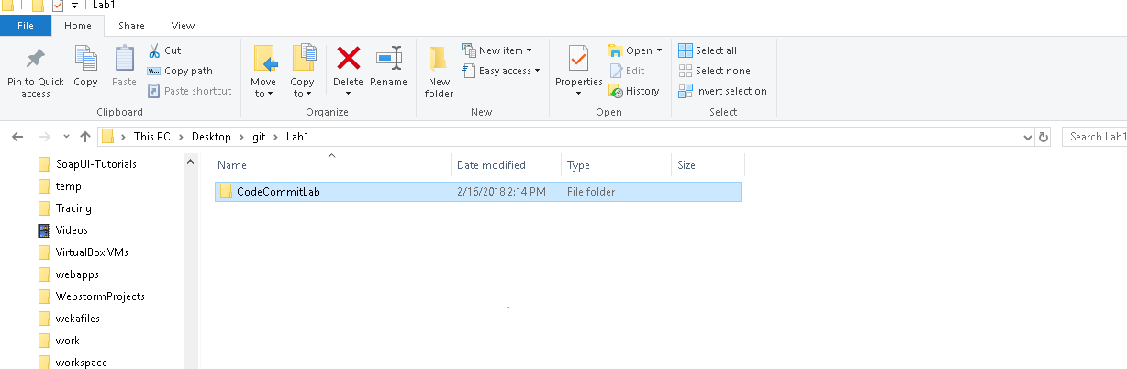

Step8:

Now open the CodecomitLab and paste wat ever folders or file you wanted to upload to git and give the git commands inorder to add ,to commit and push.

Once you add all the folders open the git bash in CodecommitLab and add all ur files to git

git status

git add .

git commit –m “default”

git push origin master

git status

************Done

Just reload the your codecomit page and ypou will see ur uploaded folders

