**grep _Assignment06**

1. **Use any .c file. Using grep command extract and display** 
   1. **all lines beginning with #include with line numbers:**
2. To get all lines begging with #include with line numbers, we use grep command with -n option $ grep -name “^#include” -n filename.

Output:

* 1. **display all lines which do not begin with #include:**

1. To get all lines that are not begin with #include, we use -v option in grep this prints all lines other than given pattern.

Output: $ grep -v “^#include” -n p5.c.

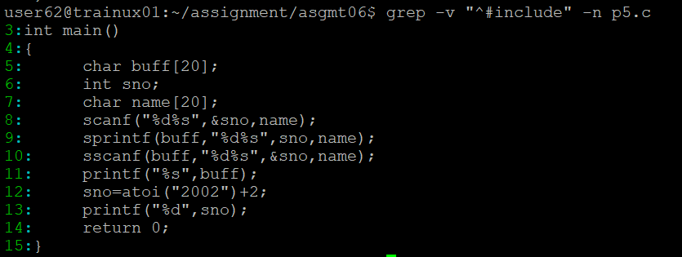

* 1. **display the line number of main():**

1. To display the line number of main(), we use $ grep “main() -n p5.c.

Output:



* 1. **extract all lines containing characters of opening and closing parathesis {(,)):**

1. To extract all lines containing opening and closing parathesis, we use $ grep “[{, (, ), }]” -n p5.c.

Output:

1. **Perform the above operations on a set of *.c files:**
2. **all lines beginning with #include with line numbers:**
3. we use same command but giving multiple files.

Output: 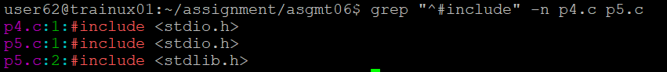

1. **display all lines which do not begin with #include:**
2. Output: A computer screen shot of white text

   Description automatically generated
3. **display the line number of main():**
4. Output: 
5. **extract all lines containing characters of opening and closing parathesis {(,)):**
6. Output: 