# **LINUXBASICCOMMANDS_ASSIGNMENT01**

1. **Which command is used to know the current working directory?**
2. We use pwd(present working directory) to know the current working directory. Syntax: $ pwd.

Output: The below says that we are currently in user62 directory.

1. **How would you find out its contents?**
2. We can find out the contents of our present working directory using the command “ls”, this prints all the files and directories. Syntax: $ ls.

Output: The below printed the contents of user62 directory.



1. **Identify the commands with inputs to do the following.**
2. **create a directory d1:**
3. To create any directory, we need to use the command “mkdir”.

Syntax: $ mkdir <directory name>.

Creating d1 directory: $ mkdir d1

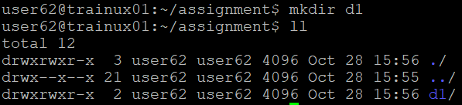

1. **create a subdirectory d2 in d1:**
2. To create a subdirectory in any directory, we need to use the command

$ mkdir ./<parentdirectory>/<subdirectory>.

Creating d2 in d1: $ mkdir ./d1/d2

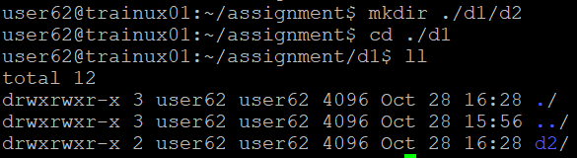

1. **change to directory d2:**
2. We can change to d2 directory using command “cd”.

Syntax: $ cd <directory>.

Changing to d2: $ cd d2



1. **create an empty file “f1.txt”:**
2. To create a file, we use touch or vi command. Syntax: $ touch <filename>.

Creating a f1.txt: $ touch f1.txt

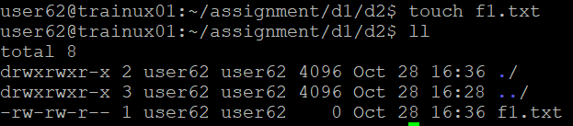

1. **display the contents of “f1.txt”:**
2. To display the contents of the file we use the command “cat”.

Syntax: $ cat <filename>.

Displaying the contents of f1.txt: $ cat f1.txt

1. **view the contents of d1 from current directory d2:**
2. To display the contents of the parent directory from the current directory we use the command $ ls ../ or ll ../(to view contents in long list).

View contents of d1 from d2: $ ll ../

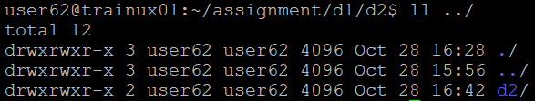

1. **Use the ls command with its options. How will you identify directories from the listing?**
2. To identity directories from the listing, we use the command $ ls -d */.

Output:

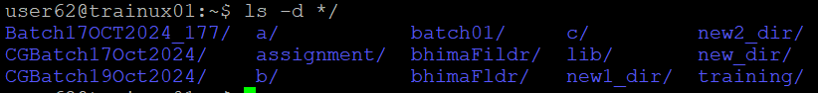

**5. Use ls to do the following.**

**a.** **List files with single character names:**

1. To list files with single character names, we use the command

$ ls -p | grep -E '^[a-zA-Z0-9](\..+)?$' | grep -v /.

Output:



1. **List hidden files also. [Note: Hidden files are files having name started with a “.”]:**
2. To print hidden files also we use command $ ls -a.

Output:



1. **Suppose there are files tb1.1, tb2.1, tb3.1, …. tb10.1. Write command to list all the files [Hint: use wild card characters]:**

A. To print all these files we use command $ ls tb*.1.

Output:



1. **Write the command to list all files in descending order of their size?**
2. To list all files in descending order of their size we use command $ ls -lS.

Output:

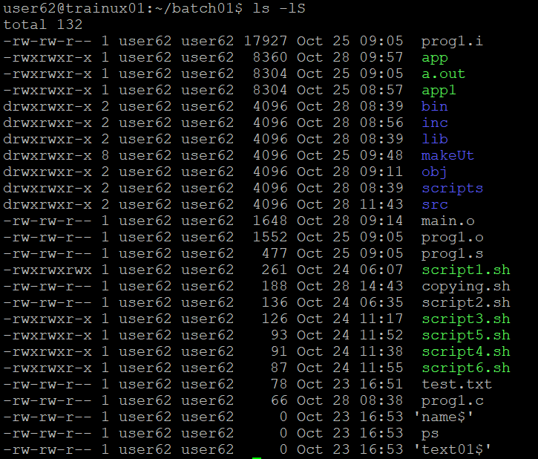

1. **Suppose there are files temp1, temp2, temp3. Write command to remove the files without listing them explicitly?**
2. To remove these files without listing explicitly we use command $ rm temp*. Output: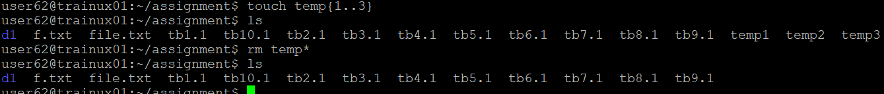
3. **Which command is used to list top few lines in the file?**
4. To list top few lines in the file, we use command “head”.

Syntax: $ head -n <filename>.

Output: $ head -5 file.txt.



1. **Create a directory “testdir”?**
2. We can create a directory using command “mkdir”. Syntax: $ mkdir <directory name>.

Creating testdir: $ mkdir testdir

Output:



1. **Use cp command to do the following.**
2. **Copy the file tb1.1 (created above) in the same directory:**
3. To copy tb1.1 in directory testdir, we use command $ cp ../tb1.1 ./.

Output:

1. **Write a command to copy all the files i.e tb1.1,tb2.1,tb3.1,…..tb10.1 in a new directory –“new”:**
2. To copy files tb1.1,….tb10.1 to the directory new, we use command

$ cp ../tb{1..10}.1 ./new.

Output:

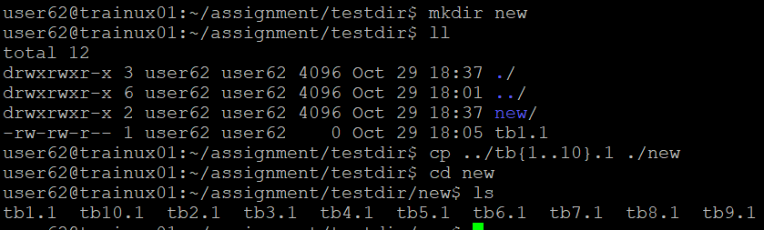

1. **Create a subdirectory in new in named “new1”:**
2. To create a subdirectory “new1” in new, we use command $ mkdir new1.

Output:



1. **Write a command to copy selectively only tb2.1, tb6.1, tb7.1 and tb10.1 in the directory new1:**
2. To copy selectively only tb2.1, tb6.1, tb7.1, tb10.1, we use the command $ cp ../../tb{2,6,7,10}.1 ./new1.

Output:

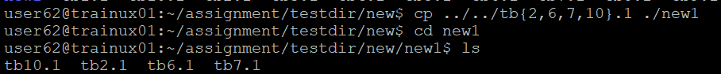

1. **Write a command to copy the entire directory “new” to a directory** **“newprogs”. [Note: use the –R option of “cp” command]:**
2. To copy entire directory new to directory “newprogs”, we use command

$ cp -R ./testdir/new ./newprogs.

Output:

1. **Find out the difference between**
   1. **“mv” & “cp”:**
2. **mv:** This command is used to move files or directories from one position to other and it can rename the files, efficiently changing their position.

**cp:** This command is used to create a copy file or directory in a new location without altering the original.

* 1. **“rm”, “rmdir”:**
     1. **rm:** This command is used to remove files or directories, including their contents. To use rm with directory requires the -r option to remove its contents recursively.

**rmdir:** This command is used to specifically delete empty directories.

* 1. **“mkdir” and “mkdir -p”:**
     1. **mkdir:** This command is used to create a single directory, if directory already exists it return an error.

**mkdir -p:** This command is used to create the specified directory and any necessary parent directories that do not already exists. If the target directory already exists it will not return an error.

1. **Use a single command rmdir once to remove “testdir” and all its sub directories and files created above?**
   * 1. Single command “rmdir” cannot remove the directory that containing some contents like some subdirectories and files.
2. **Which command is used to get the manual information of a command?**
   * 1. To get the manual information of a command we use the command

$ man <command name>.

Example: $ man rmdir

Output:



1. **If you are not able to change to a directory what could be the likely cause?**
   * 1. If we are unable to change to a directory if might be of these reasons:
2. Directory doesn’t exist: If the specified directory is deleted or not specified correct path.
3. Lack of permissions: If we donot have appropriate read or execute permissions, then we will not allow to enter the directory.
4. Path is a file: If the specified path path is a file, not a directory.
5. **Explain the differences among the following commands.**

**a. cd /:**

A. This command used to change to the root directory.

**b**. **cd . :**

1. This command is used to move up one level t the parent directory.

**c. cd:**

* 1. This command is used to take us to our home directory.

**d. cd ../..  :**

1. This command is used to move up two levels in the directory hierarchy.