# **LINUXENVIRONMENTVARIABLE_ASSIGNMENT**

1. **State the command for the following.**
2. **view current environment variables:**
3. To view the current environment variables, we use the commands printenv or env. Syntax: $ printenv or $ env.

Output: For $printenv

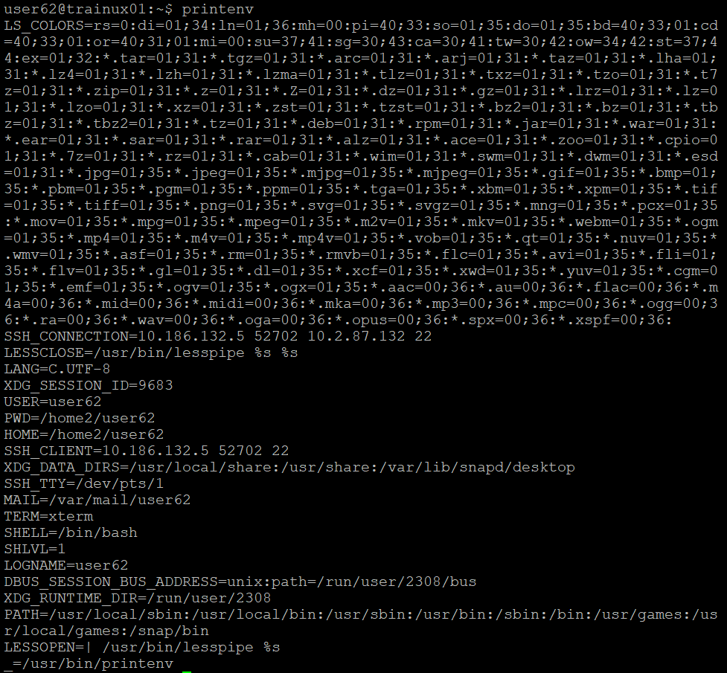

For env:

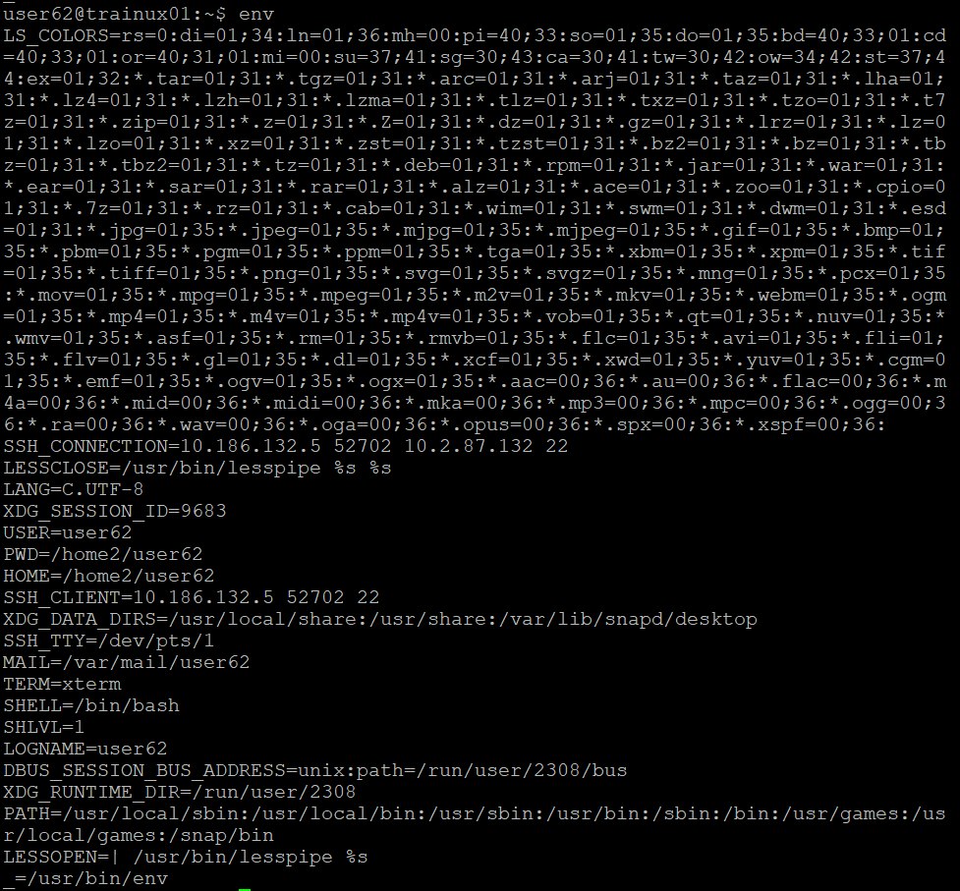

1. **display the PATH environment variable value:**
2. To display the any environment variable value, we use the command $ printenv <envname>. For this $ printenv PATH.

Output:



1. **update PATH to include the path to your home directory:**
2. To update the path to include the path to my home directory, we use the command $ PATH =” $ PATH:$ HOME”.

Output:



1. **How will you make the environment changes applicable to all users? Which script is to be modified?**
2. To make the environment changes applicable to all users, we need to modify the /etc/profile script. This file is executed for all users upon login, making any variables defined their available system wide. You can make the environment changes by adding lines like export PATH=”$ PATH:/new/path” at the end of the file. For immediate effect, users can run source /etc/profile, or the changes will automatically apply when they next login. But to do this we need the root user permission.
3. **I have installed an application named “myapp”. After installation, if I invoke the application, it fails with error as “Command myapp not found”. How will you fix this?**
4. After installation of the myapp, if we invoke then if it shows error as “command myapp not found” it may be the the application installation directory is not included in the PATH environment variable. We must follow few steps to resolve this problem:

**Step1**: Find the installation directory using the command “find” as “$ find -name myapp”. Then it gives the directory where the myapp is residing.

Sample Output: /usr/local/bin/app (assumed path to app).

**Step2**: After we need to add the directory to our PATH variable. Open bashrc file using the command “$ vi ~/.bashrc”, add the line export PATH=”$PATH:/usr/local/bin” at the end of the file and save the file.

**Step3**: Now to commit changes we need to run command “$ source ~./bashrc”. To make sure that the PATH is updated successfully, run the command echo $PATH then the output should include …:/usr/local/bin: …

**Step4**: Your application path is successfully added to the PATH environment variable. Now if you run/invoke the myapp it should be finely runs.