**SHELLSCRIPT_ASSIGNMENT04**

1. **Create a script named “myscript” in current directory to do the following.**

**a) display “hello user”:**

* 1. To display the given message, we use command “echo”.

Output: The content in the myscript.sh

**b) list files in current directory:**

1. To list all files in current directory, we use command “ls”.

Output: The content in myscript.sh

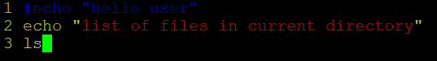

**c) name of logged in user:**

1. To get name of the logged in user, we use command “whoami”.

Output: The content in myscript.sh

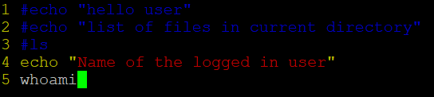

**d) date:**

1. To display the date, we use command “date”.

Output: The content in myscript.sh

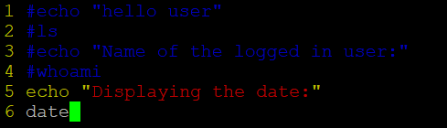

1. **Add execute permission and run the script from**
   * 1. **current directory:**
   1. To change permissions, we use command “chmod”. Syntax: $ chmod [options] mode file. To add execute permission to file myscript, we write $ chmod a+x myscript.sh. And run the script using. /<filename>.

Output:

1. **Create a subdirectory named “test”?**
   1. To create a subdirectory test, we use command $ mkdir test in current directory.

Output:

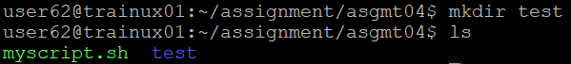

1. **Change to “test” directory. Run the script “myscript” [Hint: You will have to update PATH to include the directory containg script to run script from any location]?**
   1. To run script in test directory, we can use “../myscript.sh” as the myscript.sh is in its parent directory or we can update PATH by adding directory path containing script so that we can run this script in any location. We need to add PATH by opening hidden file .bashrc and write “export PATH=$PATH:pathtodirectory and save the file. Now go to test and run the script.

Output: The content in .bashrc



