**Code coverage_Assignment**

**Getting Started with gcov**

1. **Login into the Linux server with your login Ids**
2. **Create a new directory called code_cov in your home directory <home> mkdir code_cov**
3. Output:

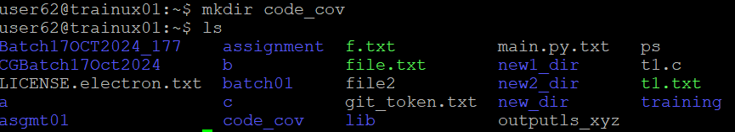

1. **Go inside the directory you have created in (2) /<home>/code_cov cd code_cov**
2. Output:



1. **Copy the following files from the path as mentioned by the trainer:**
   1. **sample.c**
   2. **link.c**
   3. **link.h**
2. Output:



1. **Take a look at the example programs sample.c and link.c**

**Compilation**

1. **Compile the files sample.c and sample1.c and put the output in the executable file called output**

**gcc –o output –ftest-coverage –fprofile-arcs sample.c link.c**

1. Output:

**Execution**

1. **Execute the file output**

**./output**

1. Output:



1. Now run gcov for each source file one by one

gcov sample.c

View the output file sample.c.gcov with the vi editor

vi sample.c.gcov

gcov link.c

1. Output:

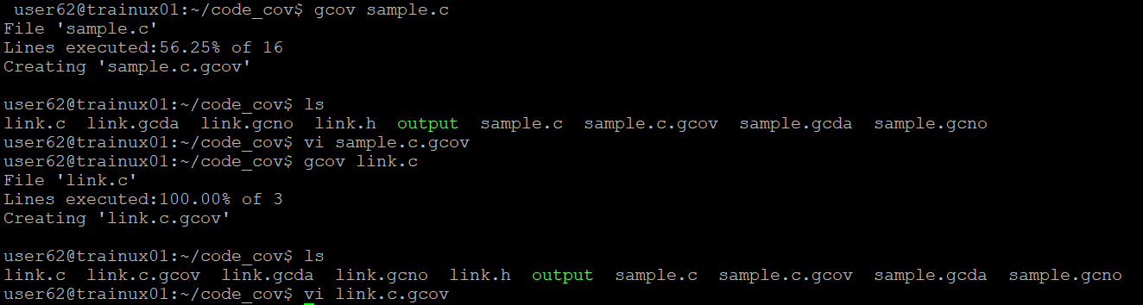

1. Run output again, this time with command line arguments:

./output a a b b

1. Output:

10. Now run gcov for sample.c again

What do you observe?

1. Output:

