## **Library Module – Static Library**

1. **Create 3 files as below. Let cal_utility.c, .h files be part of the library**
   1. **libapplication.c – will contain main() and will invoke functions in cal_utility.c:**
2. Created a libapplication.c file that contains main() and invoking add(), sub() functions in cal_utility.c**.**

Output: The code in libapplication.c

* 1. **cal_utility.c – will contain atleast 2 or more functions [ You may add definitions of the functions in this file]:**

1. Created a cal_utility.c file containing definitions of mul() and div() functions.

Output: The code in cal_utility.c

* 1. **cal_utility.h – will contain the extern declarations/prototypes of the functions in cal_utility.c:**

1. Created a cal_utility.h file containing prototypes of the functions in cal_utility.

Output: The code in cal_utility.h

1. **Refer the steps for static library-based application and create a static library application using above set of files?**
2. To create a static library, we need to first compile the cal_utility.c file to create a .o file. This .o file will form the static library, to do that use ar command. (Ensure that library name is prefixed with “lib” and extension as “.a”) as $ ar rcs -o libcal.a cal_utility.o.

Output:

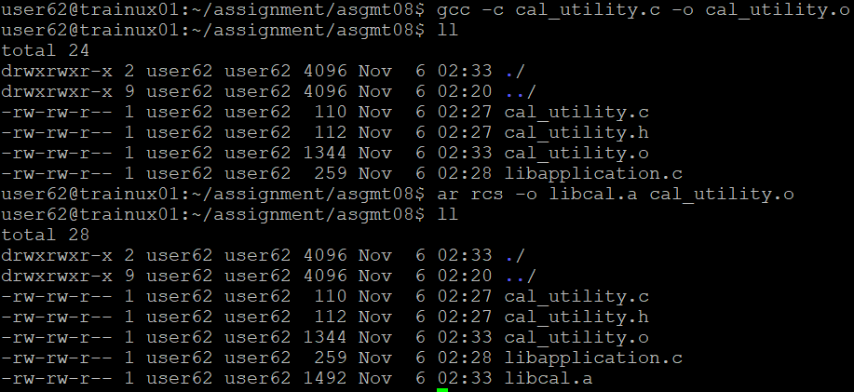

1. **Execute the application created in step #2?**
2. To create an executable file, link the library with the .o file containing the main() using command below. [Exclude the “lib” prefix and extension in library name].

$ gcc libapplication.c -L./ -lcal -o stcal

Output:

