**Vi Editor – Assignments**

1. **Invoke the vi editor with a filename (which is to be created)?**
2. To invoke vi editor, we use command vi followed by filename $ vi <filename>. After opens the file for editing in vi editor.

Output:

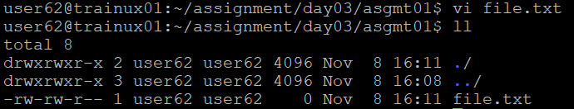

1. **Type a few lines (at least 10) in the editor. Let one or more lines contain the words given below.**

**delhi mumbai chennai Mumbai**

1. To write in vi editor, we need to press “i” then it goes to insert mode and write few lines with one or more lines containing the words delhi, mumbai, chennai, Mumbai.

Output:

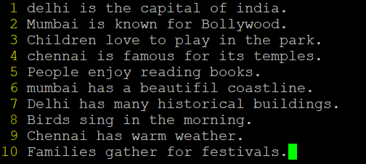

1. **Save the file without exiting the editor.**
2. To save the file without exiting the editor, we need to press “Esc” then it goes to Esc mode and :w and enter.
3. **Navigate quickly to the beginning & end of the file?**
4. We use “gg” to go beginning of the file and “G” to go end of the file.
5. **Delete first two lines & copy it after the last line.**
6. We use “ndd” to delete n lines and “nyy” to copy n lines and “p” to paste copied content.

Output:

1. **Now Copy the last two lines & paste them before the first line.**
2. We use “shift+p” or “P” to paste before the line.

Output:

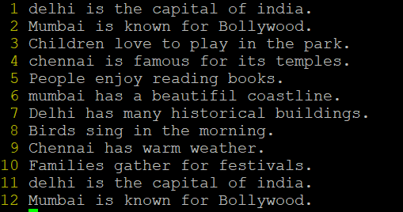

1. **Combine last two lines of the file in a single line.**
2. We use “J” to combine two lines in a single line.

Output:

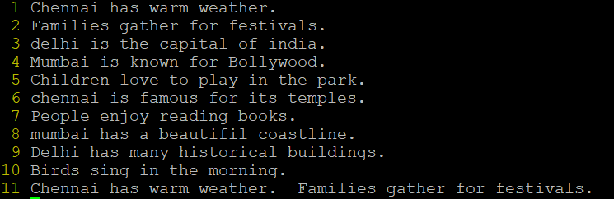

1. **How will you insert a line before the first line? (Hint: Find such an option in the tutorial document)**
2. We use “O” to insert line above the current cursor location.

Output:

1. **How will you paste a yanked buffer before the current line?**
2. We use “P” to paste a yanked buffer before the current line.
3. **Search the document for a string “delhi”?**
4. We use “/word” to search word, n move to next occurrence and N move to previous occurrence.
5. **Replace a single occurrence of “delhi” with “Mumbai”?**
6. We use “:s/text1/text2” to replace single occurrence of the string text1with text2.

Output: Before

After

1. **Replace all occurrences of “delhi” on a particular line with “Mumbai” using one command?**
2. We use “:s/text1/text2/g” to replace all occurrences of the string text1with text2.

Output: Before

After

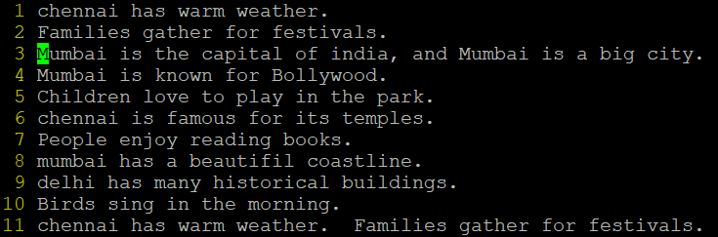

1. **Replace “delhi” with “mumbai” for the entire document using one command?**
2. We use “:%s/text1/text2/g” to replace all occurrences of the string text1with text2.

Output: Before

After

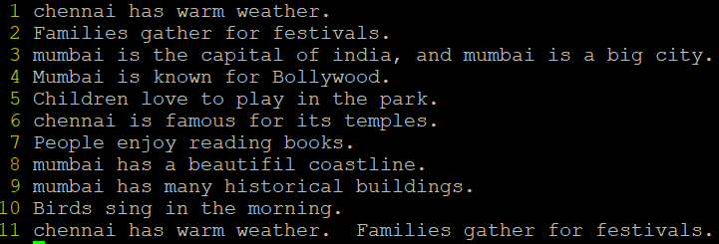

1. **Replace all occurrences of “delhi” with “mumbai” for part of a document (e.g. line number 13to 37).**
2. We use “:[start],[end]s/text1/text2/g” to replace all occurrences of the string text1with text2for part of file.

Output: Before

After(give startLine=4, endLine=10)

1. **Undo the above command**
2. We use “u” to undo.

Output:

1. **Replace only the first occurrence of “delhi” with “mumbai” in each line, for part of a document (e.g. line number 13to 37).**
2. We use “:[start],[end]s/text1/text2” to replace only first occurrence of the string text1with text2in each line for part of file.

Output: Before

After

1. **Undo the above comment. Redo it. Undo it again.**
2. We use “ctrl+r” to redo.

Output:

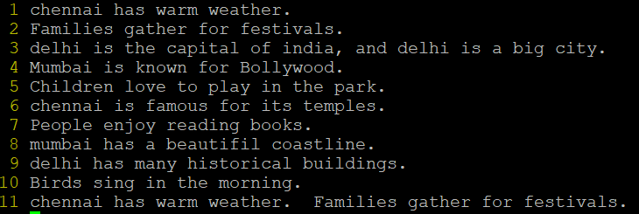

1. **Replace all occurrences of “delhi” with “mumbai” for complete file interactively.**
2. We use “:%s/text1/text2/gc” to replace all occurrences of the string text1with text2for complete file interactively.

Output: Need to enter y/n to confirm changes.

After



1. **Search for a word backwards. Loop through all matches.**
2. We use “?word” to search word backwards, press “n” to find next occurrence of same text in same direction, and press “N” to find next occurrence of same text in opposite direction.
3. **Search for a word forwards. Loop through all matches.**
4. We use “/word” to search word forwards, press “n” to find next occurrence of same text in same direction, and press “N” to find next occurrence of same text in opposite direction.
5. **Join two lines together.**
6. We use “J” to join two lines.

Output: Before

After

1. **Enable line numbering and then disable it**
2. We use “:set number” to set numbering and “:set nonumber” to disable numbering.

Output: Enabled numbering

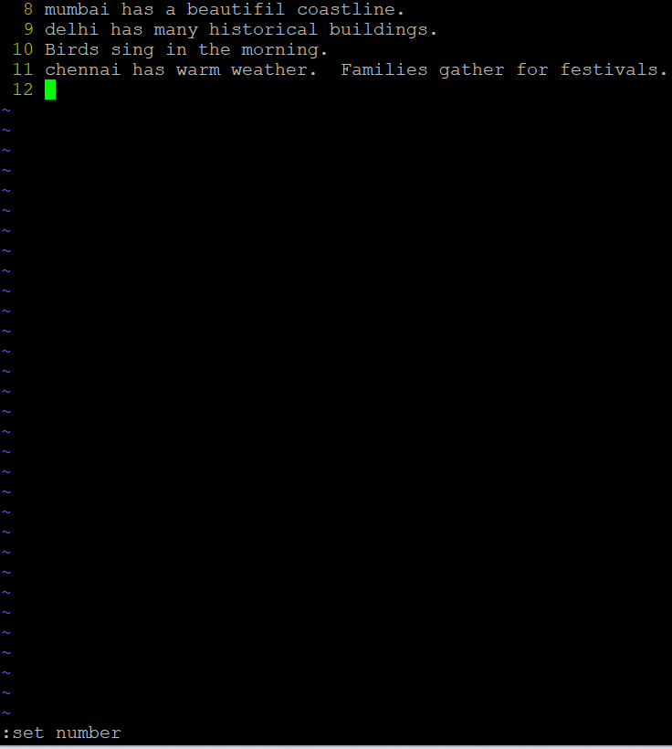

Disabled numbering

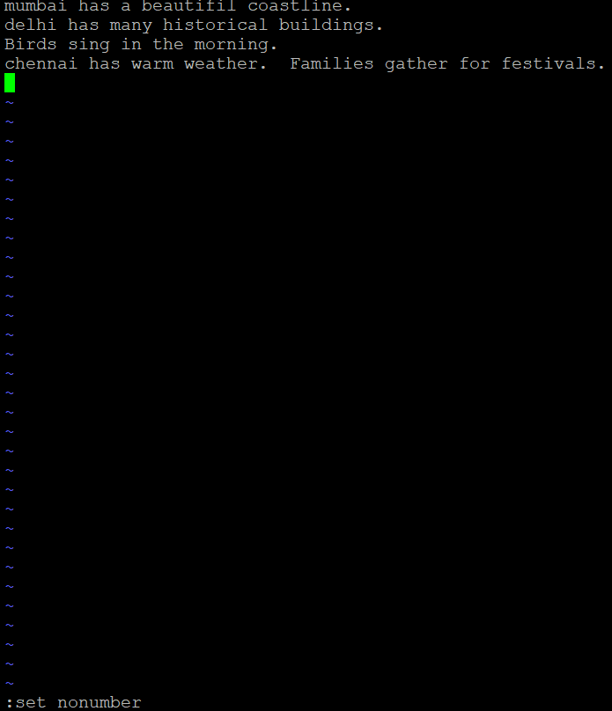

1. **Make the search case insensitive**
2. We use “/word\c” \c makes the search word case insensitive.
3. **Delete 4lines (and then paste them somewhere else)**
4. We use “ndd” to delete specific number of lines and “p” to paste them.

Output: Before

After (deleted 4lines and pasted)

**25. What is the command to delete part of the line starting from the current cursor position?**

1. We use “d$” to delete rest of the line from the current cursor position.

Output: Before

After

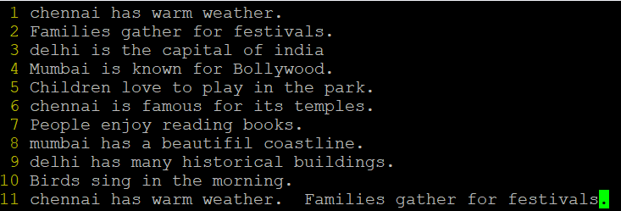

**26. What is the command to delete the current word?**

1. We use “dw” to delete specific word, after keeping cursor at specific word.