Queue assignments

Mandatory

- Refer the example code of queue using array in socodery. Modify the data structure as below and accordingly update the code to add support to keep MAX_QUEUE_SIZE user input strings read at runtime. Consider a configurable queue capacity
#define MAX_QUEUE_SIZE 5
typedef struct queue
{
int arr[MAX_QUEUE_SIZE];
char **data;
int front;
int rear;

}queue_t;
- Code:
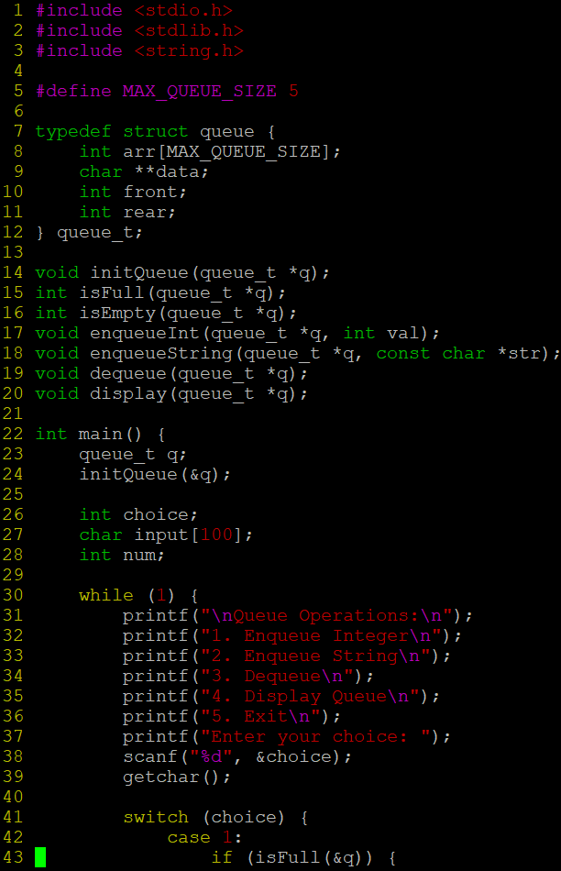
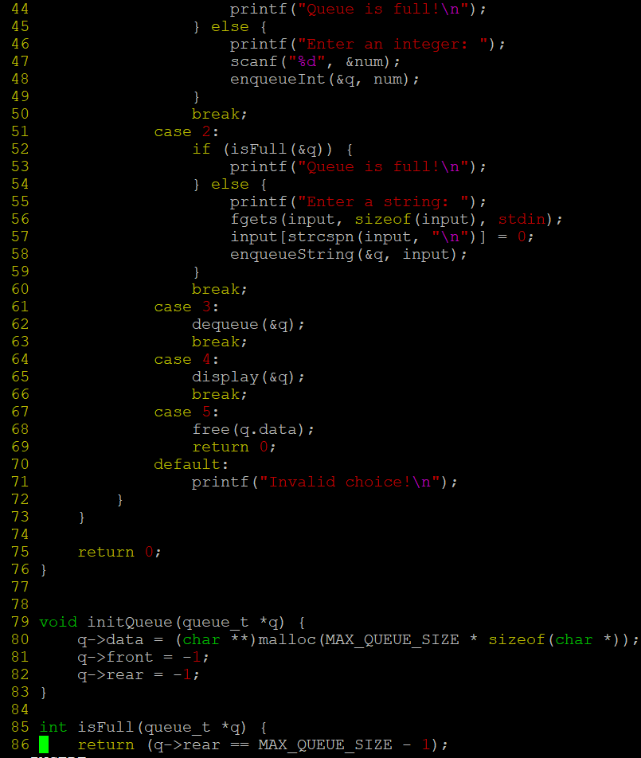
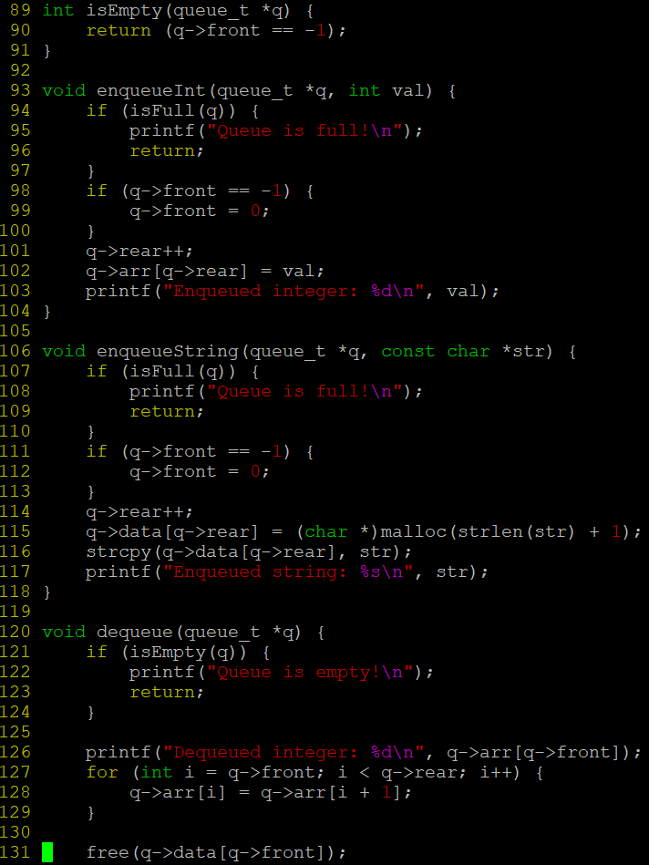
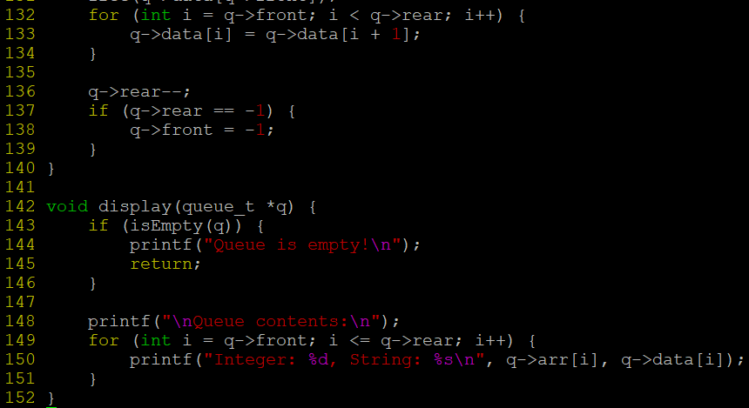
Output:
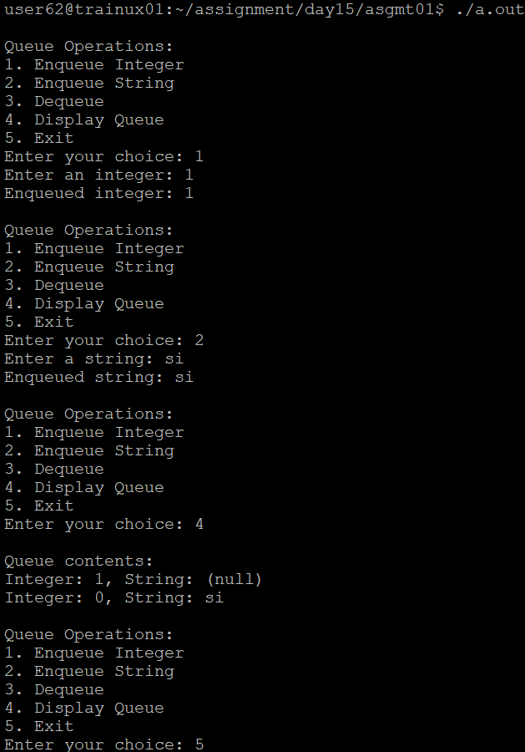

- Refer the example code of queue using list in socodery. Modify the data structure as below and accordingly update the code to add support to keep string data read from user (of maximum length 80 characters) at runtime. Ensure 0 memory leaks.
typedef struct node_q
{
Int data;
char *data; //data read from user at runtime
struct node_q *next;
}node;
- Code:
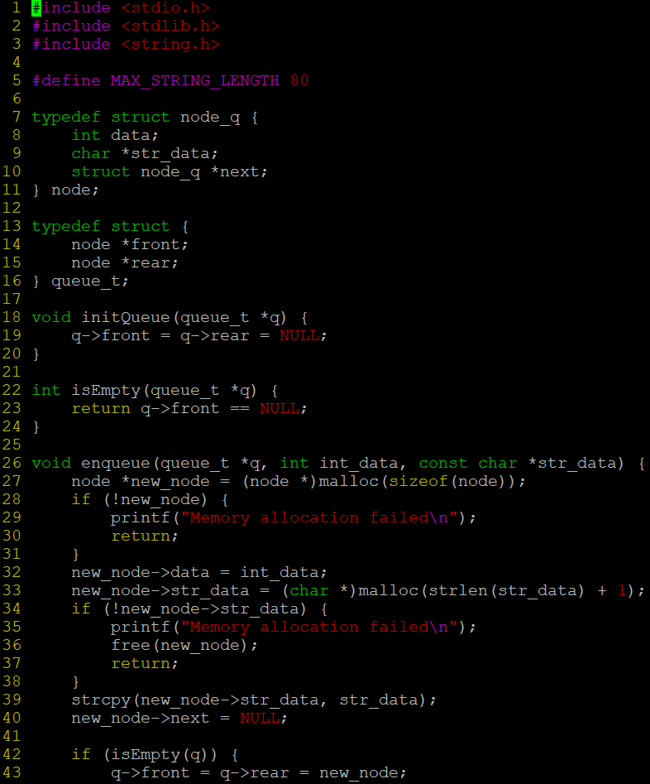
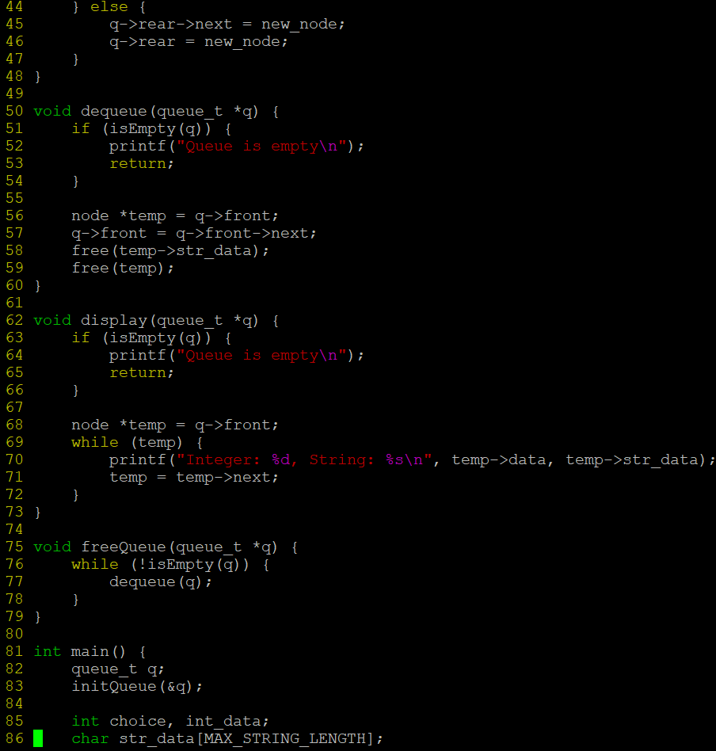
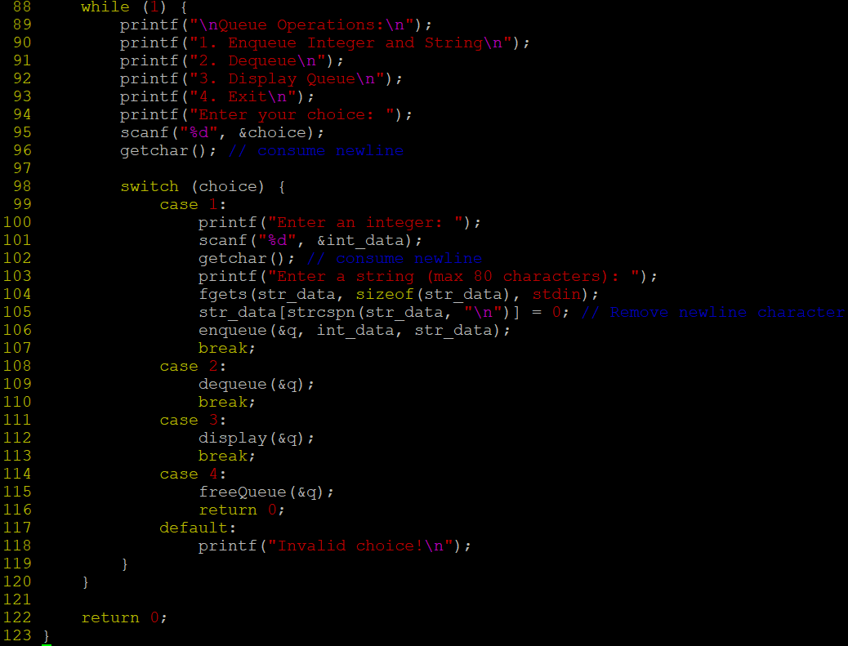
Output:
