|  |  |  |  |  |  |  |  |  |  |
| --- | --- | --- | --- | --- | --- | --- | --- | --- | --- |
| U.S. DEPARTMENT OF TRANSPORTATION FEDERAL AVIATION ADMINISTRATION STATEMENT OF COMPLIANCE WITH AIRWORTHINESS STANDARDS | | | | | | | ODA Project No. N/A | | |
| **AIRCRAFT OR AIRCRAFT COMPONENT IDENTIFICATION** | | | | | | | | | |
| MAKE | MODEL NO  737- | | | | TYPE (Aircraft, Engine, Propeller, etc.)  Airplane | | | NAME OF APPLICANT/AUTHORIZATION NO.  Boeing Commercial Airplanes  ODA-300064-NM | |
| **LIST OF DATA** | | | | | | | | | |
| IDENTIFICATION | | | TITLE | | | | | | |
| telexName    ~ CAT B message has not been sent | | | NOTE: Boeing Commercial Airplanes has received FAA Organization Designation Authorization (ODA) delegation. As such, the data identified on this form, as approved by the ODA authorized representative below, or when approved by the FAA (if checked as recommend approval below), is FAA-approved for the serial number(s)/effectivity/model series listed. Application of this FAA-approved data to airplanes other than those listed on this form requires additional FAA-approval.  **Aft Cargo Door –**   |  |  |  |  | | --- | --- | --- | --- | | **Door P/N:** | doorPN | **Door S/N:** | doorSN | | **Airline:** | operatorFull | **Registry:** | reg | | **Serial Number:** | sNum | **Reported Hours:** | hours | | **Variable:** | var | **Reported Cycles:** | cycles |   **Problem:** While accomplishing the requirements of AD 2013-13-12,  **Repair:**  The repair is structurally acceptable as a Category B Repair as defined in 737- SRM 51-00-06 with the following supplemental inspections.  **Inspection Threshold and Requirements per SB 737-52A1153, Tables 5 and 6.**  **Inspection Threshold and Requirements per SB 737-52-1154, Table 5. (if crack in D)**  This repair has been approved as an Alternative Method of Compliance (AMOC) to the corrective action requirement of paragraph (s) of AD 2013-13-12 and has been found to meet the Type Certificate Basis of this airplane. Delegation of AMOC authority for AD 2013-13-12 was granted to AR Richard Weiner by the Seattle Aircraft Certification Office per letter 120S-13-515 dated 13 August 2013. This AMOC is transferable with the door and meets the requirements for showing compliance with 14 CFR 39.7. Before using this AMOC, notify your appropriate principal inspector, or lacking a principal inspector, the manager of the local Flight Standards District Office/Certificate Holding District Office.  This approval is based on … | | | | | | |
| **PURPOSE OF DATA**  ODA approval of compliance data for structural approval for the engineering of the above repair as an AMOC to AD 2013-13-12 for S/N sNum. | | | | | | | | | |
| **APPLICABLE REQUIREMENTS** (List specific sections)  14 CFR Part 25, Sections 25.301, 25.303, 25.305, 25.307, 25.571(c), 25.571(b)[25-45], 25.601, 25.603, 25,605, 25.609, 25.613, 25.615  14 CFR Part26, Section 26.43(d)  NOTE: Amendment levels for all applicable requirements listed on this form are per the model certification basis except as noted above. | | | | | | | | | |
| **CERTIFICATION** - As directed by the Administrator and in accordance with the conditions and limitations of authorization under 14 CFR, data listed above and on attached sheets numbered N/A have been examined in accordance with established procedures and found to comply with applicable requirements of the Airworthiness Standards listed. | | | | | | | | | |
| **I (~~We~~) Therefore:** |  | | **Recommend approval of these data** | | | | | | |
| **X** | | **Approve these data** | | | | | | |
|  | |  |  | | | | | | |
| **SIGNATURE(S) OF AUTHORIZED REPRESENTATIVE(S)** | | | | **NAME** | | **CLASSIFICATION**(S) | | | **Date** |
|  | | | | Richard Weiner, AR-635661 | | Structural | | |  |
|  | | | |  | | Structural | | |  |
|  | | | | W. H. Peterson, AR-635773 | | Structural | | |  |

FAA Form 8100-9 (2-02)

# Deviation and Repair Description

While incorporating 737-52A1153 R1 to Aft Cargo Door P/N: doorPN, with Door S/N: doorSN,

Figure Deviation locations

# Inspection Requirements

Service Bulletins 737-52A1153 and 737-52-1154 have identical inspection thresholds. This extract is from 737-52A1153, Compliance Table 5.

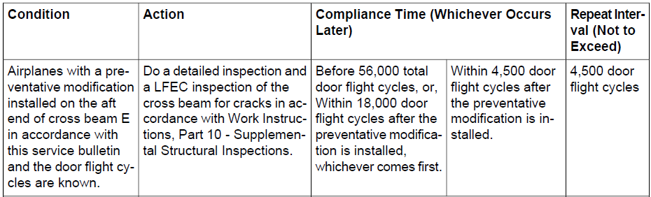

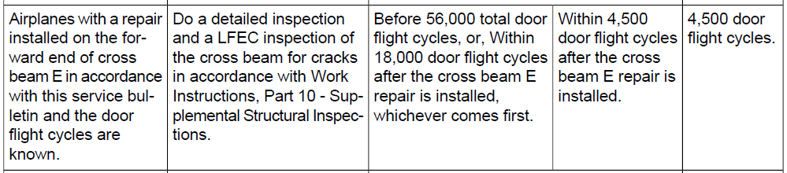

## Inspection Requirements for Beam E

The damage tolerance inspection threshold and methods in the bulletin are provided to the operator.

**Inspection Requirements:**

**Inspection Threshold:**

The later of

* Before 56,000 total door flight cycles, or, within 18,000 door flight cycles after repair installation, whichever comes first.

and

* Within 4,500 door flight cycles after repair installation.

If the total door flight cycles are not known, the threshold for the repeat inspections is 4,500 door flight cycles after repair installation.

**Inspection:** Low Frequency Eddy Current inspection of the Beam E Outer T-Chord through the outer skin every 4,500 door flight cycles, per Service Bulletin 737-52A1153, Tables 5 and 6.

**Inspection:** Detailed Inspection of Beam E every 4,500 door flight cycles, per Service Bulletin 737-52A1153, Tables 5 and 6.

## Inspection Requirements for Beam D

The damage tolerance inspection threshold and methods in the bulletin are provided to the operator.

**Inspection Requirements:**

**Inspection Threshold:**

The later of

* Before 56,000 total door flight cycles, or, within 18,000 door flight cycles after repair installation, whichever comes first.

and

* Within 4,500 door flight cycles after the repair installation.

If the total door flight cycles are not known, the threshold for the repeat inspections is 4,500 door flight cycles after repair installation.

**Inspection:** Low Frequency Eddy Current inspection of the Beam D Outer T-Chord through the outer skin every 4,500 door flight cycles, per Service Bulletin 737-52-1154, Table 5.

**Inspection:** Detailed Inspection of Beam D every 4,500 door flight cycles, per Service Bulletin 737-52-1154, Table 5.

## Inspection Requirements for Beam D

The operator did not find any cracks on Beam D. The MRO does not state if the preventative modification was installed for Beam D, therefore there are no inspection requirements for Beam D.

# Airworthiness Directive AD 2013-13-12

AD 2013-13-12 requires Service Bulletin 737-52A1153, and under some circumstances, requires Service Bulletin 737-52-1154.

**AMOC**

The requirements of AD 2013-13-12 that relate to bulletins 737-52A1153 and 737-52-1154 are listed here, as well as how the requirement relates to this repair and substantiation.

* Paragraph (o) requires an operator to determine the door configuration at a time specified in S. B. 737-52A1153.
* The operator did not report any deviations; this substantiation and approval does not address this requirement.
* Paragraph (s) requires an operator to perform an initial screening inspection of Beam E.

* The operator performed the required re-assembly with a deviation, which was found to be acceptable for static strength, durability, and damage tolerance in this substantiation, therefore this deviation is acceptable as an AMOC. (deviations: f5b, f5c, f6b, f6c)
* Paragraph (t) requires an operator to perform an initial screening inspection of the lower corner frames and reinforcing frame angles at a time specified in S. B. 737-52A1153.
* Paragraph (v) states that the damage tolerance inspections provided in S. B. 737-52A1153 (Tables 5 & 6) and S. B. 737-52-1154 (Table 5) are not required by the AD, but “may be used in support of compliance with section 121.1109(c)(2) or 129.109(b)(2)”, which require airlines to perform supplemental inspections.
* The damage tolerance inspections for this repair are the same as those referenced in this paragraph, and are provided with this approval, therefore the operator will not need to use this paragraph. Note that an AMOC to this paragraph is not provided.

# Compliance Checklist

FAR 25.301 Loads Complies

FAR 25.303 Factor of safety Complies

FAR 25.305 Strength and Deformation Complies

FAR 25.307 Proof of Structure Complies

FAR 25.365 Pressurized Cabin Loads Complies

Not Required

Pressure loads were not calculated.

FAR 25.561 Emergency Landing Complies   
 Not Required

FAR 25.571 Failsafety / SSI or Damage Tolerance Not Required   
 Stage 1   
 Complies 25-571 (c) (Failsafety)   
 Complies 25-571 (b) (Damage Tolerance)   
 Complies 25-571 (b) [25-45] (Damage Tolerance)

Failsafe aspects are unchanged.

FAR 25.601 General Complies

FAR 25.603 Materials Complies

FAR 25.605 Fabrication Methods Complies

FAR 25.607 Fasteners Complies   
 Not Required

FAR 25.609 Protection of Structure Complies

Protection of structure provisions were applied to the repair area per SB instructions regarding finishes and installation procedures.

FAR 25.611 Inspection Provisions Complies   
 Not Required

FAR 25.613 Material Strength Properties Complies

FAR 25.615 Design Properties Complies   
 Not Required

FAR 25.619 Special Factors Complies   
 Not Required

FAR 25.621 Casting Factors Complies   
 Not Required

FAR 25.623 Bearing Factors Complies   
 Not Required

FAR 25.625 Fitting Factors Complies   
 Not Required

FAR 26.43 Continued Airworthiness Not Required   
 Stage 1   
 Complies, Threshold only   
 Full Compliance

This part is on the FCBS list as Note 1, therefore a damage tolerance evaluation is required by 14 CFR 26.43. The repair is acceptable for Continued Airworthiness per the discussion above.

Is this a US registered aircraft? Yes  No

Is this a Repair with Alterations? Yes  No

Is this repair in an area affected by an AD? Yes  No

Is this repair providing an AMOC to an AD? Yes  No

Include the Structural Aspects Only note? Yes  No

# References & Parts

* 737- operated by

|  |  |  |  |  |
| --- | --- | --- | --- | --- |
| Variable | Basic | Line Number | Serial Number | Registry |
| var |  | lineNum | sNum | reg |

* doorPN, Aft Cargo Door,  Inner Skin.
* AD 2013-13-12
* SB 737-52A1153, REV. 1, GROUP group CONFIG config
  + 65C37547, sh., SB DRAWINGS
* SB 737-52A1154, REV. 2, GROUP CONFIG
  + 65C30004, sh., SB DRAWINGS
* Analysis substantiating SB 737-52A1153 R01 and SB 737-52-1154 R02  
  CASTLE Package 201409220105 (deviations: f6b, f6c)