Visual Grounding (High-Level Architecture)
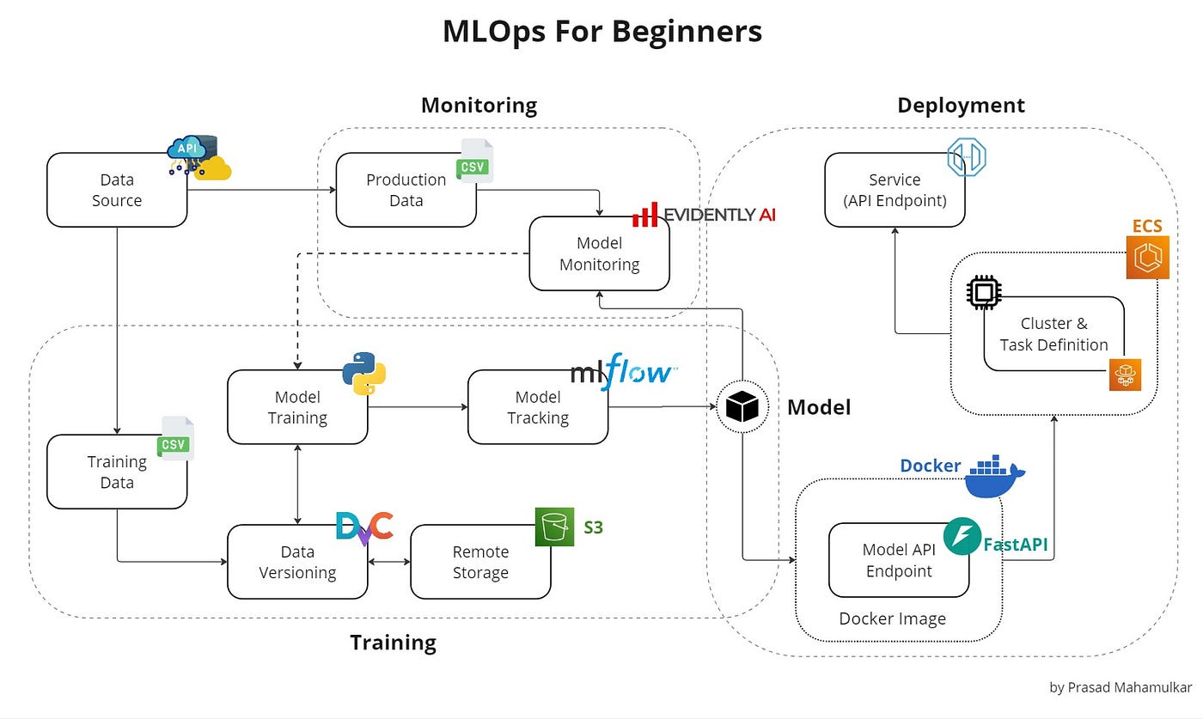
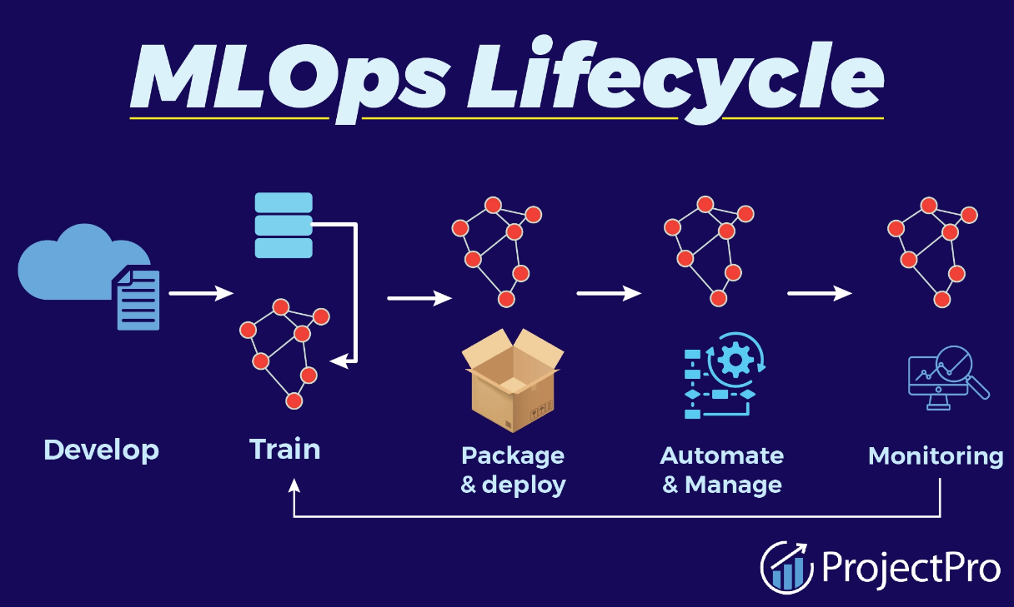

3) Lifecycle Table (Tools at Each Stage + Alternatives + Why Yours Is Correct)
Stage | Industry Options | Your Tool | Why Yours Is Correct
Data Validation | GE, Deequ, Soda | Great Expectations | Standard, integrated, senior-ready
Training | MLflow, SageMaker, Airflow | MLflow | Artifacts + metrics + reproducibility
Registry | MLflow, S3, DVC | MLflow Registry | Versioning + promote + rollback
Serving | FastAPI, BentoML, KFServing | FastAPI + Docker | Simple, fast, easy to demo
Monitoring | Prometheus, StatsD | Prometheus | Industry standard metrics
Drift | Fiddler, WhyLabs | Evidently AI | Perfect OSS drift tool
Dashboards | Grafana, Kibana | Grafana | Beautiful UI, alerting
Orchestration | Airflow, Dagster | Prefect | Clean DAG, simple, Pythonic
Retraining | Airflow, Jenkins | Prefect + MLflow | Lightweight, ideal for you

4) Executive Summary (Tooling & Architecture)
This MLOps system follows a full end-to-end lifecycle covering data validation → model training → versioning → serving → monitoring → drift detection → auto-retraining.
The architecture uses lightweight, industry-standard open-source tools suited for a single-engineer or small-team deployment.
Tool Choice Justifications
- Great Expectations for data validation (clean, standard, integrates with Prefect).
- MLflow for experiment tracking + registry (versioning, staging/production, rollback).
- FastAPI + Docker for serving (fast, simple, interview-friendly, cloud-neutral).
- Prometheus + Grafana for metrics (industry standard, DevOps-ready).
- Evidently AI for drift detection (best OSS option, direct Prometheus export).
- Prefect for orchestration (modern, Pythonic, lighter than Airflow).
This stack balances clarity, maturity, and demonstrability, making it ideal for hands-on assessments.
End-to-End Flow
- Data ingestion → Great Expectations validation
- Model training under MLflow tracking
- Model versioning in MLflow Registry
- FastAPI loads the current Production model
- Docker Compose orchestrates local services
- Prometheus collects model + infra metrics
- Evidently calculates drift → exposes to Prometheus
- Grafana displays dashboards + alerts
- Prefect triggers retraining when drift threshold breached
- MLflow Registry updates → Production model switches cleanly
This architecture demonstrates production-grade thinking, rollback safety, observability, and continuous improvement, matching expectations of a Senior MLOps Engineer.

