**Project Title: Smart Parking System Using IoT**

**Project Description:**

The Smart Parking System using IoT aims to create a modern, automated parking management solution that enhances user convenience, reduces traffic congestion, and optimizes space utilization in parking lots. This system utilizes IoT sensors, communication devices, and a user-friendly application to achieve the following objectives:

1. Real-time Parking Availability: IoT sensors installed in each parking space detect the presence of vehicles and transmit this data to a centralized server, providing real-time information on parking space availability.
2. User-Friendly Mobile App: A mobile application allows users to check the availability of parking spaces in real-time, reserve spots in advance, and navigate to their reserved or available parking space within the parking facility.
3. Payment Integration: Users can make secure payments for parking fees through the mobile app, enabling cashless transactions and reducing the need for physical payment systems.
4. Data Analytics: The system collects and analyzes data on parking space utilization, helping parking operators make informed decisions about pricing, capacity planning, and maintenance.
5. Security and Safety: Integrated surveillance cameras and smart lighting ensure the safety of the parking facility. In case of emergencies, the system can alert authorities and provide assistance.
6. Environmental Impact: By reducing the time spent searching for parking, the system can help decrease carbon emissions from idling vehicles.

Components:

* + IoT sensors (ultrasonic, magnetic, or infrared) for detecting vehicle presence.
  + Microcontrollers or IoT devices for sensor data processing and communication.
  + Cloud-based server for data storage and processing.
  + Mobile application for user interaction.
  + Payment gateway integration.
  + Surveillance cameras and smart lighting.
  + Emergency notification system

**Design Thinking:**

Sensors: IoT sensors are placed in parking spots to detect the presence of vehicles. These sensors can be ultrasonic, infrared, or magnetic sensors.

Data Collection: The sensors collect data on parking spot occupancy in real-time and transmit it to a central server or cloud platform via wireless communication protocols like Wi-Fi, LoRa, or cellular networks.

Data Processing: The collected data is processed to determine the availability of parking spots and provide real-time updates to drivers through a mobile app or electronic signage.

Mobile App: Drivers can use a mobile app to check parking spot availability in real-time, reserve parking spaces, and navigate to available spots.

Payment Integration: The system can also integrate with payment platforms, allowing users to pay for parking through the app or automated payment kiosks.

Analytics and Optimization: The system can analyze parking usage data to optimize parking space allocation, pricing, and improve overall parking management.

Environmental Impact: Smart parking systems can reduce traffic congestion, decrease emissions, and improve the overall efficiency of urban transportation.

Scalability: IoT-based smart parking systems can be easily scaled to cover larger areas and accommodate more parking spots.

Overall, a smart parking system using IoT technology improves convenience for drivers, enhances parking space utilization, and contributes to more efficient urban planning and traffic management.

**Flow Chart:**

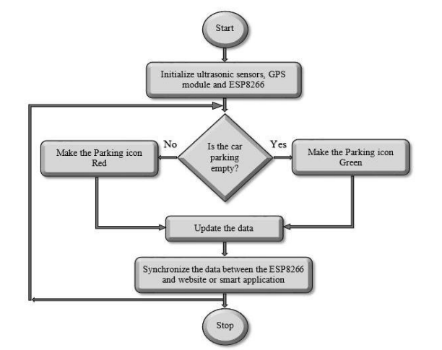

Team Members:

R.Deepika Sri-921021104006

Muthu Vaishali-921021104030

L.Lucky Malathi-921021104023

M.Sowmiya-921021104047