Cash identification and cash application US97

Process Definition Document (PDD)

HP In

**[TCS UAP]**

Robotics Process Automation (RPA)

Process Design Document

“[Parcel Monkey]” v1.0

Document History

|  |  |  |  |  |  |  |
| --- | --- | --- | --- | --- | --- | --- |
| Date | Version | Role | Name | Organization | Function | Comments |
| 09-Aug-2020 | 1.0 | Author | *Sowmith Kunapaneni* | *TCS* | *Developer* | Draft |
|  |  |  |  |  |  |  |
|  |  |  |  |  |  |  |

Contents

1.1 Purpose of the document 4

1.2 Objectives 4

1.3 Process key contacts 4

1.4 Minimum Pre-requisites for automation 4

2.0 As IS process description 5

2.1 Applications used in the process 6

2.2 Inputs for Process 6

2.3 As IS Detailed Process map 6

2.4 Additional sources of process documentation 7

3.0 To BE Process Description 8

3.1 TO BE Detailed Process Map 8

3.2 In Scope for RPA 8

3.3 Business Exceptions Handling 8

3.3.1 Known Exceptions 8

3.4 Application Error and Exception Handling 9

* 1. Introduction

Robotic Process Automation is the technology that allows anyone today to configure computer software, or a “robot” to emulate and integrate the actions of a human interacting within digital systems to execute a business process.

Bot Reads the data from the Input Excel file i.e. Source and Destination of the package, submits them in the Parcel Monkey website and fetches the details about the quote, updates them in the Input Excel file under the column name status.

### Purpose of the document

The Process Definition Document outlines the business process chosen for automation using Automation Anywhere Robotic Process Automation (RPA) technology.

The document describes the sequence of steps performed as part of the business process, the conditions and rules of the process prior to automation and how they are envision to work after automating it, partly or entirely. This specifications document serves as a base for developers, providing them the details required for applying robotic automation to the selected business process.

### Objectives

The objective of this process automation is linked to the project business case and is mainly intended to:

• Fetch best delivery service for the given source, destination and weight of a parcel based on highest rating.

• Save Time & human involvement.

• Improve overall performance and reliability

### Process key contacts

The specifications document includes concise and complete requirements of the business process and it is build based on the inputs provided by

|  |  |  |
| --- | --- | --- |
| **Group Representative:** | Sowmith.K | Sowmithkunapaneni@gmail.com |
| **Team Members:** | Haritha.K | harithakandukuri4@gmail.com |
|  | Srinivasulu.D | srinivasdodda568@gmail.com |
|  | Sai Kumar.T | saikumartumuluri1998@gmail.com, |
|  | Tejeswar.J | yogeshtejeswar2@gmail.com |
|  | Ramya.V | ramya31899@gmail.com |

### Minimum Pre-requisites for automation

1. Filled in Process Definition Document
2. Proper licenses required to logon to machines and applications (AA Client).
3. Test Data to support development.
4. Dedicated system and application access are given to developers with the adequate permissions.

## As IS process description

|  |  |  |
| --- | --- | --- |
| # | Item | Description |
| 1 | **Process full name** | Parcel Monkey |
| 2 | **Process Area** | TCS UAP |
| 3 | **Department** | Logistics |
| 4 | **Process short description**  (operation, activity, outcome) | The bot is used to fetch shipping service name from the Parcel Monkey website and update the shipping service name based on the highest rated quote from the website. |
| 5 | **Role(s) required for performing the process** | SME  Business Analyst  Developer  User |
| 6 | **Process schedule and frequency** | N/A |
| 7 | **# of items processes /month** | N/A |
| 8 | **Average handling time per item** | N/A |
| 9 | **Peak period (s)** | N/A |
| 10 | **Total # of FTEs supporting this activity** | N/A |
| 11 | **Level of exception rate** | N/A |
| 12 | **Input data** | Package’s Source, Destination and weight |
| 13 | **Output data** | Shipping Service Name |
| 14 | **Dependencies**  (upstream, downstream) | Websites:  1. https://www.parcelmonkey.co.uk/  Files:  1. ParcelMonkey.xlsx  Services:  AA Client service. |

### Applications used in the process

The table includes a comprehensive list all the applications that is use as part of the process automated, at various steps in the flow.

|  |  |  |  |  |
| --- | --- | --- | --- | --- |
| # | App Name – App Code | Web/Desktop Application | Credentials used to Access Application | Test/Prod Environment Available? |
| 1 | Parcel Monkey | Web Application | N/A | -Internet Explorer or IE9 higher version |
| 2 | Microsoft Excel | Desktop Application | N/A | -Windows 10 Home. |

### Inputs for Process

|  |  |  |  |  |
| --- | --- | --- | --- | --- |
| Input Type | | Input description | | Input Location |
| XML | XML File ConfigFile.xml  For getting the required file path and website details | | “C:\Users\Personal\Documents\Automation Anywhere Files\Automation Anywhere\My Docs\Travel_InsuranceProject\ConfigFile\ConfigFile.xml” | |
| Excel | Excel File ParcelMonkey.xlsx  For entering data extracted from the  web. | | $AAApplicationPath$ \Automation Anywhere\My Docs\ParcelMonkey\My Docs\ParcelMonkey.xlsx | |

### As IS Detailed Process map

This chapter depicts the AS IS business process in detail to enable the developer to build the automated process. List the steps in the procedure as it is done today in the manual process.

|  |  |
| --- | --- |
| Step | **Short Description of Key Process Steps** |
| 1.1 | Open: https://www.parcelmonkey.co.uk/ |
| 1.2 | Set Collect from, Delivering to and Weight fields in webpage. |
| 1.3 | Click on Get Quote and Book option and wait for webpage to load |
| 1.4 | Extract the Delivery Service Name based on highest rating and update the status in Excel file |
| 1.5 | Send an Email with Excel file as attachment to the customer |

### Additional sources of process documentation

|  |  |  |  |
| --- | --- | --- | --- |
| # | Source | Screenshot | Descrption |
| 1.1 | Website:  <https://www.parcelmonkey.co.uk/> Home page |  | Home page of the parcel monkey, where input must be entered. |
| 1.2 | Extra details required Page. |  | If Extra details are required for processing the record |
| 1.3  1.4 | Services Page |  | Services page for UK to UK shipments. |
| 1.5 | Services Page |  | Services page for International Shipments. |
| 1.6 | Service not Available page |  | Service not available for international shipments page |
| 1.7 | Service not Available page |  | Service not available for UK TO UK shipments page |
| 1.8 | Invalid Weight |  | When weight is zero or negative page |
| 1.9 | Input Excel Sheet |  | Sample excel sheet containing four coumns |

## To BE Process Description

### TO BE Detailed Process Map

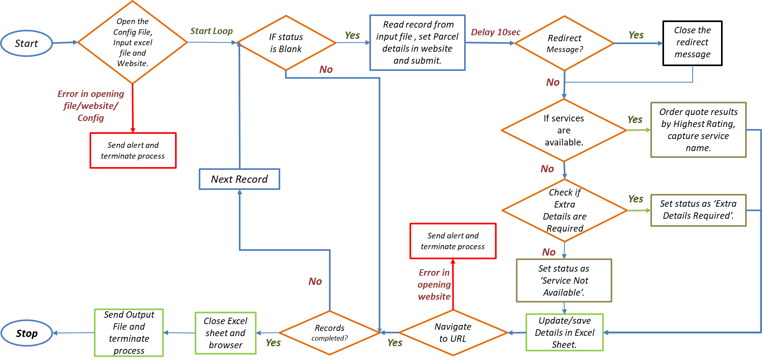

### In Scope for RPA

Total Use case is In Scope for RPA i.e. Use case can be automated from end to end.

### Business Exceptions Handling

The Business Exceptions are:

#### Known Exceptions

|  |  |  |  |  |
| --- | --- | --- | --- | --- |
| **BE #** | **Exception name** | **Step**  **(Step numbers from BRD)** | **Para meters** | **Action to be taken** |
| 1 | If Service is Not available |  | Service not available. | Log relevant information i.e. service not available. |
| 2 | Extra details are required |  | Extra details required | Log status as Extra Details Required. |
| 3 | Invalid weight |  | Weight is zero or less. | Log status as Weight is Zero. |
| 4 | Excel File absent |  | Excel file | Log the same and stop the task. |
| 5 | XML file absent |  | XML file | Log the same and stop the task |

### Application Error and Exception Handling

A comprehensive list of all errors, warnings or notifications should be consolidated here with the description and action to be taken, for each, by the Robot.

|  |  |  |  |  |
| --- | --- | --- | --- | --- |
| **AE #** | **Error name** | **Step** | **Parameters** | **Action to be taken** |
| 1 | Internet Problem |  | Internet | Save the excel sheet and Log and stop the task. |
| 2 | Not Responding |  | Application | If IE or Excel doesn’t respond, log the same and stop the task. |