**Parcel Monkey**

**How to use Bot:** The Bot Reads the data from the Input Excel file i.e. Source and Destination of the package, submits them in the Parcel Monkey website and fetches the details about the quote, updates them in the Input Excel file under the column name status.

This bot has two dependency files viz Input Excel file and the config file.

***Configuration file:***

Name: “ParcelMonkeyConfig.xml”.

Location:” $AAApplicationPath$\Automation Anywhere\My Docs\ParcelMonkey\My Docs”.

***Input Excel File:***

Name & Location: Can be configured using Configuration File.

***Folder Structure Expected:***

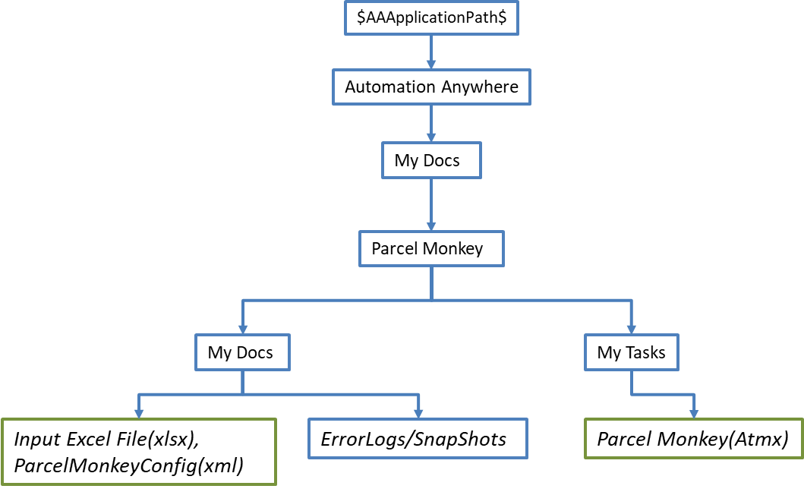

**Use the following information to configure your bot.**

|  |  |  |  |  |
| --- | --- | --- | --- | --- |
| **Parameter Name** | **Type** | | **Direction** | **Additional Info** |
| **Input Excel File** | | | | |
| Input Excel file | File | | Input | Provide input records to be updated according to the shipping details. |
| **Content of CSV file** | | | | |
| Source | Column Name | | Input | Source of the Package. |
| Destination | Column Name | | Input | Destination of the Package. |
| Weight | Column Name | | Input | Weight of the Package. |
| Status | Column Name | | Output | Extracted from the Website. |
| **Config File** | | | | |
| ParcelMonkeyConfig.xml | File | | Input | Provides the Email ID and the path of the input excel file. |
| **Content of xml file** | | | | |
| Excel File Path | | String | Input | Provides the file path to the input excel file. |
| Email | | String | Input | Provides Email address to be used inside the bot. |
| URL | | String | Input | Points to the website of Parcel Monkey. |
| **Other fields** | | | | |
| vInputPath | | String | Input | It is taken from the config file and points to the Input excel file location. |
| vEmail | | String | Input | It is taken from the config file and provides the Email to be used. |
| vURL | | String | Input | It is taken from the config file and points to the website of parcel monkey. |
| vCounter | | Value | Input | It works along with counter variable, considering the presence of headers. |
| vCollectFrom | | String | Input | It is taken from the input excel file and submitted to the website. |
| vDeliveringTo | | String | Input | It is taken from the input excel file and submitted to the website |
| vDeliveryServiceName | | String | Output | This is Extracted from the website and is used to update information in the Excel Sheet. |
| vWeight | | Value | Input | This is taken from the input excel file and is submitted to the website. |