### 

**[TCS UAP Project]**

Robotics Process Automation (RPA)

Solution Design Document

Parcel Monkey_1.6

About this Document

Purpose

The Solution Design Document outlines the design process chosen for automation using Automation Anywhere- Robotic Process Automation (RPA) technology.

The document describes the sequence of steps performed as part of the process, the use of log files and assumptions. This specifications document serves as a base for developers, providing them in detail working of the process with step wise description of the same.

Version Control

| Version | Description of change | Authored by | Date |
| --- | --- | --- | --- |
| 1.0 | Draft | Haritha Kandukuri | 21-July-2020 |
| 1.1 | Draft | Ramya Vulluri | 21-July-2020 |
| 1.2 | Draft | Sowmith Kunapaneni | 21-July-2020 |
| 1.3 | Draft | Tejeswar Julakanti | 30-July-2020 |
| 1.4 | Draft | Sai Kumar Tumuluri | 30-July-2020 |
| 1.5 | Updated | Srinivas Dodda | 14-July-2020 |

Contents

1. Introduction 5

1.1. Overview 5

1.2. Objectives 5

1.3.Minimum Pre-Requisites For Automation 5

2. Solution Overview 6

2.1. Solution Diagram And Key Process Steps 6

2.2. Solution Description 7

3. Operational Control and Alerting 10

3.1. Data Storage 10

4. Assumptions 10

4.1. Technical 10

List of Variables

|  |  |  |  |  |
| --- | --- | --- | --- | --- |
| **Parameter Name** | **Type** | | **Direction** | **Additional Info** |
| **Input Excel File** | | | | |
| Input Excel file | File | | Input | Provide input records to be updated according to the shipping details. |
| **Content of CSV file** | | | | |
| Source | Column Name | | Input | Source of the Package. |
| Destination | Column Name | | Input | Destination of the Package. |
| Weight | Column Name | | Input | Weight of the Package. |
| Status | Column Name | | Output | Extracted from the Website. |
| **Config File** | | | | |
| ParcelMonkeyConfig.xml | File | | Input | Provides the Email ID and the path of the input excel file. |
| **Content of xml file** | | | | |
| Excel File Path | | String | Input | Provides the file path to the input excel file. |
| Email | | String | Input | Provides Email address to be used inside the bot. |
| URL | | String | Input | Points to the website of Parcel Monkey. |
| **Other fields** | | | | |
| vInputPath | | String | Input | It is taken from the config file and points to the Input excel file location. |
| vEmail | | String | Input | It is taken from the config file and provides the Email to be used. |
| vURL | | String | Input | It is taken from the config file and points to the website of parcel monkey. |
| vCounter | | Value | Input | It works along with counter variable, considering the presence of headers. |
| vCollectFrom | | String | Input | It is taken from the input excel file and submitted to the website. |
| vDeliveringTo | | String | Input | It is taken from the input excel file and submitted to the website |
| vDeliveryServiceName | | String | Output | This is Extracted from the website and is used to update information in the Excel Sheet. |
| vWeight | | Value | Input | This is taken from the input excel file and is submitted to the website. |

# Introduction

## Overview

To fetch the delivery service for the given source, destination and weight of a parcel based on highest rating from the parcel monkey website.

## Objectives

The objective of this process automation is linked to the project business case and is mainly intended to:

* Fetches best delivery service for the given source, destination and weight of a parcel based on highest rating.
* Saves Time & human involvement.
* Improve overall performance and reliability.

### Minimum Pre-Requisites for Automation

1. Filled in Process Definition Document
2. Credentials (user ID and password) required to logon to machines and applications.
3. Test Data to support development.
4. Dedicated system and application access are given to developers with the adequate permissions.

# Solution Overview

### Solution Diagram and Key Process Steps

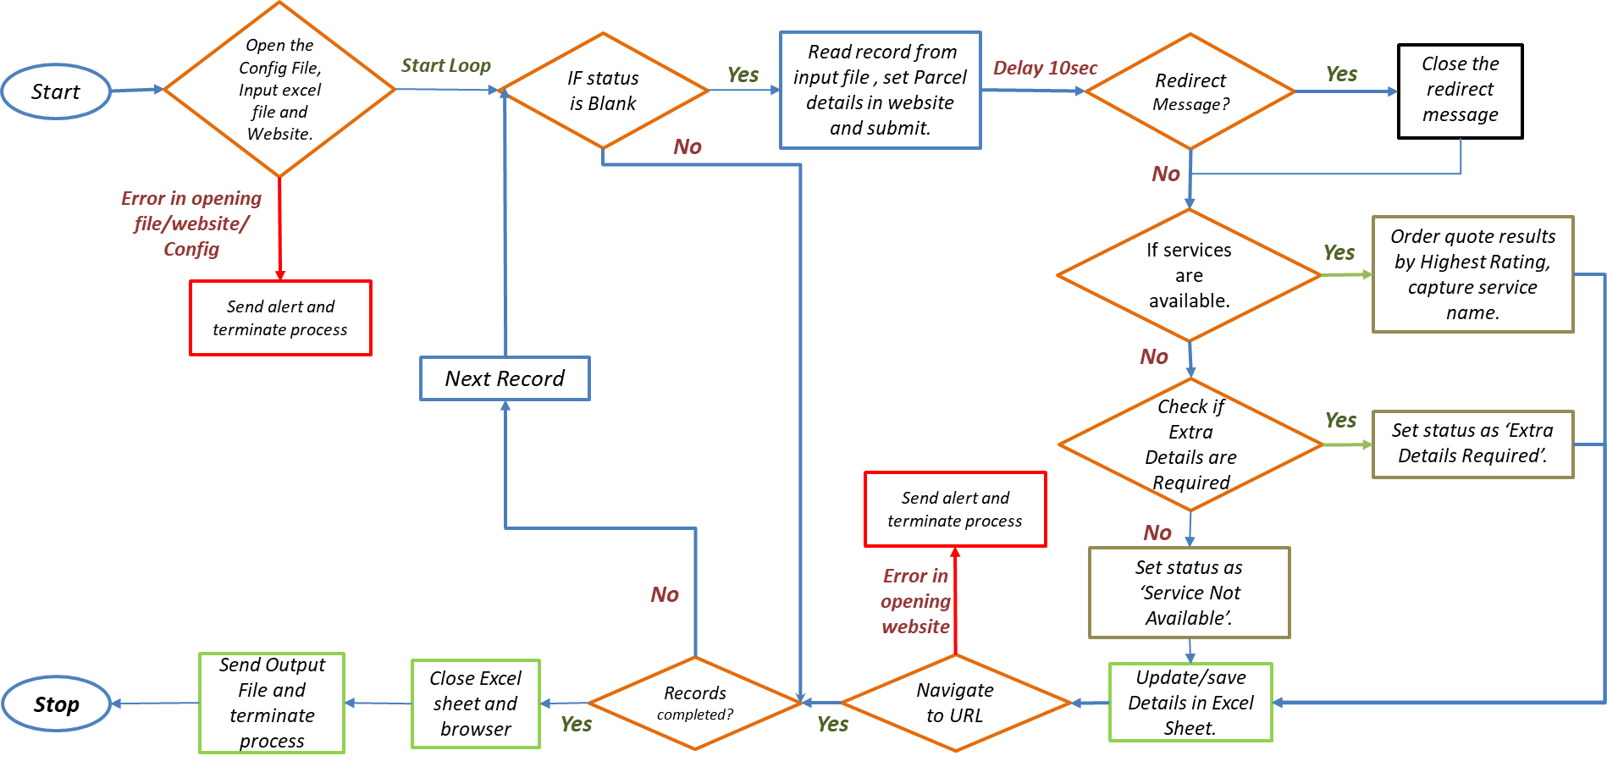

|  |  |
| --- | --- |
| Step | **Short Description of Key Process Steps** |
| 1.1 | Open: <https://www.parcelmonkey.co.uk/> |
| 1.2 | Set Collect from, Delivering to and Weight fields in webpage |
| 1.3 | Click on Get Quote and Book option and wait for webpage to load |
| 1.4 | Extract the Delivery Service Name based on highest rating and update the status in Excel file |
| 1.5 | Send an Email with Excel file as attachment to the customer |

### Solution Description

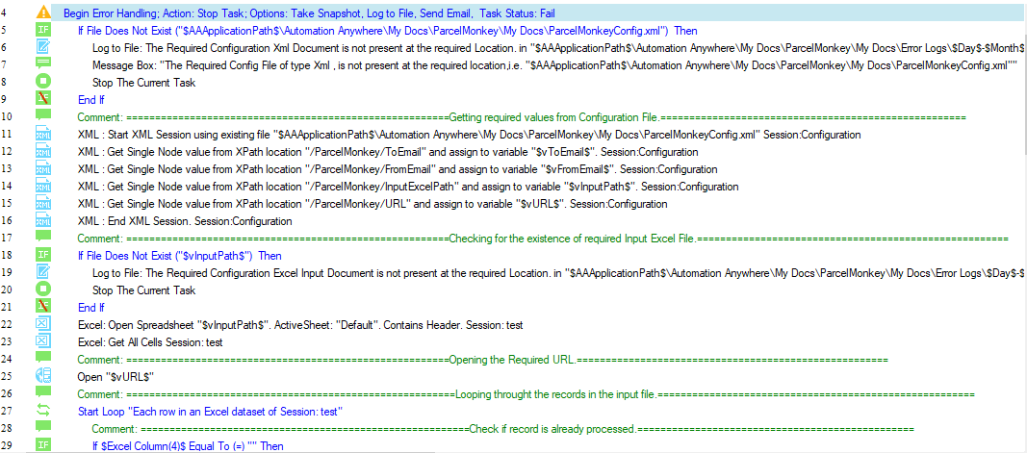

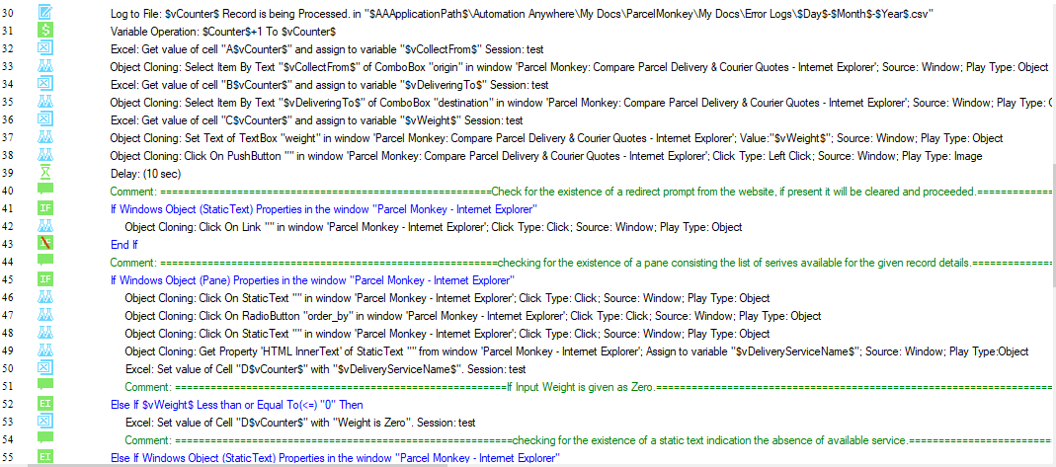

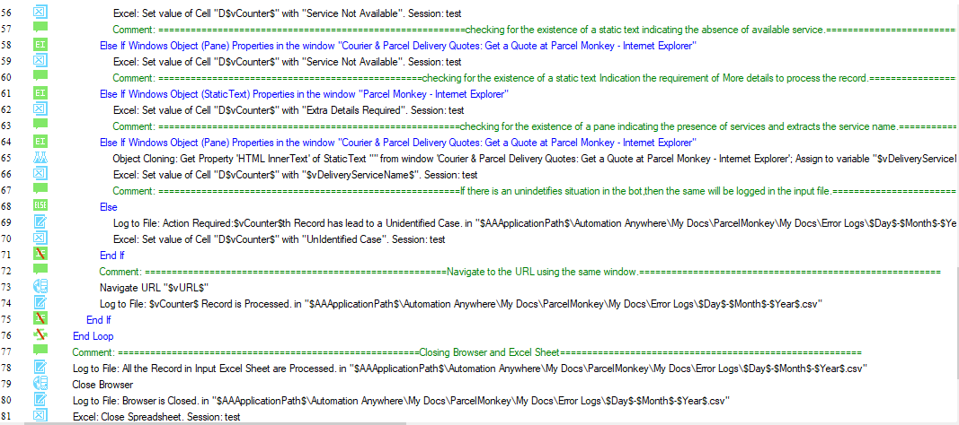



Step 1: In this step, we are using an Error handling command to handle any unexpected system error. If any error occurs in between execution of program, then the error handling options such as Take Snapshot, Run task again and save log data into file are used.

Step 2: A log file is created to log whether a Config file exists or not. Then, if file does not exist command is used to check whether the Config file exists or not.

Step 3: If file does not exist, then it is logged as “The Required Configuration Xml Document is not present at the required Location” into the log file and ends the task.

Step 4: If file exists, then an XML session is started and it reads the required information from the document, stores them in respective variables and ends the session.

Step 5: A log file is created to log whether a Excel file exists or not. Then, if file does not exist command is used to check whether the Excel file exists or not.

Step 6: If file does not exist, then it is logged as “The Required Configuration Excel Input Document is not present at the required Location.” into the log file and ends the task.

Step 7: If file exists, then the excel file is opened using the Open Spreadsheet command keeping Active sheet as default, contains header and session named as test.

Step 8: It checks whether the status cloumn of input excel file is NULL or not by using Excel Column(4) command. If it is NULL, it reads the source, destination and weight fields and stores them in respective variables and then step 10 to step 25 will be processed. If it is not NULL, it logs the log file as “All the Records in Input Excel Sheet are Processed” and follows step 22 to step 25.

Step 9: Open the webpage-<https://www.parcelmonkey.co.uk/> using using Open browser command of Web Recorder.

Step 10: Click on Collect from tab on the webpage by using Object Cloning-Click on Link command and set the field with corresponding variable.

Step 11: Click on Delivering to tab on the webpage by using Object Cloning-Click on Link command and set the field with corresponding variable.

Step 12: Click on Parcel weight tab on the webpage by using Object Cloning-Click on Link command and set the field with corresponding variable.

Step 13: Click on Get Quote and Book tab on the webpage by using Object Cloning-Click on Link command.

Step 14: A delay of 5 seconds is used so as to ensure that the webpage has loaded completely.

Step 15: If website is redirected, it checks the static text “Redirected from Parcel Monkey Uk” by using If Windows Object (StaticText) Properties command. Then, it closes the pop-up by using Object Cloning-Click on Link command.

Step 16: If website opens the page containing delivery services, it checks the pane of services by using If Windows Object (Pane) Properties command. Then, it clicks on Order by Highest Rating option by using Object Cloning-Click on RadioButton command and and extracts the delivery service name by using Get Property HTML Inner Text of Static Text command and updates the status in excel file with the Service Name.

Step 17: If given weight is zero/null, then it updates the status as “Weight is Zero” in excel file.

Step 18: If website does not have any available services for the given details, then it checks the static text “Service Not Available” by using If Windows Object (StaticText) Properties command and updates the status as “Service Not Available” in excel file.

Step 19: If webpage is asking any extra details, then it checks the static text “Shipping Calculator” by using If Windows Object (StaticText) Properties command and updates the status as “Extra Details Required” in excel file.

Step 20: If any case apart from the above cases is encountered, then it is updated as “Unidentified Case” in the excel file and logs the same in log file.

Step 21: The URL is freshly opened for each record of excel using Navigate URL command.

Step 22: The browser is closed by using Close Browser command and the same is logged into the log file.

Step 23: The Input Excel file is closed by using Close Spreadsheet command and te same is logged into the log file.

Step 24: An Email with Excel file containing the Delivery Service names as attachment is sent to the customer by using Send Email command and logs the same into the log file.

Step 25: Error Handling is ended by using End Error Handling command.

# Security and Credentials

### Data Storage

The data that is extracted that is the Delivery Service Name is saved in an Excel Sheet at the location:

$AAAPPLICATIONPATH$\AutomationAnywhere\My Docs\ParcelMonkey\My Docs\Parcel Monkey.xlsx

# Assumptions

### Technical

We assume that the website URL that we are using for web recorder and object cloning are not subject to change.