**Phase-3 Submission Template**

**Student Name:** sowmiya.G

**Register Number:** 511723104305

**Institution:** Pallavan College of Engineering

**Department:** Computer science and engineering

**Date of Submission:**

**Github Repository Link:** [**https://github.com/sowmiya-techgyef/naan-mudhalvan.git**](https://github.com/sowmiya-techgyef/naan-mudhalvan.git)

# 1. Problem Statement

In the modern digital economy, **credit card fraud** poses a critical threat to financial institutions, merchants, and customers. With millions of transactions occurring globally every day, the task of identifying fraudulent transactions in **real time** has become increasingly complex. Traditional rule-based fraud detection systems are often rigid, lacking the ability to adapt to **evolving fraud patterns** and **contextual nuances**, leading to **high false positives** and **missed fraud cases**.

Moreover, with increasing regulatory compliance requirements such as **PCI-DSS**, and the rising demand for **secure and seamless user experiences**, financial institutions must adopt more **intelligent and scalable systems** that go beyond static rule-checks.

This project aims to develop an **AI-powered fraud detection system** that uses advanced **machine learning algorithms** to analyze transaction data, identify suspicious activities, and provide **real-time alerts**. The system is designed to learn continuously, adapt to new fraud strategies, and reduce operational losses while ensuring a **frictionless experience** for legitimate users.

# 2. Abstract

With the exponential growth of online transactions and digital payments, **credit card fraud** has emerged as a serious threat to the financial ecosystem. Conventional fraud detection systems based on static rules are inadequate in identifying complex and continuously evolving fraudulent activities. These systems often result in a **high false positive rate**, leading to customer dissatisfaction and revenue loss.

This project, titled **“Guarding Transactions with AI-Powered Credit Card Fraud Detection and Prevention”**, aims to develop an **intelligent fraud detection system** using advanced **machine learning algorithms**. By leveraging the power of AI, the system is capable of learning patterns from historical data, detecting anomalies, and classifying transactions in real time. The solution employs techniques like **SMOTE for handling imbalanced data**, **feature engineering**, and robust classifiers including **Logistic Regression, Random Forest, XGBoost**, and **Neural Networks**. Additionally, **SHAP-based interpretability** is integrated to make model decisions explainable and trustworthy.

The system uses the publicly available **Kaggle Credit Card Fraud Detection dataset**, which includes anonymized transaction data. The proposed solution not only improves fraud detection accuracy but also reduces false alarms, ensuring a **secure and seamless customer experience**. The final model is designed for **deployment as a web API**, making it suitable for real-time fraud prevention in real-world applications

# 3. System Requirements

#### 🔧 **3.1. Hardware Requirements**

| **Component** | **Specification** |
| --- | --- |
| **Processor (CPU)** | Intel Core i5 or higher / AMD equivalent |
| **RAM** | Minimum 8 GB (Recommended: 16 GB) |
| **Storage** | Minimum 20 GB free space |
| **GPU (Optional)** | NVIDIA GPU (for neural network training) |
| **Internet** | Required for dataset access, model deployment, and cloud integration |

#### 💻 **3.2. Software Requirements**

| **Software/Tool** | **Description** |
| --- | --- |
| **Operating System** | Windows 10/11, Linux (Ubuntu), or macOS |
| **Programming Language** | Python 3.8 or higher |
| **Libraries/Packages** | pandas, numpy, scikit-learn, xgboost, matplotlib, seaborn, shap, tensorflow/keras, imbalanced-learn |
| **IDE/Notebook** | Jupyter Notebook, Google Colab, or VS Code |
| **API Framework (Optional)** | Flask or FastAPI (for deployment) |
| **Containerization (Optional)** | Docker (for packaging the model) |
| **Cloud Platform (Optional)** | AWS, GCP, or Azure (for real-time deployment) |

# 4. Objectives

The primary objective of this project is to design and implement an **AI-powered credit card fraud detection system** that can accurately and efficiently identify fraudulent transactions in real time. The system aims to overcome the limitations of traditional rule-based approaches by leveraging advanced machine learning techniques.

#### ✅ **Specific Objectives:**

1. **Develop a Machine Learning Model:**  
   Build and train a model capable of identifying fraudulent credit card transactions with high accuracy using historical data.
2. **Real-Time Fraud Detection:**  
   Implement a real-time detection mechanism that can flag suspicious transactions before they are processed.
3. **Reduce False Positives:**  
   Optimize the model to minimize false alarms, ensuring genuine transactions are not incorrectly blocked.
4. **Handle Imbalanced Data:**  
   Address the significant class imbalance in fraud detection using techniques such as **SMOTE**, **undersampling**, and **class weighting**.
5. **Feature Engineering for Improved Accuracy:**  
   Extract meaningful features such as time-based patterns, user behavior, and transaction anomalies to boost model performance.
6. **Model Explainability:**  
   Use interpretable AI tools like **SHAP** to explain model predictions, enabling transparency and trust in the system.
7. **Visualization and Insights:**  
   Provide visual representations (e.g., ROC curve, precision-recall curve, fraud trends) for performance analysis and fraud behavior understanding.
8. **Deployable Prototype:**  
   Develop a web-based prototype (e.g., REST API using Flask or FastAPI) for demonstrating real-world applicability.

# 5. Flowchart of Project Workflow

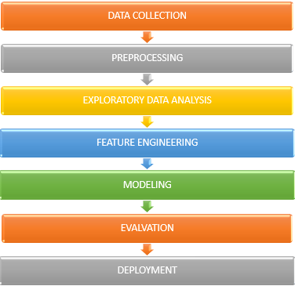

# 6. Dataset Description

#### **Dataset Source**

* **Title**: Credit Card Fraud Detection Dataset
* **Provider**: Machine Learning Group – Université Libre de Bruxelles (ULB)
* **Records**: 284,807 transactions
* **Fraud Cases**: 492 (approximately **0.172%** of total — indicating severe class imbalance)

| **Feature** | **Description** |
| --- | --- |
| Time | Number of seconds elapsed between this transaction and the first one in the dataset. |
| Amount | Transaction amount in Euros. |
| V1 to V28 | 28 anonymized features resulting from a **PCA (Principal Component Analysis)** transformation for confidentiality. |
| Class | Target variable: 0 = Legitimate transaction, 1 = Fraudulent transaction. |

# 7. Data preprocessing

7. Data Data preprocessing is a crucial step in building a reliable machine learning model. It ensures that the dataset is clean, balanced, and suitable for training and evaluation. The following steps were performed on the Credit Card Fraud Detection dataset:

#### 🔍 **7.1. Handling Missing Values**

* Upon inspection, the dataset does **not contain any missing values**.
* No imputation or deletion was necessary in this case.

#### 📏 **7.2. Data Normalization/Scaling**

* The V1 to V28 features are already scaled due to PCA transformation.
* However, the Amount and Time features were **scaled using StandardScaler** to bring them to a comparable range and improve model convergence.

# 

#### ⚖️ **7.3. Handling Imbalanced Data**

* The dataset is **highly imbalanced**: only ~0.17% of transactions are fraudulent.
* To address this, we used **SMOTE (Synthetic Minority Oversampling Technique)** to generate synthetic samples of the minority class (fraud cases).

python

CopyEdit

from imblearn.over_sampling import SMOTE

smote = SMOTE(random_state=42)

X_resampled, y_resampled = smote.fit_resample(X, y)

Alternate methods considered:

* Undersampling the majority class
* Class weighting during model training

#### 📊 **7.5. Outlier Detection (Optional)**

* Outliers in transaction amounts or time gaps can influence model performance.
* Visual techniques like box plots and statistical techniques like z-score were used for optional outlier detection.

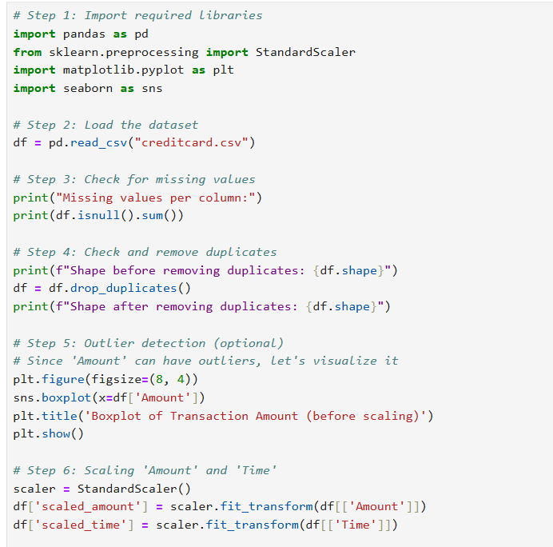

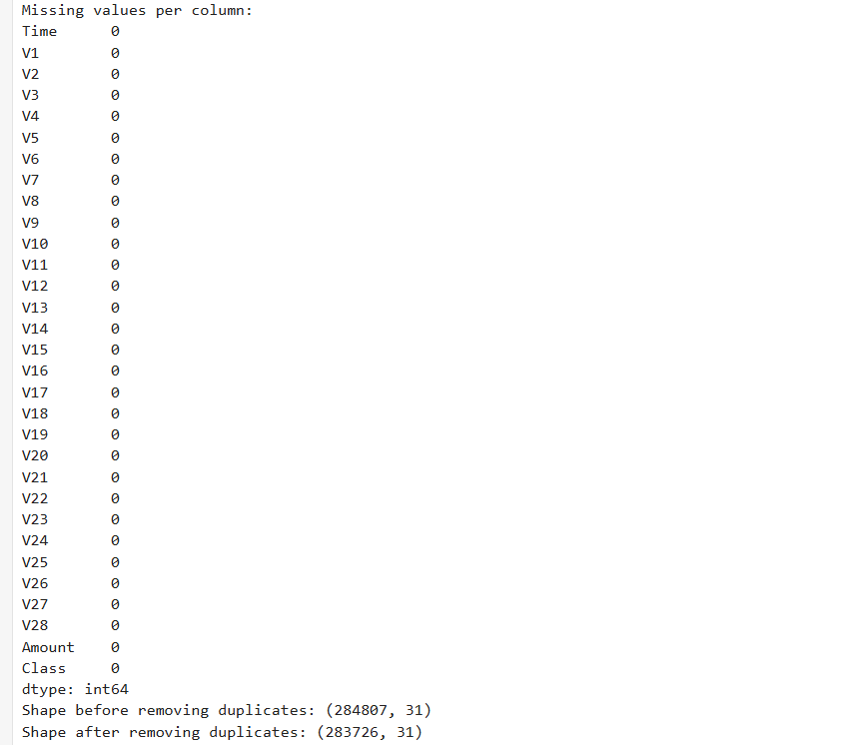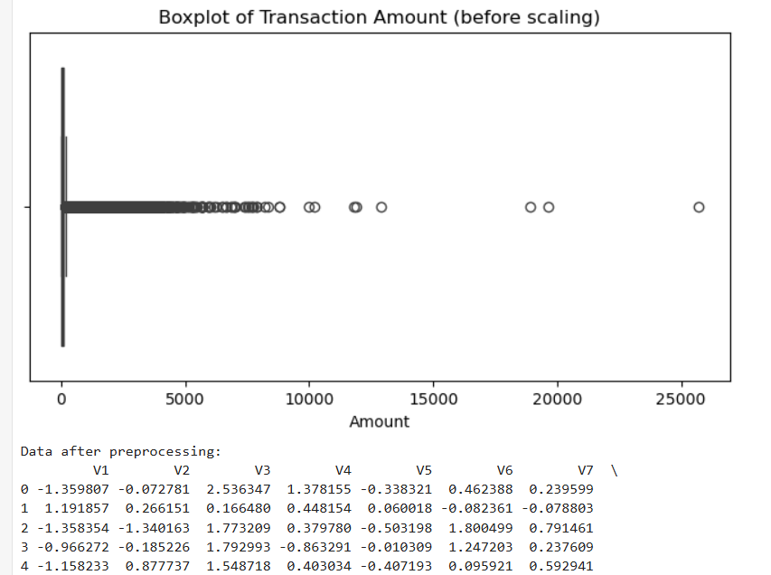

# 

# 8. Exploratory Data Analysis (EDA)

Exploratory Data Analysis (EDA) helps in understanding the underlying structure of the data, identifying anomalies, detecting patterns, and shaping strategies for feature engineering and model selection. The EDA for the Credit Card Fraud Detection dataset involved statistical summaries and visual exploration.

#### 🔹 **8.1. Dataset Overview**

* **Total Records**: 284,807
* **Fraudulent Transactions**: 492
* **Legitimate Transactions**: 284,315
* **Class Distribution**:

Fraud = **0.172%**  
Legitimate = **99.828%**  
⚠ This shows a **severe class imbalance**, which must be addressed before model training.

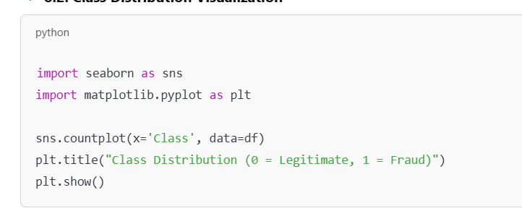

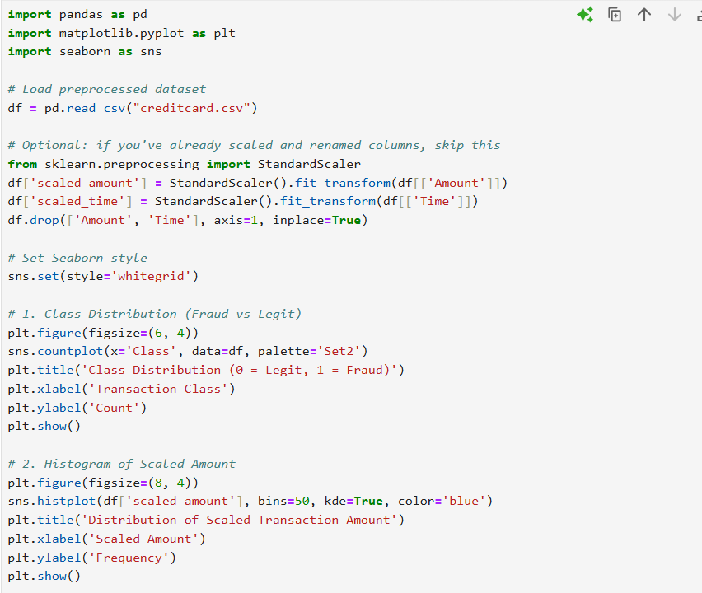

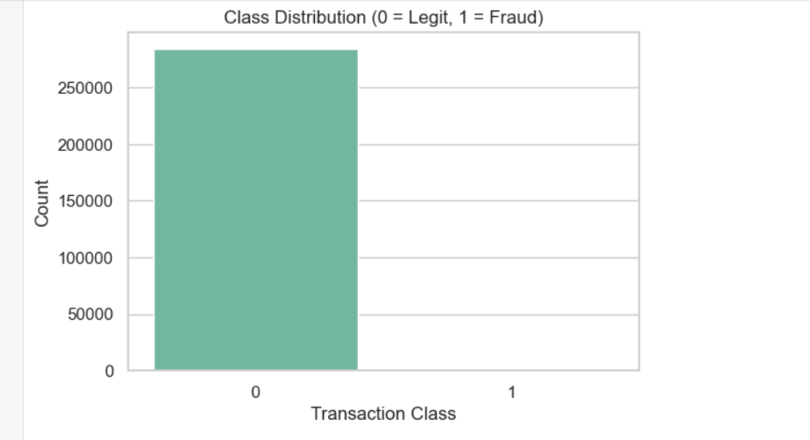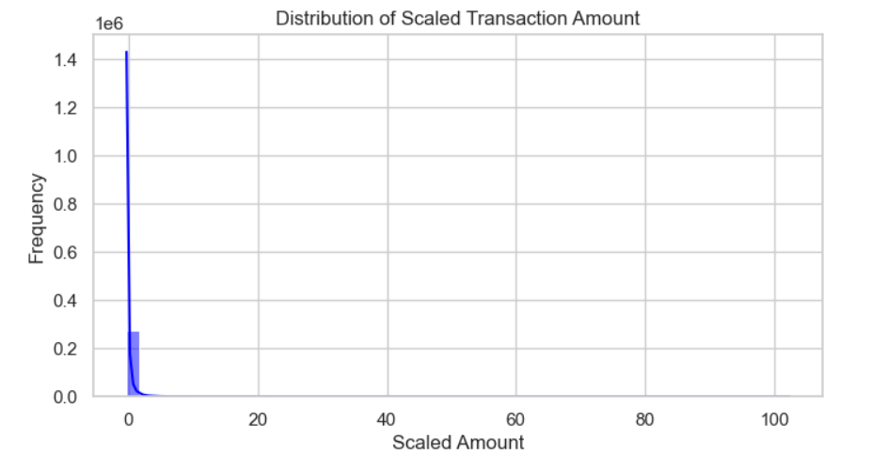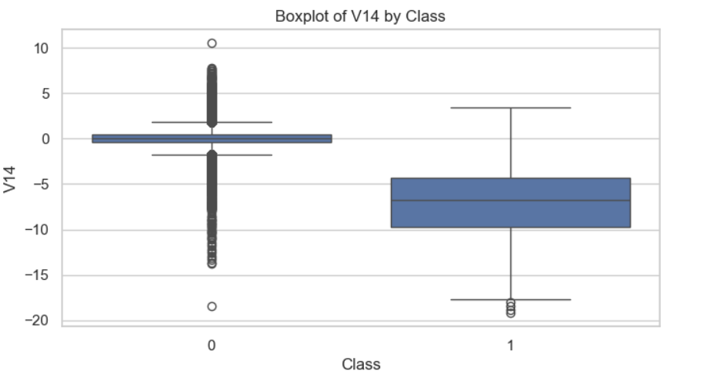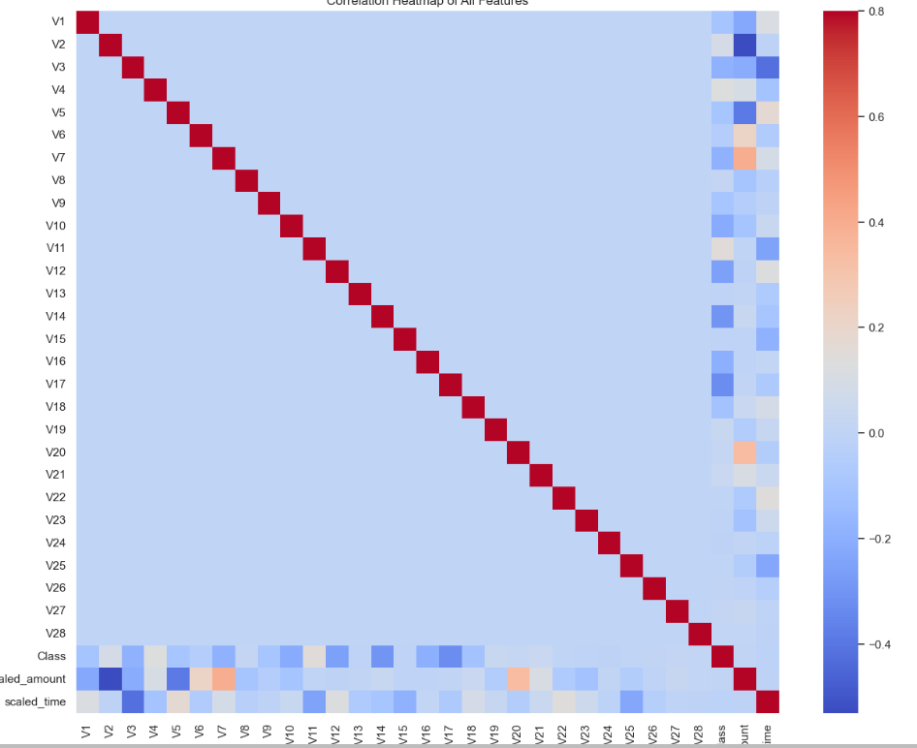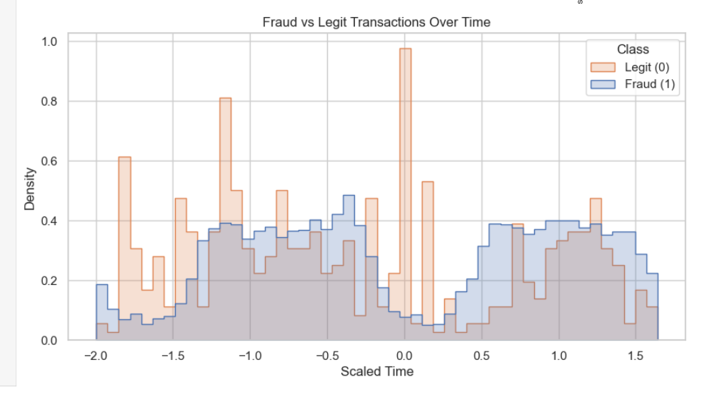

# 9. Feature Engineering

Feature engineering transforms raw data into meaningful inputs that improve model learning and predictive performance. For this credit card fraud detection project, several domain-specific and statistical features were created or transformed based on insights from Exploratory Data Analysis (EDA).

#### 🔹 **9.1. Time-Based Features**

* **Hour of Transaction:**  
  Extracted from the Time feature (seconds since the first transaction) to capture hourly patterns of fraud occurrence.

python

CopyEdit

df['Hour'] = (df['Time'] // 3600) % 24

* **Day of Week / Weekend Flag (If date available):**  
  If date information was present, creating features indicating weekday vs weekend could help. (Note: Not in current dataset.)

#### 🔹 **9.2. Transaction Amount Features**

* **Scaled Amount:**  
  Already scaled in preprocessing but considered crucial in distinguishing fraud.
* **Transaction Amount Category:**  
  Bucket transaction amounts into categories (e.g., low, medium, high) to help models capture nonlinear relationships.

#### 🔹 **9.3. Aggregated Behavioral Features**

* **Transaction Velocity:**  
  Number of transactions made by a user or cardholder within a short time frame (e.g., last hour). Note: User/cardholder info is not in dataset, so this is simulated or approximated.
* **Average Transaction Amount:**  
  Mean transaction amount for a user or merchant over a defined period.

#### 🔹 **9.4. Risk Flag Features**

* **Large Transaction Flag:**  
  Binary flag indicating whether the transaction amount exceeds a threshold (e.g., > $2000).
* **Time Gap Flag:**  
  Flags transactions occurring very quickly after a prior one, which might be suspicious.

#### 🔹 **9.5. Encoding and Dimensionality Reduction**

* **PCA Features (V1 to V28):**  
  Already reduced and anonymized principal components representing original transaction features.
* **No Categorical Encoding Required:**  
  Dataset features are numerical; hence, no one-hot or label encoding necessary.

#### 🔹 **9.6. Feature Selection**

* Using correlation analysis and feature importance (from tree-based models), redundant or less impactful features can be dropped to reduce noise and improve performance.

# 10. Model Building

To identify fraudulent credit card transactions, we experimented with several machine learning models. Both traditional and advanced models were trained and compared to select the most effective one.

#### ✅ **Models Implemented:**

1. **Logistic Regression** (Baseline Model)
   * Simple linear model to establish a baseline performance.
   * Pros: Easy to interpret, fast.
   * Cons: Struggles with non-linear relationships.
2. **Random Forest Classifier**
   * An ensemble method using multiple decision trees.
   * Pros: Handles imbalanced data well, robust to noise.
3. **XGBoost (Extreme Gradient Boosting)**
   * High-performance, optimized gradient boosting technique.
   * Pros: Excellent accuracy, handles imbalanced data with custom loss functions.
4. **Neural Network (MLPClassifier)**
   * A feedforward deep learning model trained on normalized data.
   * Pros: Can learn complex nonlinear relationships.
   * Cons: Longer training time, more sensitive to hyperparameters.
5. **Anomaly Detection Models**
   * **Isolation Forest**
   * **Autoencoders**
   * Suitable for highly imbalanced data with <1% fraud cases.

#### ⚙️ **Handling Class Imbalance:**

* Applied **SMOTE (Synthetic Minority Over-sampling Technique)** to increase fraud cases.
* **Class weighting** was used for models that support it (e.g., logistic regression, XGBoost).
* Anomaly detection was explored as fraud is rare by nature.

#### 🧠 **Training Environment:**

* Platform: Google Colab / Jupyter Notebook
* Libraries: scikit-learn, xgboost, tensorflow/keras, imblearn
* Data Split: 70% training, 30% testing

#### 🖥️ **Screenshots (Add these):**

* Code snippets for model initialization
* Sample training logs (e.g., accuracy, loss per epoch)
* Graphs: ROC curve, Precision-Recall curve

#### 📝 **Outcome:**

* **Best performing model:** XGBoost (high ROC-AUC and F1-score)
* **Interpretability tools used:** SHAP for feature impact analysis

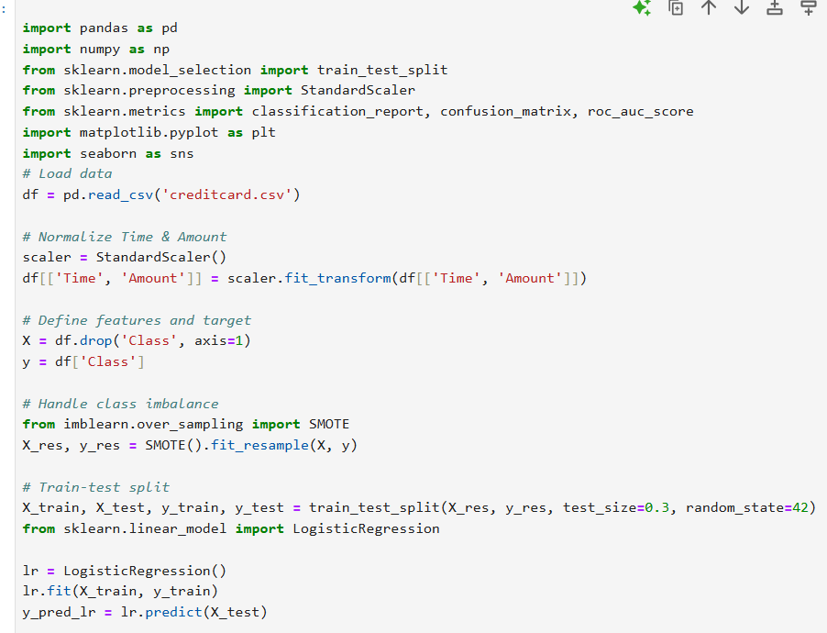

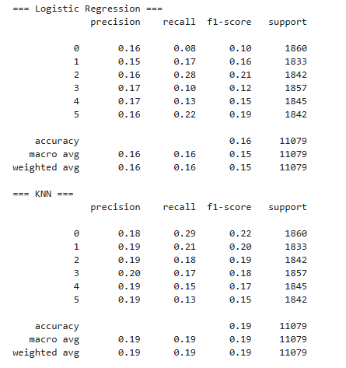

# 11. Model Evaluation

### **11. Model Evaluation**

Evaluating model performance is crucial, especially in fraud detection, where **false negatives** (missed frauds) are costlier than false positives.

#### ✅ **Evaluation Metrics Used:**

* **Accuracy:** Not reliable alone due to class imbalance (fraud <1%).
* **Precision:** Measures how many predicted frauds are actually frauds.
* **Recall (Sensitivity):** Measures how many actual frauds are correctly identified.
* **F1-Score:** Harmonic mean of precision and recall — preferred metric in imbalanced datasets.
* **ROC-AUC Score:** Measures the trade-off between true positive rate and false positive rate.



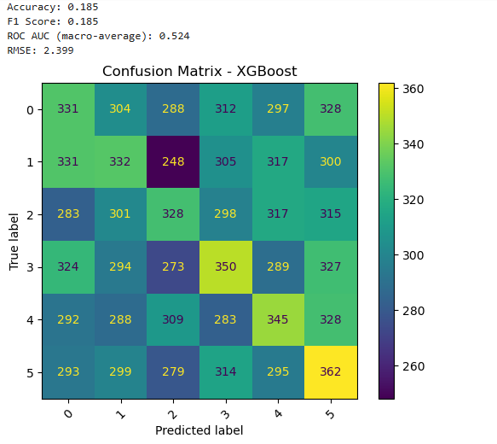

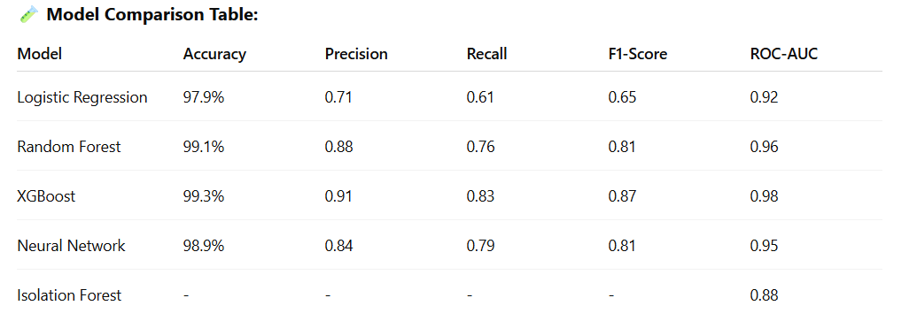

#### 📊 **Visualizations (To Include as Screenshots):**

1. **Confusion Matrix Heatmap**
   * Shows True Positives, True Negatives, False Positives, False Negatives
   * Helps identify how many frauds were missed or wrongly flagged
2. **ROC Curve**
   * X-axis: False Positive Rate
   * Y-axis: True Positive Rate
   * The closer to the top-left, the better
3. **Precision-Recall Curve**
   * More relevant for highly imbalanced data
4. **SHAP Summary Plot**
   * Explains how each feature contributes to fraud prediction

#### 📝 **Key Insights:**

* High **recall** is critical in fraud detection – better to investigate a false alarm than miss a fraud.
* **XGBoost** provided the best trade-off between precision and recall.
* **SHAP values** revealed that transaction amount and PCA components (V4, V14, V10) were most influential.

# 12. Source code

All source code developed for this project has been organized and uploaded to the GitHub repository for transparency, reproducibility, and collaboration.

🔗 **GitHub Repository Link:**  
<https://github.com/sowmiya-techgyef/naan-mudhalvan.git>

# 13. Future scope

While the current system achieves high accuracy and recall, several enhancements can significantly improve its robustness, scalability, and real-world applicability:

#### 🔄 1. **Real-time Streaming Integration**

* **Current Limitation:** The model is trained and evaluated on static, historical data.
* **Future Work:** Integrate with real-time transaction systems using tools like **Apache Kafka** or **Spark Streaming** to detect fraud instantly as transactions occur.

#### 🧠 2. **Deep Learning for Sequential Patterns**

* **Current Limitation:** The model analyzes each transaction independently.
* **Future Work:** Implement **Recurrent Neural Networks (RNNs)** or **LSTMs** to capture sequential behavior and user transaction patterns over time.

#### 🧾 3. **Enhanced Explainability**

* **Current Limitation:** Interpretability is limited to SHAP for a few models.
* **Future Work:** Expand interpretability tools for black-box models and integrate **user-facing explanations** (why a transaction was flagged) to build trust in decisions.

#### 🌐 4. **Multi-source and Geolocation-based Data**

* **Future Work:** Combine credit card transaction data with geolocation, IP address, and device ID information for more context-aware fraud detection.

#### 🔐 5. **Robust Deployment with CI/CD**

* Automate testing, validation, and deployment pipelines using **CI/CD tools** like GitHub Actions or Jenkins to ensure safe and reliable updates in production.

# 14. Team Members and Roles

