**Smart Water Management system**

**Introduction:**

**Smart water management is the activity of planning , developing, distributing and managing the use of water resources using an array of IOT technology .Which are designed to increase transparency and make more reasonable.**

**Hardware Components:**

1. **Ultrasonic sensor**
2. **pH sensor**
3. **Digital thermometer sensor**
4. **Turbidity sensor**
5. **RF module.**

**Software components:**

1. **Git application**
2. **Visual studio code**
3. **Programming language (python)**

**Design for smart water fountain:**

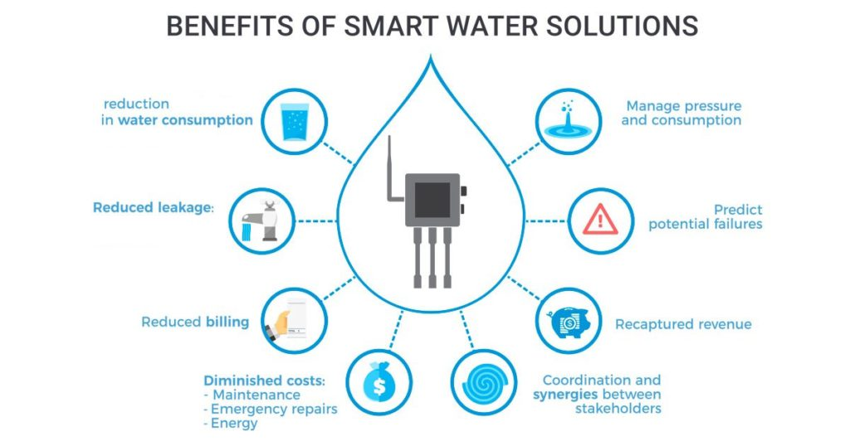

**INNOVATIVE SOLUTIONS :**

**Smart Water Monitoring and Management Systems, based on the combination of sensors, big data and AI technologies, can provide to water utility operators, farmers and companies the ability to measure, monitor and control their water distribution networks as well as the quality of the water distributed.**

**5 INNOVATIVE STEPS OF SMART WATER MANAGEMENT :**

1. **Reducing waste of water-intensive industries :**

**Real-time water metering and other applications such as smart irrigation systems or crop water management systems can help farmers reduce waste while maintaining soil health, improving water conservation, and increasing crop yield.**

1. **Monitoring water quality to fight pollution and diseases :**

**Sensors and IoT technology for real-time monitoring and control can help monitor and prevent pollution and even improve the water quality.**

1. **Improving the efficiency of water systems :**

**By monitoring the pressure, flow, moisture, temperature, time difference between points and other parameters directly within the systems, the IoT can facilitate maintenance prediction and avoid breakage, leakage, and equipment downtime.**

1. **Creating awareness of household water use thanks to smart meters :**

**Individual consumers can now make savings by lowering their water bill while preserving water supplies on a daily basis.**

1. **Providing running water through innovative solutions all around the world :**

**People with irregular or low incomes are faced with daily hardships in procuring water.**

**DEVELOPMENT OF SMART WATER :**

1. **Improve water quality**
2. **Implement leakage control**
3. **Reduce wasting water**
4. **Transparency.**

**IMPROVE WATER QUALITY :**

**IoT sensors are used to measure various parameters of water quality, such as pH, temperature, dissolved oxygen, and the presence of chemicals and microorganisms. These sensors can be placed in rivers, lakes, and other bodies of water, and they can transmit data in real-time to a central monitoring system.**

**IMPLEMENT LEAKAGE CONTROL :**

**Leakage control work involves the following major steps: Preparatory work: updating maps, databases of consumer connections, residing population, water mains, valves and fire hydrants etc.; planning of activities. Test for loss assessment and locating the defects (leak detection).**

**REDUCE WASTEING WATER :**

**The development of smart techniques requires technology use in the water systems as well as its implementations. Smart water systems are used to improve the situation of many networks characterized by degraded infrastructure, irregular supplies, and low levels of customer satisfaction or substantial deviations of the proportional bills to real consumption. A smart water system can lead to more sustainable water services, reducing financial losses, enabling innovative business models to serve the urban and rural population better**

**TRANSPARENCY :**

**IoT technologies which are designed to increase transparency, and make more reasonable and sustainable usage of these water resources.**

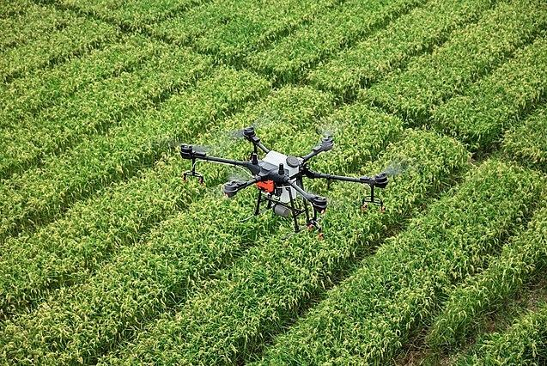

**DEVELOPMENT OF SMART WATER :**

* + **IoT water management systems leverage numerous sensors that collect real-time insights on how resources are used.**
  + **These devices transmit the gathered data to the user’s application online**
  + **This information empowers analysis of consumption patterns and encourages more rational water consumption.**

**SMART CITY WATER MANAGEMENT :**

* + **With the help of sensors, a smart city water management system can enable you to collect real-time data—information that helps you visualize water distribution across the network. Residents with smart meters can make more informed decisions.**
  + **Water waste and disrupted water supply chains are a drain on the city’s budget. IoT can help you watch the health of water equipment and detect problems, like leaks in pipes.**

**REAL WORLD EXAMPLE :**

**SMART IRRIGATION OF CITY PARKS :**

* + **The solution calculates the amount of water each area needs depending on the state of the soil, weather forecast, and irrigation calendar. If something goes wrong, such as a leak, the authorities are alerted right away and they’re even shown the location.n**

**MAIN BENEFITS :**

1. **Better transparency in water**
2. **Fewer incidents**
3. **Enhanced control over the water supply**
4. **Saved city budget**
5. **Improved city sustainable management**

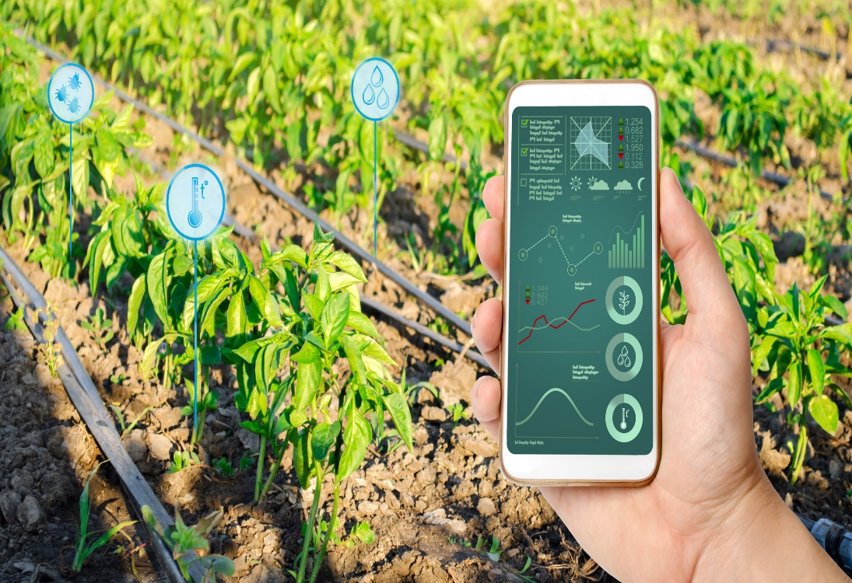

**SMART DAM MONITORING :**

* + **IoT sensors remotely watch water levels at each dam site. The system sends instant alerts if flooding is possible. With smart capabilities, there’s no need to send staff to measure water levels on site. The system even has pre-programmed formulas that replace manual calculations.**

**MAIN BENEFITS :**

* + **Real-time water level monitoring**
  + **Better dam functionality**
  + **Enhanced dam reliability**
  + **Faster decision-making**
  + **Saved time and resources**

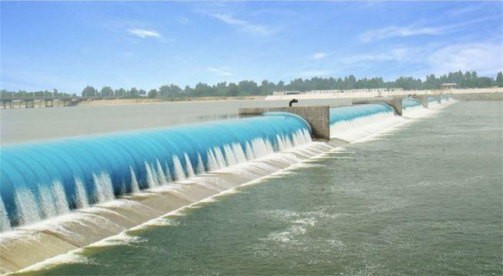

**Conclusion:**

**Traditionally, water management policies and practices have dealt only with problems of water distribution to meet the ever-increasing demand, rather than better management of existing resources. The largely fragmented approach that results has contributed to the overexploitation of water resources.**

**Project submitted by,**

* **Name: C.Sowmiya**
* **TOPIC : Smart water management using iot**
* **Email id : sowmiyasowmiya48910@gmail.com**
* **Nan muthalvan I’d: au713921106051**
* **College code:7139**