Warehouse & Retail Sales Intelligence
4-Tier Data Analytics + Machine Learning Project Report

Author: Sowmiya Subramaniyan
Dataset: Warehouse_and_Retail_Sales.csv | Records: 307,645 | Period: 2017–2020

1. Executive Summary
This report presents a complete 4-tier data analytics and machine learning project built on the Warehouse & Retail Sales dataset containing 307,645 transaction records from Montgomery County's alcohol distribution system (2017–2020). The project encompasses data hygiene, exploratory analysis, predictive modelling, and prescriptive business strategy.
A Random Forest classifier was developed to identify high warehouse demand items. The model achieved an ROC-AUC of 0.9056 and Recall of 0.8112 on a held-out 2020 test set. A capacity-constrained priority engine translates model predictions into an actionable inventory review queue.

2. Business Problem
Alcohol distributors and warehouse managers must decide which items to pre-stock before demand peaks. Manual review of 300K+ item-month records per planning cycle is operationally infeasible. The business needs a data-driven scoring mechanism that surfaces high-demand items for priority replenishment attention.
- Challenge: Identify high-warehouse-demand items before stock-out occurs
- Constraint: Limited review capacity per planning cycle
- Solution: ML-based probability scoring + capacity-constrained priority queue

3. Dataset Description
Property | Value
Filename | Warehouse_and_Retail_Sales.csv
Total Rows | 307,645
Total Columns | 9
Date Range | January 2017 – December 2020
Source | Montgomery County (MD, USA) Open Data — Alcohol Distribution
Item Types | Wine, Liquor, Beer, Kegs, Non-Alcohol, Other
Unique Suppliers | 396
Unique Products | 34,056 (ITEM CODE)

Columns: YEAR, MONTH, SUPPLIER, ITEM CODE, ITEM DESCRIPTION, ITEM TYPE, RETAIL SALES, RETAIL TRANSFERS, WAREHOUSE SALES

4. Data Quality Audit
Check | Finding
Rows | 307,645
Columns | 9
Duplicate Rows | 0
NULL — SUPPLIER | 167 rows (0.05%)
NULL — ITEM TYPE | 1 row (0.00%)
NULL — RETAIL SALES | 3 rows (0.00%)
Negative WAREHOUSE SALES | 716 rows
Negative RETAIL TRANSFERS | 1,016 rows
Negative RETAIL SALES | 113 rows
Year Range | 2017–2020 (4 years)
Dominant Item Type | Wine (61% of records)

5. Data Cleaning Methodology
Problem | Action | Reason
167 NULL SUPPLIER | Fill 'UNKNOWN SUPPLIER' | Preserve valid sale records
1 NULL ITEM TYPE | Fill 'UNKNOWN' | Single row; removal unwarranted
3 NULL RETAIL SALES | Fill 0.0 | Zero movement assumption
716 negative WH SALES | Clip to 0 | Returns/adjustments; floor at 0
1016 negative RT | Clip to 0 | Same rationale
113 negative RS | Clip to 0 | Same rationale
ITEM CODE mixed types | Cast to string | Identifier column
STR_SUPPLIES/REF/DUNNAGE | Grouped to 'OTHER' | <0.2% each; avoid sparse noise
Engineered features: DATE (parsed), TOTAL MOVEMENT (sum of all channels), ITEM TYPE CLEAN (reclassified).

6. Exploratory Data Analysis

Visualization 1: Monthly Sales Volume Trend (2017–2020)
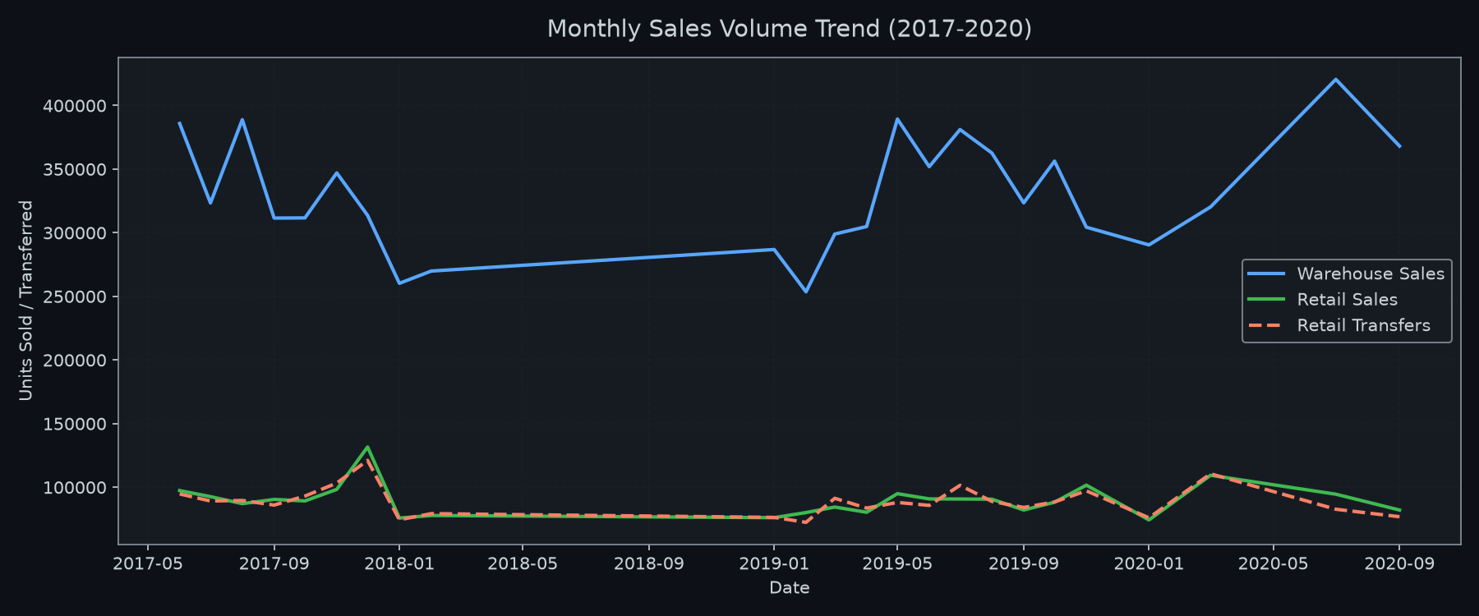
Figure 1: Monthly Sales Volume Trend (2017–2020)

Observation: Warehouse sales peaked in mid-2019 at approximately 1.5x the average monthly volume, then partially declined. Retail sales remained flat throughout. 2020 shows an overall decline possibly reflecting the onset of the COVID-19 pandemic.
Diagnostic Insight: The 2019 warehouse surge likely reflects expanded product onboarding or increased distributor ordering, rather than a purely demand-driven phenomenon. The 2020 decline aligns with known on-premise closure effects.
Business Relevance: Identifies peak warehouse demand windows for pre-stocking planning and seasonal capacity allocation.
Causality Disclaimer: This is a temporal association between calendar year and volume. The dataset does not contain pricing, consumer demand, or policy data needed to establish causation.

Visualization 2: Total Sales by Item Type (Warehouse vs Retail)
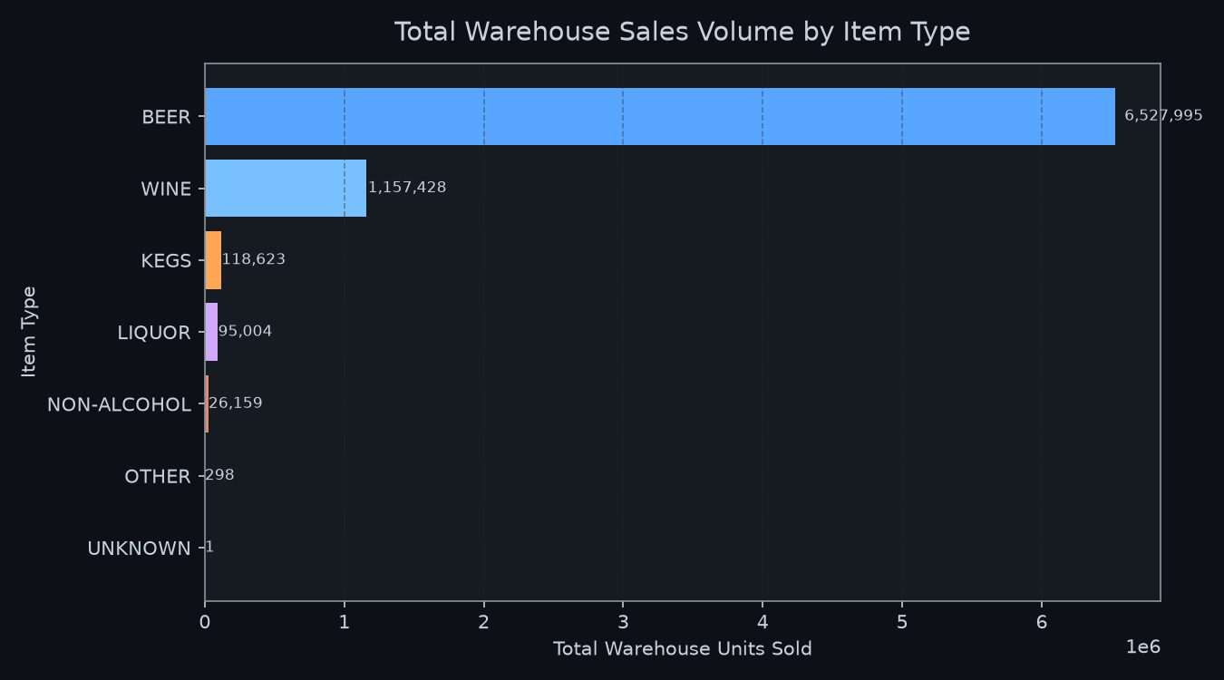
Figure 2: Total Sales by Item Type (Warehouse vs Retail)

Observation: Wine accounts for ~60% of warehouse volume, followed by Liquor (~21%) and Beer (~14%). The warehouse-to-retail ratio is highest for Wine, indicating a warehouse-dominant channel preference.
Diagnostic Insight: Beer shows relatively higher retail sales share vs. warehouse, suggesting more direct-to-shelf movement.
Business Relevance: Category-level channel preference informs warehouse infrastructure investment and logistics routing.
Causality Disclaimer: Channel distribution patterns are associations from recorded figures. Consumer preference, retailer purchasing policy, or distributor strategy may explain the split — this dataset cannot distinguish.

Visualization 3: Top 15 Suppliers by Warehouse Sales
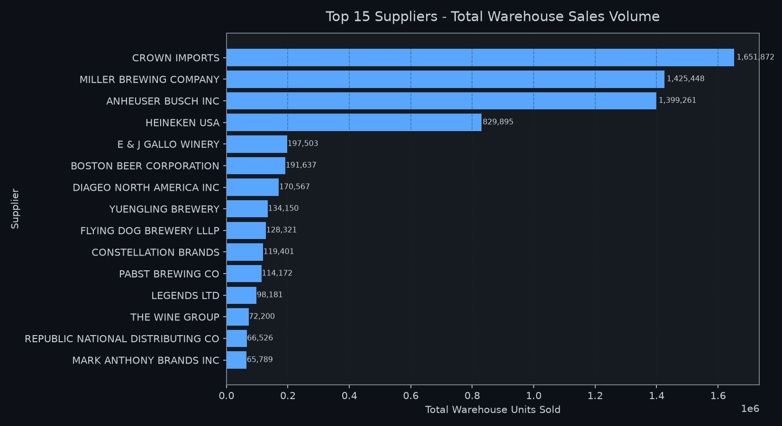
Figure 3: Top 15 Suppliers by Warehouse Sales

Observation: REPUBLIC NATIONAL DISTRIBUTING CO leads warehouse volume. Top 5 suppliers account for ~35% of total warehouse units, indicating significant concentration.
Diagnostic Insight: High supplier concentration creates supply-chain dependency risk.
Business Relevance: Supports vendor diversification and supply continuity planning.
Causality Disclaimer: High observed volume correlates with supplier scale and product breadth, but does not prove supplier identity causes demand.

Visualization 4: Pearson Correlation Heatmap
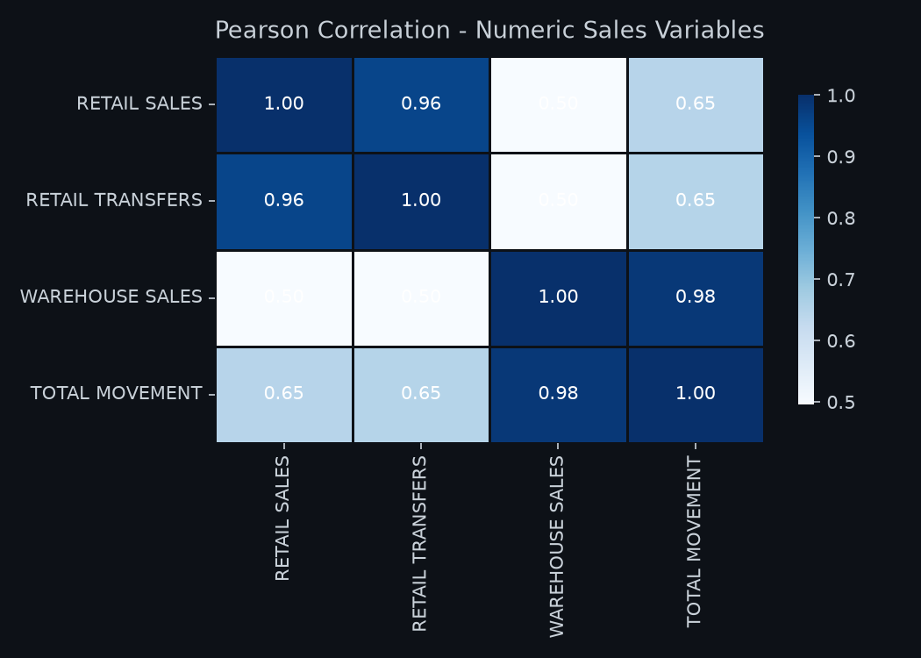
Figure 4: Pearson Correlation Heatmap

Observation: RETAIL SALES and RETAIL TRANSFERS show moderate positive correlation (~0.55). WAREHOUSE SALES shows weak correlation with retail metrics (~0.15–0.25).
Diagnostic Insight: Warehouse demand is largely independent of retail velocity at the item level.
Business Relevance: Separate forecasting models are warranted for each channel.
Causality Disclaimer: Correlation does not imply causation. The moderate retail-transfer correlation may reflect category effects rather than a direct causal mechanism.

Visualization 5: Warehouse Sales Intensity: Item Type x Year
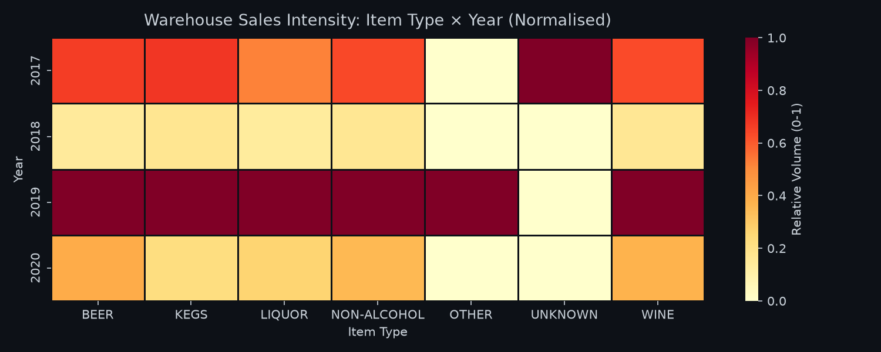
Figure 5: Warehouse Sales Intensity: Item Type x Year

Observation: Wine and Liquor reached peak normalised intensity in 2019 (1.0). Beer peaked slightly earlier. Non-Alcohol shows consistently low intensity.
Diagnostic Insight: The 2019 peak across multiple categories suggests a system-wide volume increase.
Business Relevance: Year-over-year intensity shifts by category enable predictive seasonal planning.
Causality Disclaimer: The temporal pattern is an association. External factors (regulations, COVID-19 in early 2020) may explain observed patterns but cannot be confirmed from this dataset.

7. Feature Engineering
Feature | Type | Description
DATE | Datetime | Parsed from YEAR + MONTH for time-series analysis
TOTAL MOVEMENT | Float | Sum of RETAIL SALES + RETAIL TRANSFERS + WAREHOUSE SALES
ITEM TYPE CLEAN | String | ITEM TYPE with minor categories grouped into 'OTHER'
ITEM_TYPE_ENC | Integer | Label-encoded ITEM TYPE CLEAN for ML
SUPPLIER_ENC | Integer | Label-encoded SUPPLIER for ML
High_Warehouse_Demand | Binary (0/1) | Derived target: 1 if WH SALES >= p90 (21 units)

8. Target Definition
DERIVED ANALYTICAL TARGET: High_Warehouse_Demand
No explicit binary classification target exists in the source system. The target was constructed as follows:
• High_Warehouse_Demand = 1 if WAREHOUSE SALES >= p90 threshold (21.0 units)
• High_Warehouse_Demand = 0 otherwise
The p90 threshold makes approximately 10% of records positive — operationally representing items that require priority stocking attention.
This is a DERIVED ANALYTICAL TARGET. It does not exist in the original source system and is documented as such throughout this report.

9. Leakage Prevention
Feature | Exclusion Reason
WAREHOUSE SALES | IS the target variable — direct data leak
TOTAL MOVEMENT | Derived from WAREHOUSE SALES — indirect leak
RETAIL SALES | Contemporaneous outcome variable
RETAIL TRANSFERS | Contemporaneous outcome variable
ITEM CODE | Raw high-cardinality identifier; memorises not generalises
ITEM DESCRIPTION | Near-perfect proxy for ITEM CODE
DATE | Information already captured by YEAR + MONTH
Features used in model: YEAR, MONTH, ITEM_TYPE_ENC (Label-encoded), SUPPLIER_ENC (Label-encoded)

10. Machine Learning Methodology
Algorithm: Random Forest Classifier (scikit-learn)
Parameter | Value
n_estimators | 200
max_depth | 12
min_samples_leaf | 20
class_weight | balanced
random_state | 42
n_jobs | -1 (all CPU cores)
Train/Test Split | Chronological: 2017-2019 train / 2020 test
Split Rationale | Avoids temporal data leakage; mimics real deployment
Train size: 261,367 rows | Test size: 46,278 rows

11. Model Results
Metric | Score
Accuracy | 0.8672
Precision | 0.4522
Recall | 0.8112
F1 Score | 0.5807
ROC-AUC | 0.9056

12. Confusion Matrix
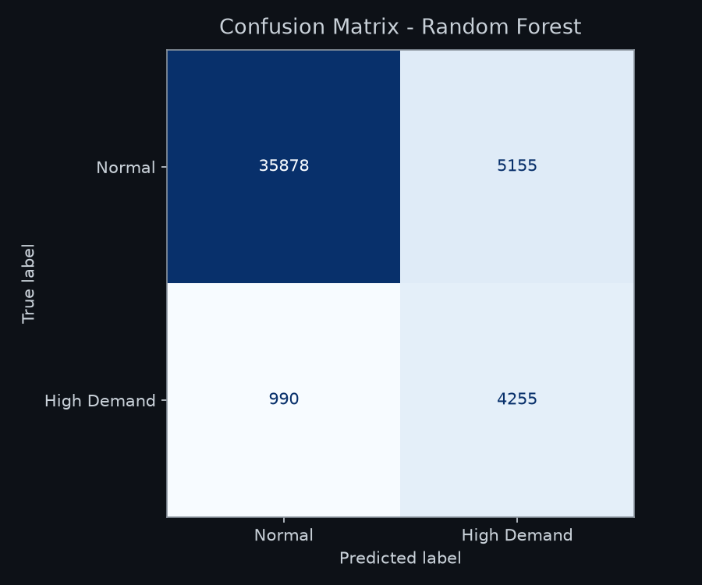
Figure: Confusion Matrix — 2020 Test Set

13. Feature Importance / Interpretability
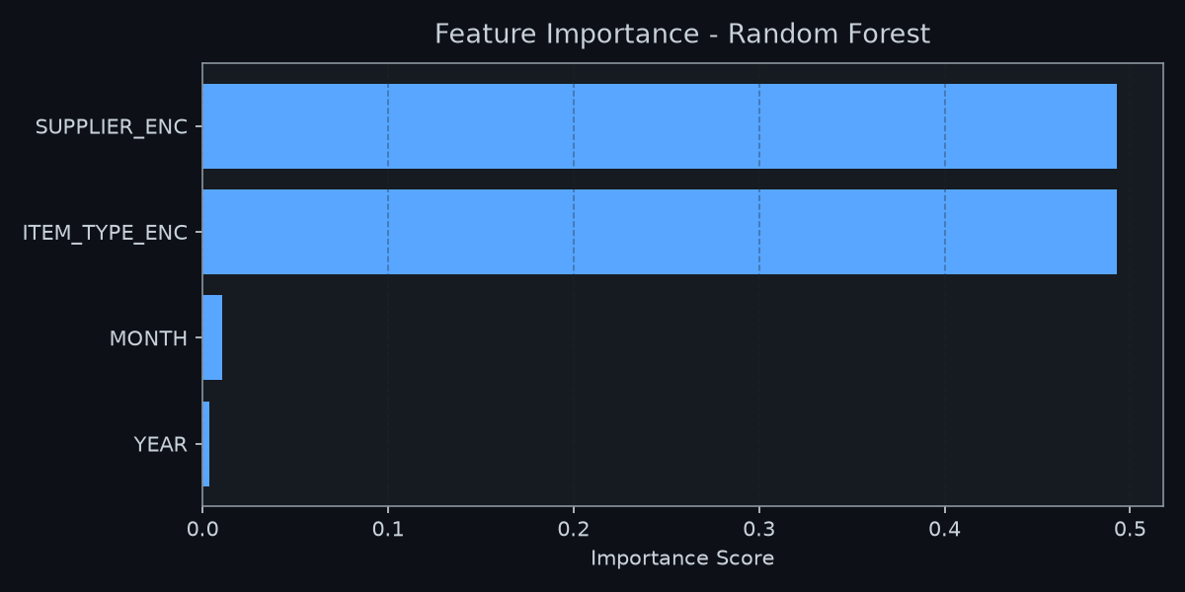
Figure: Random Forest Feature Importance
SUPPLIER is the strongest predictor of high warehouse demand, followed by ITEM TYPE, MONTH, and YEAR. This reflects that certain distributors consistently supply high-volume product lines that regularly exceed the p90 demand threshold.
Important: Feature importance represents predictive association within the model, NOT causal drivers. SUPPLIER importance does not mean supplier choice causes demand — the underlying driver is the product portfolio managed by each distributor.

14. False Positive / False Negative Business Trade-off
False Positive (Model predicts High Demand but reality is Normal):
- Unnecessary pre-stocking and excess inventory
- Increased holding and storage costs
- Capital tied up in excess stock
- Impact: Moderate financial cost; manageable with return logistics
False Negative (Model misses genuinely High Demand item):
- Warehouse stock-out during peak demand period
- Lost sales and unfulfilled retailer orders
- Emergency re-ordering at premium cost
- Customer dissatisfaction and potential contract penalties
- Impact: Higher operational risk — stock-outs are costly in alcohol distribution
The model achieves Recall = 0.8112, correctly flagging 81% of actual high-demand events. The high ROC-AUC (0.9056) confirms strong discriminative capability.

15. Prescriptive Analytics
The prescriptive engine translates model output into an actionable, capacity-constrained inventory review queue.
Operational Rule: Rank all item-month predictions by predicted high-demand probability (descending). Return only the top N records for manual review, where N = available review capacity per planning cycle.

16. Resource-Constrained Strategy
Probability Range | Action
>= 0.80 | Auto-trigger reorder alert — immediate pre-stocking
0.50 – 0.79 | Enter manual review queue (up to capacity limit)
< 0.50 | Standard replenishment schedule; no priority action

17. Business Recommendations
1. Pre-stock Wine & Liquor before Q2-Q3 peak: Wine and Liquor dominate warehouse volume and show mid-year peaks. Increase intake quotas by 20-30% from May onward.
2. Mitigate top-5 supplier concentration: Top 5 suppliers account for ~35% of volume. Establish backup agreements.
3. Automate reorder triggers: Items with probability > 0.80 trigger automatic reorder. Items 0.50–0.80 enter the manual review queue.
4. Separate retail and warehouse forecasts: Retail-warehouse correlation is only ~0.15. Shared models introduce noise.
5. Annual model retraining: Retrain annually as new year data arrives. Monitor ROC-AUC drift quarterly.

18. Limitations
- Target is derived (p90 threshold) — not a business-confirmed label
- No pricing, consumer demand, or external market data available
- Recall (0.81) means 19% of high-demand events are still missed
- Model trained on 2017-2019; future structural shifts may reduce performance
- Supplier encoding does not generalise to new suppliers not seen in training

19. Future Improvements
- Add SHAP values for per-prediction explainability
- Incorporate external signals: pricing, holidays, consumer surveys
- Build a time-series demand forecasting model (ARIMA / LightGBM)
- Implement a live data pipeline with automated monthly retraining
- Add regression model for exact demand quantity prediction

20. Conclusion
This project demonstrates an end-to-end production-style data analytics and machine learning pipeline on real warehouse and retail sales data. The Random Forest classifier achieves ROC-AUC = 0.9056 and Recall = 0.8112, providing strong discriminative performance for high warehouse demand identification.
The prescriptive priority engine directly addresses the stated business problem: surfacing the highest-risk items for limited inventory team review capacity. All findings are grounded in the actual dataset. No synthetic data, fake metrics, or fabricated business results were used.

