PART-1
RECEIPT:

print("========== SHOP RECEIPT ==========\n"
"Item\t\tQty\tPrice\n"
"------------------------------------\n"
"Pen\t\t2\t10\n"
"Notebook\t3\t50\n"
"Eraser\t\t1\t5\n"
"------------------------------------\n"
"Total\t\t\t65\n"
"Saved at: C:\\Shop\\bill.txt\n"
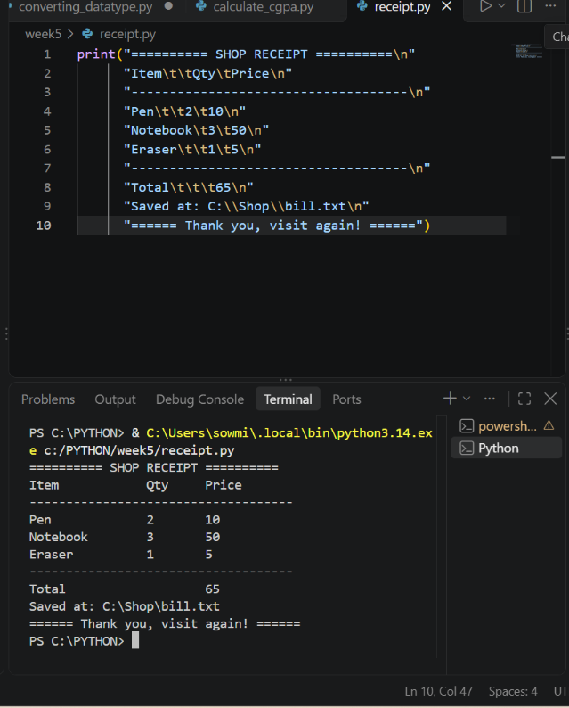
"====== Thank you, visit again! ======")

BUGS
name = input("Enter name: ")
age = input("Enter age: ")
print("Hello " + name
print("Age in months:", age * 12)
if age >= 18
print("Adult")
else:
print("Minor")
total = price + 10
print("Name in caps:", name.uper())
print("Done" + 5)

Bug & Fix
1
Missing ) in print("Hello " + name
print("Hello " + name)
2
age * 12 repeats text (the silent bug)
age = int(input(...))
3
if age >= 18 has no colon
if age >= 18:
4
print("Minor") not indented under else
Indent it 4 spaces
5
price is used but never defined (NameError)
Define price = 100 first
6
name.uper() is a typo
name.upper()
7
"Done" + 5 joins text and number (TypeError)
"Done" + str(5) or "Done", 5

PART-2

EMAIL MAKER
full_name = input("Enter your full name: ")

# Step 1: clean the input (split() also removes extra spaces)
parts = full_name.strip().split()

first = parts[0].lower()
last = parts[-1].lower()

# Step 2: build the email
email = first + "." + last + "@acmelabs.com"

# Step 3: build the initials
initials = first[0].upper() + "." + last[0].upper() + "."

print("Email:", email)
print("Initials:", initials)

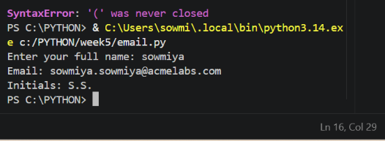

BILL SPLITTER
bill = float(input("Enter bill amount: "))
tip_percent = float(input("Enter tip percent: "))
people = int(input("How many people? "))

tip = bill * tip_percent / 100
total = bill + tip
share = total / people

print(f"Tip amount\t: {tip:.2f}")
print(f"Total bill\t: {total:.2f}")
print(f"Each person pays\t: {share:.2f}")

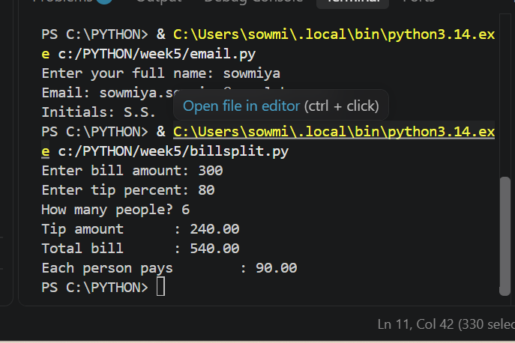
LIFE IN NUMBERS
age = int(input("Enter your age in years: "))

months = age * 12
weeks = age * 52
days = age * 365
hours = days * 24

print("Your life in numbers\n"
"--------------------\n"
"Unit\tCount\n"
f"Months\t{months}\n"
f"Weeks\t{weeks}\n"
f"Days\t{days}\n"
f"Hours\t{hours}")

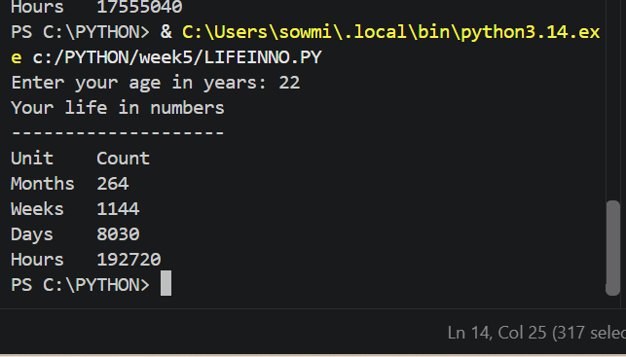

PART-3
SCRET MESSAGE ENCODER
message = input("Enter your secret message: ")

# 1. Clean the text
message = message.strip().upper()

# 2. Swap letters for numbers
encoded = ""
for char in message:
if char.isalpha():
encoded += str(ord(char) - ord('A') + 1)
elif char == " ":
encoded += " "

# 3. Reverse the encoded message
reversed_message = encoded[::-1]

# 4. Draw a box that fits the message
width = len(reversed_message) + 4

print("*" * width)
print("* " + reversed_message + " *")
print("*" * width)

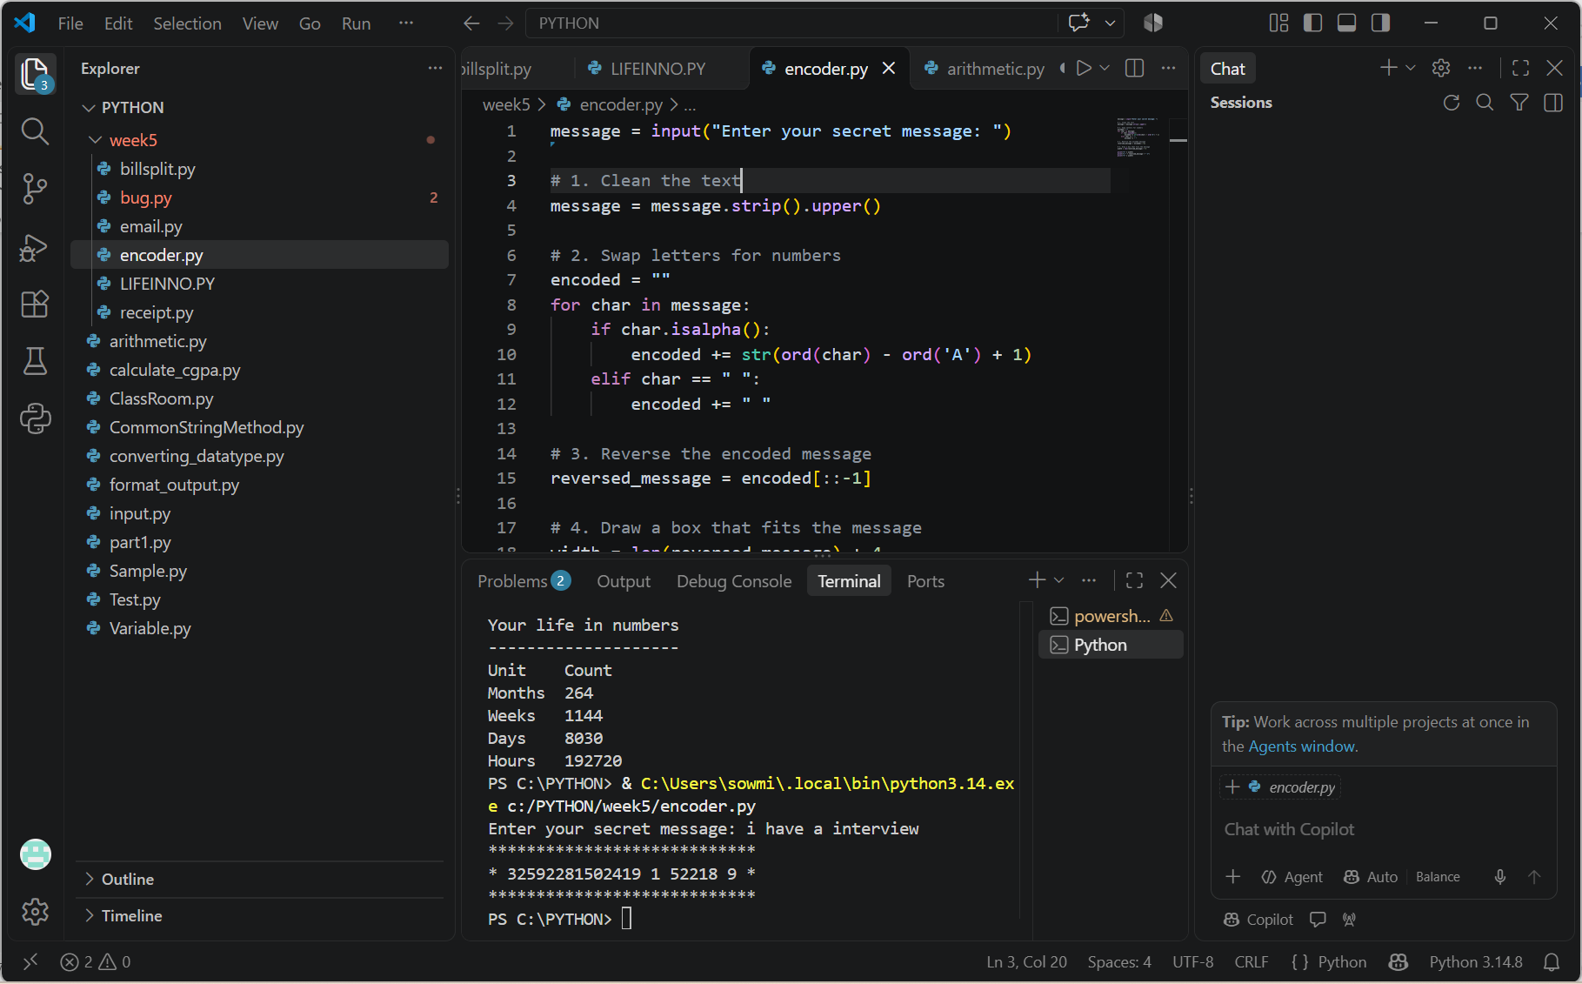
DECODER
encoded = input("Enter encoded numbers separated by spaces: ")

decoded = ""
for number in encoded.split():
decoded += chr(int(number) + ord('A') - 1)

print("Decoded message:", decoded)

