Brand Name: Film Freak

Blog Creation
Link: https://flimfreakbuddy.blogspot.com/2023/09/cinema-has-been-part-of-entertainment.html
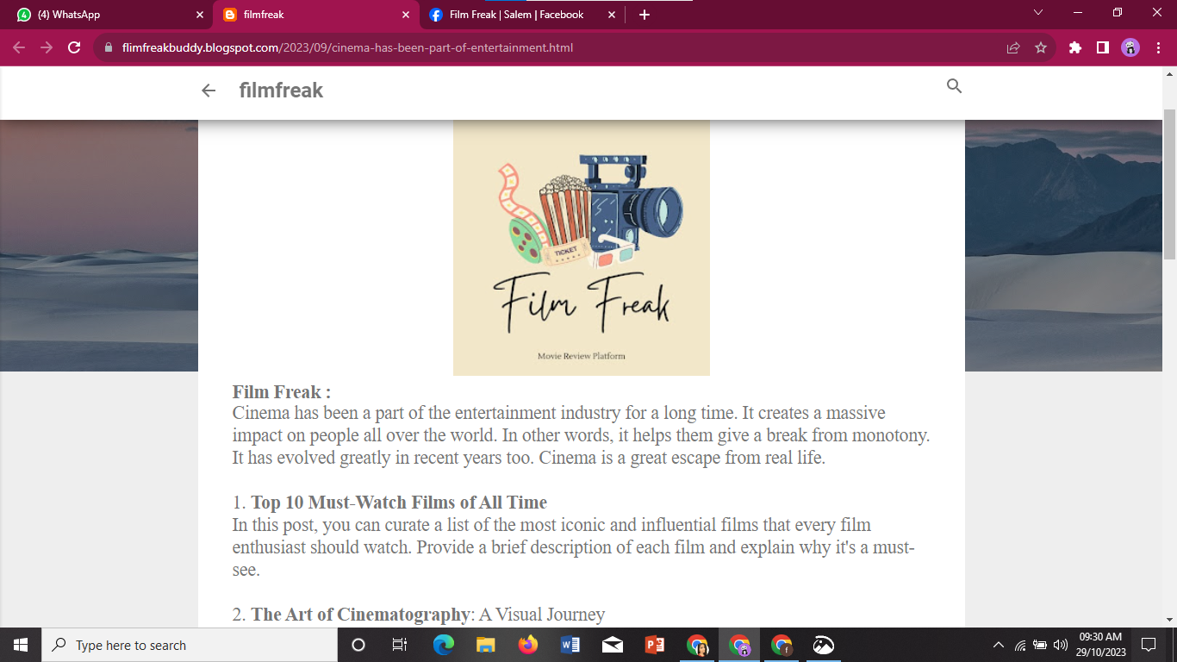

Facebook Business Page Creation
Link: https://www.facebook.com/profile.php?id=61550578052441
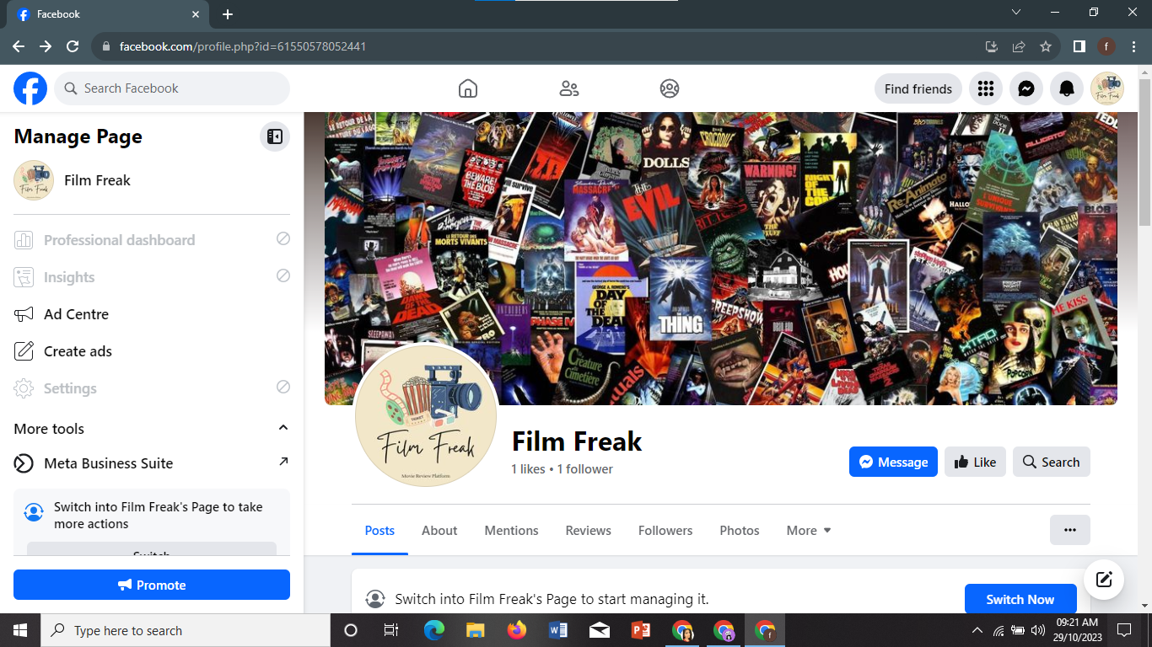

Poster Creation
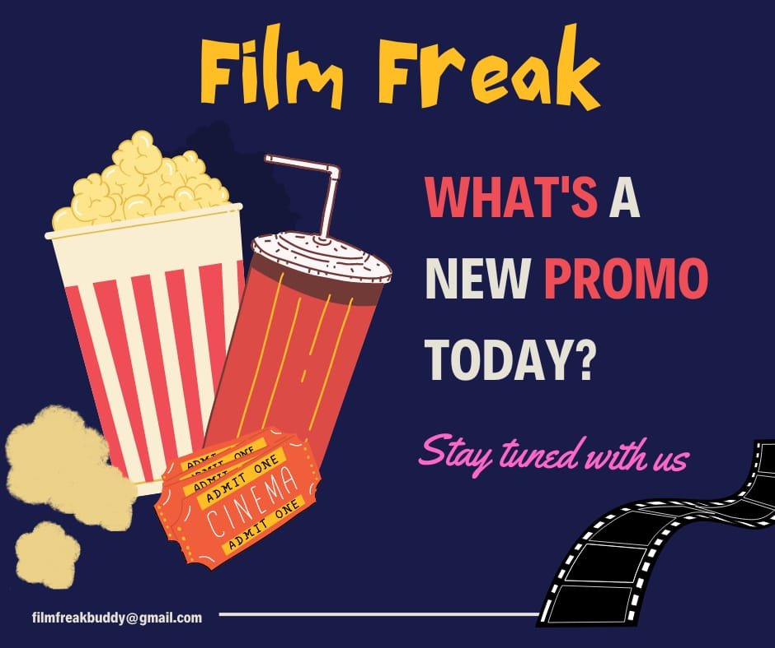

News Letter Creation
