**Test 1:** Manufacturer(s) list for a given location, with a specific nature of business, and the capability to perform a specific manufacturing process. (with default pagination of 10 per page)

**Request body:**

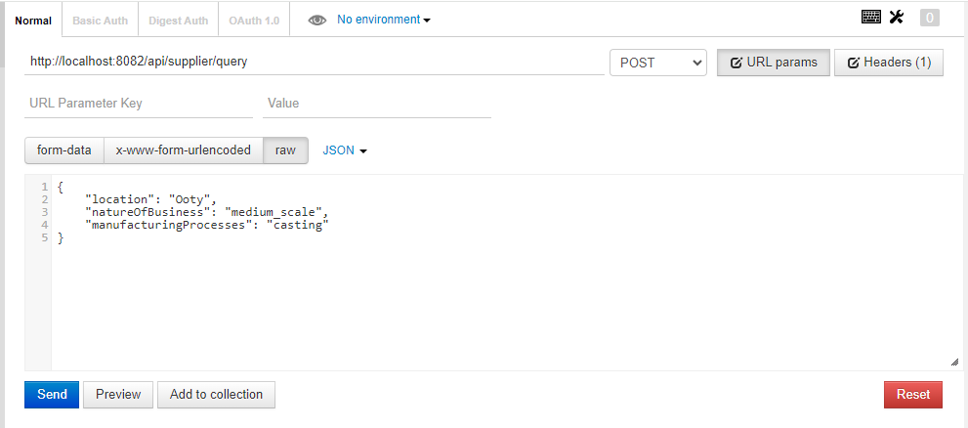

**Response:**

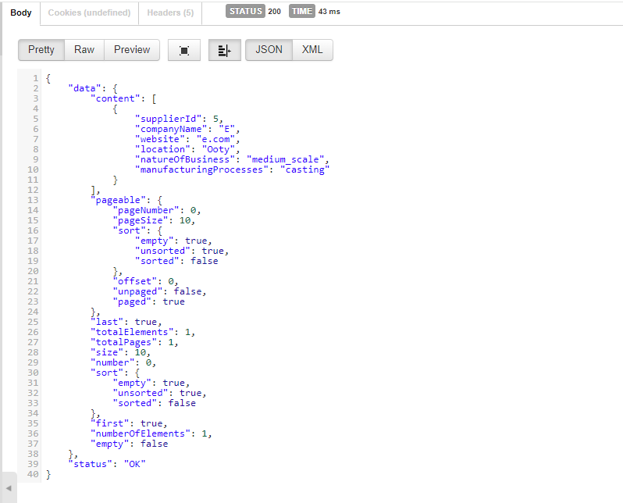

**Test 2:** Manufacturer(s) list for a given location, with a specific nature of business, and the capability to perform a specific manufacturing process. (pagination with user input)

**Request Body:**

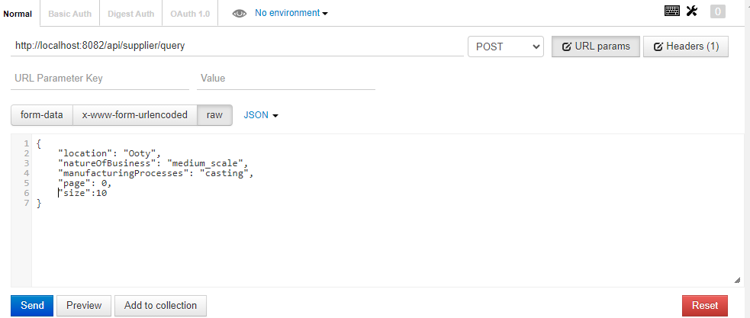

**Response:**



**Test 3:** Response of “not available suppliers”, when all inputs are valid

**Request Body:**

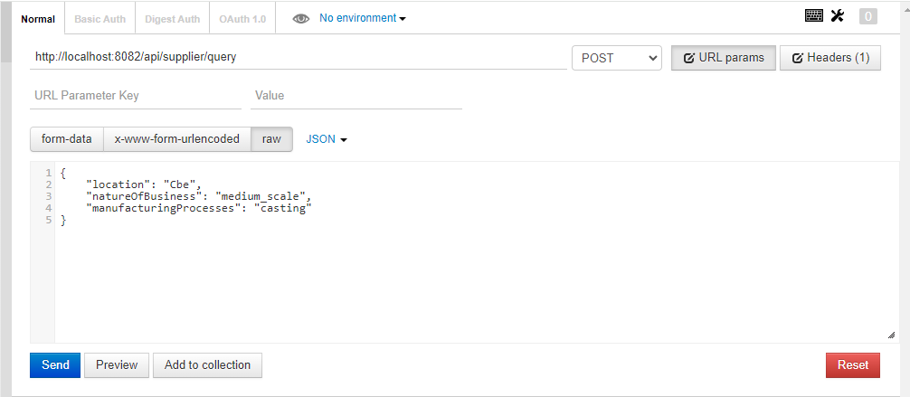

**Response:**

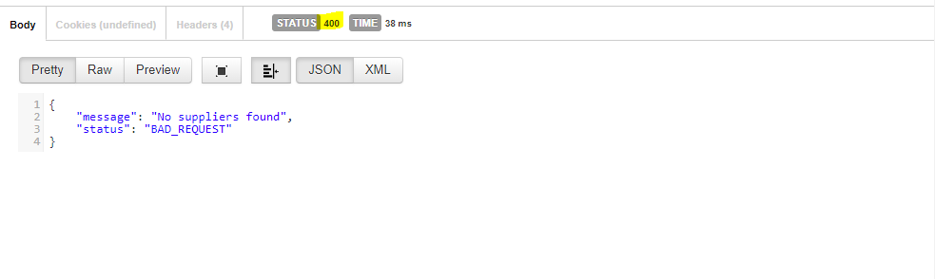

**Test 4:** Response for “nature_of_business “ input which is not in small_scale, medium_scale,large_scale

**Request Body:**

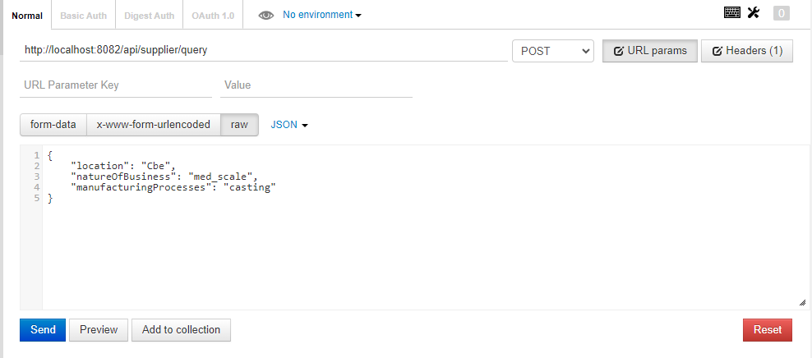

**Response:**

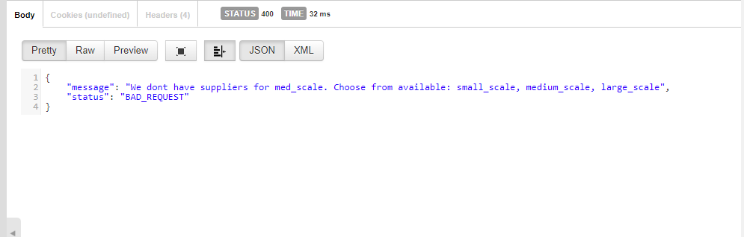

**Test 5:** Response for “manufacturing_processes “ input which is not in moulding, 3d_printing, casting, coating

**Request Body:**

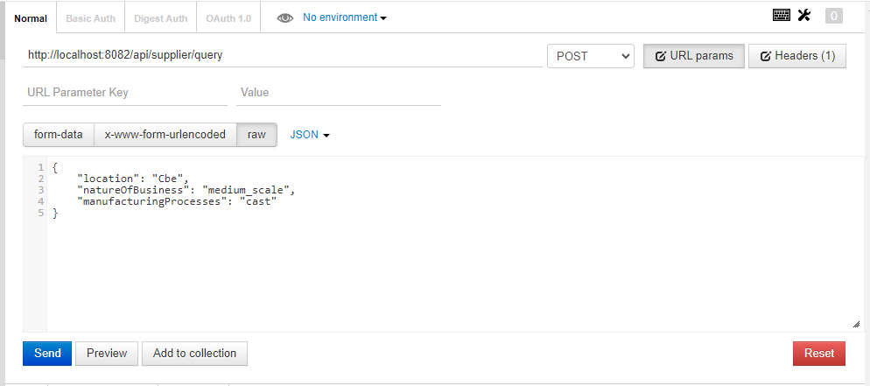

**Response:**

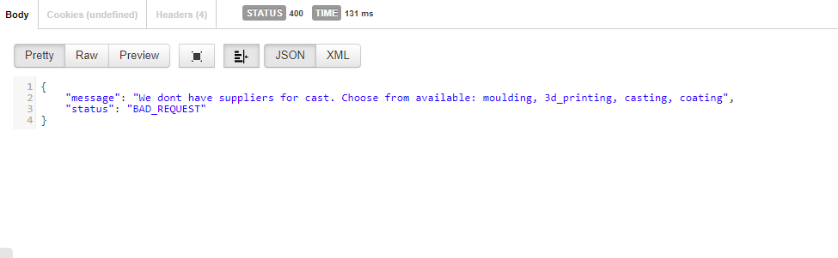

**Test 6:** Response for empty fields

**Request Body:**

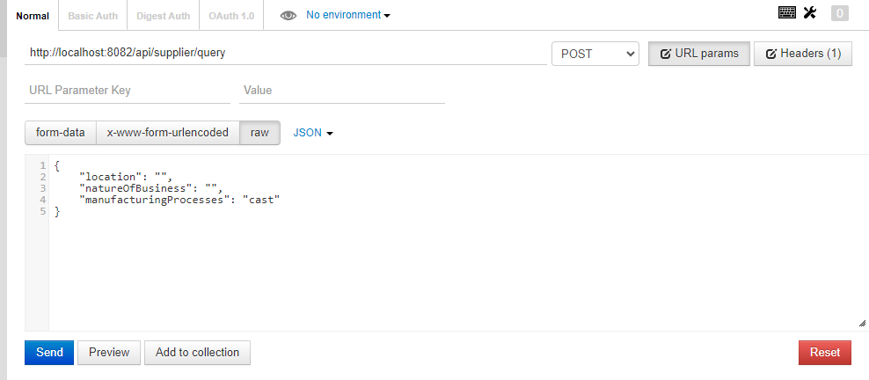

**Response:**

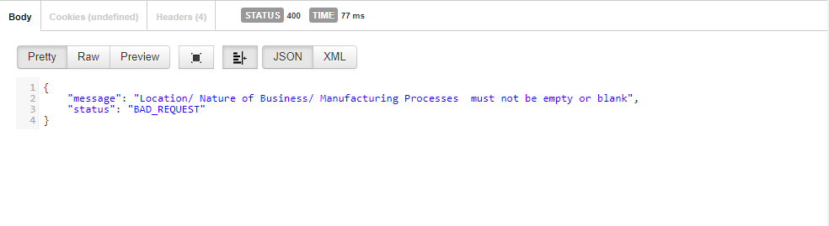

**Test 7:** Response for Pagination input (<0)

**Request Body:**

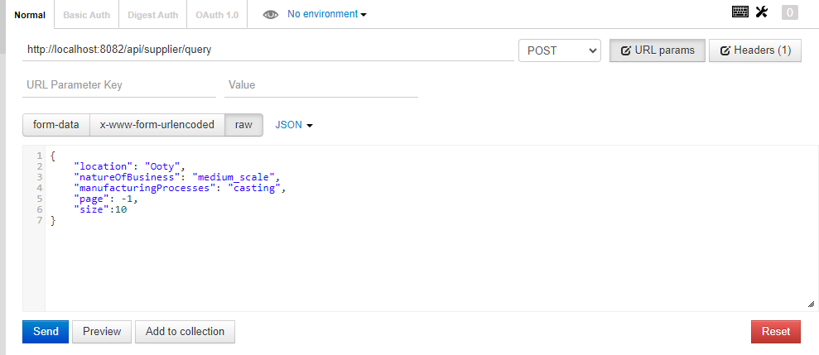

**Response:**

