Sequential Process: Sending an email

Parallel Process:

Taking notes during a lecture

Listening to music while traveling:

Structure diagram: For a wedding

Flow chart: Going for a movie

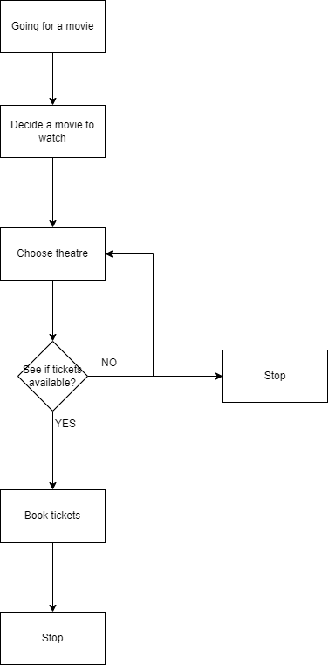

Structure Diagram: Starting a company

Flowchart: Starting a freelance service

