WEEK 2 PROJECT REPORT
SUPERSTORE SALES ANALYSIS USING MICROSOFT POWER BI
Data Preparation, DAX Measures, Data Modeling and Interactive Dashboard
Submitted By
Sowmiya R
B.Sc. Data Science and Artificial Intelligence
Week 2
Academic Project Report

1. Introduction
This Week 2 project focuses on analyzing the Superstore sales dataset using Microsoft Power BI. The project demonstrates the complete workflow from data preparation and date transformation to data modeling, DAX calculations, KPI creation, visualization, and interactive dashboard development. The purpose is to convert raw sales records into meaningful information that can be used to understand sales, profit, orders, quantity, region, category, and segment performance.

2. Project Objectives
- To prepare and transform the Superstore dataset using Power Query.
- To convert Order Date and Ship Date into proper date data types.
- To create a separate DimDate table for time-based analysis.
- To create Month Name, Month Number, and Year fields.
- To establish a one-to-many relationship between DimDate and the sales table.
- To create DAX measures for Total Profit and Total Orders.
- To display important business metrics using KPI cards.
- To create interactive charts for Region, Category, and Segment analysis.
- To apply filters and slicers for interactive data exploration.
- To build a clear and useful Power BI dashboard.

3. Tools and Technologies Used
Tool / Technology | Purpose
Microsoft Power BI | Data analysis, modeling, visualization and dashboard creation
Power Query | Data cleaning and transformation
DAX | Creating calculated columns and measures
Superstore Dataset | Source data for sales analysis

4. Data Preparation and Transformation

4.1 Date Data Type Conversion
The first step was to prepare the date fields in Power Query Editor. The Order Date and Ship Date columns were converted to the Date data type. The values were displayed in DD-MM-YYYY format. Column profiling showed 100% valid values with 0% errors and 0% empty values, confirming that the date fields were successfully prepared for analysis.
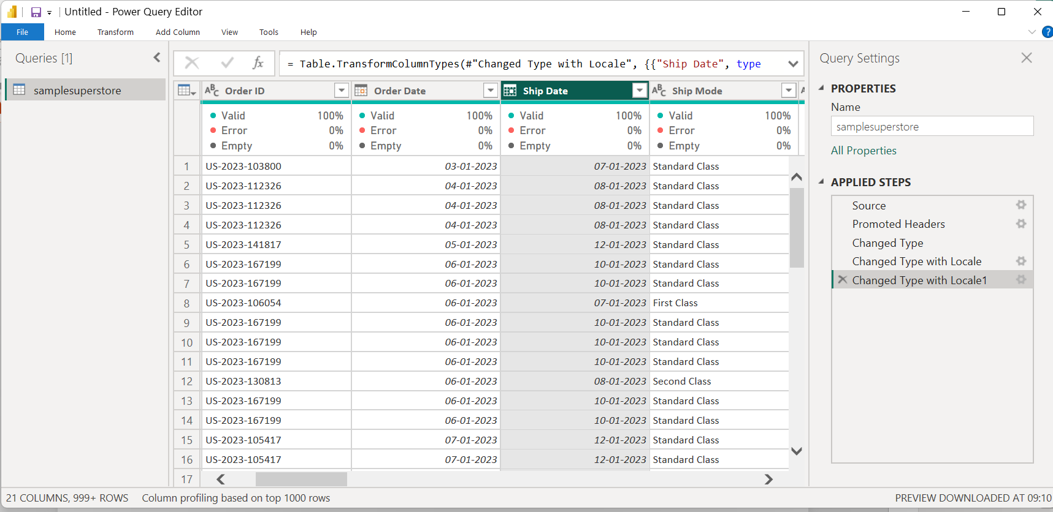
Figure 1: Date type conversion and validation in Power Query Editor.

5. Creation of DimDate Table
A separate date dimension table named DimDate was created using the DAX CALENDAR function. The table generates a continuous date range between the minimum and maximum Order Date in the Superstore dataset.
DAX Formula: DimDate = CALENDAR(MIN(samplesuperstore[Order Date]), MAX(samplesuperstore[Order Date]))
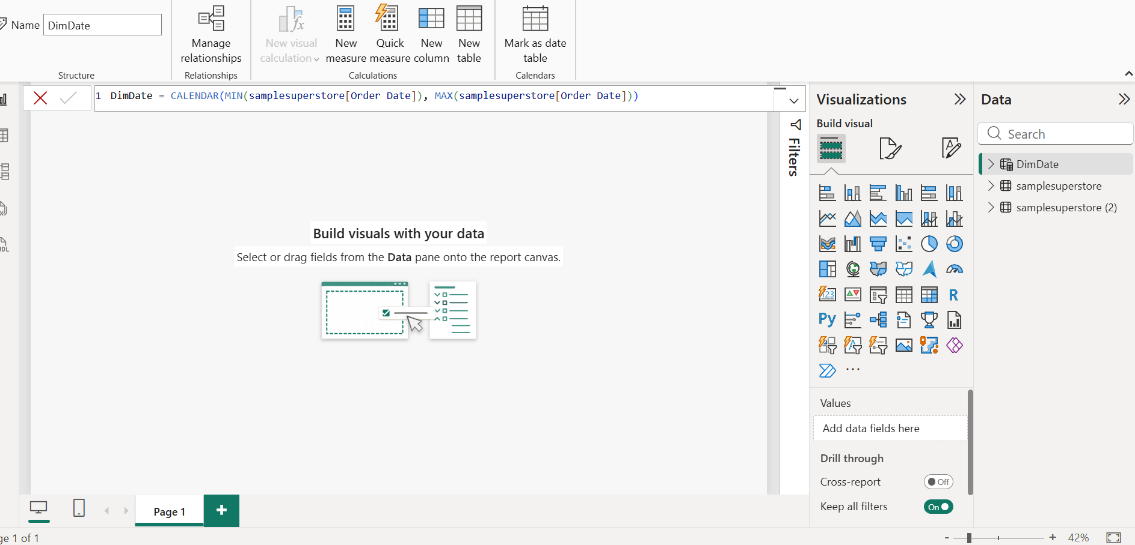
Figure 2: Creation of the DimDate table using the CALENDAR DAX function.

6. Creation of Month Name Column
A Month Name calculated column was created inside the DimDate table using the FORMAT function. The MMM format displays short month names such as Jan, Feb, Mar and Apr. This field is useful for monthly trend analysis and dashboard filtering.
DAX Formula: Month Name = FORMAT('DimDate'[Date], "MMM")
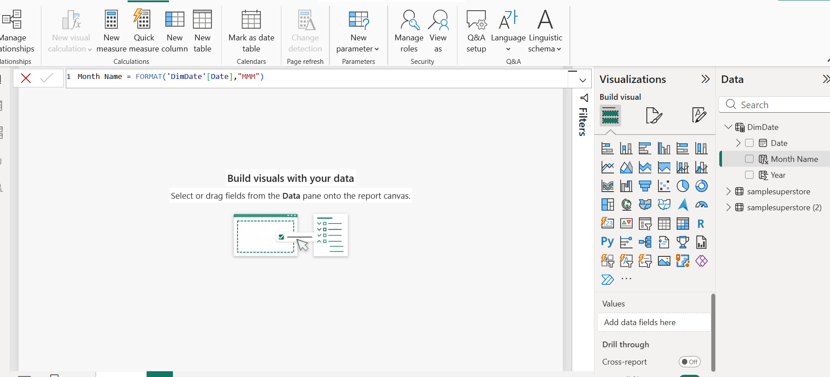
Figure 3: Creating the Month Name column in the DimDate table.

7. Establishing the Date Relationship
A relationship was established between the DimDate table and the samplesuperstore table. The Date column from DimDate was connected to the Order Date column in samplesuperstore. The relationship uses One-to-Many (1:*) cardinality, Single cross-filter direction, and is active. This enables the date dimension to filter and analyze the sales data by date, month, and year.
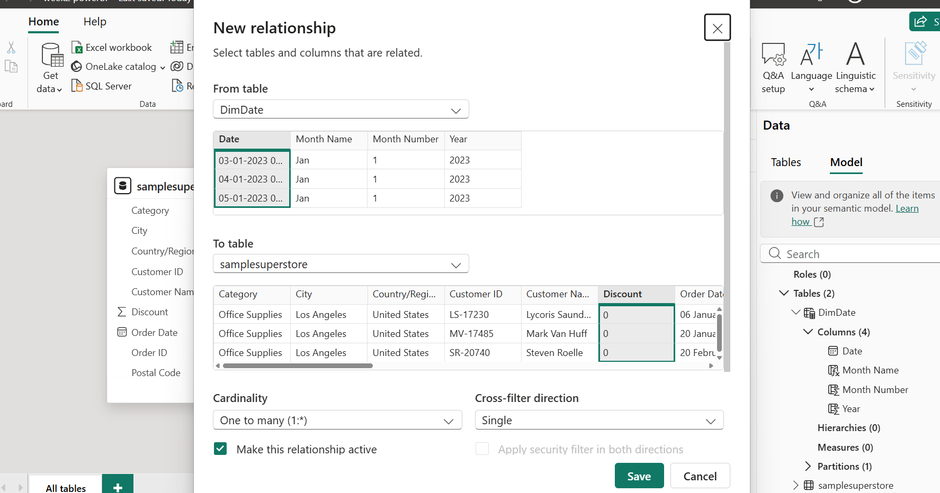
Figure 4: Establishing a one-to-many relationship between DimDate and samplesuperstore.

8. Creation of DAX Measures

8.1 Total Profit Measure
A Total Profit measure was created using the SUM function. It aggregates the values in the Profit column and provides a reusable measure for overall and filtered profit analysis.
DAX Formula: Total Profit = SUM(samplesuperstore[Profit])
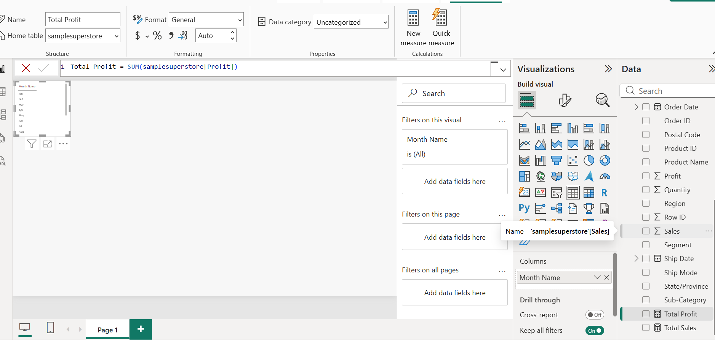
Figure 5: Creating the Total Profit measure using DAX.

8.2 Total Orders Measure
A Total Orders measure was created using DISTINCTCOUNT on Order ID. This counts unique orders and avoids counting repeated order IDs as separate orders.
DAX Formula: Total Orders = DISTINCTCOUNT(samplesuperstore[Order ID])
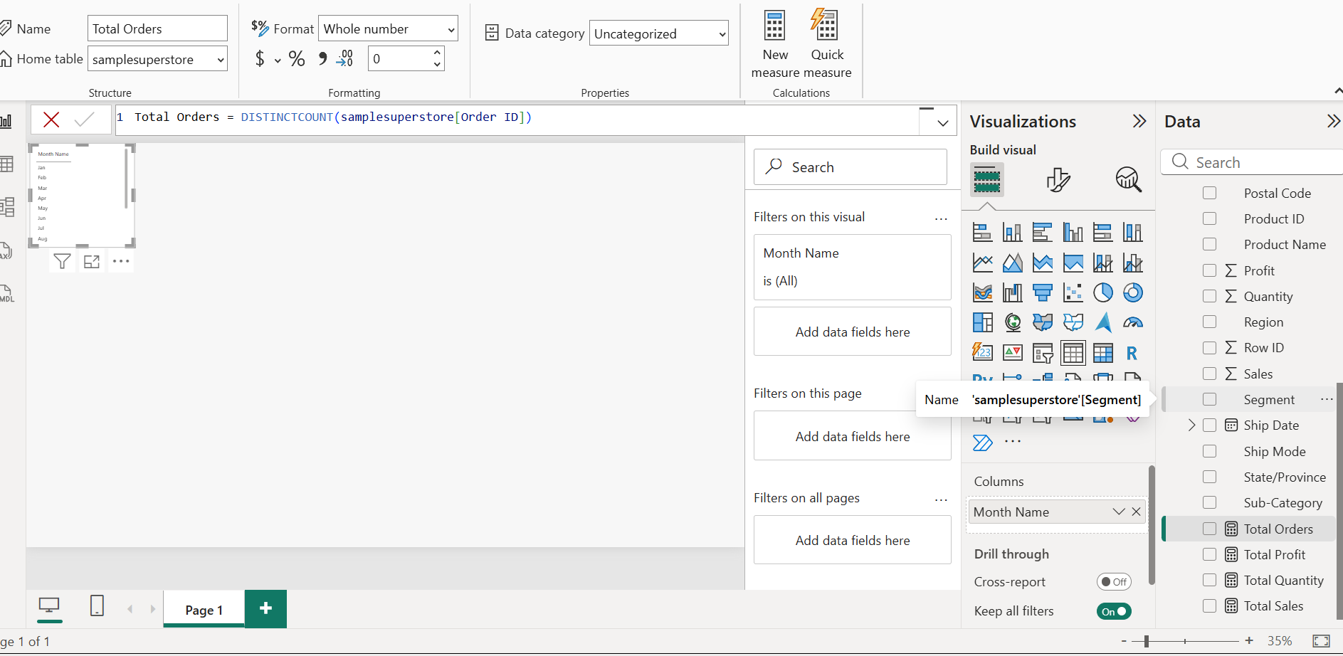
Figure 6: Creating the Total Orders measure using DISTINCTCOUNT.

9. KPI Cards
Card visuals were created to display key performance indicators. The dashboard shows Total Sales, Total Profit, Total Orders, and Total Quantity. These cards provide a quick summary of the business performance before detailed analysis.
- Total Sales: 2.33M
- Total Profit: 292.30K
- Total Orders: 5K
- Total Quantity: 39K
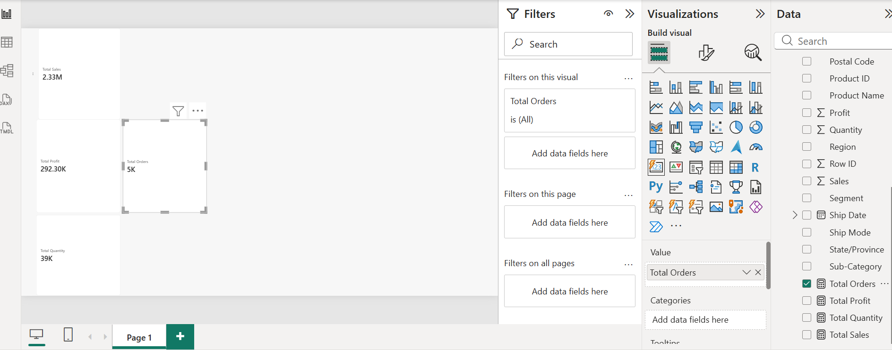
Figure 7: KPI cards displaying Total Sales, Total Profit, Total Orders and Total Quantity.

10. Interactive Dashboard
An interactive dashboard was developed using KPI cards, charts, and filters. The dashboard contains visuals for Total Sales by Region, Total Sales by Segment, and Total Sales by Category. Region, Category, and Segment filters allow users to focus on selected portions of the data.
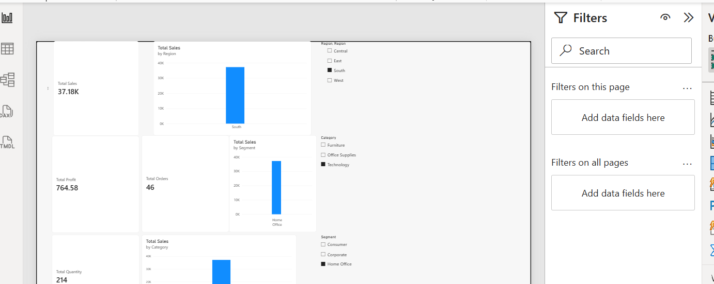
Figure 8: Interactive Power BI dashboard with KPI cards, charts and filters.

11. Filtered Dashboard Analysis
The final dashboard demonstrates interactive filtering. When selections are applied, the KPI cards and charts respond to the selected context. In the displayed filtered view, the dashboard shows Total Sales of 37.18K, Total Profit of 764.58, Total Orders of 46, and Total Quantity of 214. The charts also reflect the selected Region, Category, and Segment values.
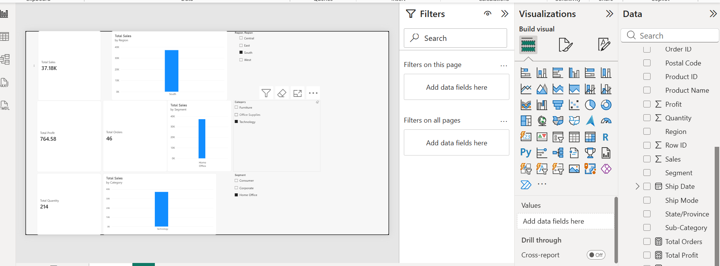
Figure 9: Final filtered dashboard view.

12. Key Findings
- The Superstore dataset was successfully cleaned and prepared for analysis.
- Order Date and Ship Date were converted to valid date fields.
- A dedicated DimDate table was created for time-based analysis.
- Month Name, Month Number and Year fields were available for date analysis.
- A one-to-many relationship was established between DimDate and the sales table.
- DAX measures were created to calculate important business metrics.
- KPI cards provide a quick overview of sales, profit, orders and quantity.
- Sales can be analyzed by Region, Category and Segment.
- Interactive filters allow users to examine specific parts of the dataset.
- The final dashboard presents the data in a clear and interactive format.

13. Learning Outcomes
- Understanding the Power BI interface and report-building workflow.
- Using Power Query for data transformation and validation.
- Working with date data types and date dimensions.
- Understanding relationships between tables.
- Writing basic DAX formulas and reusable measures.
- Creating KPI cards and analytical charts.
- Using filters and slicers to make reports interactive.
- Building a business dashboard from raw data.
- Presenting data as meaningful visual insights.

14. Challenges Faced
The main challenges involved handling date formats, creating the date dimension, establishing the correct relationship between tables, and configuring visuals and filters. These issues were addressed by checking data types, using appropriate DAX expressions, validating the relationship settings, and testing the dashboard visuals with different filter selections.

15. Result
The project successfully transformed the Superstore dataset into an interactive Power BI dashboard. The completed report includes date preparation, data modeling, DAX measures, KPI cards, analytical charts, and interactive filters. The dashboard can be used to explore sales performance from multiple business dimensions.

16. Conclusion
The Week 2 project provided practical experience in using Microsoft Power BI for data preparation, data modeling, DAX calculations, visualization, and dashboard development. The Superstore dataset was converted from raw records into an interactive analytical report. The creation of the DimDate table, establishment of relationships, development of measures, and use of KPI cards and filters demonstrated the complete process of building a useful business intelligence dashboard. This project strengthened practical skills in data analysis and visualization and provided a foundation for more advanced Power BI reporting.

