INTRODUCTION
1.2 Overview
Administrator should be able to create all base data including Semester, Candidate, Course and Lecturer, Lecturer should have the ability to create Internal Results, Dean, who is one of Lecturer, should be the only one with ability to update internal results re-evaluation can be initialized by candidate for all internal results. Now only dean can update the marks after re-evaluation.

1.2 Purpose
- Ensure data accuracy’s.
- Minimize manual data entry.
- Greater efficiency.
- User friendliness.
- Minimum time required.
- Problem Definition & Design Thinking

  - Empathy Map

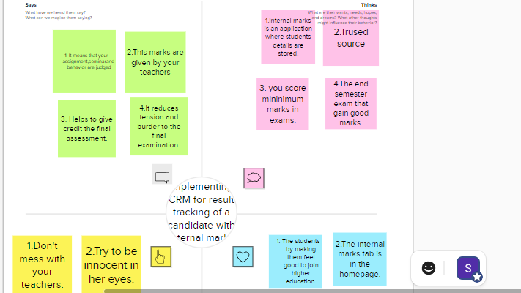

  - Ideation & Brainstorming Map

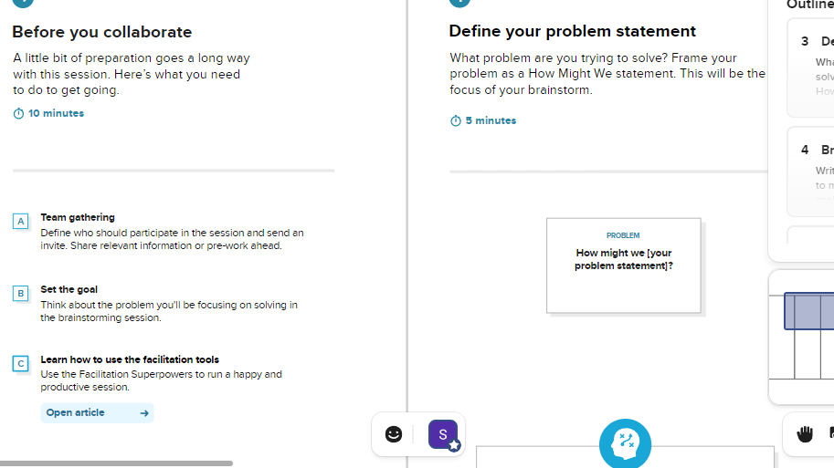
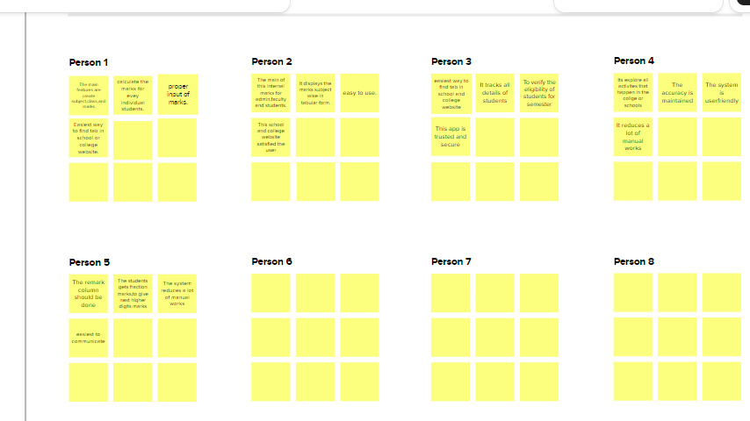

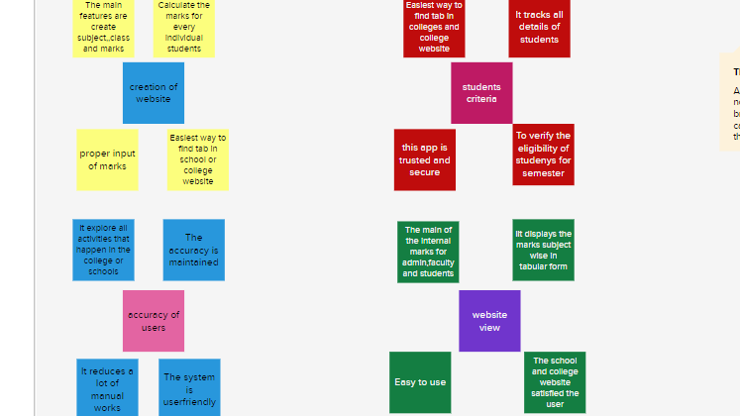

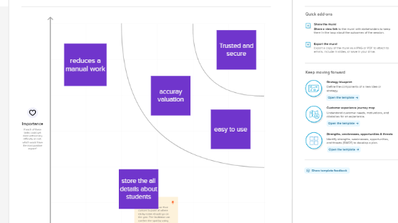

RESULT

3.1Data Model:

Object Name | Fields in the object
Semester
  Field Label | Data Type
  Semester | lookup
Candidate
  Field Label | Data Type
  Candidate | Text
Course Details
  Field Label | Data Type
  Course Details | Master Detail
Lecture Details
  Field Label | Data Type
  Lecture Details | Master Detail
Internal Results
  Field Label | Data Type
  Internal Result | Lookup

3.2 Activity & Screenshot
- create custom object
- Creation of objects for Candidate Internal Result Card, for this 5 objects i.e Semester, Candidate, Course Details, Lecture Details, Internal Results.

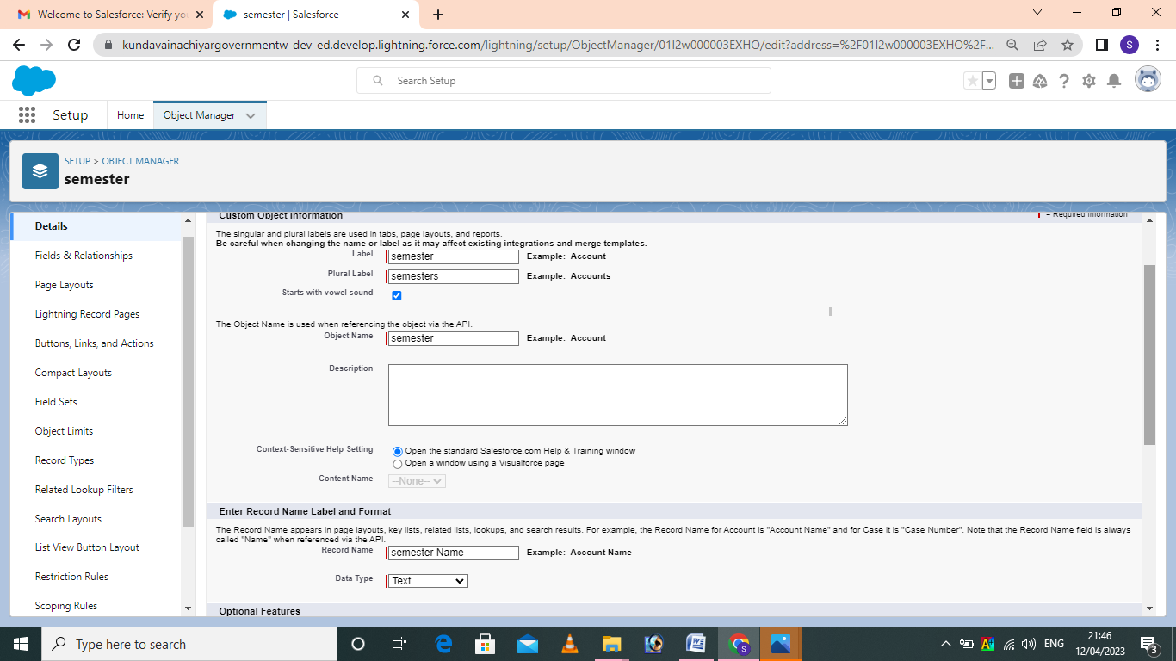

- Field and Relationship
- Create fields in an object

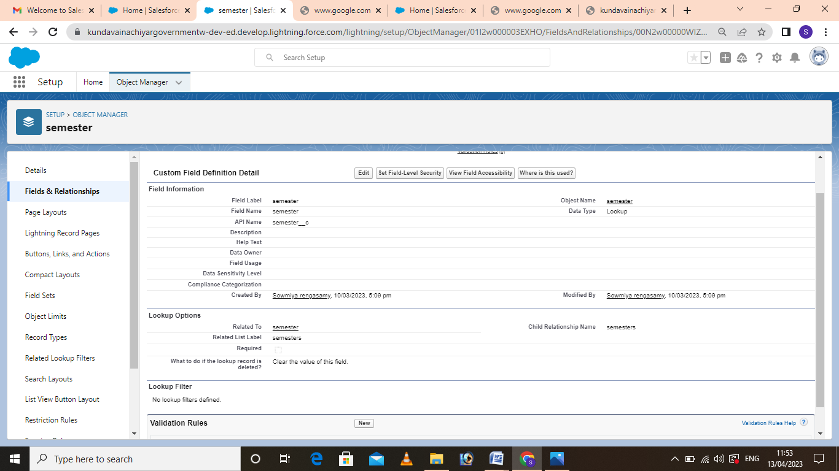

- USERS
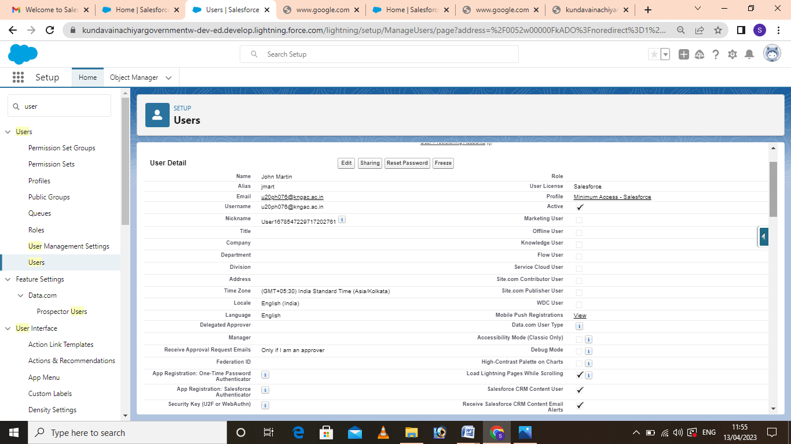

4. Report and Dashboard

- Finally completing the tasks, we get the report and dashboard of our project.

Reports
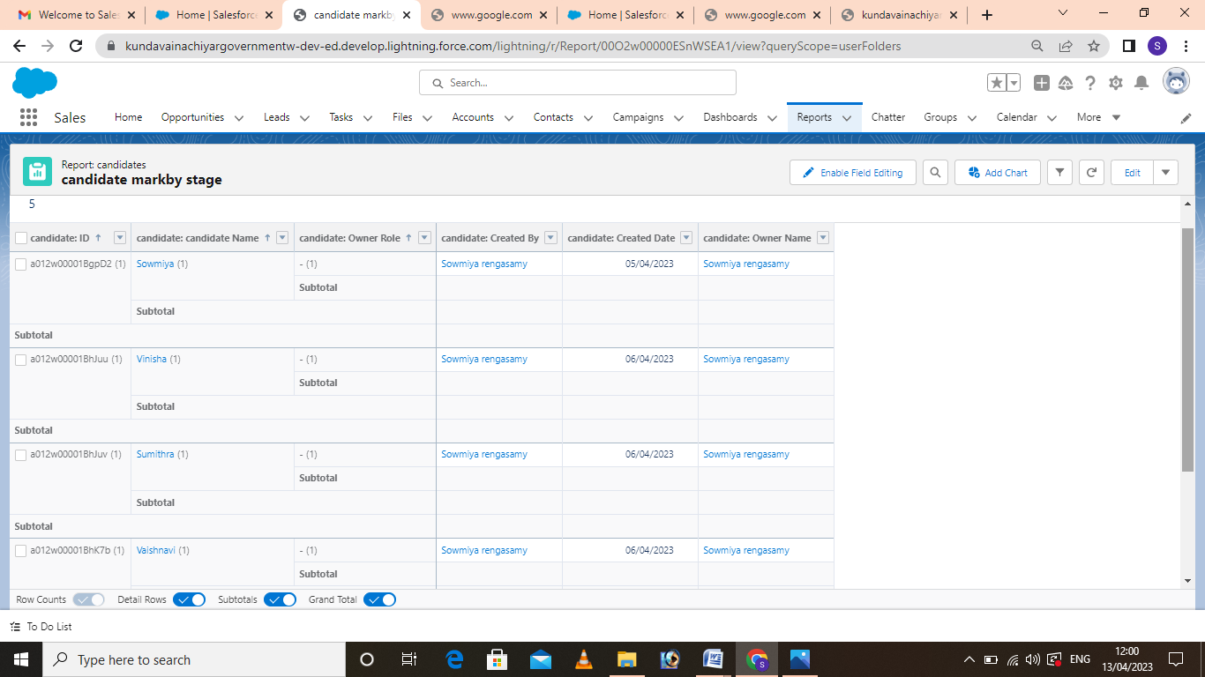

Dashboard

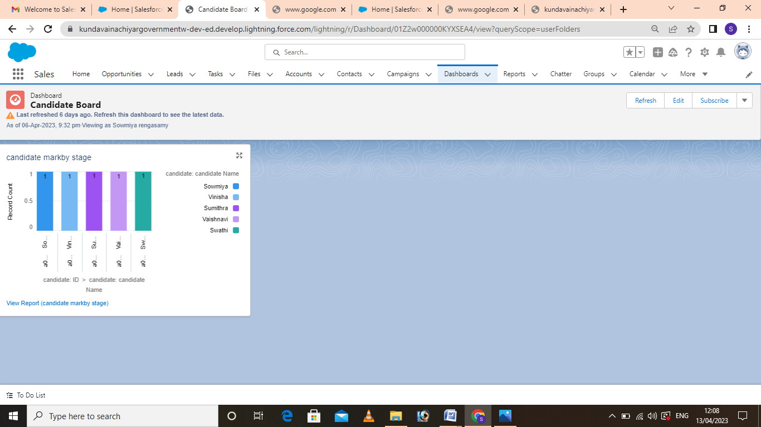

4.Trailhead Profile Public URL

Team lead - https://trailblazer.me/id/s2020batch3

Team Member 1 - https://trailblazer.me/id/v2020batch4

Team Member 2 - https://trailblazer.me/id/s202 0batch5

Team Member 3 - https://trailblazer.me/id/v2020batch

Team Member 4 - https://trailblazer.me/id/s2020batch4

5.ADVANTAGES
- Most accuracy.
- Less cost.
- Easily tracking all students result.
- Reduce manual works.
- Time consuming.

DISADVANTAGES

- Prone to hacks.
- Cannot edit or modify scores after the deadline.
- Difficult for a user to utilize the application.
- Minor technical glitches and issues.

APPLICATIONS

In schools and colleges to tracking the students results marks.

Store information related to your school and college current and potential students.

Any place to track the students marks.

5.CONCLUSION

Student internal result tracking system can be used in educational institutions to maintain their students marks easily. Achieving this objective is difficult using the manual system as information scattered, can be redundant, and collecting relevant information may be very time consuming.

6. FUTURE SCOPE
- Utilize resources in an efficient manner by increasing their productivity through automation.
- Be easy to operate.
- The system generates types of information that can be used for various purpose.

