WEEK 4 TASK
Predictive Modeling and Optimization in Logistics Systems
Forecasting last-mile delivery time and using the forecast to cut cost and late deliveries
Prepared by: Sowmiya S
21 October 2026 | Python 3 (pandas, scikit-learn, SciPy, Matplotlib)
Code and data: https://github.com/sowmiyas-04/logistics-last-mile-analysis (folder: week4)

1. Executive summary
A last-mile delivery operation cannot plan well if it cannot predict how long a delivery will take. This report builds a model that forecasts delivery time in minutes from route, traffic, weather and driver features, tests that model statistically, and then uses its forecasts to make four operational decisions: who delivers what, what delivery time to promise, which vehicle to use, and where the network is losing time.
Question | Answer
Best model | Tuned Gradient Boosting. Test RMSE 10.07 min (95% CI 9.51 to 10.70), MAE 7.46 min, R² 0.873.
Beat a simple baseline? | Yes, by about 11% on test RMSE (10.07 vs 11.37 for linear regression), and the gap is consistent across CV folds.
Biggest delay drivers | Route distance, stops per route, zone and traffic. Together they carry about 87% of the model's measured predictive signal.
Main bottleneck | Urban deliveries in peak hours: 29% of orders but 55% of all deliveries over 90 minutes.
Best-evidenced savings | Vehicle allocation by linear programming: 20% lower cost and breach rate down from 21.4% to 17.8% (predicted).
Cheapest customer-facing fix | A conformal-calibrated P90 promise time hits 91% on-time with promises 2.6 min shorter than a fixed +15 min buffer.

Important scope note. The data is simulated, because no real delivery log was available. The statistical results therefore describe how the methods behave on data with known structure, not a real depot. Section 10 sets out what that does and does not prove.

2. Problem definition
Prediction target: delivery time in minutes, measured from dispatch to confirmed handover, for a single parcel. Task type: supervised regression.
Why this target. Delivery time feeds every downstream planning decision. An unbiased forecast lets planners set realistic customer promises, a forecast of the spread lets them add the right safety margin, and a forecast conditional on vehicle and driver lets them compare options before dispatch. The service-level agreement (SLA) used throughout is 90 minutes: an order is a breach if it takes longer.
Decisions the model supports:
- Assignment: match orders to drivers and vehicles so total predicted time is lowest.
- Promise time: quote customers an ETA that is met a chosen share of the time.
- Resource allocation: choose vehicle class per order under fleet-capacity and cost limits.
- Network design: find which segments (zone, time, weather, route density) generate late deliveries.

3. Dataset and data simulation
A synthetic dataset of 6,000 deliveries was generated with a fixed random seed. Delivery time is produced by a known formula with realistic structure: it grows with distance and stops, is multiplied by congestion (stronger in urban zones), weather, vehicle type and driver experience, and then has multiplicative log-normal noise plus small additive noise. This gives a right-skewed target with variance that grows with trip length, as in real delivery data.
Feature | Type | Description
distance_km | Numeric | Route distance, gamma-distributed, 0.5 to 35 km
weight_kg | Numeric | Parcel weight, log-normal, 0.2 to 40 kg
stops_on_route | Numeric | Number of drops on the route, 1 to 15
traffic_index | Numeric | Congestion score 0 to 10, higher in peak hours and urban zones
driver_exp_yrs | Numeric | Driver experience in years
hour, day_of_week, is_peak | Numeric | Dispatch hour (7 to 21), weekday (0 to 6), peak flag (hours 8, 9, 12, 13, 17, 18, 19)
zone | Categorical | Urban (50%), Suburban (35%), Rural (15%)
weather | Categorical | Clear (72%), Rain (22%), Storm (6%)
vehicle | Categorical | Bike (35%), Van (50%), Truck (15%)
delivery_min | Target | Delivery time in minutes: mean 72.0, SD 28.1, median 68.4, range 12.1 to 286.6, skewness 1.03

Data quality. To mimic real logs, 2.5% of rows have missing values (90 in traffic_index, 60 in driver_exp_yrs). These are median-imputed inside the modeling pipeline, so imputation values are learned from training folds only and never leak from the test set.

4. Exploratory analysis and statistical tests
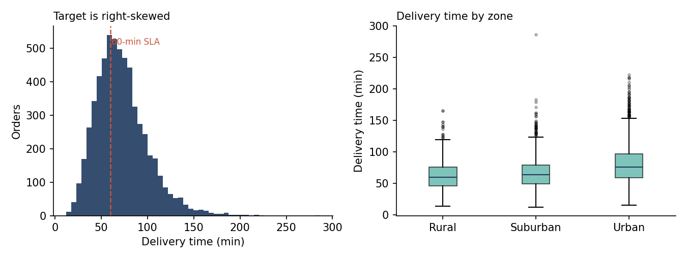
Figure 1. Delivery time is right-skewed (left); urban deliveries are slower and more variable (right).
Because the target is skewed, rank-based tests (Kruskal-Wallis, Spearman) were used for group and correlation comparisons rather than ANOVA and Pearson. Every test below is significant, but with 6,000 rows nearly any real difference is, so effect sizes are reported to show what matters.
Test | Result | Effect size | Reading
Welch t-test: peak vs off-peak time | 78.3 vs 63.1 min, t = 22.3, p < 1e-100 | Cohen's d = 0.57 | Medium effect: peak adds about 15 min
Kruskal-Wallis: zone | H = 435.6, p < 1e-90 | eta² = 0.072 | Largest categorical effect. Urban 79.7 vs Rural 62.5 min
Kruskal-Wallis: weather | H = 121.0, p < 1e-26 | eta² = 0.020 | Small but real. Clear 69.5, Rain 76.9, Storm 84.3 min
Kruskal-Wallis: vehicle | H = 78.4, p < 1e-17 | eta² = 0.013 | Small. Vans fastest (68.7), trucks slowest (77.5)
Spearman: distance | rho = 0.56 | - | Strong monotonic link
Spearman: stops per route | rho = 0.56 | - | Equally strong. Route density matters as much as distance
Spearman: traffic index | rho = 0.35 | - | Moderate
Spearman: weight / experience | rho = 0.09 / -0.08 | - | Weak. Experience helps slightly
Chi-square: breach (>90) by zone | χ² = 332.8, df = 2, p < 1e-70 | Cramér's V = 0.24 | Urban breach 31.9% vs 12% elsewhere
Chi-square: breach by peak | χ² = 244.1, df = 1, p < 1e-50 | Cramér's V = 0.20 | Peak 29.2% vs off-peak 12.2%
Chi-square: breach by weather | χ² = 80.0, df = 2, p < 1e-17 | Cramér's V = 0.12 | Clear 19.5%, Rain 26.9%, Storm 36.8%

Insight. Zone, time of day and route density explain far more variation than weather or vehicle choice. This already hints that the operational levers are scheduling and route design rather than weather response.

5. Model selection and implementation

5.1 Candidate models and rationale
Model | Why it was included
Linear Regression | Interpretable baseline. If it were enough, complexity would not be justified.
Ridge (alpha = 10) | Checks whether regularisation helps with correlated features (distance, stops, traffic).
Decision Tree (depth 8) | Captures interactions and non-linearity, and is easy to explain, but unstable on its own.
Random Forest (100 trees) | Averages many trees to cut variance. Strong default for tabular data.
Gradient Boosting | Builds trees sequentially on the previous errors. Typically strongest on tabular data with interactions, which this problem has (congestion × zone × weather).

5.2 Preparation, split and validation
- Split: 80% train (4,800) and 20% test (1,200), fixed seed. The test set was used once, for final reporting.
- Pipeline: median imputation, one-hot encoding of zone, weather and vehicle, standard scaling for the linear models only. Everything is inside a scikit-learn Pipeline so preprocessing is refit within each fold.
- Cross-validation: 5-fold on the training set, reporting RMSE, MAE and R².
- Tuning: RandomizedSearchCV on Gradient Boosting, 12 sampled configurations × 3-fold CV over number of trees (150, 250, 350), learning rate (0.03, 0.05, 0.1), depth (2 to 4), subsample (0.7, 0.85, 1.0) and minimum leaf size (5, 10, 20). Best: 350 trees, learning rate 0.05, depth 4, subsample 0.7, min leaf 10.
- Metrics: RMSE (penalises large misses, which cause SLA breaches), MAE (average miss in minutes, easy to explain), R² (variance explained), MAPE (relative error).
The search was deliberately small because of limited compute, so the tuned model is a good configuration rather than a provably optimal one. Full code is in Appendix A.

6. Evaluation and validation

6.1 Cross-validated and held-out performance
Model | CV RMSE (± SD) | CV MAE | CV R² | Test RMSE | Test MAE | Test R²
Linear Regression | 11.74 ± 0.51 | 8.69 | 0.824 | 11.37 | 8.43 | 0.839
Ridge (alpha = 10) | 11.74 ± 0.51 | 8.68 | 0.824 | 11.36 | 8.41 | 0.839
Decision Tree (depth 8) | 15.11 ± 0.74 | 11.05 | 0.709 | 15.00 | 11.08 | 0.719
Random Forest | 12.08 ± 0.68 | 8.73 | 0.814 | 11.42 | 8.43 | 0.837
Gradient Boosting (default) | 10.68 ± 0.59 | 7.86 | 0.855 | 10.27 | 7.58 | 0.868
Tuned Gradient Boosting | 10.45 ± 0.51 | 7.72 | 0.861 | 10.07 | 7.46 | 0.873
Table 1. Errors in minutes. Test MAPE for the tuned model is 10.6%.
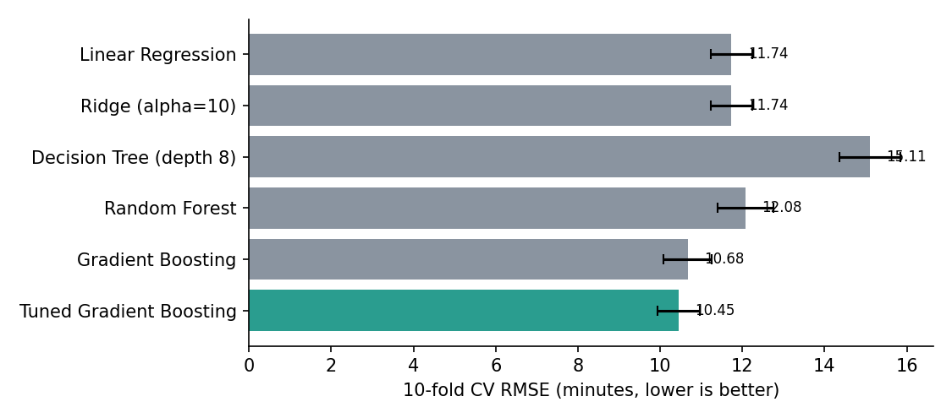
Figure 2. Cross-validated RMSE by model: tuned boosting is lowest, linear models are close behind.
Reading the table. Two results are worth noting. First, plain linear regression beats the Random Forest and the depth-8 tree. The simulator's core effects are multiplicative, and the log-normal noise puts a floor under every model, so extra flexibility gains little. Second, boosting wins because it learns the interactions (urban × peak × storm) that a linear model must approximate. Test scores sit slightly better than CV scores, which is normal sampling variation rather than leakage: the test set was never used for any choice.

6.2 Is the improvement real? Paired tests and confidence intervals
Comparison (CV fold RMSE) | Mean gain (min) | Paired t-test | Wilcoxon p
Linear Regression vs Tuned GB | 1.29 | t = 6.73, p = 0.0025 | 0.0625
Random Forest vs Tuned GB | 1.63 | t = 12.62, p = 0.0002 | 0.0625
Default GB vs Tuned GB | 0.23 | t = 3.45, p = 0.026 | 0.0625

The tuned model beat every competitor in all five folds, and the paired t-tests are significant. The Wilcoxon p-value of 0.0625 is not weak evidence: it is the smallest value a signed-rank test can produce with only five folds (2 / 2⁵). So the t-test and the consistent fold-by-fold wins are the real evidence. CV folds also share training data, so these p-values are somewhat optimistic. The gain from tuning (0.23 min) is statistically detectable but operationally trivial, and the practical gain is from choosing boosting over linear (1.3 min).
A 2,000-sample bootstrap on the test set gives a 95% confidence interval of 9.51 to 10.70 min for RMSE and 7.09 to 7.86 min for MAE, so the typical forecast error is about 7 to 8 minutes.

6.3 Residual diagnostics
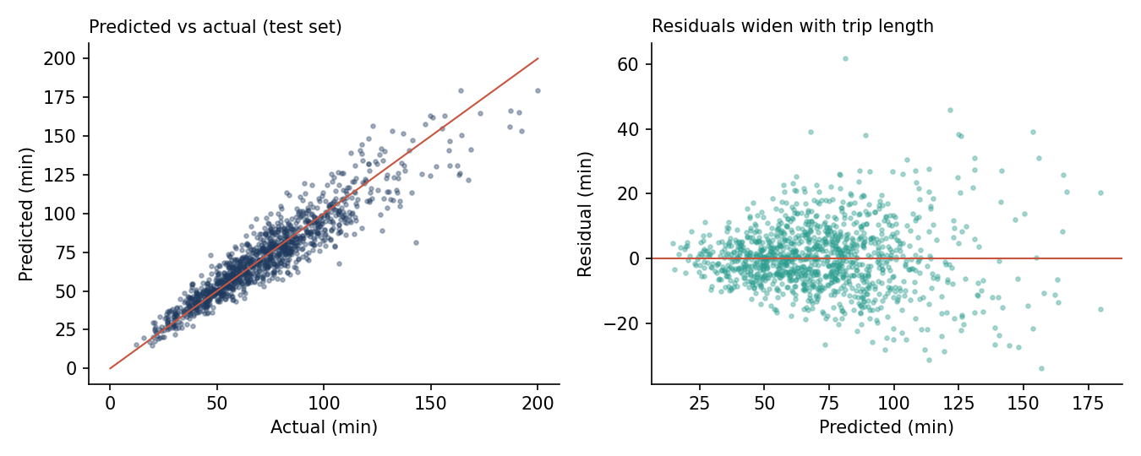
Figure 3. Predictions track actuals closely (left), but errors fan out on longer trips (right).
- Bias: mean residual is +0.26 min, so the model is essentially unbiased overall.
- Normality fails: Shapiro-Wilk on a 500-point sample gives p = 3e-7, and residual skewness is 0.53. The model under-predicts the long, late deliveries more than it over-predicts.
- Heteroscedasticity: regressing squared residuals on predictions gives a slope of 2.76 (p < 1e-30, r = 0.35). Error grows with predicted time. This is a simplified Breusch-Pagan style check rather than the full test.
- Consequence: a single symmetric ± band would be too wide for short trips and too narrow for long ones. This is why Section 8.2 uses quantile models with calibration instead of a normal-theory interval.
Segment | Test MAE (min)
Zone: Rural / Suburban / Urban | 7.04 / 6.44 / 8.30
Weather: Clear / Rain / Storm | 7.18 / 8.58 / 6.75
Peak: Off-peak / Peak | 6.58 / 8.08
Table 2. Error is highest where delivery times are longest (urban, rain, peak). Storm is lower than rain, probably because only 6% of orders are storm orders, so that estimate is noisy.

6.4 What drives the predictions
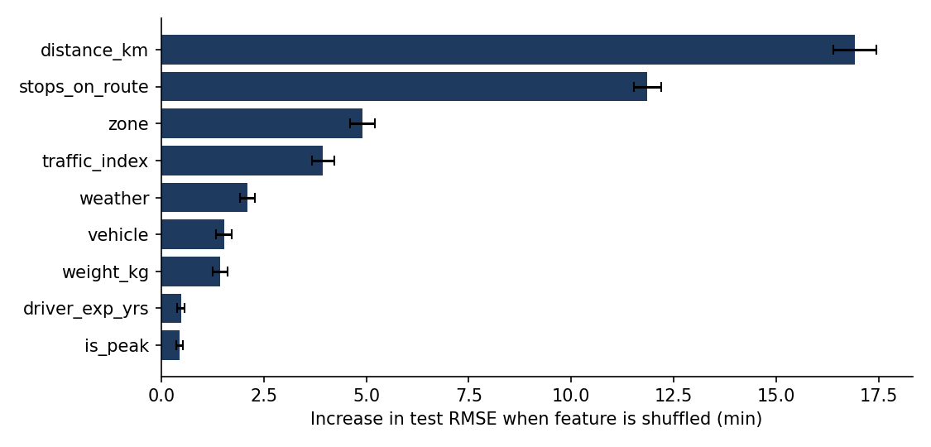
Figure 4. Permutation importance on the test set: distance and route density dominate.
Shuffling distance raises RMSE by 16.9 min and shuffling stops per route by 11.9 min, followed by zone (4.9) and traffic (3.9). Hour, day of week and the peak flag score near zero. This does not mean peak hours are irrelevant: the peak effect is real in Section 4 (d = 0.57), but the model captures it through the traffic index, which is generated from peak status. Permutation importance gives credit to whichever of two correlated features the model relies on, so the peak flag should be read together with traffic.

7. Bottleneck analysis
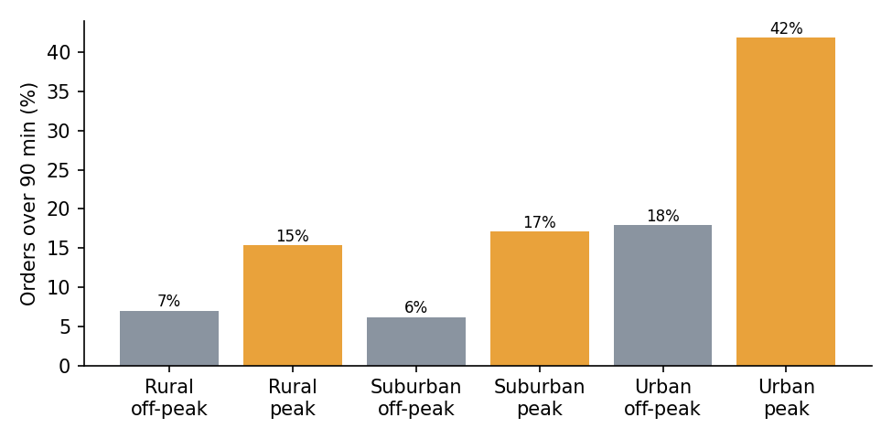
Figure 5. Share of orders over 90 minutes, by zone and time of day.
Zone | Time | Orders | Mean time (min) | Over 90 min
Rural | Off-peak | 343 | 55.6 | 7.0%
Rural | Peak | 552 | 66.8 | 15.4%
Suburban | Off-peak | 902 | 58.9 | 6.2%
Suburban | Peak | 1,207 | 69.8 | 17.1%
Urban | Off-peak | 1,243 | 68.2 | 17.9%
Urban | Peak | 1,753 | 87.8 | 41.9%

The bottleneck is urban peak. That segment is 29.2% of orders but produces 55.2% of all breaches. Its breach rate (41.9%) is more than double the next-worst cell. Within it, weather compounds the problem: urban peak orders breach 38% of the time in clear weather, 50% in rain and 60% in storms (n = 93 for storms, so treat that figure as indicative).
Two structural causes, from the model:
- Congestion: the traffic index is the third-largest driver and is highest in urban peak hours.
- Route density: 35.6% of orders sit on routes with more than 10 stops. Stops per route is the second-largest driver, and it is the one factor the operator controls directly.
Weather is a smaller and uncontrollable factor, so planning effort is better spent on urban scheduling and route density than on weather contingencies, with a lower-priority storm buffer on promises.

8. Optimization strategies
All optimisations below use the trained model to evaluate options before they are chosen. The figure summarises them.
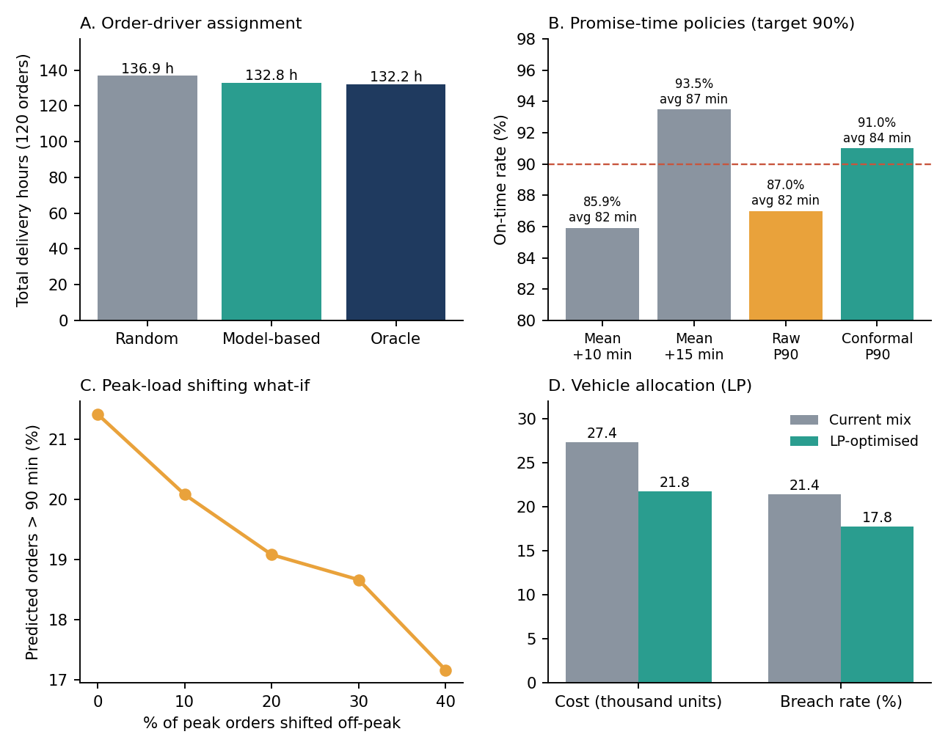
Figure 6. (A) Assignment, (B) promise-time policies, (C) peak shifting, (D) vehicle allocation.

8.1 Order-to-driver assignment (Hungarian algorithm)
Method. For 120 test orders and 120 drivers (each with a vehicle and experience level), the model predicts the time for every order-driver pair, giving a 120 × 120 cost matrix. The Hungarian algorithm (scipy linear_sum_assignment) finds the assignment with the lowest total predicted time. Results were scored with the simulator's true noise-free times, which a real depot could not do, so this is an upper-bound style evaluation.
Policy | Total time (min) | Total hours
Random assignment (mean of 500 draws) | 8,214 | 136.9
As-listed order | 8,199 | 136.7
Model-based (Hungarian) | 7,971 | 132.8
Oracle (uses true times) | 7,930 | 132.2

The model-based assignment saves 3.0% (2.0 min per order) and beat random assignment in all 500 draws. It lands within 0.5% of the oracle, so the forecast is accurate enough that little further gain is available from better prediction. The longest delivery in the batch drops from about 159 min (random average) to 139 min. The saving is modest, and that is an insight rather than a weakness: driver and vehicle choice explain little of the variance (low importance in Figure 4), so assignment alone cannot fix a network whose delays come from geography and time of day.

8.2 Calibrated promise times
Method. A quantile Gradient Boosting model predicts the 90th percentile of delivery time. The raw quantile model under-covers, so split conformal calibration is applied: a quarter of the training data is held out, and the 90th percentile of its quantile-model misses (+2.07 min) is added to future predictions. The target is 90% of deliveries arriving on or before the promise.
Promise policy | On-time | Avg promise (min) | Urban on-time | Storm on-time
Mean + 10-min buffer | 85.9% | 81.9 | 81.2% | 84.2%
Mean + 15-min buffer | 93.5% | 86.9 | 91.6% | 96.5%
Raw P90 quantile model | 87.0% | 82.2 | 84.7% | 93.0%
Conformal P90 | 91.0% | 84.3 | 88.3% | 94.7%
Scaled conformal (mean × 1.18) | 90.1% | 84.8 | 88.9% | 91.2%
Table 3. Test set, 1,200 orders. These models were refit on 75% of the training data to leave a calibration set.
A fixed +10 min buffer misses the target (85.9%) and is worst in urban zones (81.2%), where error is largest. A fixed +15 min buffer overshoots (93.5%), which means promises are about 2.6 min longer than needed for every customer. The conformal P90 hits the target and promises shorter times. It is still under target in urban zones (88.3%), so the next step is calibrating separately by segment (Mondrian conformal prediction). The gain over a well-chosen fixed buffer is real but small; the main benefit is that coverage is a dial the operator can set and check rather than a guess.

8.3 Vehicle allocation by linear programming
Method. The model predicts each order's time on each vehicle class. A linear program (scipy linprog, HiGHS solver) then chooses a class for each of 1,200 orders to minimise cost = fixed cost + per-minute cost × predicted time + 8 units for every predicted SLA breach. Constraints: every order gets exactly one vehicle, bikes cannot carry more than 15 kg, and fleet size per class is capped at 115% of today's usage (Bike 475, Van 695, Truck 211). Cost parameters (per minute: bike 0.18, van 0.30, truck 0.55) are assumptions, not measured values.
 | Current mix | LP-optimised
Vehicle mix (Bike / Van / Truck) | 34.4% / 50.3% / 15.3% | 39.6% / 57.9% / 2.5%
Total cost (units) | 27,350 | 21,782 (−20.4%)
Mean predicted time | 71.9 min | 71.3 min
Predicted breach rate (>90 min) | 21.4% | 17.8%

The result is a fleet shift away from trucks (15% to 2.5%) with no loss of speed and a lower breach rate. Trucks are slower and far more expensive per minute in this data, so they are rarely worth using. Caveat: the savings are measured on the model's own predictions, so they are somewhat optimistic (an optimiser tends to pick options where the model happens to be wrong in its favour). The plan should be piloted on a subset of routes before any fleet decision. In the first run of this analysis, an unconstrained version put 98% of orders on bikes and raised breaches, which is why capacity limits were added.

8.4 Peak-load shifting (what-if)
Peak orders moved off-peak | Mean time (min) | Over 90 min | Total hours
0% | 71.9 | 21.4% | 1,437.8
10% | 71.0 | 20.1% | 1,420.6
20% | 70.1 | 19.1% | 1,402.6
30% | 69.1 | 18.7% | 1,382.8
40% | 68.2 | 17.2% | 1,364.8

Moving 40% of peak orders to a mid-morning slot (for example through delivery-window discounts) lowers predicted breaches from 21.4% to 17.2% and saves about 73 driver-hours across 1,200 orders. The what-if assumes shifted orders face off-peak traffic (index reduced by 4) and that demand can actually be moved. The model is predictive, not causal, so this estimates the effect if the model's traffic relationship holds, not a guaranteed result.

8.5 Route-density cap
Max stops per route | Mean time (min) | Over 90 min
15 (current) | 71.9 | 21.4%
12 | 70.8 | 19.6%
10 | 68.2 | 15.4%
8 | 65.7 | 13.2%

Capping routes at 10 stops cuts mean delivery time by 3.7 min and the breach rate from 21.4% to 15.4%, the largest single reduction among the levers tested. This is a per-order effect only: the same parcels still have to be delivered, so more routes (drivers or vehicle-hours) are needed. The cost of that extra capacity must be weighed against fewer breaches, and this analysis does not price it.

9. Recommendations

9.1 Prioritised recommendations
# | Action | Evidence | Expected impact | Effort / risk
1 | Cap urban peak routes at about 10 stops and add capacity in the urban peak windows | Urban peak = 29% of orders, 55% of breaches. Stops is #2 driver | Breach 21.4% → about 15% (network-wide, 8.5) | Medium. Needs extra driver-hours
2 | Shift vehicle mix away from trucks using the LP, with fleet caps | LP on 1,200 orders (8.3) | Cost −20%, breach 21.4% → 17.8% (predicted) | Low. Pilot first (model-based estimate)
3 | Quote conformal P90 promise times, calibrated by zone | On-time 91% vs 85.9% (+10 min) at shorter promise than +15 (8.2) | Meets 90% target; fewer broken promises | Low. Add Mondrian calibration for urban
4 | Offer off-peak delivery incentives | 40% shift → breach −4.2 pts, 73 h saved (8.4) | Moderate | Medium. Depends on customer response
5 | Use Hungarian assignment for daily dispatch | 3% saving, 0.5% from oracle (8.1) | Small but near-free | Low

9.2 Monitoring plan
- Track MAE and bias weekly by zone and peak flag. Alert if urban MAE rises more than 20% above its 8.3 min baseline, and check the peak segment separately.
- Track promise-time coverage by zone. Recalibrate the conformal offset monthly or after any network change.
- Retrain quarterly, or sooner if traffic patterns, fleet or depot locations change.

10. Reflection and limitations

What I learned
- A more complex model was not automatically better. I expected Random Forest or boosting to win easily. Boosting did win, but plain linear regression came within 1.3 minutes of it and beat the Random Forest. I learned that choosing a model matters less than understanding where its errors sit.
- Better prediction was not the limit on better dispatch. My model-based assignment ended within 0.5% of the oracle. That told me the bigger gains come from changing the inputs the operator controls (route density, delivery timing, fleet mix), not from squeezing out a more accurate forecast.
- A single forecast is not enough to make a promise. The residual checks showed skewed, widening errors, so one fixed buffer is too loose for some deliveries and too tight for others. Modelling the uncertainty (quantiles plus calibration) worked better, although urban deliveries were still slightly under target.
- Statistical significance needs context. With 6,000 rows almost every test was significant, so I relied on effect sizes. I also learned that a Wilcoxon p-value of 0.0625 with five folds is the lowest possible, not a weak result.

What went wrong and how I fixed it
- My first SLA threshold of 60 minutes was breached by 63% of orders, which made a bottleneck analysis meaningless. I moved it to 90 minutes (22% breach).
- My first vehicle-allocation rule sent 98% of orders to bikes and raised predicted breaches. I added fleet-capacity limits and an SLA penalty and re-ran the linear program.
- The first full run was too slow for the available compute, so I reduced cross-validation from 10 to 5 folds and shrank the tuning search. This lowers the statistical power of the fold-level tests, as Section 6.2 explains.

Limitations
- Simulated data. The model recovers a formula I wrote, so R² of 0.87 says nothing about how forecastable real deliveries are. Real data would add unobserved factors such as parking, building access and failed attempts, and the ceiling would be lower.
- Predictions, not outcomes. Apart from the assignment test, the savings come from the model's own predictions and from assumed costs. Peak shifting in particular is a what-if and needs an experiment before anyone relies on it.
- Small segments. Storm results rest on 6% of the data, so I treat them as indicative only.

What I would do next
- Validate on a real delivery log with a time-based train/test split instead of a random one.
- Replace the assignment step with a full vehicle routing problem (for example OR-Tools with time windows) that uses the model's predicted travel times.
- Add segment-wise conformal calibration and SHAP values so each prediction can be explained.

Appendix A. Python code
The complete scripts are logistics_model.py and optim_v2.py. Key parts are shown here, condensed from those scripts.

A.1 Data simulation
def true_minutes(d):
base = 8 + 2.6*d.distance_km
base = base*np.where(d.zone=="Urban",1.15,np.where(d.zone=="Suburban",1.0,0.9))
cong = 1 + 0.55*(d.traffic_index/10)**2*np.where(d.zone=="Urban",1.4,0.7)
wx = d.weather.map({"Clear":1.0,"Rain":1.18,"Storm":1.45}).values
veh = d.vehicle.map({"Bike":1.0,"Van":0.9,"Truck":1.1}).values
veh_w = np.where(d.vehicle=="Bike", 1+0.05*np.maximum(d.weight_kg-5,0), 1.0)
exp = 1.25 - 0.25*(1-np.exp(-d.driver_exp_yrs/3))
peak = 1 + 0.12*d.is_peak
return base*cong*wx*veh*veh_w*exp*peak + 3.2*d.stops_on_route + 0.6*d.weight_kg

df = simulate(6000) # features drawn from gamma / log-normal / categorical choices
mu = true_minutes(df)
df["delivery_min"] = (mu*rng.lognormal(0, 0.12, n) + rng.normal(0, 1.5, n)).clip(lower=5)

A.2 Pipeline, models, cross-validation and tuning
def prep(scale):
steps = [("imp", SimpleImputer(strategy="median"))]
if scale: steps.append(("sc", StandardScaler()))
return ColumnTransformer([("num", Pipeline(steps), num),
("cat", OneHotEncoder(handle_unknown="ignore"), cat)])

Xtr, Xte, ytr, yte = train_test_split(X, y, test_size=0.2, random_state=42)
def pipe(model, scale=False): return Pipeline([("p", prep(scale)), ("m", model)])
models = {
"Linear Regression": pipe(LinearRegression(), True),
"Ridge (alpha=10)": pipe(Ridge(alpha=10), True),
"Decision Tree": pipe(DecisionTreeRegressor(max_depth=8, min_samples_leaf=10, random_state=42)),
"Random Forest": pipe(RandomForestRegressor(n_estimators=100, min_samples_leaf=3, random_state=42)),
"Gradient Boosting": pipe(GradientBoostingRegressor(random_state=42)),
}
kf = KFold(5, shuffle=True, random_state=42)
for name, m in models.items():
s = cross_validate(m, Xtr, ytr, cv=kf, n_jobs=-1,
scoring=("neg_root_mean_squared_error", "neg_mean_absolute_error", "r2"))

grid = {"m__n_estimators": [150, 250, 350], "m__learning_rate": [0.03, 0.05, 0.1],
"m__max_depth": [2, 3, 4], "m__subsample": [0.7, 0.85, 1.0],
"m__min_samples_leaf": [5, 10, 20]}
rs = RandomizedSearchCV(models["Gradient Boosting"], grid, n_iter=12, cv=3,
scoring="neg_root_mean_squared_error", random_state=42, n_jobs=-1).fit(Xtr, ytr)
tuned = rs.best_estimator_

A.3 Evaluation, statistical tests and diagnostics
pred = tuned.predict(Xte)
rmse = np.sqrt(mean_squared_error(yte, pred)); mae = mean_absolute_error(yte, pred)
r2 = r2_score(yte, pred); mape = np.mean(np.abs((yte - pred)/yte))*100

# paired tests on per-fold RMSE, bootstrap CI on the test set
t, p = stats.ttest_rel(fold_rmse["Linear Regression"], fold_rmse["Tuned Gradient Boosting"])
w = stats.wilcoxon(fold_rmse["Linear Regression"], fold_rmse["Tuned Gradient Boosting"])
boot = [np.sqrt(np.mean((yt[i] - pred[i])**2))
for i in (rng.choice(len(yt), len(yt)) for _ in range(2000))]
ci = np.percentile(boot, [2.5, 97.5])

# residual diagnostics
res = yt - pred
stats.shapiro(rng.choice(res, 500, replace=False)) # normality
stats.linregress(pred, res**2) # error grows with prediction?

# group / association tests
stats.ttest_ind(peak_times, offpeak_times, equal_var=False)
stats.kruskal(*[g.delivery_min for _, g in df.groupby("zone")])
stats.chi2_contingency(pd.crosstab(df.zone, df.delivery_min > 90))

pi = permutation_importance(tuned, Xte, yte, n_repeats=15, random_state=42,
scoring="neg_root_mean_squared_error")

A.4 Hungarian order-to-driver assignment
pred_M = np.zeros((N, N))
for j in range(N): # driver j's vehicle and experience applied to every order
f = orders.copy(); f["vehicle"] = drv.vehicle[j]; f["driver_exp_yrs"] = drv.driver_exp_yrs[j]
pred_M[:, j] = tuned.predict(f)
rows, cols = linear_sum_assignment(pred_M) # minimise total predicted minutes
realised = true_M[rows, cols].sum() # scored with true (noise-free) times

A.5 Conformal P90 promise time
Xfit, Xcal, yfit, ycal = train_test_split(Xtr, ytr, test_size=0.25, random_state=1)
qm = Pipeline([("p", prep(False)), ("m", GradientBoostingRegressor(loss="quantile", alpha=0.9, **P))]).fit(Xfit, yfit)
score = ycal.values - qm.predict(Xcal) # conformity scores on calibration set
k = int(np.ceil((len(score) + 1)*0.9)) - 1
qhat = np.sort(score)[k] # +2.07 min
promise = np.maximum(qm.predict(Xte) + qhat, point_forecast)
on_time = (yt <= promise).mean() # 91.0%

A.6 Vehicle allocation (linear program)
T = np.column_stack([tuned.predict(Xte.assign(vehicle=v)) for v in ["Bike","Van","Truck"]])
cost = fixed + cost_per_min*T + 8.0*(T > 90) # n x 3 cost matrix incl. SLA penalty
caps = np.ceil(np.bincount(current_vehicle, minlength=3)*1.15) # fleet limits
ub = np.ones((n, 3)); ub[:, 0] = (weight <= 15) # bikes cannot carry > 15 kg
A_eq = block_of_ones(n); A_ub = fleet_rows(n) # one vehicle per order; capacity rows
res = linprog(cost.ravel(), A_ub=A_ub, b_ub=caps, A_eq=A_eq, b_eq=np.ones(n),
bounds=list(zip([0]*(3*n), ub.ravel())), method="highs")
choice = res.x.reshape(n, 3).argmax(1)

A.7 Reproducibility
Random seeds are fixed (42 for data, split, models and search; 1 for the calibration split; 7 for the what-if sampling). Files: logistics_model.py, optim_v2.py, finalize.py, simulated_deliveries.csv, results.json, results2.json, results3.json.

