Advanced Data Analysis and Visualization in Logistics
Week 3 Task Report: Exploratory Analysis of a Simulated Last-Mile Delivery Network

Prepared by: Sowmiya S
Tools: Python 3, pandas, NumPy, SciPy, matplotlib, seaborn
Code repository: github.com/sowmiyas-04/logistics-last-mile-analysis

Contents
1. Executive Summary
2. Data Simulation
3. Exploratory Data Analysis
4. Visualizations, Justification and Interpretation
5. Analytical Insights
6. Recommendations
7. Reflection and Limitations
8. Conclusion
Appendix: Reproducing the Analysis

1. Executive Summary
This report analyses 5,000 simulated last-mile deliveries made across five Indian hubs (Chennai, Bengaluru, Hyderabad, Mumbai and Delhi) during 2025. The goal is to find out what drives delivery time, cost and late deliveries, and to turn those findings into specific operational actions. Total simulated transportation spend is INR 26,90,057, and 13.4% of deliveries missed their promised delivery window (SLA).
The five findings that matter most:
- Distance is the dominant cost driver. Distance alone explains 94.8% of the variation in delivery cost (r = 0.97); each extra kilometre adds about INR 31 on average.
- Trucks are the cost problem; bikes are the delay problem. Trucks make up only 18.3% of deliveries but 62.5% of total cost. Bikes make up 40% of deliveries but 55.2% of all late deliveries.
- Peak-hour traffic is the main time bottleneck. Deliveries in the 8-10 AM and 5-7 PM windows are late 20.1% of the time versus 9.4% off-peak. These windows hold 36.6% of volume but 55.2% of all delays.
- Mumbai is a structural outlier. Its delay rate is 26.3%, nearly three times Chennai's 9.3%, and its average delivery takes 1.64 h against 1.23 h in Bengaluru.
- Delays hurt customers measurably. Late deliveries average a 3.16 rating versus 4.22 for on-time ones (correlation between delay and rating: -0.55).

2. Data Simulation

2.1 Purpose and design
A hypothetical dataset was generated with Python so that realistic cause-and-effect relationships exist in the data and can be recovered by the analysis. The random seed was fixed (np.random.seed(42)) so every number in this report is reproducible. Each row represents one delivery.

2.2 Data dictionary
Variable | Type | Description
delivery_id | ID | Unique shipment identifier (D100000 onward)
date, month, weekday, hour | Time | Dispatch date, with derived month, day of week (0 = Mon) and hour (8-20)
hub | Category | Origin hub: Chennai, Bengaluru, Hyderabad, Mumbai, Delhi
vehicle | Category | Bike (40%), Van (42%), Truck (18%)
distance_km | Numeric | Route distance; gamma-distributed, scaled by vehicle type
weight_kg, units | Numeric | Shipment weight and number of units (shipment volume)
traffic | Category | Low / Medium / High; High is likely during 8-10 AM and 5-7 PM
weather | Category | Clear or Rain; rain is more frequent in Oct-Dec (northeast monsoon)
delivery_time_hr | Numeric | Travel time + doorstep service time + hub sorting delay
total_cost | Numeric (INR) | Fuel + handling + labour cost for the delivery
cost_per_km | Numeric (INR) | Derived: total_cost / distance_km
sla_hr, delayed | Numeric / Binary | Promised window (Bike 1.2 h, Van 2.2 h, Truck 4.5 h); delayed = 1 if time exceeds SLA
rating | Numeric | Customer rating (1-5), reduced when delivery time exceeds the SLA

2.3 How the data was generated
Delivery time was built from physical components rather than drawn at random: time = distance / effective speed + doorstep service time + hub sorting delay. Effective speed falls by 40% in heavy traffic, 18% in medium traffic and 20% in rain. Mumbai and Delhi hubs were given longer sorting delays to represent congestion at those facilities. Cost combines fuel (a per-km rate by vehicle), handling (a base amount plus a weight component) and labour (hourly rate times delivery time). Key excerpt:
speed = np.array([speed_base[v] for v in vehicle], dtype=float) # Bike 24, Van 30, Truck 38 km/h
speed *= np.where(traffic == "High", 0.60, np.where(traffic == "Medium", 0.82, 1.0))
speed *= np.where(weather == "Rain", 0.80, 1.0)

sort_delay = np.where(hub == "Mumbai", np.random.exponential(0.55, N),
np.where(hub == "Delhi", np.random.exponential(0.40, N),
np.random.exponential(0.22, N)))
delivery_time = distance / speed + service_time + sort_delay

fuel_cost = cost_per_km[vehicle] * distance * np.random.normal(1, 0.10, N)
handling = 6 + 0.12 * weight + np.random.normal(0, 3, N)
labour = delivery_time * hourly_rate[vehicle]
total_cost = fuel_cost + handling + labour
delayed = (delivery_time > sla).astype(int)

The final dataset has 5,000 rows and 0 missing values, so no imputation was required. The full script and the CSV are in the GitHub repository.

3. Exploratory Data Analysis

3.1 Central tendency and spread
Table 2 summarises the main numeric variables. In every case the mean is well above the median and the skewness is strongly positive, which means a minority of large, long-distance or slow deliveries pull the averages up.
Variable | Mean | Median | Std dev | Min | Max | Skew
Distance (km) | 20.05 | 10.93 | 25.36 | 1.00 | 242.30 | 2.84
Weight (kg) | 78.54 | 20.50 | 154.42 | 0.50 | 1462.30 | 3.61
Units per shipment | 31.05 | 8.00 | 64.15 | 1.00 | 726.00 | 4.11
Delivery time (h) | 1.35 | 1.06 | 1.00 | 0.22 | 9.53 | 2.58
Total cost (INR) | 538.01 | 233.03 | 807.41 | 28.02 | 7387.38 | 3.08
Cost per km (INR) | 26.45 | 23.12 | 13.56 | 8.18 | 230.28 | 3.78
Customer rating | 4.08 | 4.10 | 0.65 | 1.00 | 5.00 | -0.79
Table 2. Descriptive statistics (n = 5,000).
Reading the table: The average delivery takes 1.35 h but the median is 1.06 h, so a typical customer waits about an hour while a tail of slow deliveries inflates the mean. The same pattern appears in cost: the mean of INR 538.01 is more than double the median of INR 233.03, because heavy truck deliveries cost over INR 1,800 each on average while bikes cost about INR 114. For skewed data like this, the median describes the typical delivery better than the mean, and the mean is better for budgeting total spend.

3.2 Segment comparison
Segment | Deliveries | Avg time (h) | Avg cost (INR) | Cost / km | Late (%)
Bike | 2,004 | 0.88 | 114 | 24.60 | 18.0
Van | 2,082 | 1.32 | 375 | 24.80 | 10.0
Truck | 914 | 2.46 | 1,839 | 34.27 | 10.0
Chennai hub | 1,240 | 1.28 | 545 | - | 9.3
Bengaluru hub | 1,151 | 1.23 | 505 | - | 9.4
Hyderabad hub | 892 | 1.25 | 522 | - | 8.2
Mumbai hub | 954 | 1.64 | 595 | - | 26.3
Delhi hub | 763 | 1.41 | 524 | - | 15.9
Low traffic | 2,651 | 1.20 | - | - | 8.0
Medium traffic | 1,082 | 1.33 | - | - | 13.4
High traffic | 1,267 | 1.71 | - | - | 24.5
Clear weather | 4,205 | 1.31 | - | - | 12.3
Rain weather | 795 | 1.57 | - | - | 18.9
Table 3. Performance by vehicle, hub, traffic level and weather.

3.3 Correlation analysis
Pearson correlations were computed across the numeric variables and the delay flag (Figure 3 shows the full matrix). The relationships that matter:
- distance_km and total_cost: r = 0.97. Almost a straight line, so distance is the cost to manage.
- distance_km and delivery_time_hr: r = 0.87. Longer routes take longer, as expected.
- weight_kg and units: r = 0.95. The two measure nearly the same thing, so only one is needed in any predictive model (multicollinearity).
- delayed and rating: r = -0.55. The strongest link to customer satisfaction in the dataset.
- cost_per_km and distance_km: r = 0.02. Essentially zero: the cost of each kilometre does not depend on how far the trip is, which is why a single per-km rate per vehicle type works well for pricing.

3.4 Outliers and statistical testing
Using the interquartile-range rule (Q3 + 1.5 x IQR), deliveries longer than 2.99 h are flagged as outliers. 329 deliveries (6.6%) exceed this threshold. They are mostly long-distance truck routes and bike or van trips caught in peak traffic plus rain, so they are genuine operational events and were kept rather than removed.
A one-way ANOVA on van delivery times across the five hubs gave F = 20.74, p < 0.001, so the differences between hubs are statistically significant and not random noise. Fixing the vehicle type removes the effect of route length, which supports the conclusion that hub-level processing (not just geography) contributes to the gap.
from scipy import stats
# Is van delivery time different across hubs?
groups = [g.delivery_time_hr.values for _, g in df[df.vehicle == "Van"].groupby("hub")]
F, p = stats.f_oneway(*groups) # F = 20.74, p = 8.8e-17

# Cost model: how much does each km add?
slope, intercept, r, p, se = stats.linregress(df.distance_km, df.total_cost)
# slope = INR 31.0 per km, R-squared = 0.948

4. Visualizations, Justification and Interpretation
Each chart type below was chosen because it answers a specific logistics question. All charts were produced with matplotlib and seaborn.

4.1 Delivery time distribution (histogram with KDE)
Why this chart: A histogram shows the full shape of a variable, which a single average cannot. The KDE curve smooths the bars to make the shape easier to read, and the mean and median lines make the skew visible.
sns.histplot(df.delivery_time_hr, bins=50, kde=True, color="#2a6f97", ax=ax)
ax.axvline(df.delivery_time_hr.mean(), color="crimson", ls="--", label="Mean")
ax.axvline(df.delivery_time_hr.median(), color="darkgreen", ls="--", label="Median")

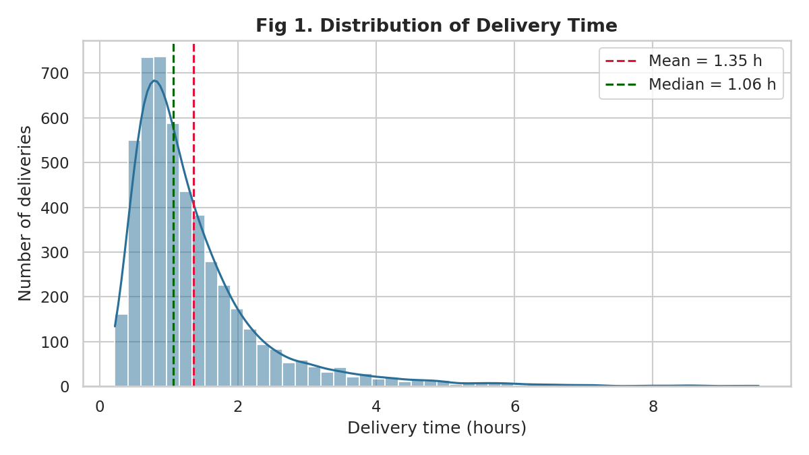
Figure 1. Distribution of delivery time
Interpretation: The distribution is right-skewed (skewness 2.58). Most deliveries finish within about 1-2 hours, but a long tail stretches past 5 hours and up to 9.53 h. Reporting only the 1.35 h average would hide both the fast majority and the slow minority, so performance should be tracked with percentiles (for example the 90th percentile) as well as averages.

4.2 Delivery time by vehicle (box plot)
Why this chart: Box plots compare the median, spread and outliers of several groups side by side, which suits comparing vehicle classes with very different operating ranges.
sns.boxplot(data=df, x="vehicle", y="delivery_time_hr",
order=["Bike", "Van", "Truck"], hue="vehicle", palette="Set2", legend=False)

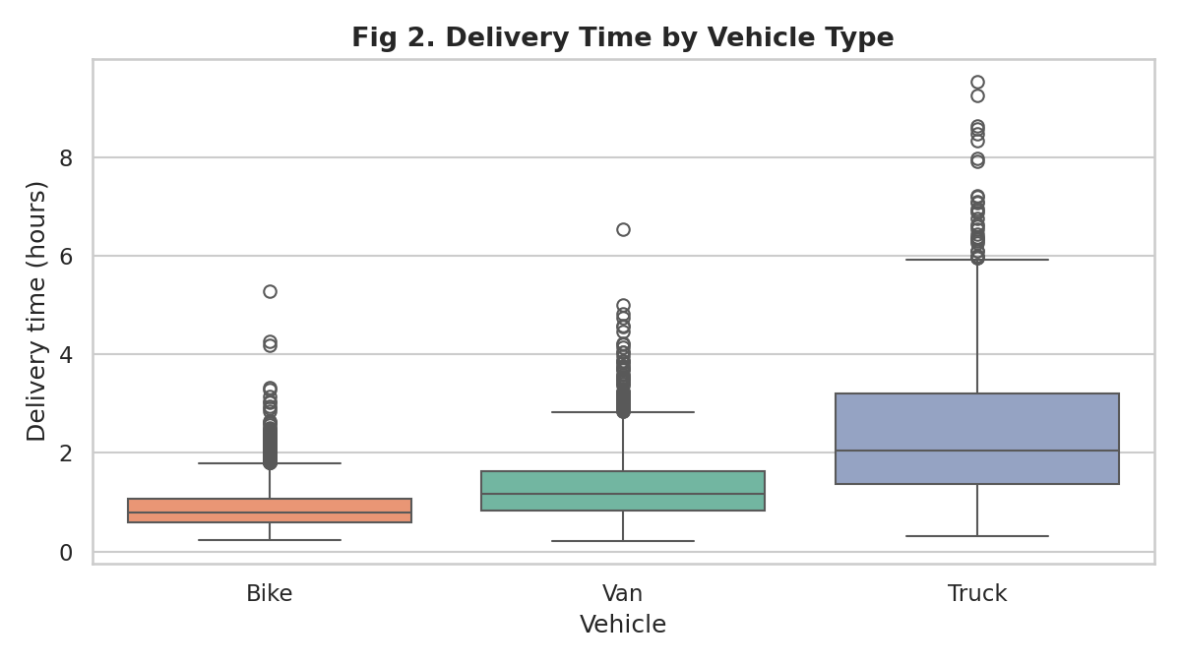
Figure 2. Delivery time by vehicle type
Interpretation: Median time rises from bikes (0.88 h average) to vans (1.32 h) to trucks (2.46 h), mainly because of route length. The more useful signal is the spread: bikes have a compact box but many upper outliers, meaning most bike trips are quick but the bad ones are bad relative to the short 1.2 h SLA. This is why bikes account for 55.2% of late deliveries despite having the shortest trips.

4.3 Correlation heatmap
Why this chart: A heatmap condenses dozens of pairwise relationships into one view and makes strong positive and negative links stand out by colour. It is the fastest way to decide which variables deserve a closer look.
cm = df[num_cols + ["delayed"]].corr()
sns.heatmap(cm, annot=True, fmt=".2f", cmap="RdBu_r", center=0, vmin=-1, vmax=1, square=True)

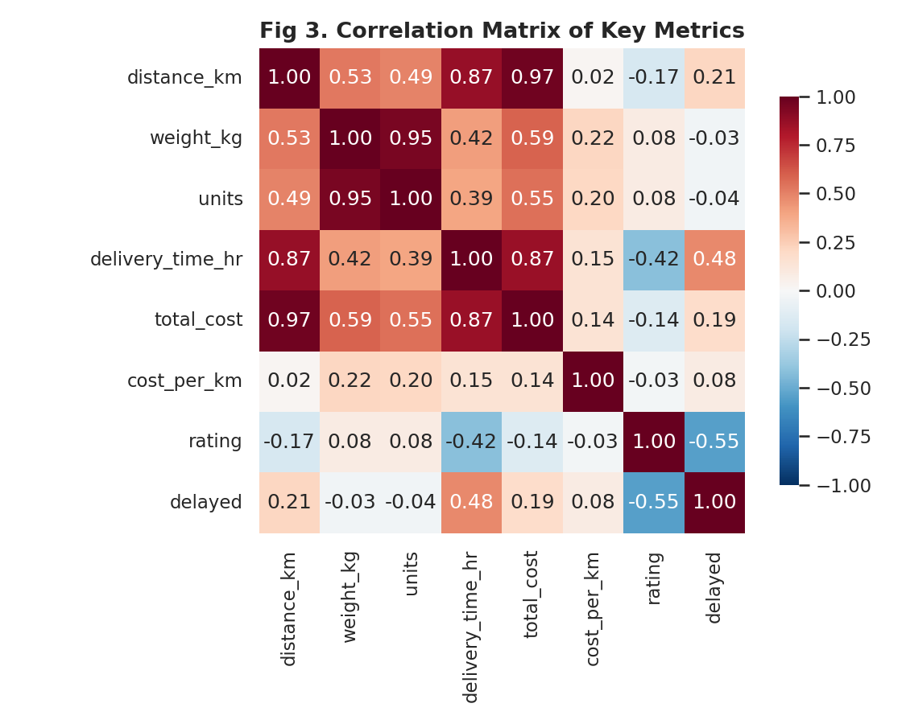
Figure 3. Correlation matrix of key metrics
Interpretation: Distance sits at the centre of the network: it correlates 0.97 with cost and 0.87 with time. Delivery time correlates -0.42 with customer rating, and the delay flag correlates -0.55 with rating. Weight and units are almost duplicates (0.95). The takeaway is that reducing late deliveries should be a priority because it is the factor most strongly tied to satisfaction.

4.4 Distance versus cost (scatter plot by vehicle)
Why this chart: A scatter plot reveals the shape of the relationship between two continuous variables. Colouring by vehicle shows whether one overall relationship hides several different ones.
sns.scatterplot(data=df.sample(1500, random_state=1), x="distance_km", y="total_cost",
hue="vehicle", hue_order=["Bike", "Van", "Truck"], alpha=0.55, s=22)

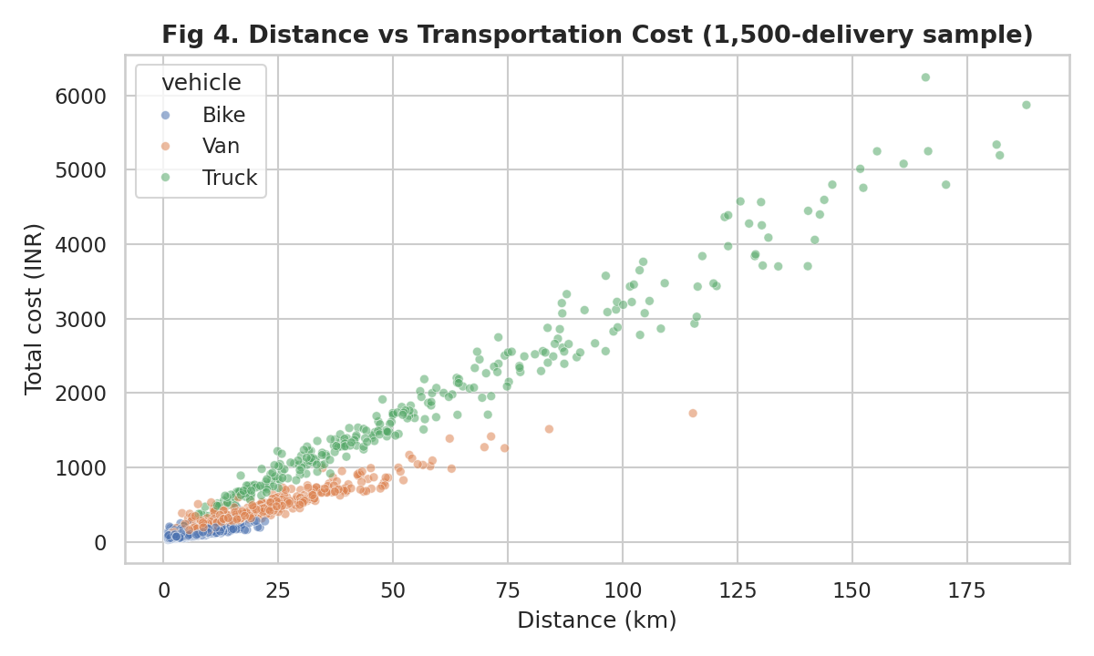
Figure 4. Distance versus transportation cost
Interpretation: The points fan out into three bands. Bikes cluster at low cost over short distances, vans sit in the middle, and trucks form a steep upper band. The steeper slope for trucks shows their cost per kilometre is higher (INR 34.27 against about INR 24.6 for bikes and INR 24.8 for vans). Overall, each additional kilometre adds about INR 31 (R-squared 0.948). Any long-haul shipment that can be consolidated or moved by a cheaper mode has a direct, large saving.

4.5 Monthly volume and delay trend (bar and line combination)
Why this chart: A dual-axis chart lets volume (bars) and delay rate (line) share one time axis, so seasonal pressure and service quality can be read together.
m = df.groupby("month").agg(vol=("delivery_id","count"), d=("delayed","mean")).reset_index()
ax1.bar(m.month, m.vol, color="#a9d6e5")
ax2 = ax1.twinx(); ax2.plot(m.month, m.d * 100, color="crimson", marker="o")

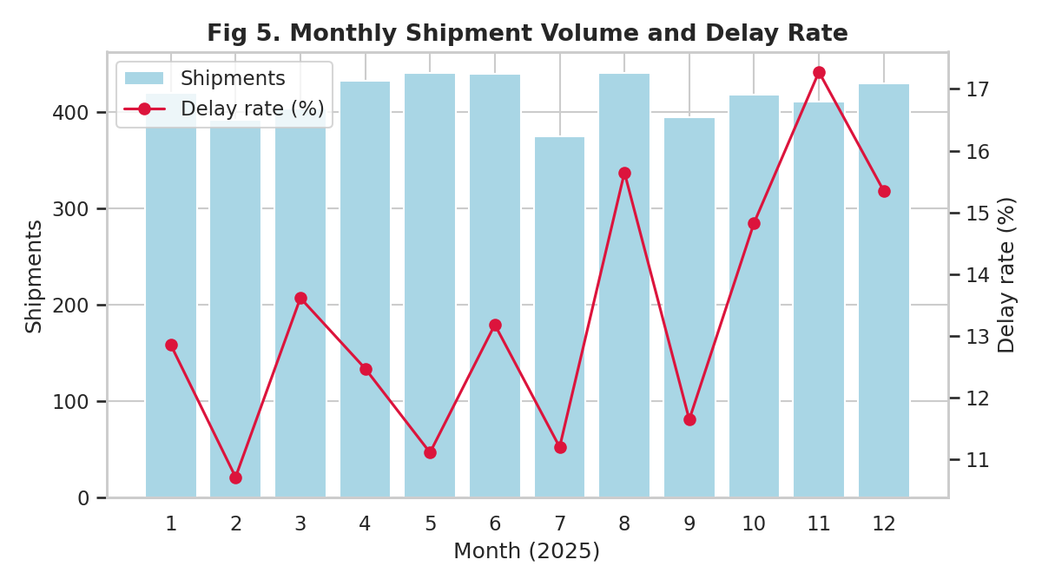
Figure 5. Monthly shipment volume and delay rate
Interpretation: Volume is stable at roughly 375-440 shipments a month, but the delay rate rises from 10.7% in February to 17.3% in November and 15.3% in December. Because volume does not rise at the same time, the cause is the weather and not capacity: rain deliveries are late 18.9% of the time versus 12.3% when clear, and the rainy-season months carry most of the rain. Seasonal buffers should therefore be planned for October to December.

4.6 Delay rate by hub (bar chart)
Why this chart: A sorted bar chart is the clearest way to rank categories and spot outliers among them, here the five hubs.
h = df.groupby("hub").delayed.mean().mul(100).sort_values(ascending=False)
sns.barplot(x=h.index, y=h.values, hue=h.index, palette="rocket", legend=False)

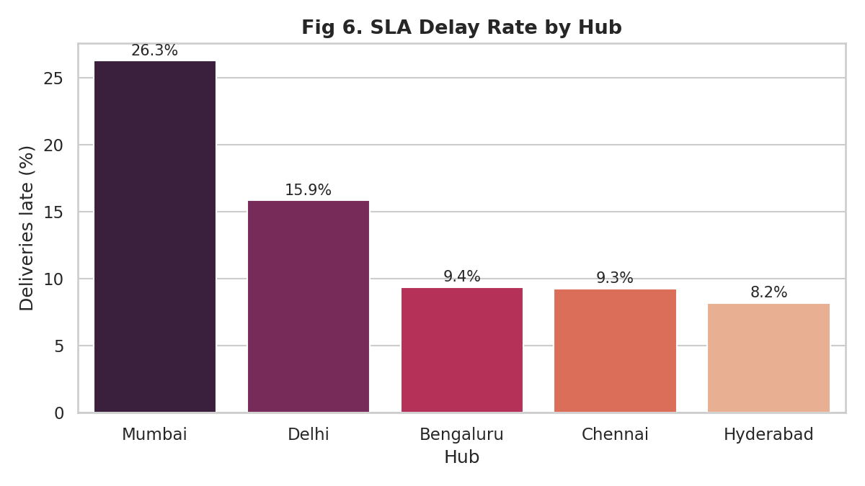
Figure 6. SLA delay rate by hub
Interpretation: Mumbai (26.3%) and Delhi (15.9%) are far above Chennai, Bengaluru and Hyderabad, which all sit at about 8.2%-9.4%. Together Mumbai and Delhi handle 34% of volume. Since the ANOVA test shows the hub effect remains after holding vehicle type fixed, the problem is partly inside the hubs (sorting and dispatch time), not only the roads around them.

4.7 Delay rate by hour and weekday (heatmap)
Why this chart: A two-dimensional heatmap shows when problems occur. A bottleneck that depends on time of day and day of week is invisible in a simple bar chart.
pv = df.pivot_table(index="weekday", columns="hour", values="delayed", aggfunc="mean") * 100
sns.heatmap(pv, cmap="YlOrRd", cbar_kws={"label": "Delay rate (%)"})

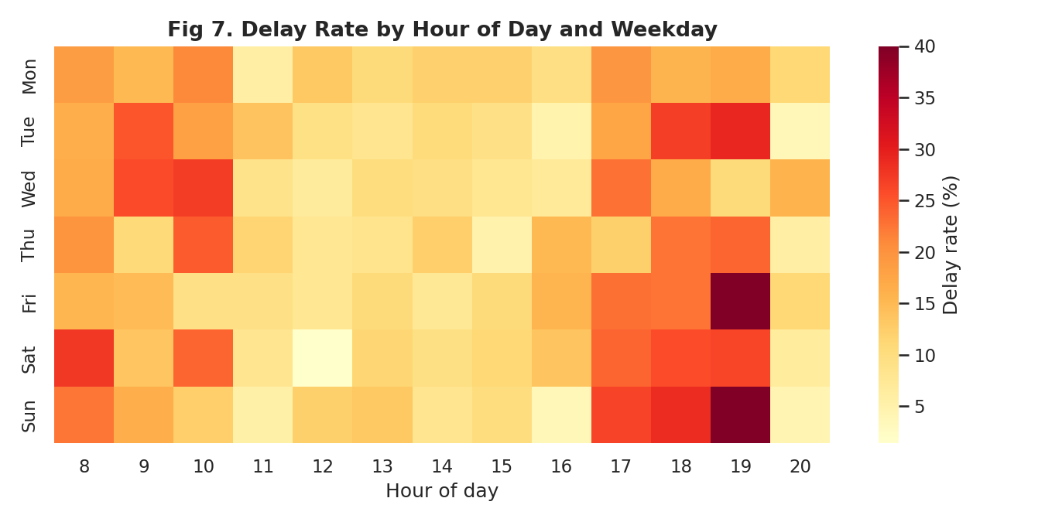
Figure 7. Delay rate by hour of day and weekday
Interpretation: Two dark bands appear at 8-10 AM and 5-7 PM, matching commuter traffic. Peak windows hold 36.6% of deliveries but 55.2% of the delays (20.1% late versus 9.4% off-peak). Midday from 11 AM to 4 PM is consistently the safest period. A note of caution: individual hour-and-day cells contain only a few dozen deliveries, so the very darkest cells (such as 7 PM on Friday and Sunday) are partly sampling noise and the band pattern is more reliable than any single cell.

4.8 Cost per km by vehicle and traffic level (grouped bar chart)
Why this chart: Grouped bars compare a metric across two categorical factors at once, showing whether traffic changes the unit economics of each vehicle.
sns.barplot(data=df, x="vehicle", y="cost_per_km", hue="traffic",
order=["Bike","Van","Truck"], hue_order=["Low","Medium","High"], errorbar=None)

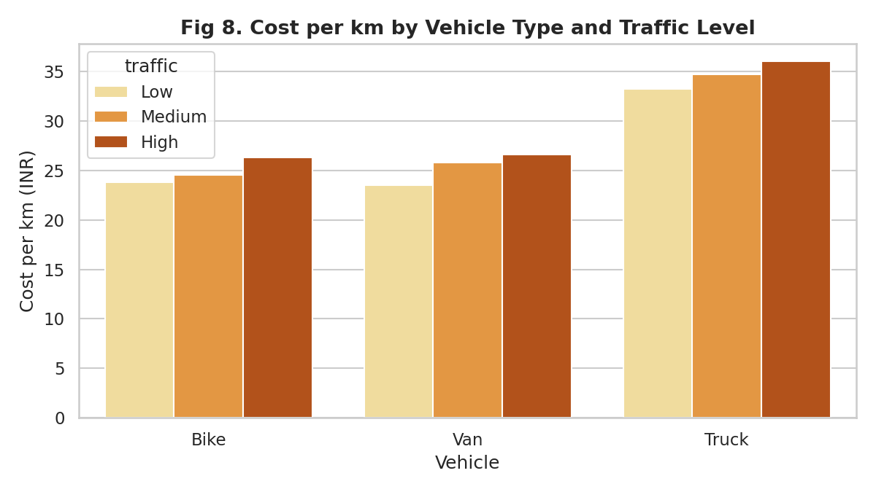
Figure 8. Cost per km by vehicle type and traffic level
Interpretation: Trucks cost about INR 34.27 per km against INR 24.6-24.8 for bikes and vans, and cost per km rises with traffic for every vehicle because slower speeds increase paid labour hours per kilometre. Congestion is therefore both a service problem and a cost problem.

5. Analytical Insights

5.1 Operational efficiency
Overall efficiency is acceptable (86.6% of deliveries on time, average rating 4.08), but performance is uneven. Chennai, Bengaluru and Hyderabad operate at around 8-9% late, while Mumbai reaches 26.3%. Raising Mumbai and Delhi to the level of the other hubs would remove most of the network's avoidable delays.

5.2 Cost drivers
Three factors explain most of the cost. First, distance (R-squared 0.948). Second, vehicle choice: trucks consume 62.5% of spend for 18.3% of deliveries. Third, time: labour cost is proportional to delivery time, so every delay also raises cost. Weight and units have only moderate correlation with total cost (about 0.55-0.59), and much of that is because heavy shipments go on trucks and travel further.

5.3 Bottlenecks
- Time-of-day: morning and evening peak windows (55.2% of delays).
- Location: Mumbai and Delhi hubs (long sorting delays).
- Season: October to December rain, with the delay rate reaching 17.3% in November.
- Vehicle: bike deliveries fail the tight 1.2-hour SLA 18.0% of the time, giving bikes 55.2% of all late deliveries.

6. Recommendations
- Shift dispatch away from peak windows. Move flexible, non-urgent orders into the 11 AM-4 PM window. If even a quarter of peak-hour deliveries moved off-peak at the off-peak delay rate, the network would avoid roughly 49 late deliveries a year in this sample.
- Run a sorting-process audit at Mumbai and Delhi. Target a reduction of Mumbai's average hub delay so its delay rate falls from 26.3% toward the 9% of the best hubs. Track dock-to-dispatch time as a new KPI.
- Review SLA design for bikes. Either widen the 1.2-hour bike promise for longer routes, or cap bike assignments at a shorter distance. Bikes cause 55.2% of delays.
- Consolidate truck loads. At INR 34.27 per km, trucks are the biggest line in the budget. Route consolidation and fuller loads attack 62.5% of spend directly.
- Add a seasonal buffer for October to December. Quote longer delivery windows during rain, add reserve riders, and pre-position stock closer to customers.
- Monitor percentiles, not just averages. Because the data is right-skewed, report the 90th percentile of delivery time and delay rate by hub and hour on a weekly dashboard.

7. Reflection and Limitations
What worked: building the dataset from physical components (speed, distance, service time) meant the EDA could recover real structure, and the chart choices each had a clear question behind them. The most useful technique was segmenting before concluding. The overall correlation between distance and cost looked simple, but the by-vehicle scatter and cost-per-km chart showed that truck economics are very different from bike economics.
What surprised me: I expected trucks to have the worst delay rate because they are slowest. They actually have one of the best (10%), because their SLA is generous (4.5 h) relative to the time they need. The worst performer on delays is the bike, which has the shortest trips but the tightest promise. This shows that SLA design affects measured performance as much as operations do, and any real analysis should check whether a metric is measuring performance or a target.
Limitations: this is simulated data, so effects such as the Mumbai hub delay and the peak-hour slowdown were put in by design and a real network would be messier, with missing values, data-entry errors and interacting causes. Hour-by-weekday cells are small, so the single hottest cells in Figure 7 should not be over-read. The analysis is descriptive and correlational; it does not prove that moving deliveries off-peak will deliver the estimated saving. Next steps would be a regression or gradient-boosting model to predict late deliveries, and testing the recommendations on real operational data.

8. Conclusion
The analysis of 5,000 simulated deliveries shows that logistics performance in this network is shaped by a small number of identifiable factors: distance and vehicle type for cost, and peak-hour traffic, hub processing and seasonal rain for delays. Visualization made each of these visible: histograms and box plots exposed the skew that averages hide, the heatmaps located the time and place of the bottlenecks, and the scatter and grouped bar charts quantified the cost drivers. Acting on the six recommendations above targets the areas where the data shows the largest, most measurable gains.

Appendix: Reproducing the Analysis
Files in the GitHub repository:
- logistics_analysis.py - generates the dataset, runs all statistics and saves the eight charts.
- logistics_dataset.csv - the simulated 5,000-row dataset used throughout this report.
- charts/ - figure PNG files (fig1 to fig8).
pip install pandas numpy matplotlib seaborn scipy
python logistics_analysis.py

