E-COMMERCE SALES DATA ANALYSIS AND DASHBOARD
- Introduction
This project focuses on analyzing an e-commerce dataset using Microsoft Excel. The main objective is to clean, transform, and analyze the data to extract meaningful business insights. Various Excel tools such as formulas, XLOOKUP, Pivot Tables, and dashboards were used to perform the analysis.
- Objectives

• To analyze the e-commerce sales dataset and understand customer purchasing behavior.
• To clean and preprocess the data by handling missing values, removing duplicates, and correcting formatting issues.
• To integrate data from multiple tables using functions like XLOOKUP to create a unified dataset.
• To perform descriptive statistical analysis such as mean, median, mode, and standard deviation to summarize the data.
• To handle missing values using imputation techniques such as average and category-wise average (AVERAGEIF).
• To create pivot tables for summarizing and comparing data across different dimensions such as category, gender, region, and age group.
• To build an interactive dashboard using charts and slicers for better data visualization.
• To derive meaningful business insights to support data-driven decision making.

- Data Cleaning
The dataset was cleaned to ensure accuracy and consistency. The following steps were performed:
- Removed duplicate records
- Handled missing values
- Standardized text using TRIM and PROPER functions
- Corrected formatting issues
- Data Integration
Multiple tables such as customer, product, and store data were merged using XLOOKUP. This helped in creating a single consolidated dataset for better analysis.
- Data Analysis Techniques
The following techniques were used for analysis:
- Excel formulas such as AVERAGE, MEDIAN, MODE, and STANDARD DEVIATION
- Descriptive statistics for understanding data distribution
- Pivot Tables for summarizing and comparing data
- Key Analysis
Several analyses were performed using Pivot Tables:
- Average sales across different age groups
- Gender-wise average spending
- Impact of loyalty levels on customer purchases
- Category-wise average unit price and discount
- Region-wise performance comparison
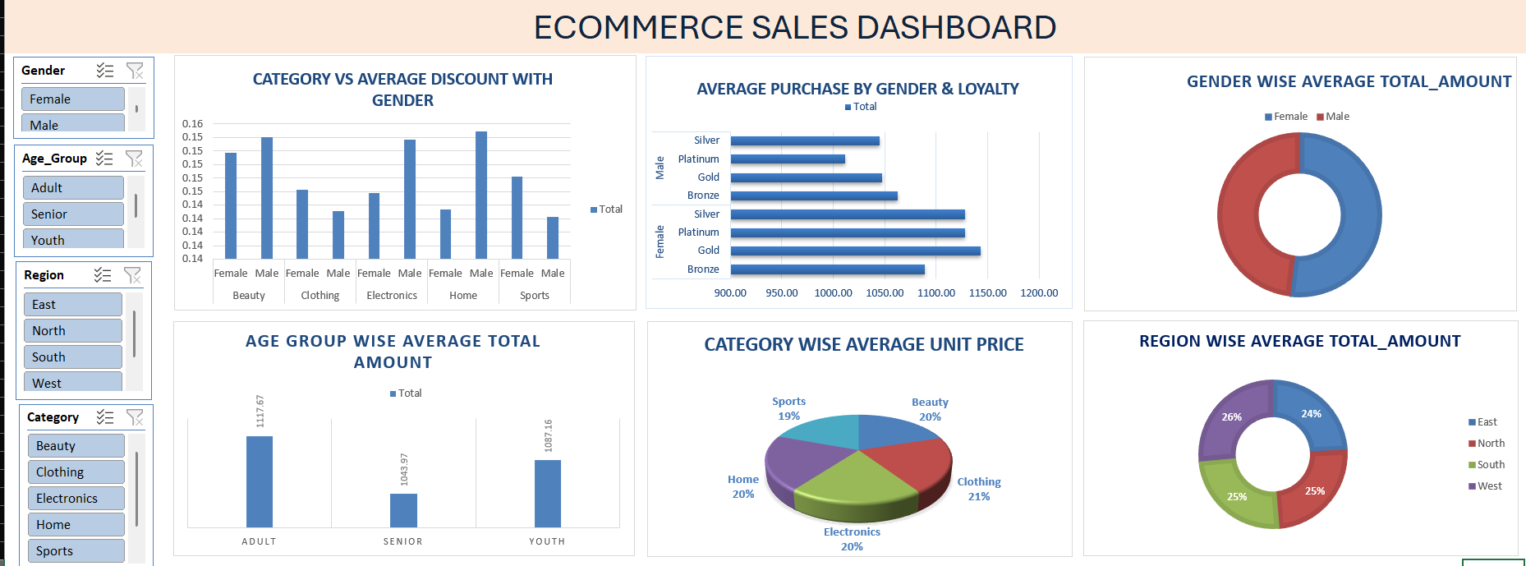
7.Dashboard Creation
An interactive dashboard was created using Pivot Charts. Slicers were added to filter data dynamically based on category, region, gender, and age group. The dashboard provides a clear and visual representation of the analysis.

Figure 1: E-Commerce Sales Dashboard

8.Key Insights
Descriptive Analysis
- Adult customers have the highest average spending.
- Female customers spend slightly more than male customers.
- The West region shows better performance compared to other regions.
Diagnostic Analysis
- Higher spending by adult customers may be due to greater purchasing power and financial stability.
- Female customers may contribute more to sales due to higher engagement in categories such as clothing and beauty products.
Predictive Analysis
- Sales are likely to remain higher among adult customers in the future.
- Regions like the West are expected to continue performing better based on current trends.
Prescriptive Analysis
- Marketing strategies should focus more on the adult customer segment to maximize revenue.
- Targeted offers and promotions can be provided for female customers to further increase sales.
- Additional efforts should be made to improve performance in underperforming regions such as the East.

9.Conclusion
The project successfully demonstrates how Excel can be used for data cleaning, integration, analysis, and visualization. The dashboard provides meaningful insights that can help in understanding customer behavior and improving business decisions.

