Data Analytics (DA)
Module -3
MySQL Assignment-1 DDL Commands, Constraints

Problem Statement:
As a Data Analyst, the company requires an Employee Database to store and manage information
related to employees, departments, and locations within the organization.
You are required to design and manage this employee database using MySQL DDL commands,
focusing on creating, modifying, and managing database objects while enforcing appropriate
constraints to ensure data integrity and consistency.
Dataset Description:
You will work to create the following three tables:
● Table: Departments
Attributes:
○ department_id – Primary Key
○ department_name
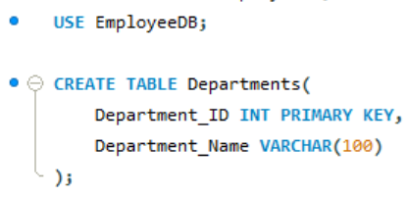
● Table: Location
Attributes:
○ location_id – Primary Key
○ location_name
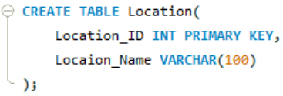
● Table: Employees
Attributes:
- Employee_id – Primary Key
- Employee_name
- Gender
- Age
- Hire_date
- Designation
- Salary
- department_id – Foreign Key referencing department(department_id)
- location_id—Foreign Key referencing location(location_id)
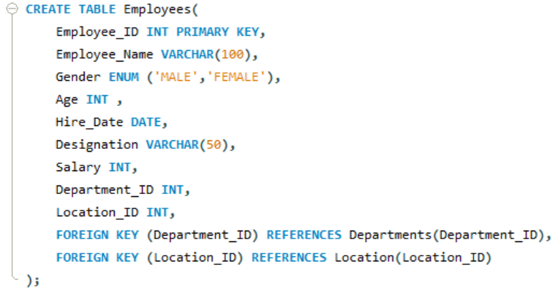

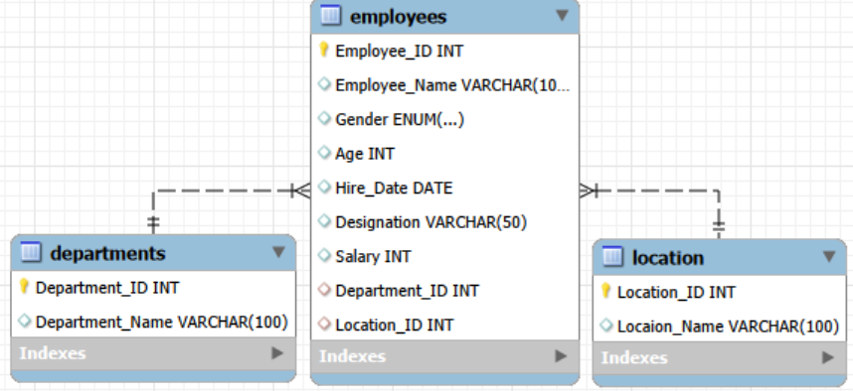

Tasks:
DDL Commands
1. Database and Table Creation (CREATE):
● Create a Database for this project
● Create all three tables in MySQL with appropriate data types and relationships.
Aswers already done above.

2. Table Alteration (ALTER)
● Add a new column named "email" to the Employees table to store
employee email addresses.
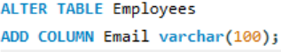

● Modify the data type of the "designation" column in the Employees table to
support a wider range of values.
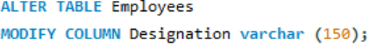

● Drop the “age” column from the Employees table.
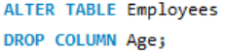

● Rename the “hire_date” column to “date_of_joining”.
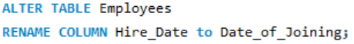

3. Table Renaming (RENAME):
● Rename the "Departments" table to "Departments_Info".

● Rename the "Location" table to "Locations".

4. Table Truncation (TRUNCATE):
● Truncate the Employees table.

5. Database & Table Dropping (DROP):
● Drop the Employees table and then the “employee” database.
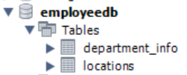
Tasks: Constraints :
1. Database Recreation:
● Drop the 'employee' database if it exists

● Recreate it using the provided schema, ensuring that all tables are created with the appropriate constraints as instructed.

● Establish links between the "department_id" and "location_id" fields in the "employees" table and their respective tables.
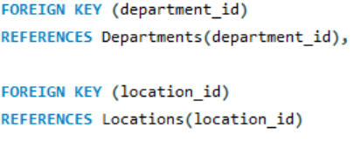

2. Departments Table:
● Ensure that the "department_id" uniquely identifies each department.

● Set up constraints on the "department_name" to avoid duplicate and null entries.
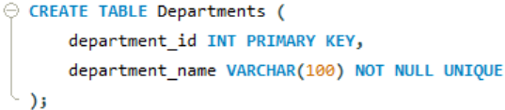
3. Locations Table:
● Establish a mechanism to automatically generate unique identifiers for each location, ensuring that they are incremented sequentially.

● Implement constraints to prevent the insertion of null and duplicate locations.
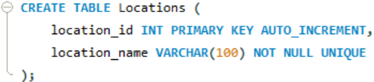
4. Employees Table:
● Guarantee that each employee has a distinct identifier.

● Create a restriction to ensure that the employee's name is always provided.

● Limit the acceptable values for the "gender" field to only 'M' or 'F'.

● Enforce a condition to ensure that the employee's age is 18 or above.

● Automatically assign the current date to the "hire_date" field if not specified. Deliverables
