ELK Anomaly Detection

* Signed in with personal mail ID for free trail

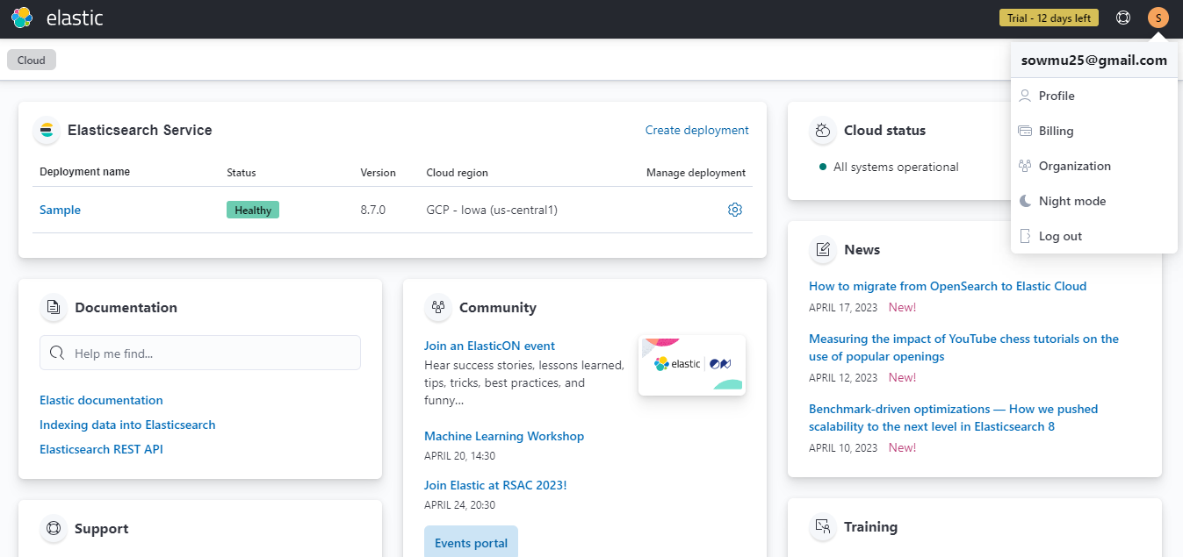

* Created a deployment with the following configurations:

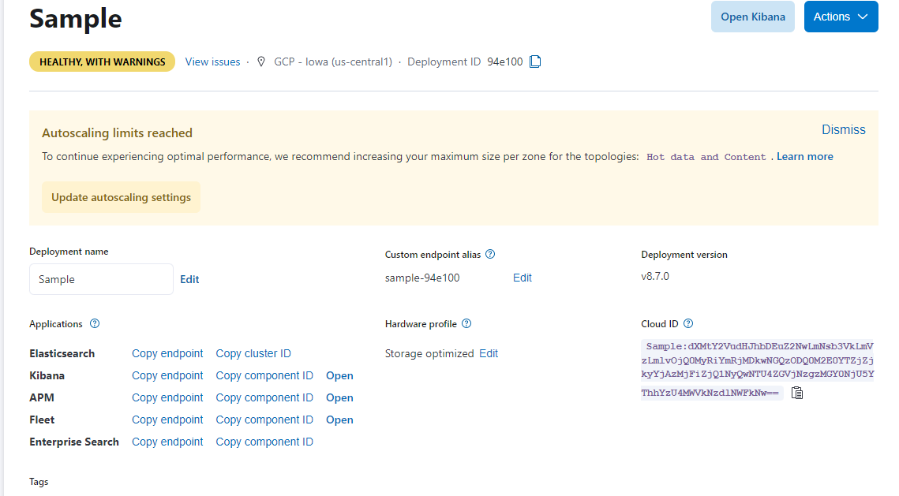

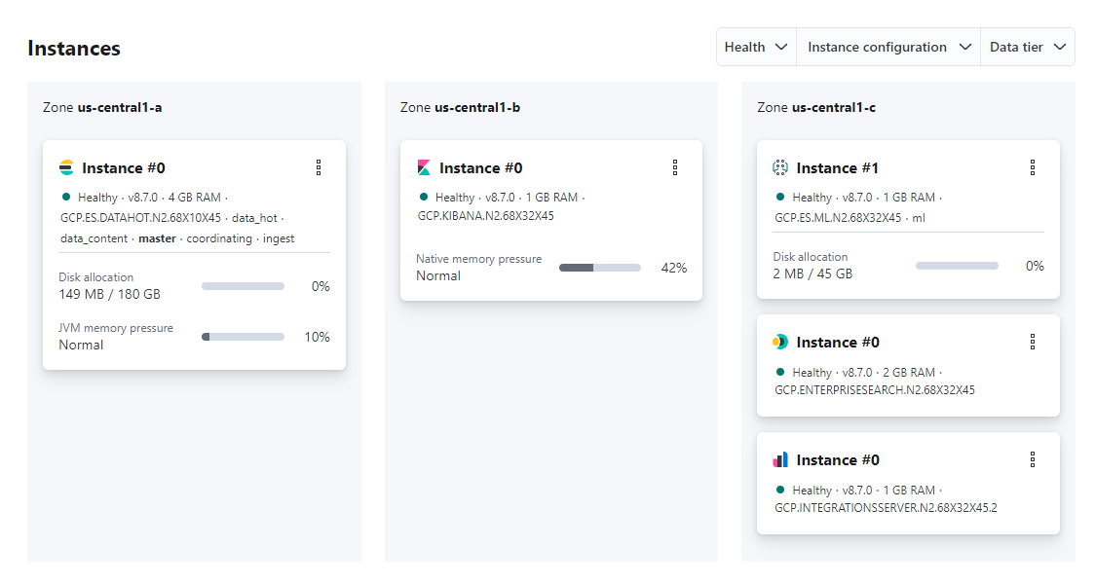

* Machine Learning feature enabled using free trail

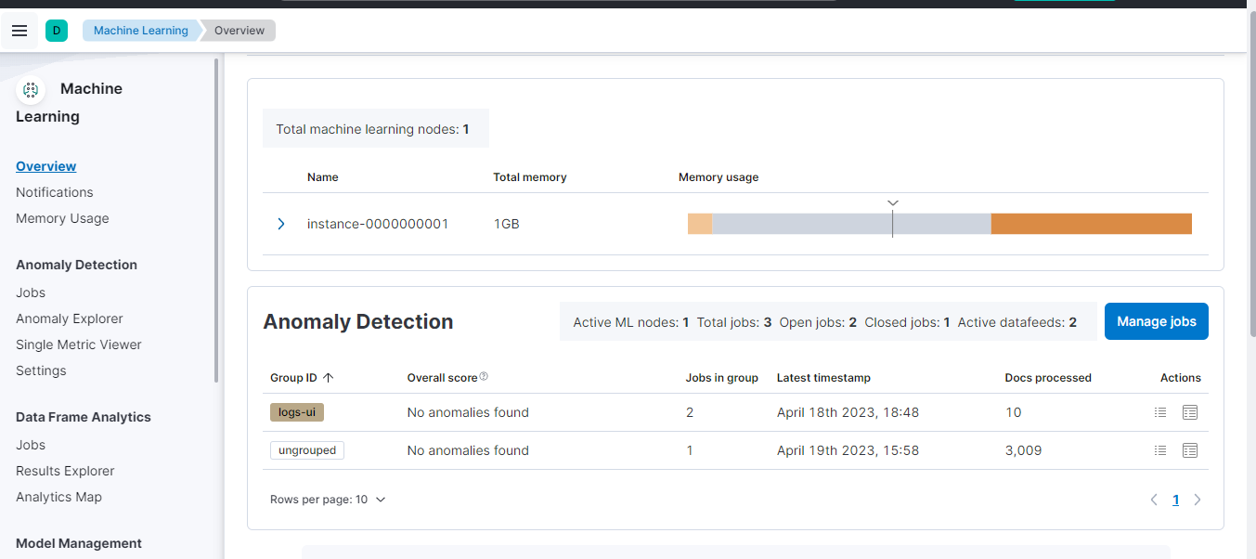

* Uploaded sample data from ElasticSearch and created a job with freq 15mins:

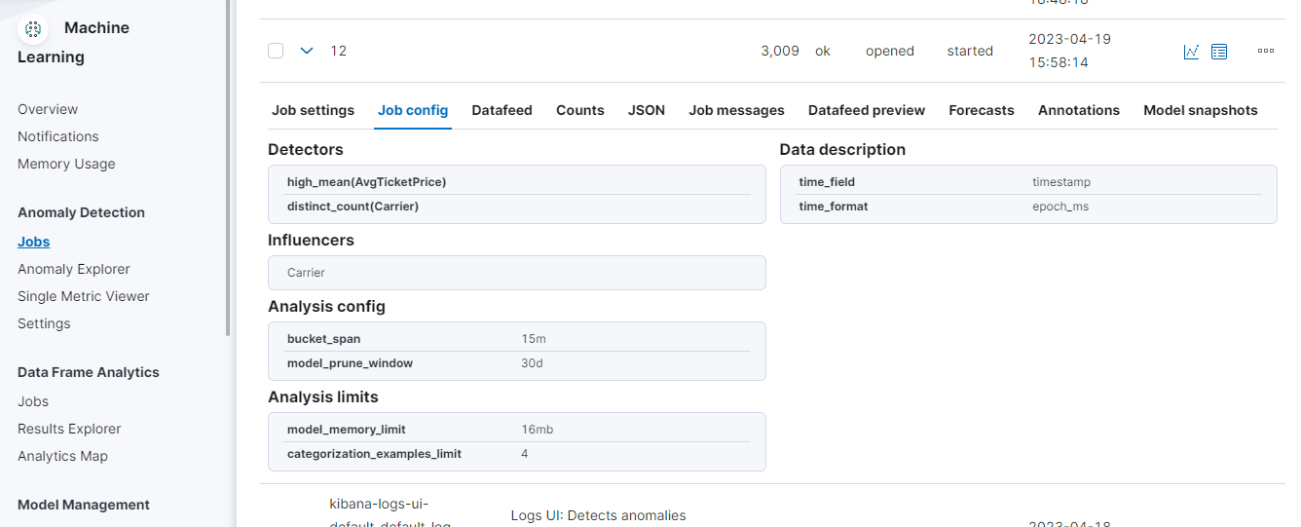

* Anomaly Explorer:

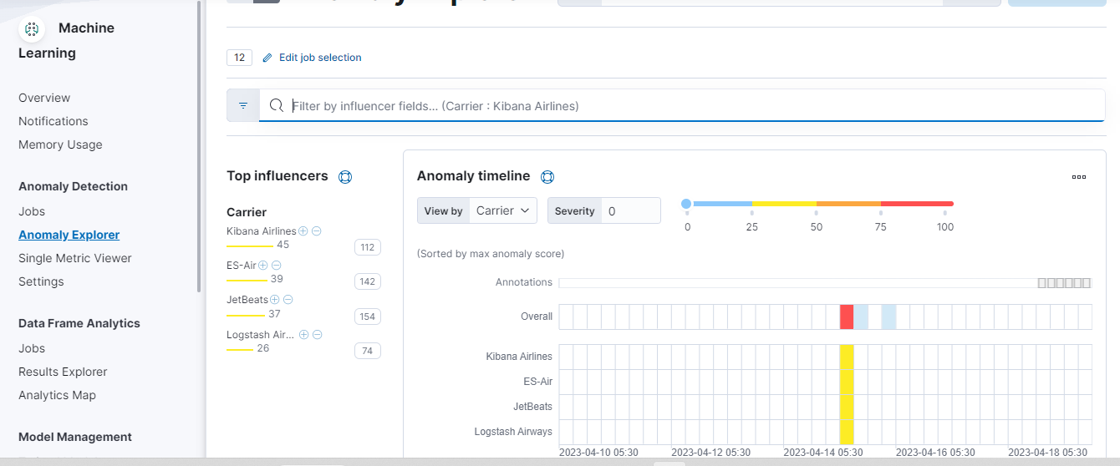

* Anomaly detected:

