**TODO-APP**

**1. GETTING STARTED**

**GITHUB REPO:** [**https://github.com/sowmya-520/todo-app**](https://github.com/sowmya-520/todo-app)

1. Create a folder and open visual studio.

2. Run the command



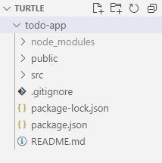

3. Install all the dependencies

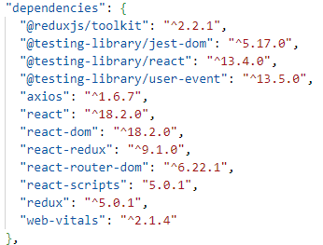

**5. As per the given requirements, I created pages and slicers using react redux tookit.**

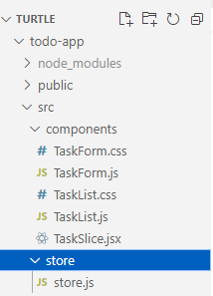

6. Now , configure the store and app.js file.

7.Run the application by using the command

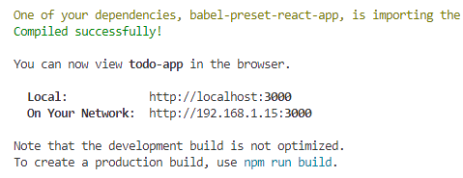

OUPUTS:

* When No tasks are added

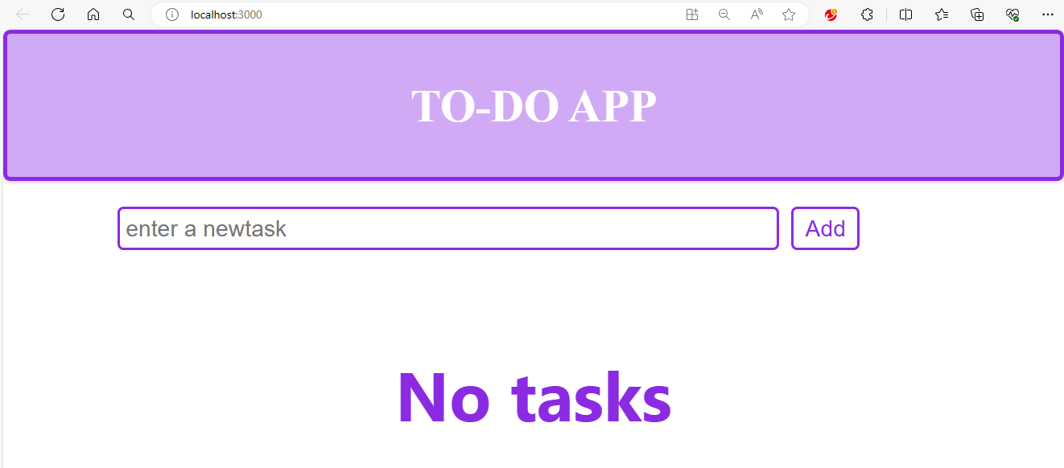

🡪When tasks are added

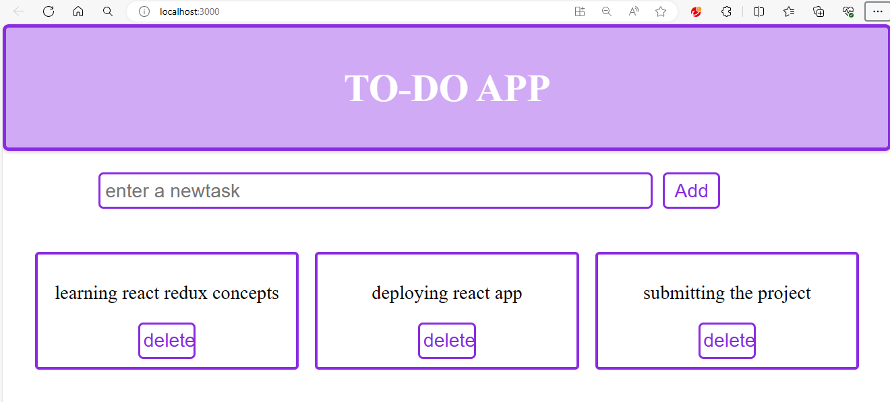

🡪Deleting the task

after clicking on the delete button, task gets deleted.

