# My Experience

The exercise assigned to me has been a unique experience. It enabled me to step into the world of Dockers. Though I have been working on Cloud-native projects, I did not have a direct experience of deployment. What was more gratifying was that I had the hands-on experience to understand dockers, install the Docker desktop, and through PowerShell as the interface, I was able to develop a sample application with the help of the instructions. I have successfully used GitHub pages to publish a Markdown file. Let me elaborate the activities that I performed in each step:   
  
Step 1:     Install Docker Desktop on Windows

Docker Desktop on Windows enables to build and share containerized applications and microservices.   
As a preparatory step, I had checked the System Requirements, and enabled Windows Subsystem for Linux 2 on Windows machines, Docker Desktop provided the ability to work natively on Linux through WSL2 on Windows machines.  
I would like to present screen shots that were captured during the process of Docker Desktop for Windows installation.

Fig 1: Docker Desktop installation  
Post the installation, the Docker Desktop icon (Whale icon) is seen in the status bar.d  
  
Fig 2: Docker Desktop

Features:  
Docker Desktop provide the ability to toggle between Linux and Windows Server environments to build applications.

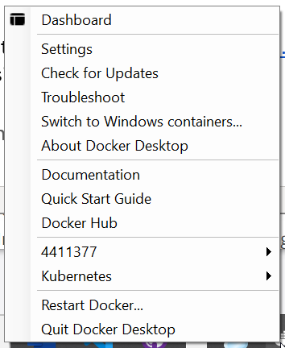

Fig 3: Docker Desktop icon right-click  
  
Verification:  
The Docker version command was checked:  
Fig 4: Docker Version  
  
Once installed it enabled to:  
a. Clone a GIT repository to the local docker image

b. Build  
c. Run

d. Share (optional step)  
For example:  
  
What went well  
The instructions that were part of <https://docs.docker.com/docker-for-windows/install/> are clear and comprehensive.

What needs improvement  
  
The **System Requirements** section has information covered in two tabs, namely **WSL2 Background** and **Hyper-V backend and Windows containers**. It is not clearly mentioned if both the requirements must be essentially satisfied.

Step 2: Get familiar with Docker Desktop  
  
In this step, I got familiar with the use of the Docker Run command and when run successfully, the new Container information appears in the Docker Desktop

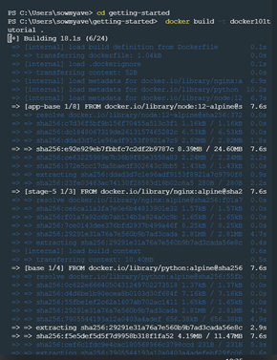  
Fig 5: Docker build command   
  
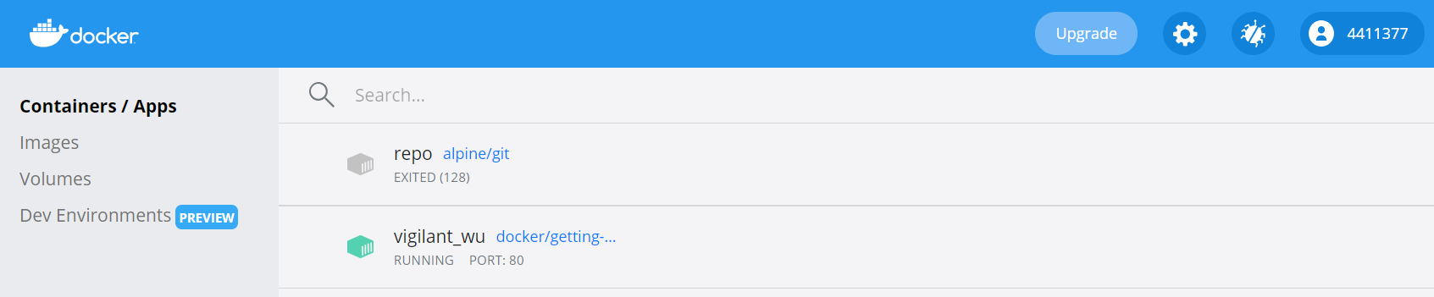  
Fig 6: Docker Desktop with the new app Container in the running state

Step 3: Download and Run a Simple Application in a Docker Container  
  
The aim of this exercise is to build a simple Todo list manager that runs in Node.js. , I built a container image with the help of a Dockerfile.  
When an image was built, the container started and the app was in the running state.  
The following figure indicates that along with the existing container, the new container is available in the assigned port:  
 a. vigilant_wu in Port 80 and   
 b. epic_wrightin port 3000 (newly created container image)  
  
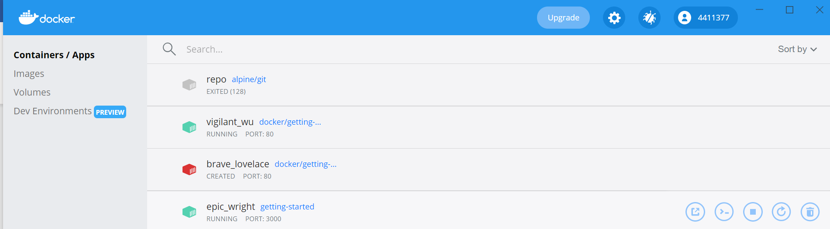  
Fig 7: App container images   
When it was tested in the browser (<http://localhost:3000>), the todo list manager running in Node.js appeared as follows:  
Fig 8: Todo list manager  
Step 4: Publishing in the GitHub  
As a part of this exercise, I have created an GitHub account (sowmya-venkat)

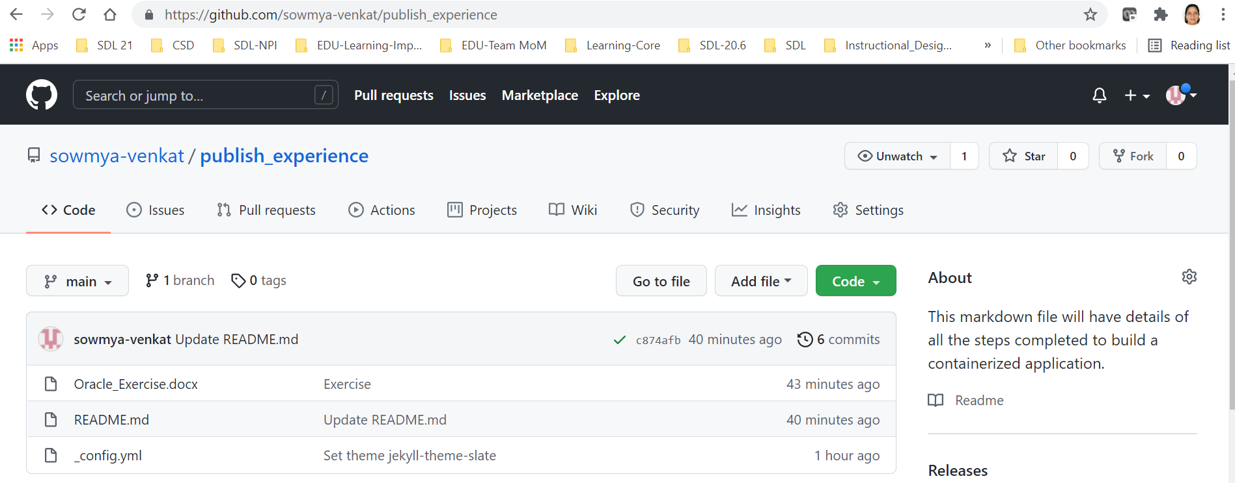  
I had created a repository (publish_experience), modified the README.md page to include my experience, and the created a link to this document for detailed information.  
While there are many advanced features, I had attempted to do a basic publishing.  
  
Personally, the world of Dockers and the usage of Markdown and GitHub are new exposures. I did not have to apply any specific Troubleshooting methods, though I had to repetitively do some steps to build on the learning. The documentation has been fairly clear and the instructions that were part of this exercise had set the expectations.   
I had attempted this development in a short span of time, and I am happy that I could publish my first markdown file.  
I have thoroughly enjoyed this challenge, and needless to say, I have been fascinated with working on the practical side of Dockers!