Render link - <https://nodejs-files-system.onrender.com>

Github : https://github.com/sowmya009/NodeJS_File_System.git

Postman :

POST : <http://localhost:3000/createFile>

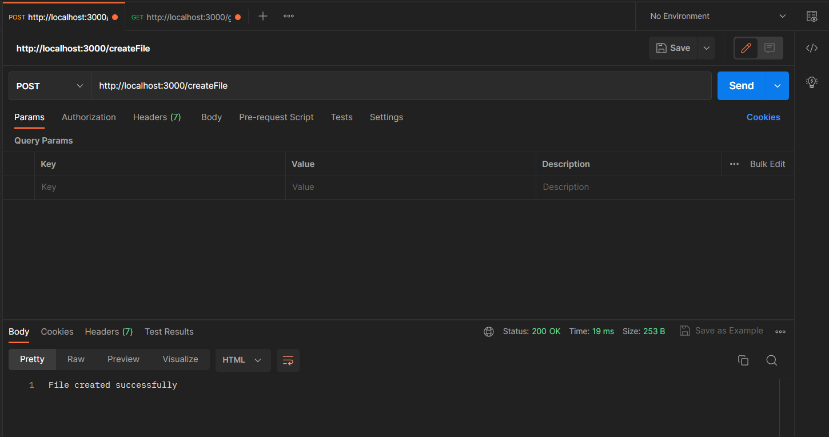

GET : <http://localhost:3000/getTextFiles>

