**STUDENT FACULTY FEEDBACK PORTAL**

**USER MANUAL**

**CONTENTS:**

* **Introduction**
* **The Look**
* **Login Page**
* **Student Login**

**Courses**

**Course Feedback**

**Faculty Feedback**

**Complaints,Compliments,Questions,Ideas**

* **Faculty Login**

**Login page**

**Courses undertaking and Ratings**

**Graph**

**Complaints, Compliments, Questions, Ideas**

* **Admin Login**

**Login page**

**Add/Delete Question**

**See feedback**

**Disable Feedback**

* **Conclusion**
* **More to come!!**

**INTRODUCTION**

**Student faculty feedback portal is a portal where students and teachers can interact with each other regarding their respective courses consistently.**

**“NO SIGNIFICANT LEARNING CAN OCCUR WITHOUT A SIGNIFICANT RELATIONSHIP”**

**In our portal we can guarantee to keep that relationship safe and sound by providing an interface between the students and teachers in which ----**

**The student gives feedback to the respective courses he has and to the teachers who teach him. He has an option to share his ideas about anything (regarding subject), pose complaints, ask questions and also give compliments regarding the faculty’s work. The student can reveal his/her name or keep it anonymous while providing ideas, questions, compliments or complaints.**

**The faculty can see their respective courses and their ratings for that course.The faculty will be given an average rating out of 5 depending on the feedback given by the all the students to him. He/she can also compare his performance comprehensively in the form of a bar graph. He/she can even download the bar graph in which can be downloaded in jpeg/png/svg format He/she receives messages about the ideas, questions, complaints and compliments given by the students to him .**

**The admin can take control over any actions of the feedback portal. He can view the feedback given by all the students to any faculty .He can add and delete questions that are asked to take the feedback from the students. He can also set the timings for the feedback form to operate and disable them whenever required.**

**There is always a Logout button to logout.**

**THE LOOK**

**It is a portal designed using HTML, CSS, JQUERY JAVASCRIPT, PHP, Mysql, Ajax**

**It is elegant and user friendly**

**It enhances the purpose of the feedback portal**

**Login form**

**As soon as the feedback portal is opened you will see a window as shown asking you to enter the login details like email id , password etc.**

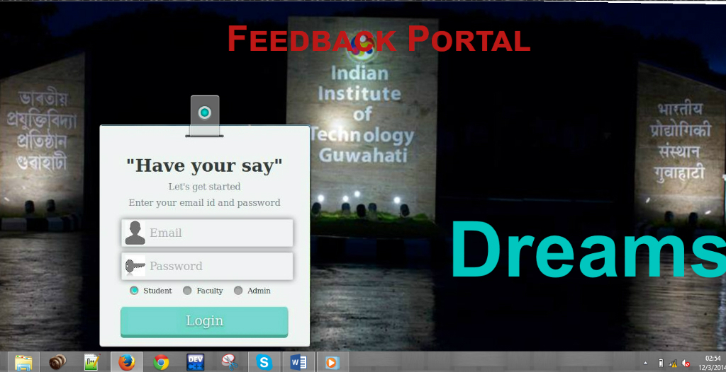

**Login Form:**

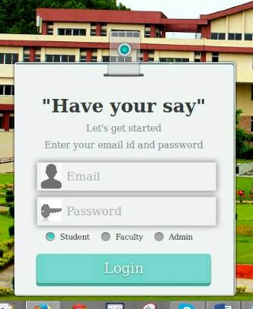

Enter email id

Enter password

Login as- student/faculty/admin

LOGIN

**If the supplied credentials are right then you enter into your respective portal, else an error message will be displayed.**

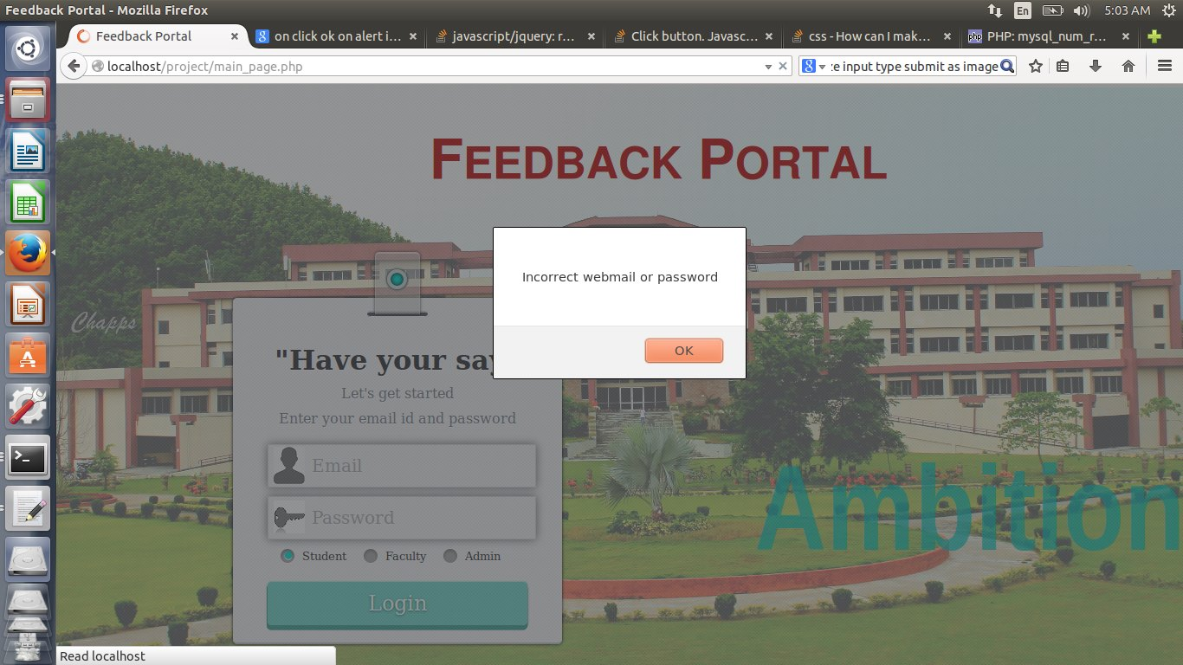

Error message

**Student Login:**

If you are a student then you will be seeing a screen as follows. It has different images which will be equal to the number of your courses

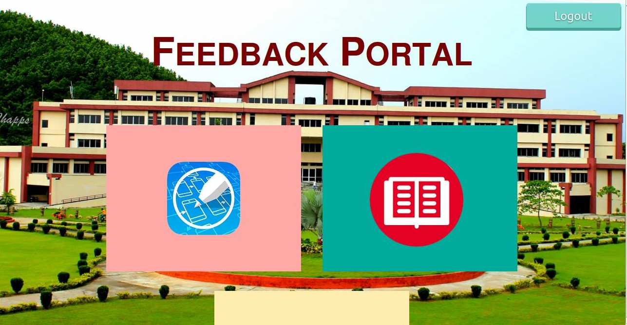

Courses for which the student is registered

Logout

Courses:

If you move your pointer over the image you can see the course name, the faculty who are in charge of the course and a button to give feedback.

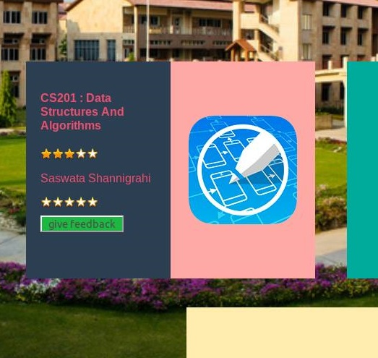

Course name

Course rating

Professor Name

Professor rating

Give Feedback

Course Feedback

If you click on give feedback you can see the questions for different sub categories like course and faculty. You can give your answers and then leave any comments

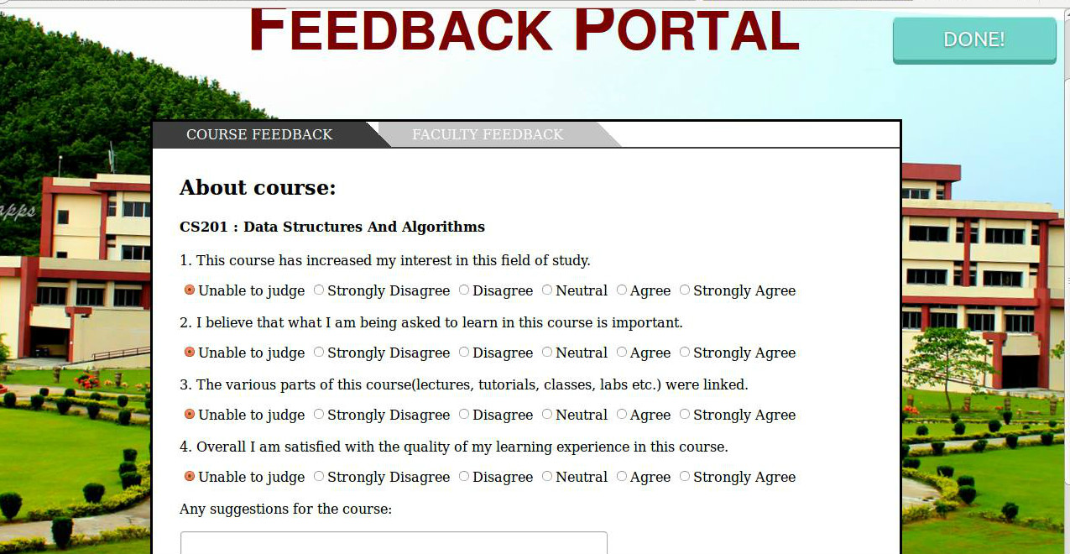

Faculty Feedback

After giving your feedback you can change the tab and give feedback to the faculty.

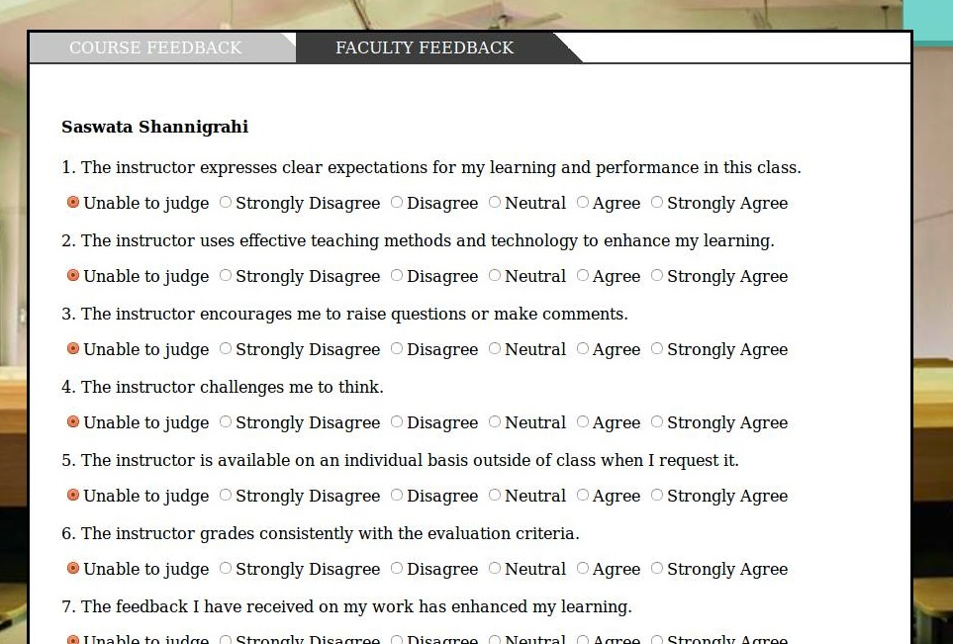

Complaints

Compliments

Questions

Ideas

After the above…you will be again seeing the main student portal where you can see the rating given by you. If you click the image a container will be dropped down where you can give your ideas, compliments, questions and complaints to the respected faculty either by your name or anonymously.

Faculty Login

If you are faculty member then login using the same form shown above (Login form) and your page will be opened as shown



Courses undertaking

You can see your name and can view all the courses under you and the average rating you got (out of 5) in each course

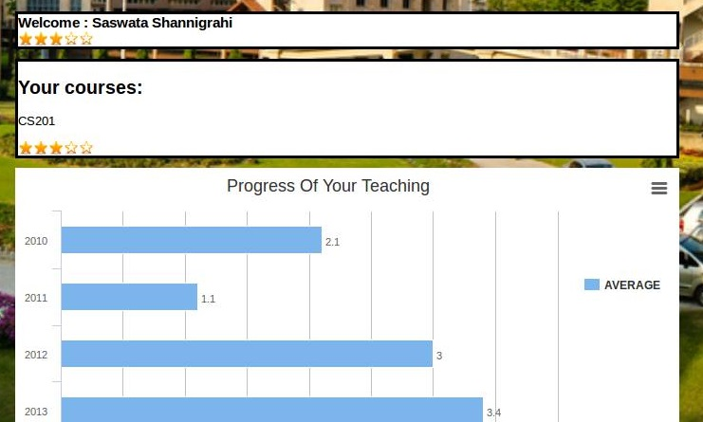

Bar graph

Here you can comprehensively compare your performance year wise and in the present year it will changing depending on the average feedback you get which helps you to improve. You can also download your graph for further reference as shown below

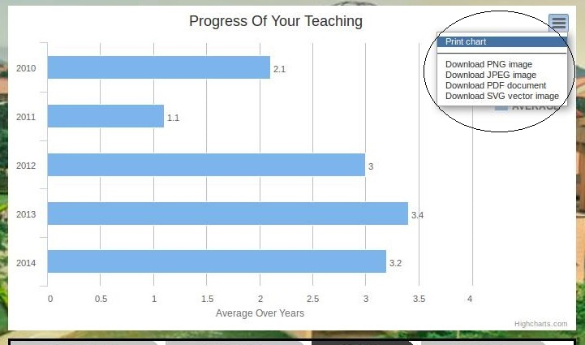

Complaints

Compliments

Questions

Ideas

Here you can see all the Complaints, Compliments, Questions, Ideas given by the students.This can be done whenever the students posts anything for you.

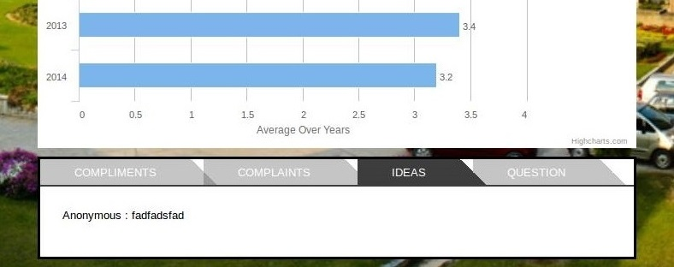

Admin Login

If you are the admin you should login as shown before (Login form) and your page will be shown as below

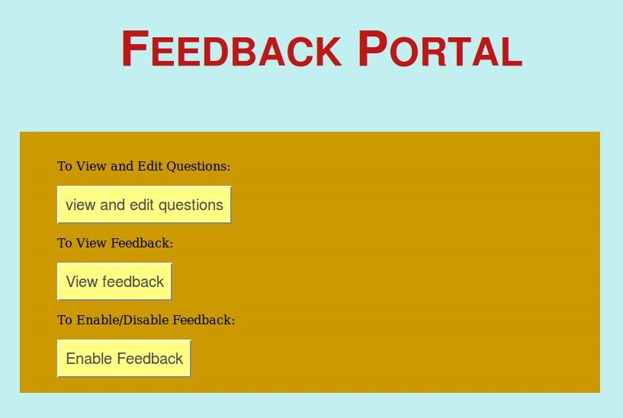

Add/Delete Questions

As the admin you have the rights to add or delete any question from the feedback portal as follows:

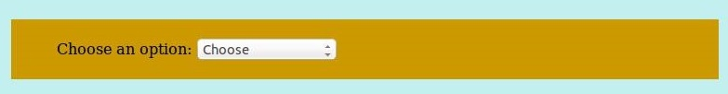

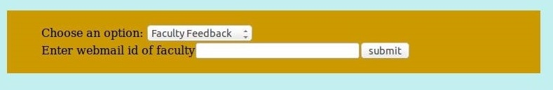

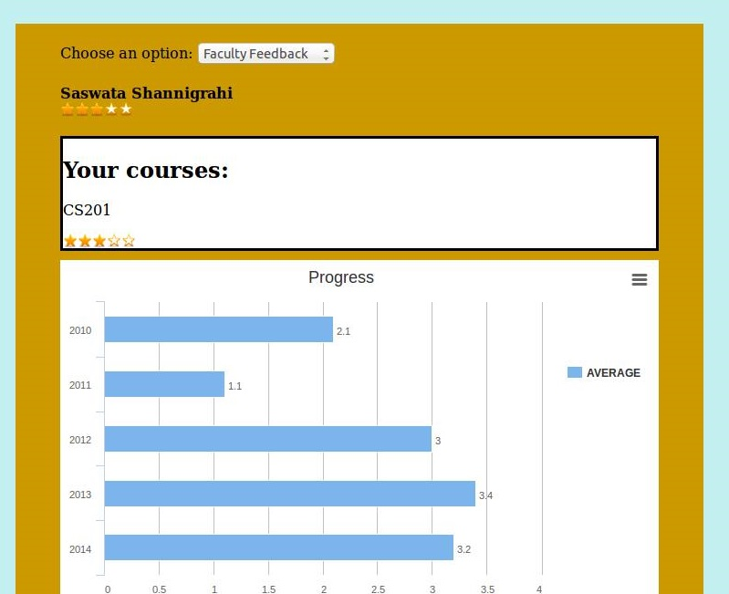

See feedback

You can see the feedback given by all the students to all the courses of any faculty by entering their email id as shown

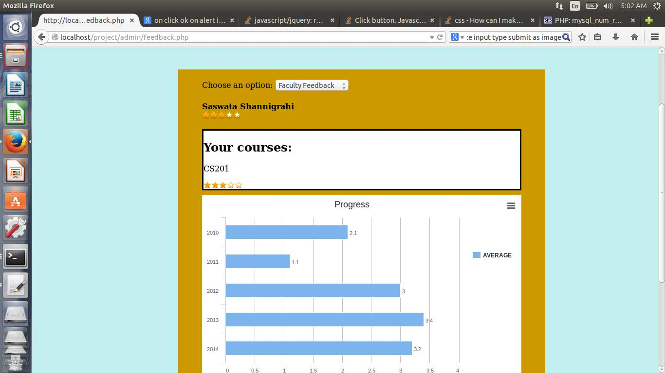

Disable Feedback

You can set the day and timings for the feedback portal to be active or closed as shown

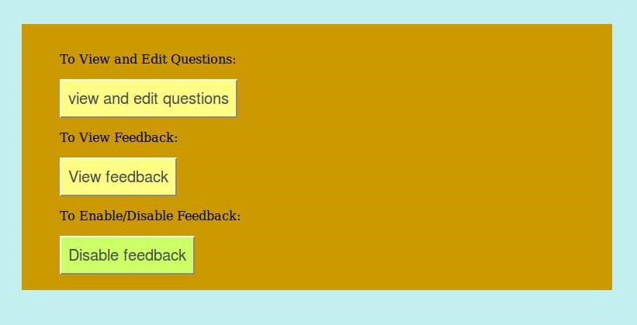

Conclusions

* Feedback portal meets the needs of students, faculty and administration effectively
* Encourages student involvement and responsibility.
* Helps to link teaching and learning and can be incorporated with best teaching practices.
* The consistent and regular feedback helps in finding new and better ways of teaching.
* Sharing of one’s ideas to the faculty directly either anonymously or directly will be helpful for the students as they can proceed further regarding that.

More to come!!

Features:

* Instant notifications when a student, share ideas, post complaints, raise questions & give compliments to a faculty
* The faculty can also send a reply regarding the same for which the student gets the notification
* Thumbs up or Thumbs down button

A student can give a class a thumbs up or down for each and every class and this will be counted in the faculty’s page