Book Doctor Appointment System
Project Documentation
Annamacharya Institute of Technology and Sciences
Department of Artificial Intelligence and Data Science
VI Semester (2026–2027)
Individual Project
Student: Sowmya Reddy
Guide: ______________________
Faculty: _____________________

Abstract
This MERN stack application allows patients to register, browse doctors, book appointments, and lets administrators manage doctors and appointments. The application uses React.js, Node.js, Express.js and MongoDB Atlas.

Features
• User Registration/Login
• Admin Login
• Doctor Management
• Book Appointment
• Appointment Approval/Reject/Delete
• Profile Management
• Responsive Interface

Technical Architecture
Frontend: React + Bootstrap
Backend: Node.js + Express
Database: MongoDB Atlas
Deployment: Render
Authentication: JWT

ER Diagram (Description)
Entities: User, Doctor, Appointment.
One user can create many appointments. One doctor can have many appointments.

MVC Pattern
Models: User, Doctor, Appointment
Views: React Components
Controllers: Auth, Doctor, Appointment Controllers

Project Structure
client-js/
server/
models/
routes/
controllers/
middleware/
config/

Client Setup
npm install
npm run dev

Server Setup
npm install
node server.js

MongoDB Configuration
MongoDB Atlas is connected using MONGO_URI in .env file.

Execution Steps
1. Start Backend
2. Start Frontend
3. Open browser
4. Register/Login
5. Book Appointment
6. Admin manages doctors and appointments

Conclusion
The system provides an efficient online doctor appointment booking platform using the MERN stack.

Demo Screenshots

Home Page
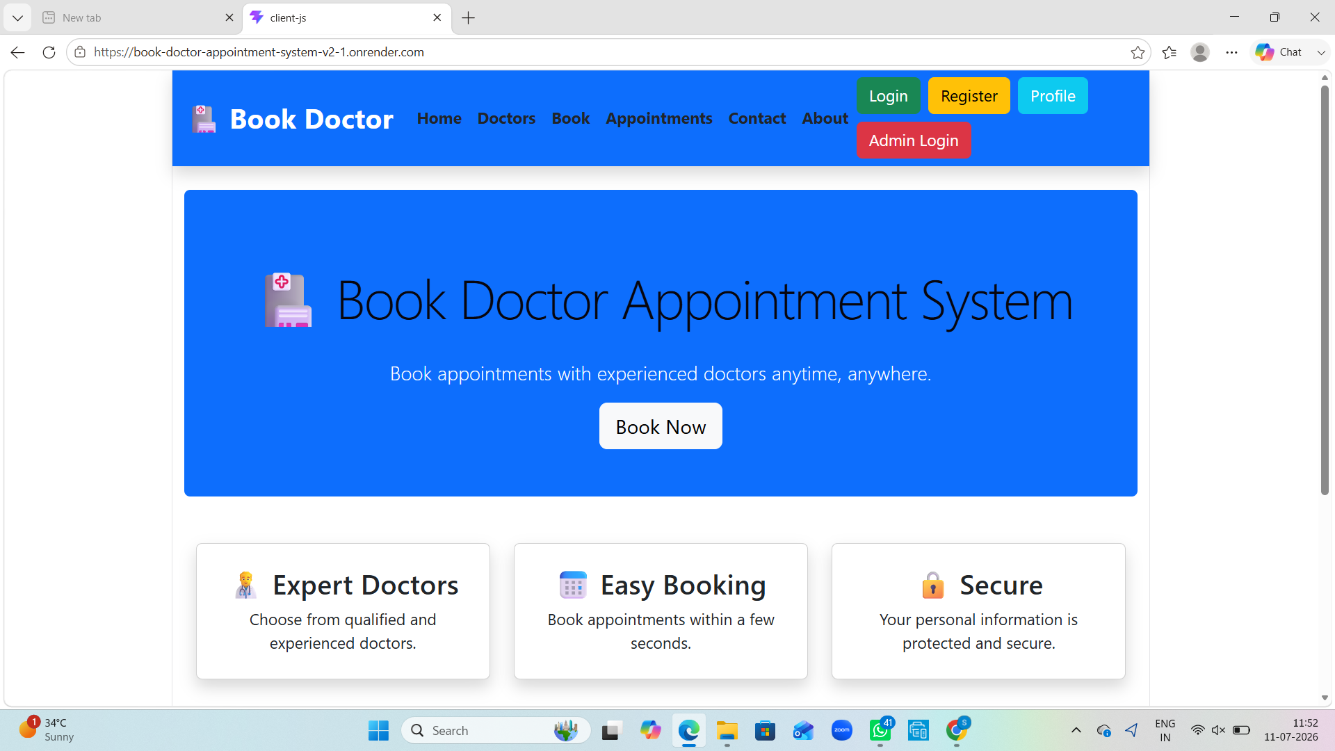
Home Page

Doctors Page
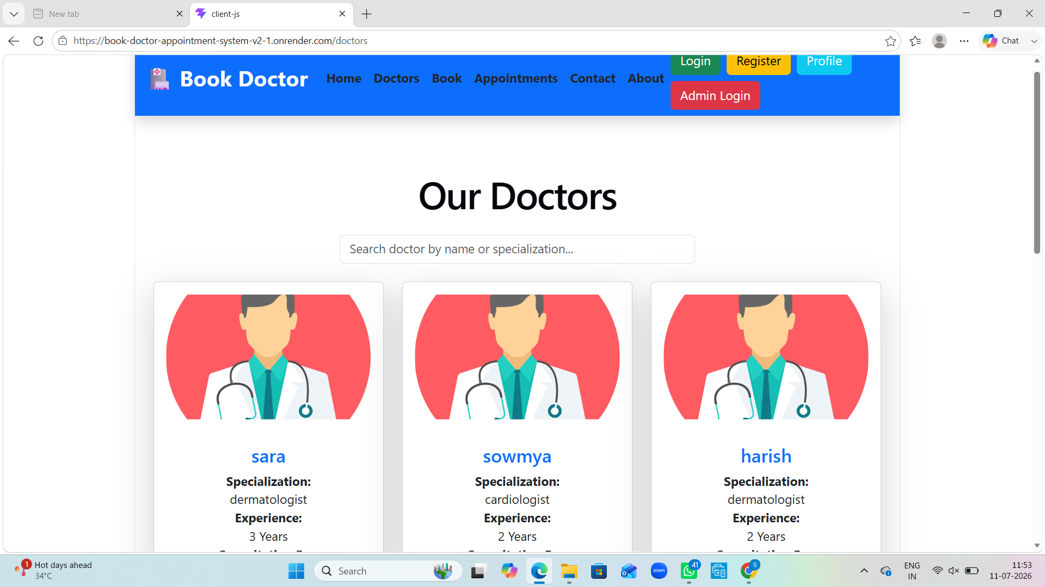
Doctors Page

Doctor Cards
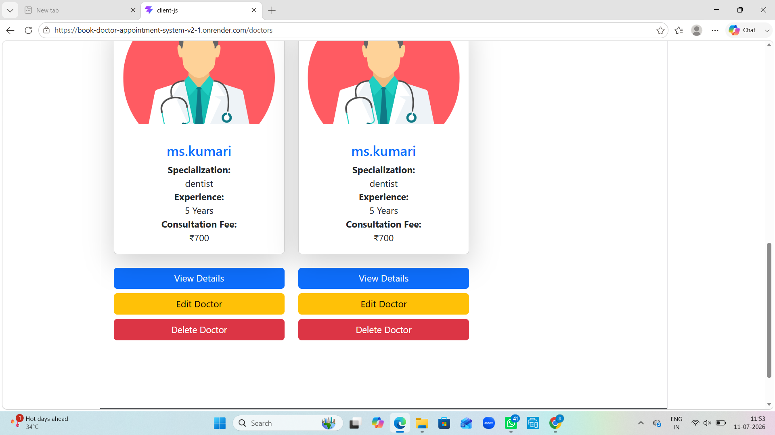
Doctor Cards

Book Appointment
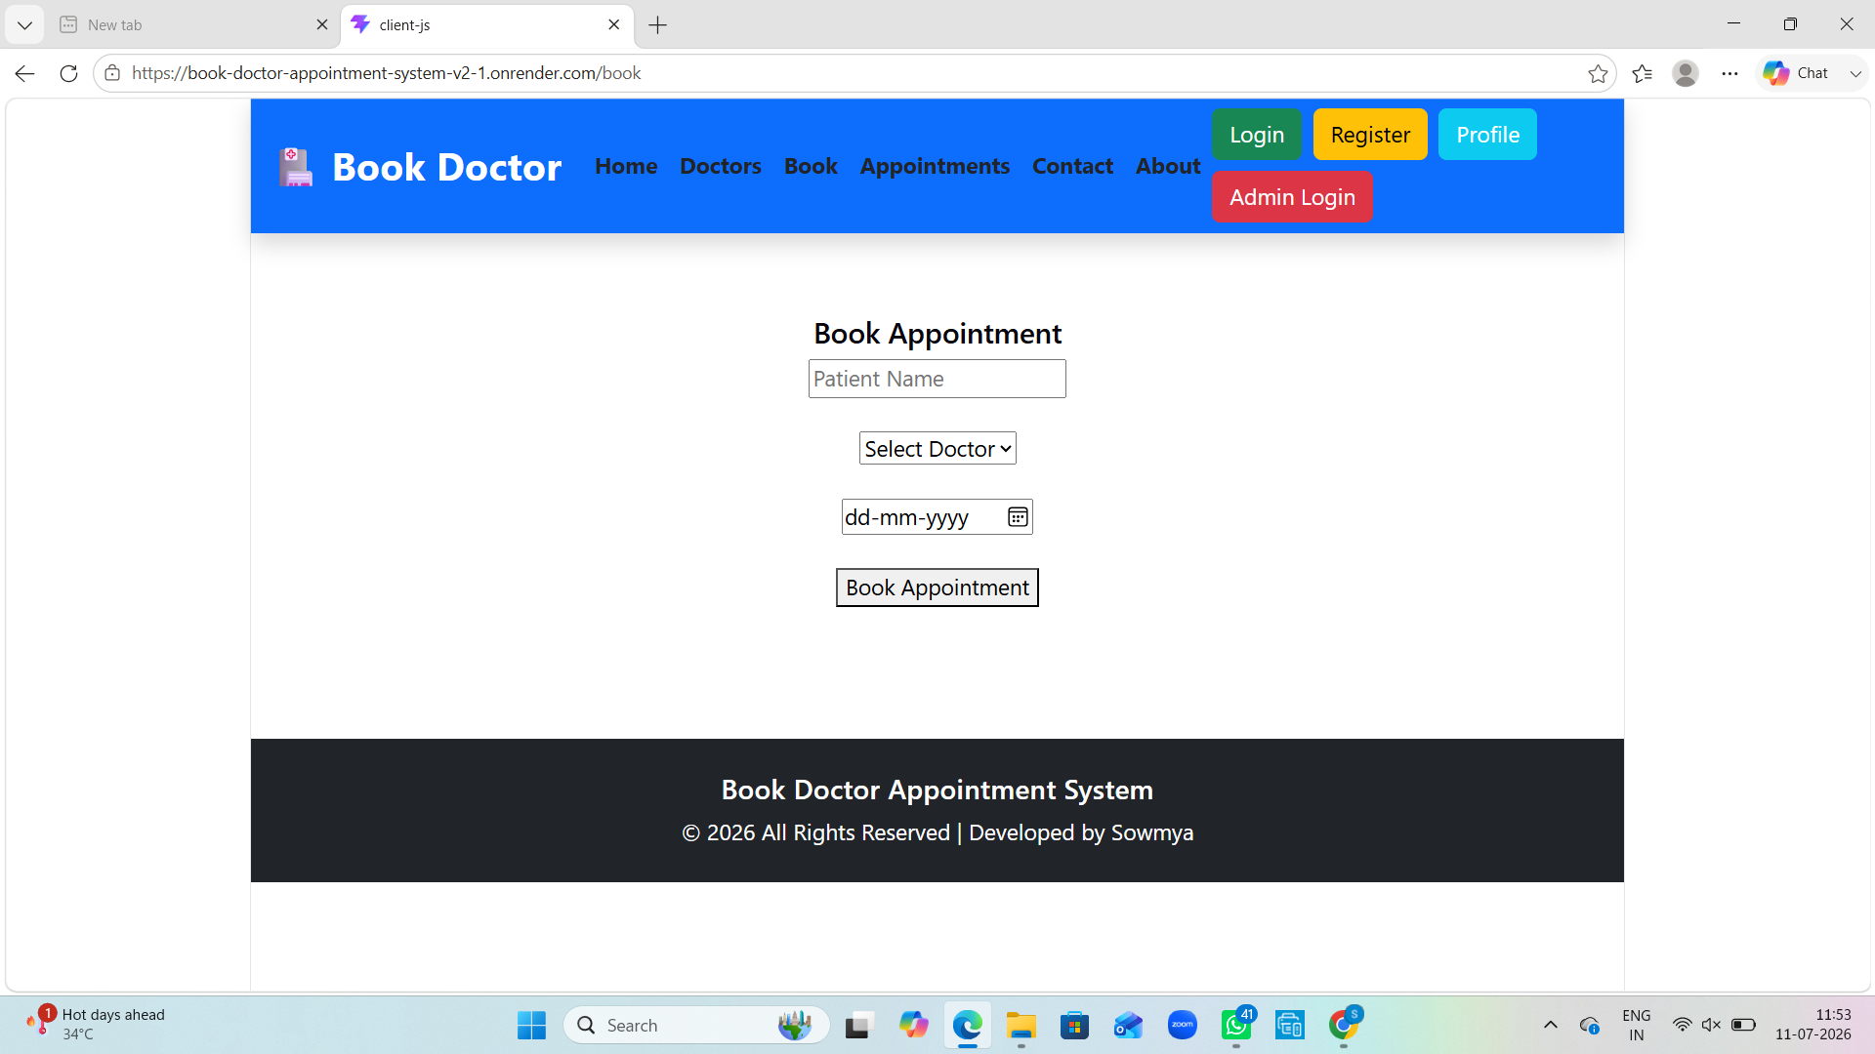
Book Appointment

Appointment Management
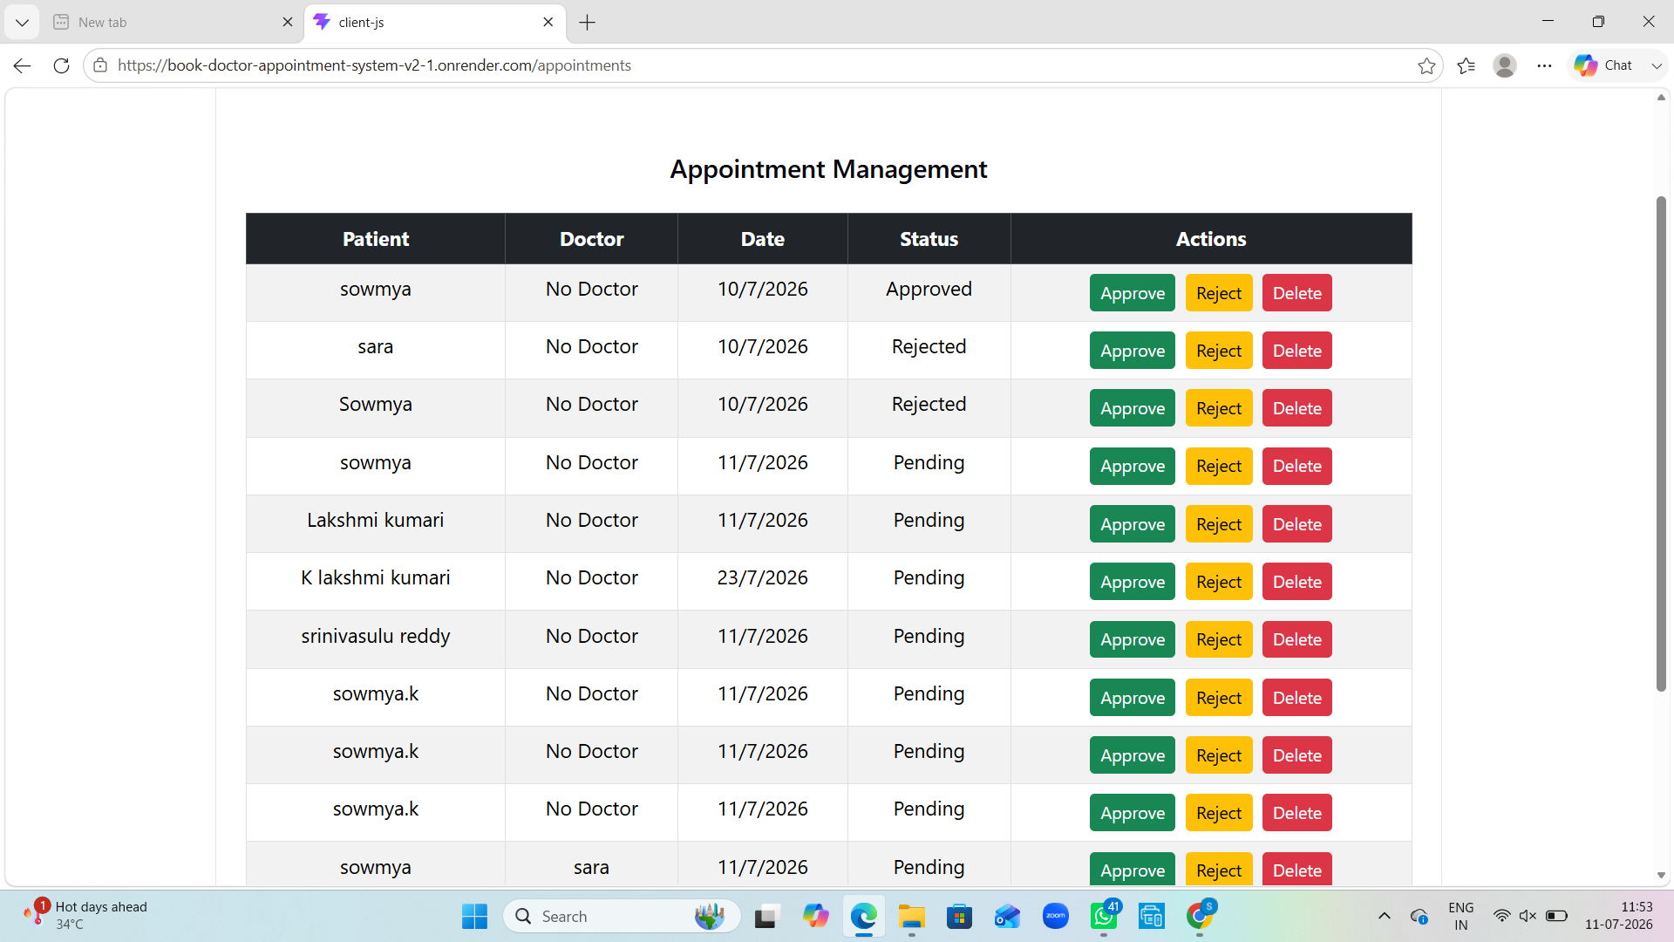
Appointment Management

Contact Page
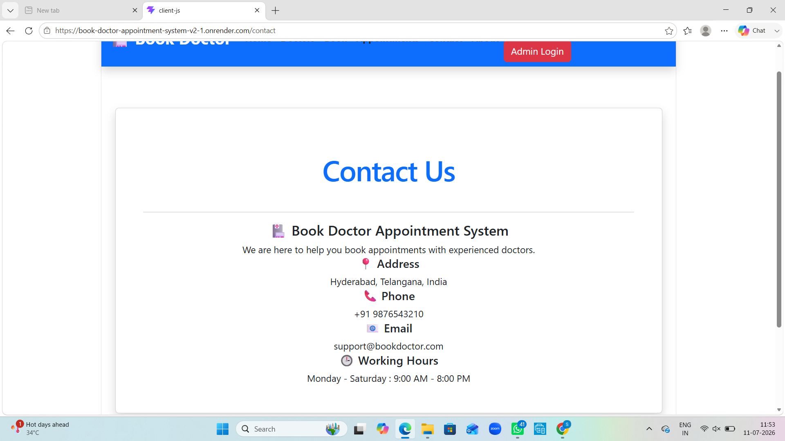
Contact Page

About Page
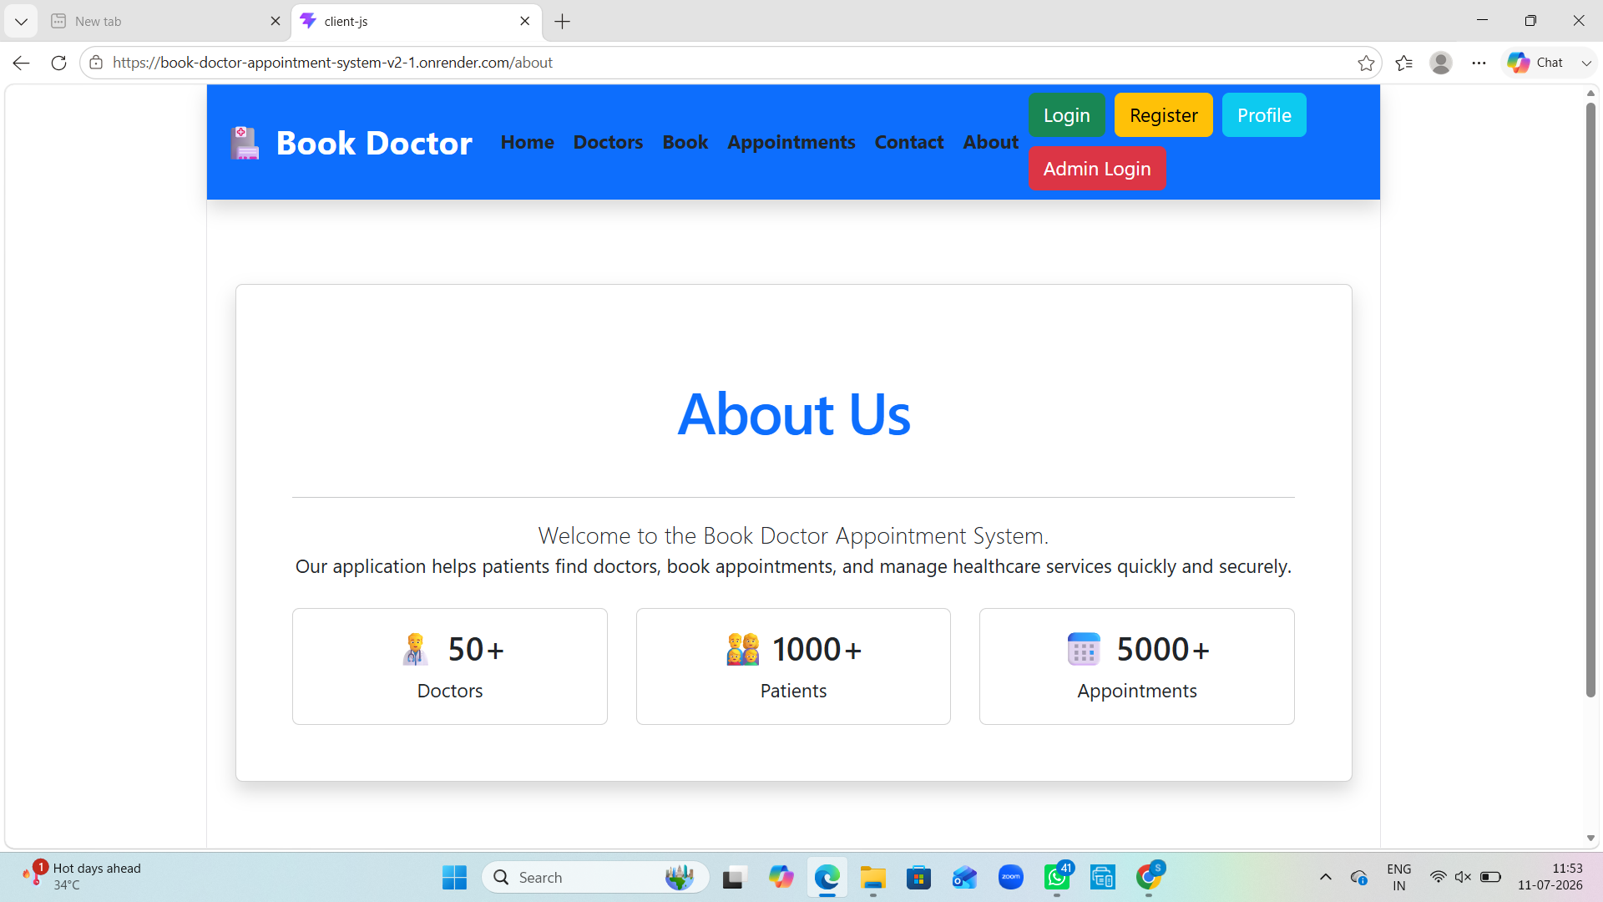
About Page

User Login
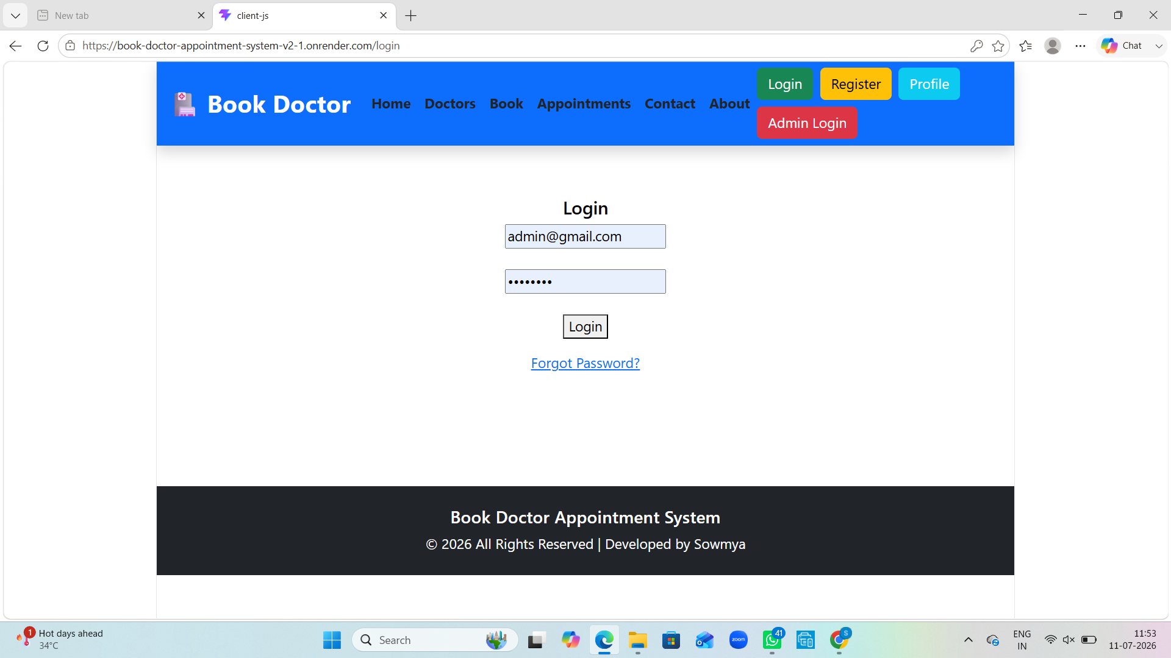
User Login

User Register
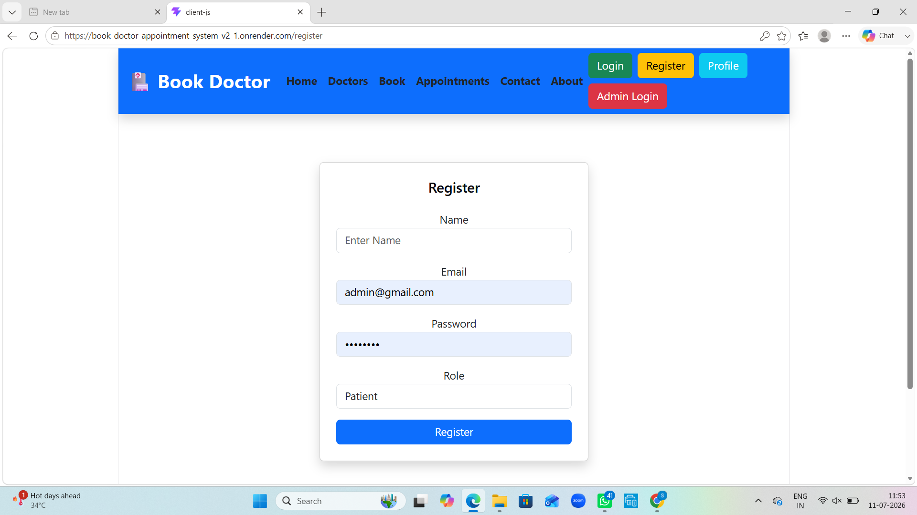
User Register

User Profile
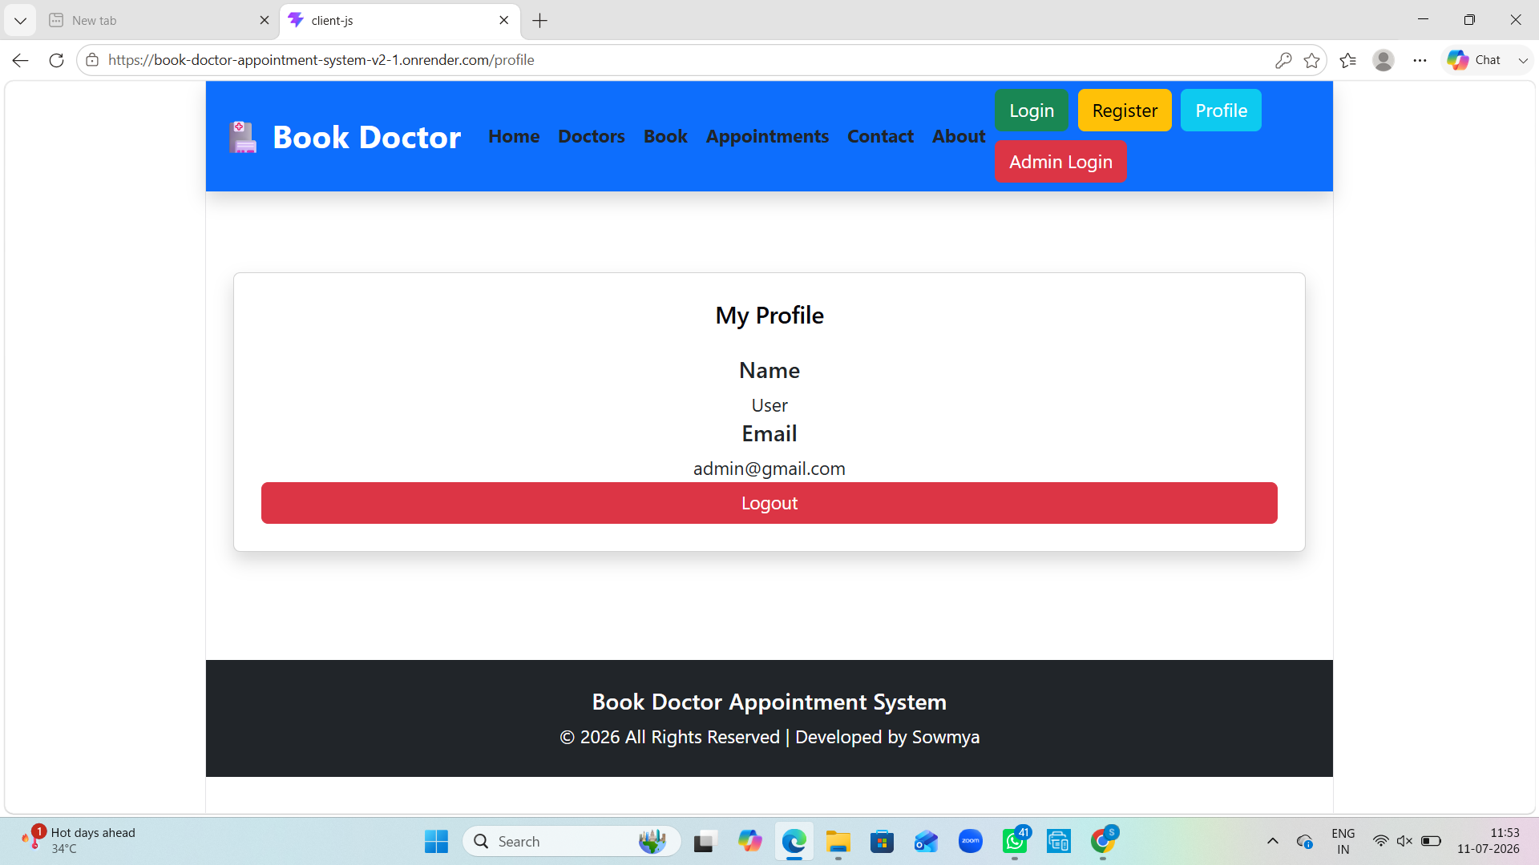
User Profile

Admin Login
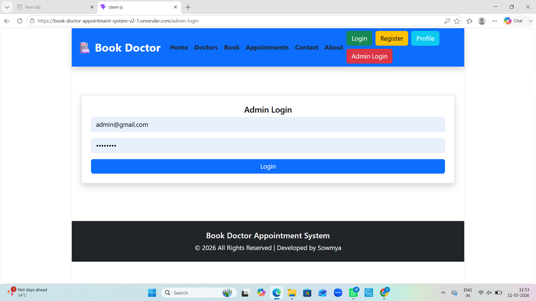
Admin Login

Admin Dashboard
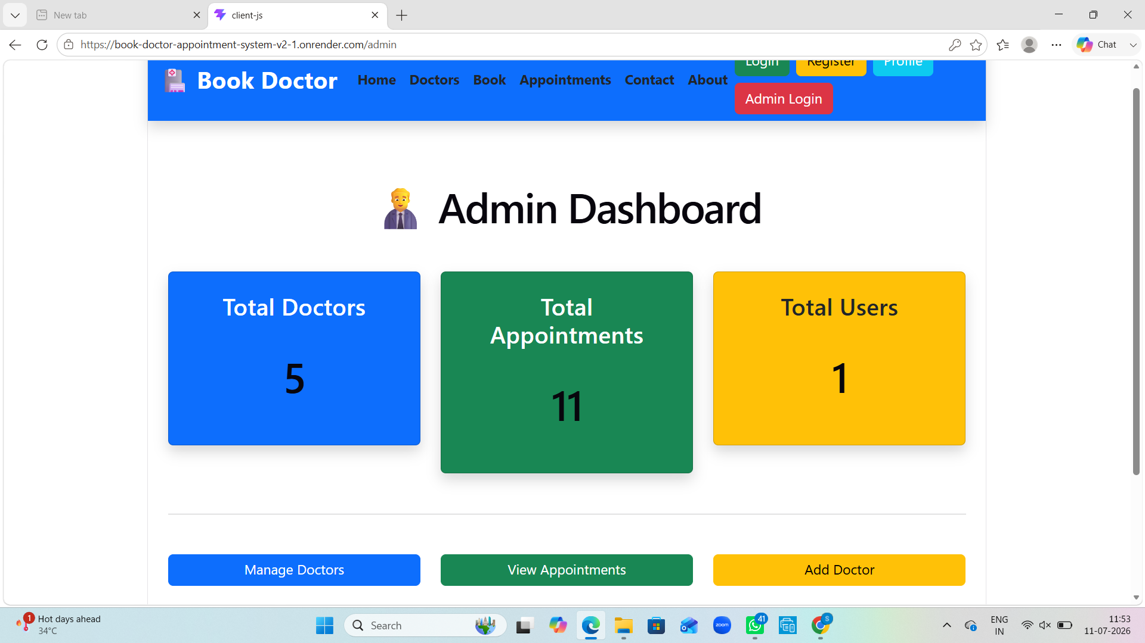
Admin Dashboard

Entity Relationship (ER) Diagram
+----------------------+
| USER |
+----------------------+
| _id |
| name |
| email |
| password |
| role |
+----------------------+
|
| 1
|
| Books
|
M
+----------------------+
| APPOINTMENT |
+----------------------+
| _id |
| patientName |
| appointmentDate |
| status |
| doctorId (FK) |
| userId (FK) |
+----------------------+
|
| M
|
| Belongs To
|
| 1
+----------------------+
| DOCTOR |
+----------------------+
| _id |
| name |
| specialization |
| experience |
| fees |
| image |
| available |
+----------------------+

Relationship Explanation
• One User can book multiple Appointments (1:M).
• One Doctor can have multiple Appointments (1:M).
• Each Appointment belongs to exactly one User and one Doctor.
• Appointment stores references (foreign keys) to both User and Doctor.

Problem Statement
Patients often spend significant time finding suitable doctors and booking appointments manually. This project provides an online platform where patients can register, view doctors, book appointments, and track appointment status. Administrators can manage doctors and appointments from a single dashboard.

Objectives
• Develop an easy-to-use doctor appointment booking system.
• Reduce manual appointment scheduling.
• Maintain patient and doctor information securely.
• Allow administrators to manage doctors and appointments.
• Deploy the application online using Render.

Existing System
The traditional appointment process relies on phone calls or hospital visits. It is time-consuming, lacks real-time availability, and often results in scheduling conflicts.

Proposed System
The proposed MERN-based web application enables online registration, doctor management, appointment booking, approval/rejection of appointments, and secure user authentication.

Modules
1. Home Module
2. User Registration & Login
3. Doctor Management
4. Doctor Details
5. Appointment Booking
6. Appointment Management
7. Admin Dashboard
8. Profile Module
9. Contact & About Pages

Software Requirements
Operating System: Windows 10/11
Frontend: React.js, Bootstrap, Axios
Backend: Node.js, Express.js
Database: MongoDB Atlas
IDE: Visual Studio Code
Version Control: Git & GitHub
Hosting: Render

Hardware Requirements
Processor: Intel Core i3 or above
RAM: 4 GB or above
Storage: 20 GB Free Space
Internet Connection

API Endpoints
POST /api/auth/register
POST /api/auth/login
GET /api/doctors
POST /api/doctors/add
PUT /api/doctors/:id
DELETE /api/doctors/:id
POST /api/appointments/book
GET /api/appointments

Testing
Unit testing was performed on backend APIs. Functional testing verified registration, login, CRUD operations for doctors, appointment booking, approval, rejection, and deletion. Deployment testing confirmed successful execution on Render.

Future Enhancements
• Online payment integration
• Doctor availability calendar
• Email and SMS notifications
• Video consultation
• Patient medical history
• Search filters and ratings

References
1. React Documentation - https://react.dev
2. Node.js Documentation - https://nodejs.org
3. Express.js Documentation - https://expressjs.com
4. MongoDB Atlas Documentation - https://www.mongodb.com
5. Render Documentation - https://render.com

