**REACT COURSE**

T Sree Sowmya

221910304044

Gitam Hyd CSE

**DAY-1 24/11/2022**

1. VISUAL STUDIO CODE : (installation)
2. NODE JS : (installation procedure in windows -11)
3. Create React App:
   1. 🡪**npm** : npm is tool present in node js. Inorder to create the project in react “npm” tool is used.

1)**Visual Studio Code:**

Go to Browser🡪Download Visual Studio code (latest version)

2) **node installation:**

Go to google🡪node js latest version download (windows 11)🡪install

1. **To check version :** *node -v*

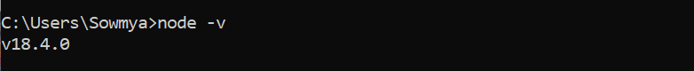

1. **Create React App:**

🡪**npm** : npm is tool present in node js. Inorder to install the create-react app “npm” tool is used.

***Check version****: npm -v*



**Installing Create React App*:*** *npm install create-react-app*

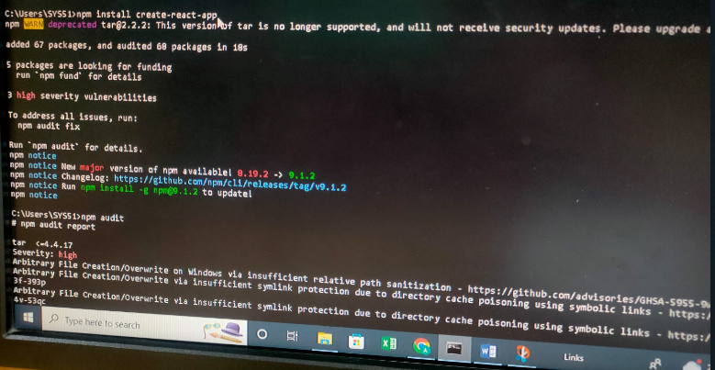

**npm audit :** *npm audit*



Create folder in desktop “React_Project”🡪create Reat Project using npx🡪and start the app which opens in browser

**Commands:**

cd Desktop

mkdir React_project---🡪*mkdir foldername*

cd React_project --🡪cd foldername

npx create-react-app sowmya4044 🡪npx create-react-app appname

cd sowmya4044

npm start

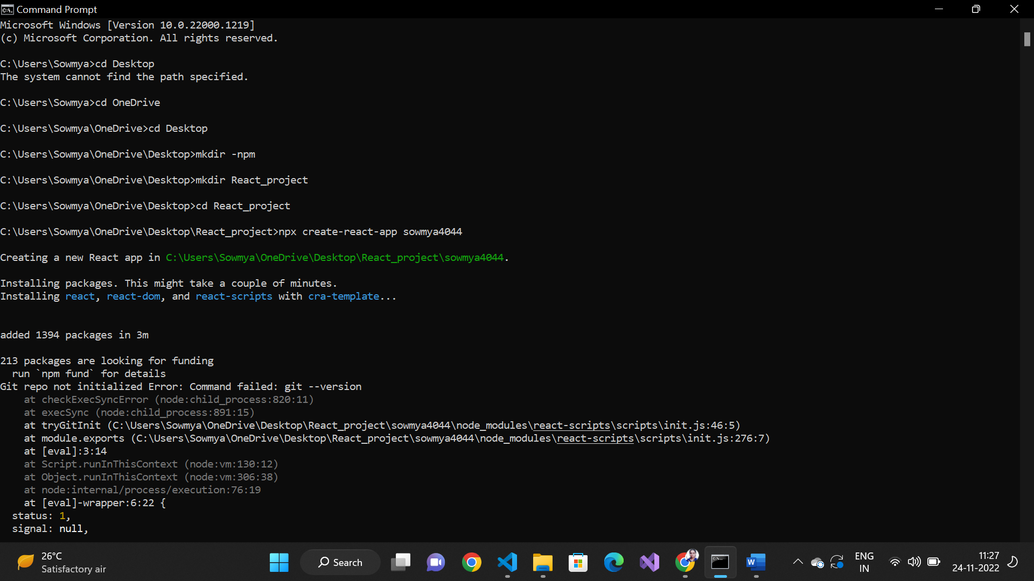

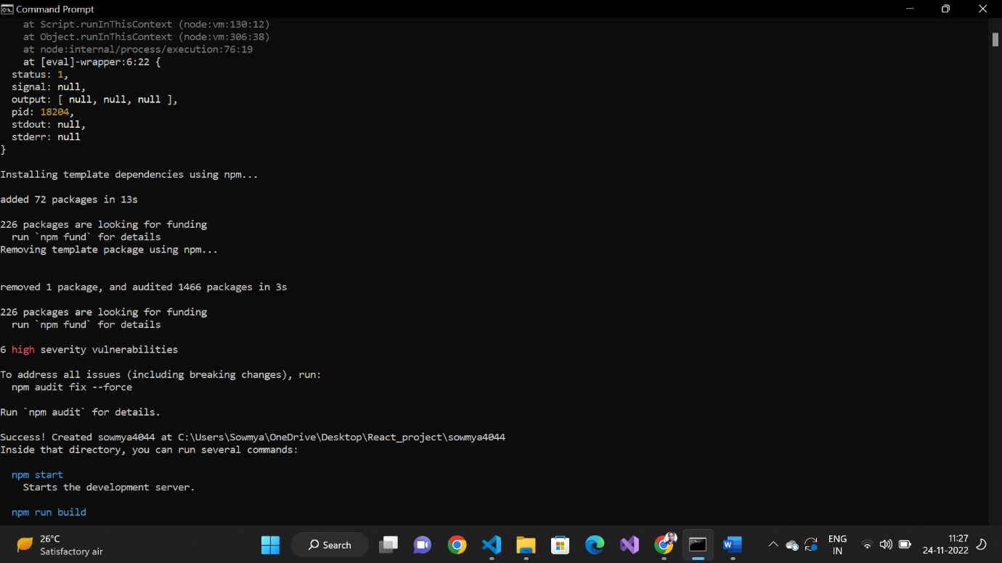

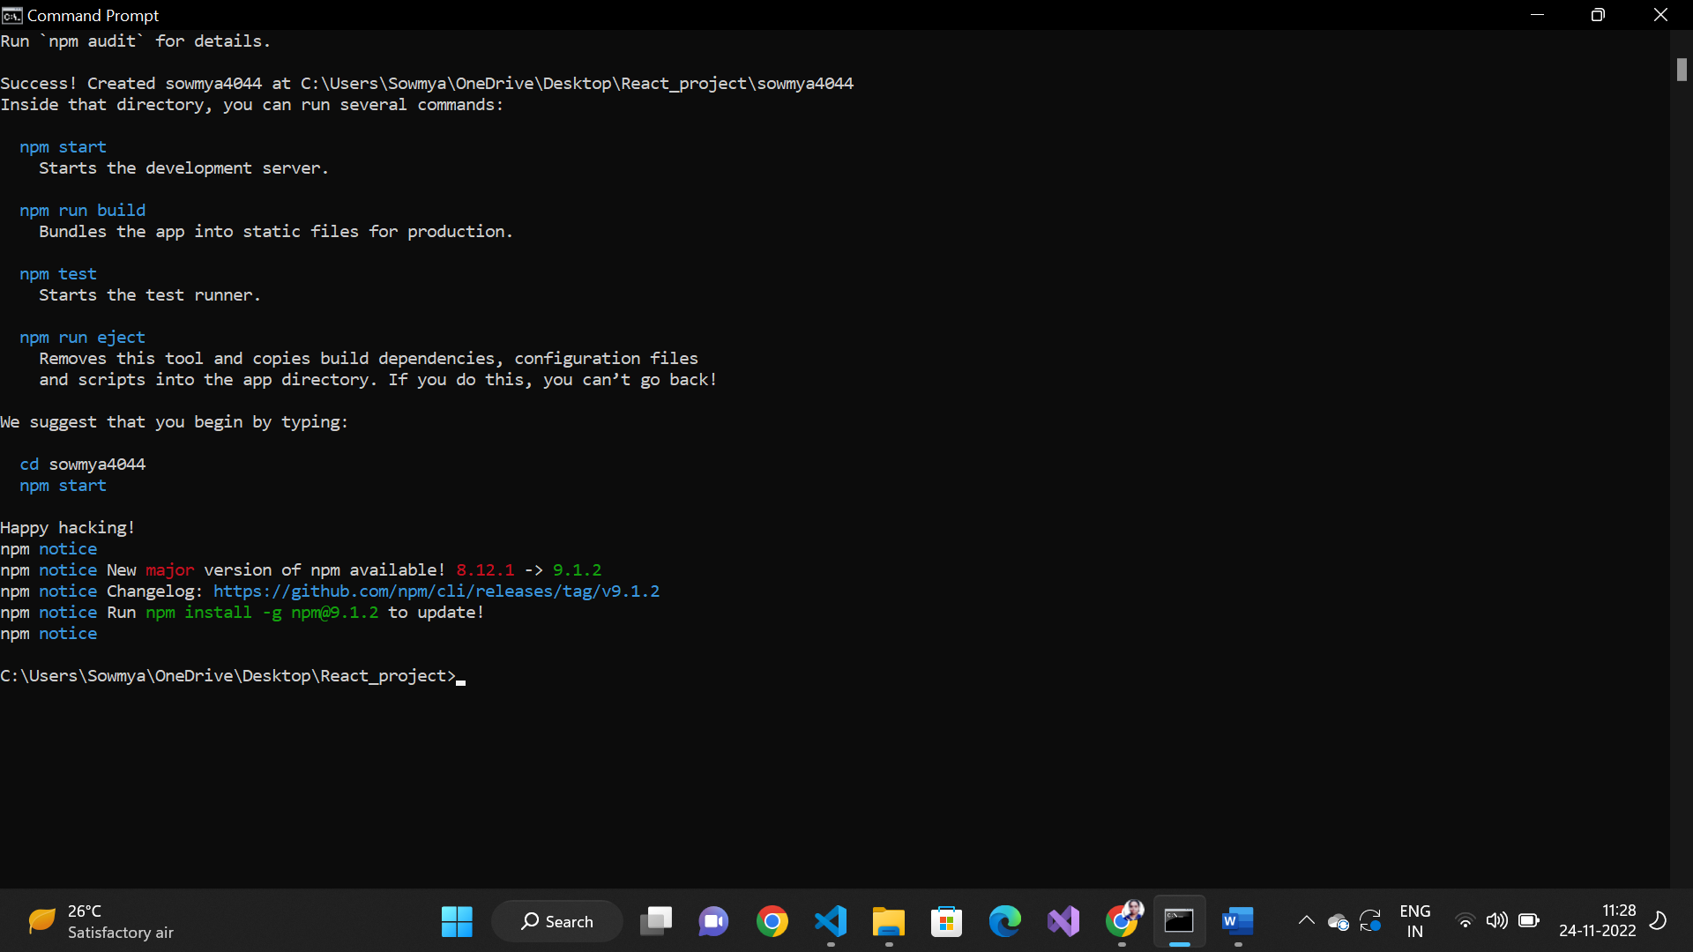

**npm start**

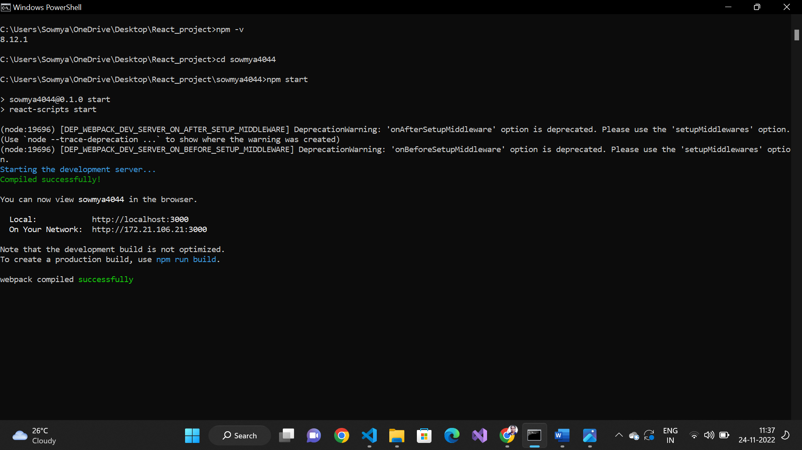

**Generates localhost :3000**

**Network : 172.21.106.21:3000**

**Will open in browser**

