**Webservice concepts**

**1.(a) Creating soap project with wsdl**

Initially, Download and install SOAP UI tool -> open it and click on SOAP which is on top (or) right click on the file and click on New SOAP project -> we can see a dialog box and in that enter Project Name and give URL (or) file name for Initial WSDL and click on OK.

-> Sometimes we can even add WSDL file at the middle of the project like ->right click on the project and click on Add WSDL- >enter url or file name and click on OK.

**Example:**

**Step-1**

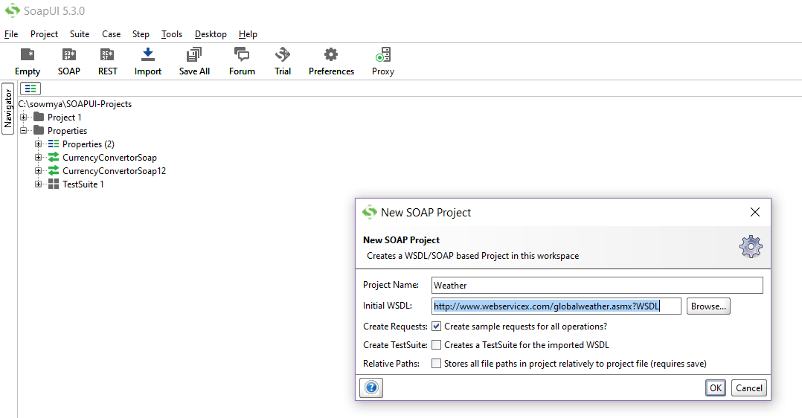

* We have given project name as Weather and imported WSDL file.

**WSDL** - Which describes all the information (requests and responses) about the webservice which is to be tested.

**Step-2**

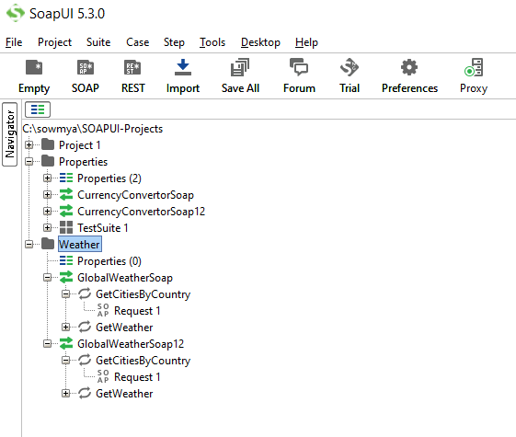

* Now, the url will be processed and respective services will be loaded into the project and requests will be generated.

**1.(b) How to send request xml?**

* At first double click on the Request1 (service name) and then u can see a box which is opened. In that click on XML u can see an input xml request of Weather webservice. “**?**” indicates the input parameters which has to be given to get a response based on that.

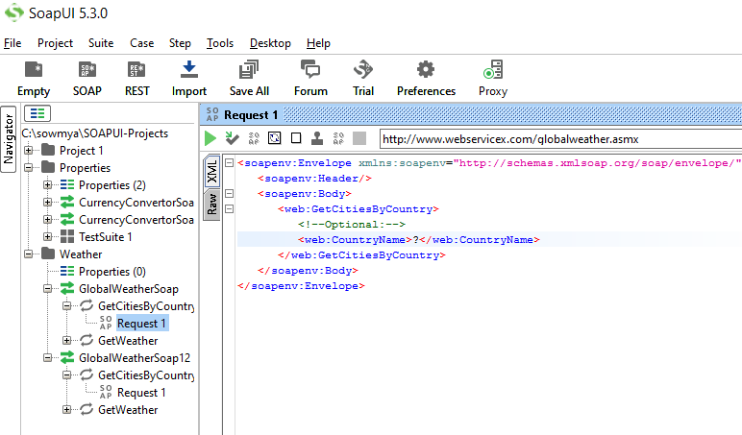

Now, Here we have two types of requests:

1. GetCitiesBy Country
2. GetWeather

* Let’s give input parameters for the first xml request (in the place of **“?”** enter India/INDIA and now click on green icon greenIcon.PNG then it will hit the Weather webservice and gives response based on our input value which is displayed towards the right side.

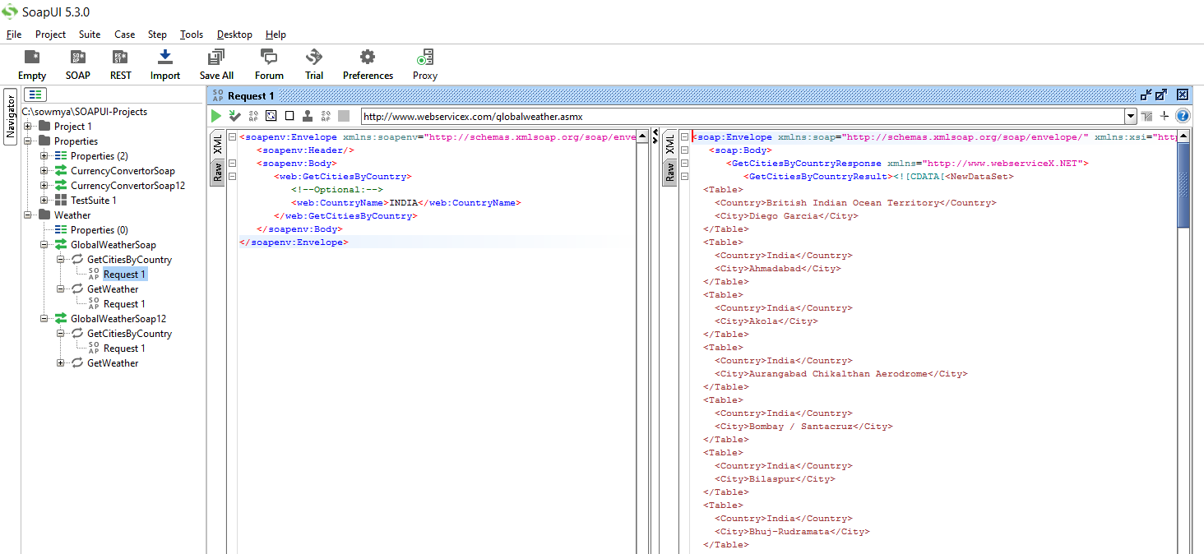

reading data from response xml using assertions  
creating propety and use the property in test steps  
creating test suite, test case, test steps  
validating reqest xml, response xml using xsd  
scurity testing, passing token string to web service